Writing Statistics (or really any) Internal Assessments

A caveat – the standards will be changing in the next few years. However, how much will actually be changing? The rumours are flying around – 4 to 5 standards with at least one external. There will still be internal assessments which need writing.

Why?

- Sheer and utter boredom – assessing the same contexts and data sets year after year is soul-destroyingly boring

- Writing Internal assessments is a valuable tool to add to your repertoire of teaching skills, and lets face it, makes you so much more employable

- Hones and develops your content knowledge of the standards more than any other professional development on offer

- Allows you to write and develop relevant and useful resources for teaching – you do not have to find resources in the black hole that is the internet

- Firmly embeds you in the ‘mind of the student’ – you will have to consider student engagement, content knowledge and the different levels needing to be demonstrated.

- You will become an expert in the standard – it’s actually pretty cool.

WHEN?
Presumably pretty soon….. but that’s another story

The NZAMT writing camp is the best professional development you can ever get.
The year before, seriously the year before. Having an assessment ready the year before enables lesson planning, development of resources and peace of mind.

Or, at least the term before so teachers are aware of the context, content and for moderation purposes

HOW – PART 1 – The Standard

Stage one of gathering all your information:
www.nzqa.govt.nz - this will form the basis of the schedule
www. ncea.tki.org.nz/Resources-for-Internally-Assessed-Achievement-Standards - this will give a framework for the assessment
www.nzqa.govt.nz/ncea/subjects/mathematics/clarifications/- this will aid in the schedule development and teacher judgement

The standard will form the basis of the schedule – it is what the student is assessed against. More on standard clarifications later on.

Parts of the standard. We chose 1.10 as an example but this applies to all the current standards.

The Explanatory Notes – This could form the main focus of your teaching planning. This shows where the standard has been derived from the New Zealand Curriculum.

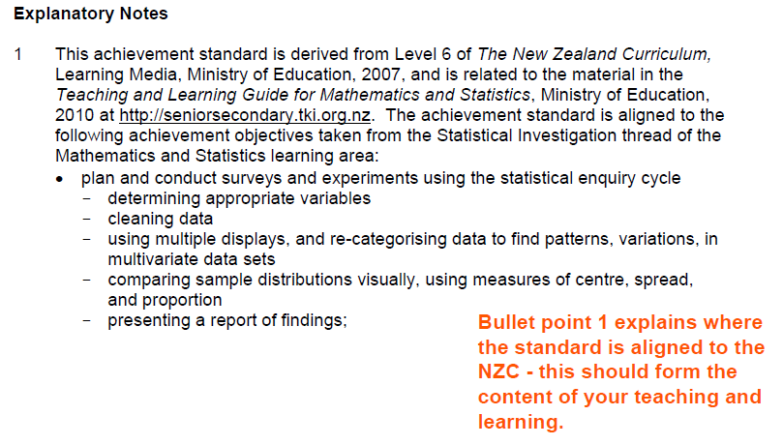

Bullet Point Two – This is the definition of the levels between Achieved, Merit and Excellence grades.

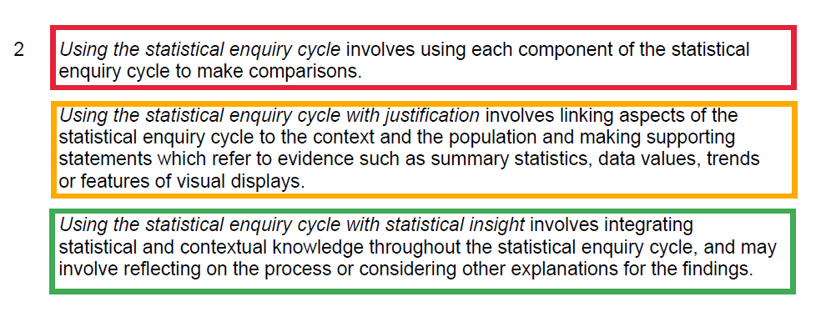

Bullet Point Three – This is the description of using the statistical enquiry cycle content the students need to be familiar with.

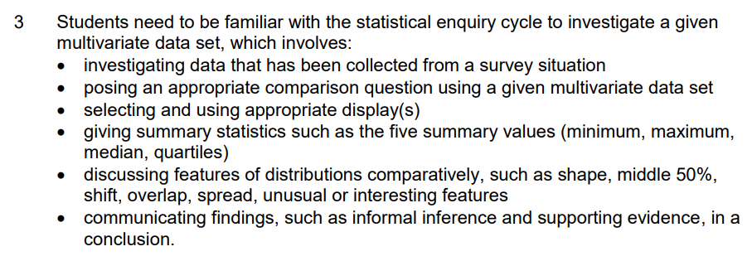

Note: For non-statistical standards, the standard indicates students need to be familiar with ‘methods related to’ and there are additional bullet points indicating the number of methods required and context requirements.

Distilling the level step ups:

Achieved - Using each component of the statistical enquiry cycle to make comparisons.

Merit - Linking to the context and the population and making supporting statements

Excellence - Integrating statistical and contextual knowledge throughout the statistical enquiry cycle, and may involve reflecting on the process or considering other explanations for the findings.

HOW – PART 2 – The tki Website

Take note! You must modify the tki assessments!
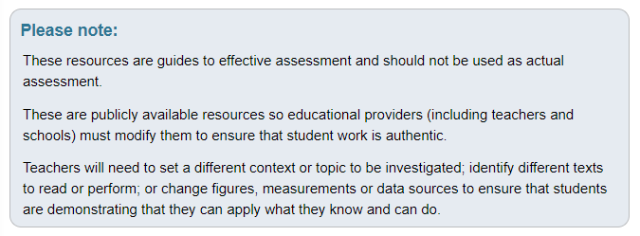

Read the Teacher guidelines: They contain valuable information on how to carry out a consistent and valid assessment.
Context/setting – This explains the data set and the contextual settings – these can be adjusted by the teacher
Conditions – This explains how the assessment could be administered with respect to assessment timings, writing questions and readiness for the standard
Resource requirements – This explains the information required by the students to complete the assessment and possible indications for starting student on the assessment

The Student Instructions – This will always follow the Statistical Enquiry Cycle:

Introduction: Describes the context and conditions to the students
Task: Problem, Plan and Data, Analysis and Conclusion
Student Resource: Data sets and explanations of variables

The Schedule – The Nuts and Bolts of the assessment
The Evidence section comes from the levels from the standard.

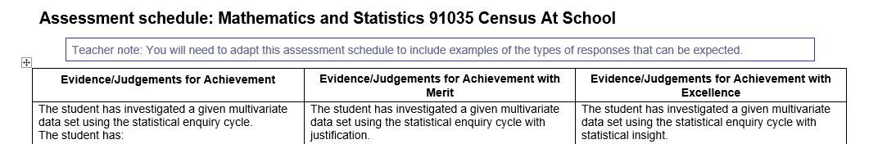

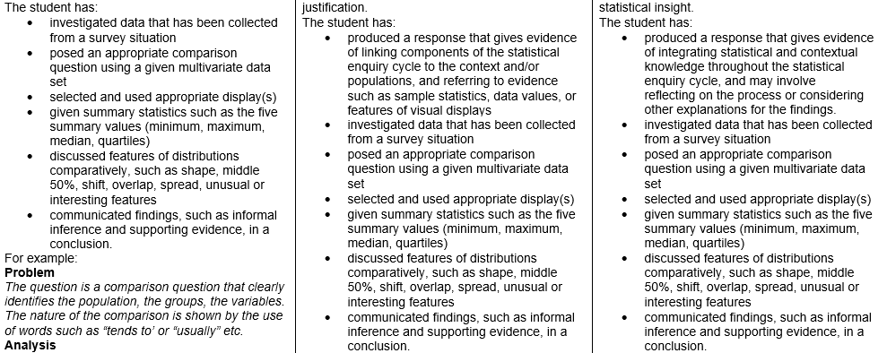
The following contains Bullet Point 3 – with the description of the Statistical enquiry cycle at the various levels – note the step ups from before:
Achieved – At Achieved level students need to provide evidence of using each component of the ‘process’.
Merit – Link components of the ‘process’ to the context. The justification comes from providing supporting evidence for any comments.
Excellence – Integrate statistical and contextual knowledge throughout the ‘process’. They need to have an understanding about the context and are expected to demonstrate they have thought about the ‘process’ they have undertaken and their findings.

The rest of the schedule is the explanation of the requirements of the statistical enquiry cycle at the various levels.

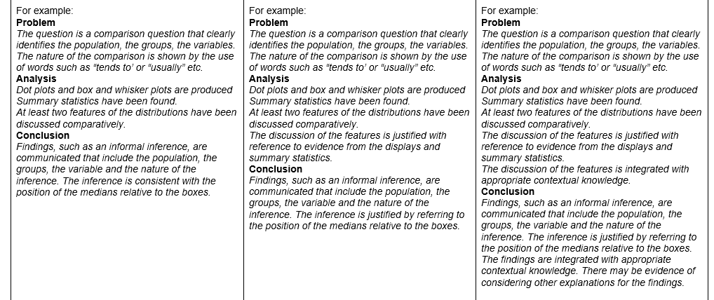

But wait, there’s more!

HOW – PART 3 – The clarifications

You will also need to check your interpretation of the tki schedule alongside the standard clarifications on the NZQA website to ensure your assessment conditions such as a ‘named populations’ and required quality of student responses are reflected in the Task and Schedule.

This is often updated – and this is advertised via Facebook, the Network of Enterprise newsletter and Principal’s Nominee’s newsletters. Making checking the clarifications part of the assessment writing process is key to staying up to date.

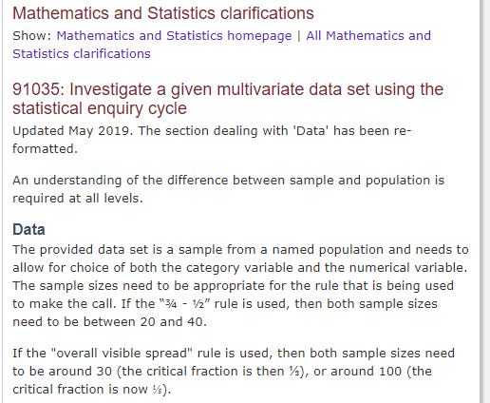

WITH WHOM?

Buddy writing assessments is the best use of teacher time
Having constructed a DRAFT assessment - it is a good idea for both to write an assessment each.
This puts you in the mind of the student - it allows you to understand the cognitive load on students to complete the reports. Is an eye opener.
Swap assessments and peer mark - this is confronting so adhere to professional boundaries and ensure new teachers are supported.

Check teachers are aware of conditions of assessments

Distribute assessments to teachers for feedback - we use different coloured paper in teacher’s pigeon holes.
Feedback can be spotty - this could change with the new standards where teachers could be strongly encouraged to complete reports and give their own feedback.
Assessment meetings before the teaching of the standard are ideal - saves difficult conversations later on.

