Warm-up task
Overview: The goal of this task is to prepare students for the Cookie cutting task, by engaging them in the context of managing variation in a mechanised process to improve or maintain consistency, often aspects found in quality control environments. It takes 10 minutes and can be done with the whole class either the day before the Cookie cutting task, or at the beginning of the class session before Task 1 is implemented. The benefit of doing the warm-up the day before is that it will give students more time to work on their written letters, and may leave some room for student presentations at the end. However, it also works well if the warm-up is presented on the same day as the main cookie cutting task, as long as the warm-up is completed within 10 minutes to leave enough time for the complete task.
Watch 24 of the most mesmerizing machines
Readiness questions:
- What colour yarn was being used? (Grey)
- What was made that can be eaten? (Toffee apples, pasta, gerkins, chocolate, bread, pretzels)
- What did these clips all have in common? (All show things being made/produced by machines)
Note: These questions are designed to check that students have engaged in the context of the problem.
The Cookie cutting task
As the problem statement below is quite long, it works well to have one or two students read it aloud, as students are more likely to pay attention when they might be called upon to read part of the problem statement.
Before students start working, ask the class three questions to check they know what they are being asked to do:
- Who are you writing to? (The class)
- What does the term consistency mean?
- What is the class’s problem? (Which cookie cutter produces the most consistent weights of cookies)
- What do they want you to give them? (A letter that describes the model, the real and simulated data, and a recommendation about which cookie cutter to use)

Cookie Cutting
Your class are fundraising for a school trip. The class has agreed on a plan to bake and sell iced cookies made from pre-made cookie dough.
The marketing and sales team has arranged to sell the cookies at a gift shop. The gift shop will sell the cookies beside the cash register. They have asked that the cookies look the same, and are exactly the same size with the average weight printed on the packaging of each cookie.
After researching what cookie cutter shapes are available the class has decided on a Kiwiana theme. They have chosen kiwi cookie cutters, that are available in two sizes, small (10cm) and large (14cm) measured from the middle of the back to the tip of the beak.
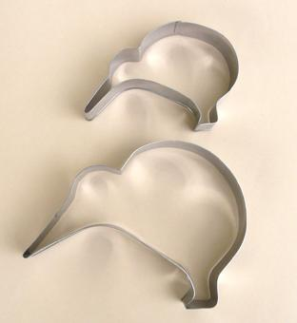
Your class need your help!
Your class knows that your team can build models to simulate data using TinkerPlotsTM. The sales team plan to sell 1000 cookies to raise enough money for the trip. They want to know before they start baking which cookie cutter will produce the most consistent cookie. They know that if a cookie is too different from the average weight, they will not be able to sell it at the shop and lose money.
Write a letter to the class. You should include your real data for the weights of cookies you make. You should also include your TinkerPlotTM models and simulated data for both the small and large cookie cutters. Use your simulated data to help the class decide which cookie cutter will produce the most consistent cookie, before they start baking.
Finish your letter with your recommendation of the best cookie cutter, and reasons for your decision, also how confident you are in your recommendation to the class and why.

Follow Up Tasks – Cookie cutting
- The gift shop has specified the cookies need to be within 10 grams of the average cookie weight. According to your model, how many of the 1000 large or small kiwi cookies will not be able to be sold?

- What advice would you give to the baking team for producing consistent cookies?

- Real data from the small and big kiwi cookie cutters is shown in the top plot below.
What improvements or suggestions would you make to the models of the small kiwi cookie weights shown below?

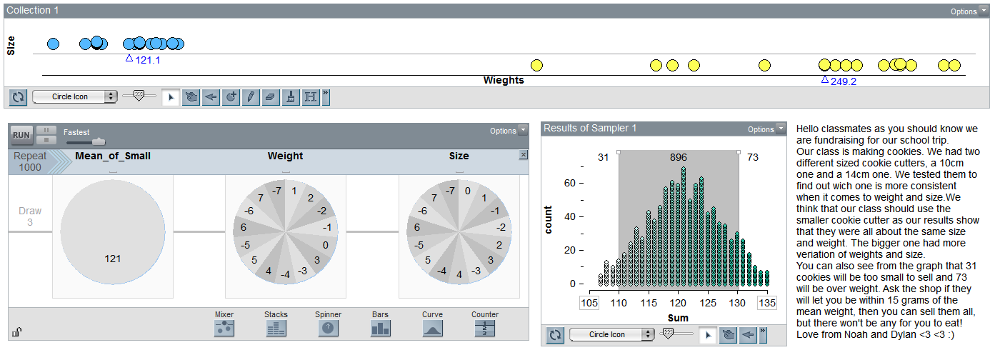
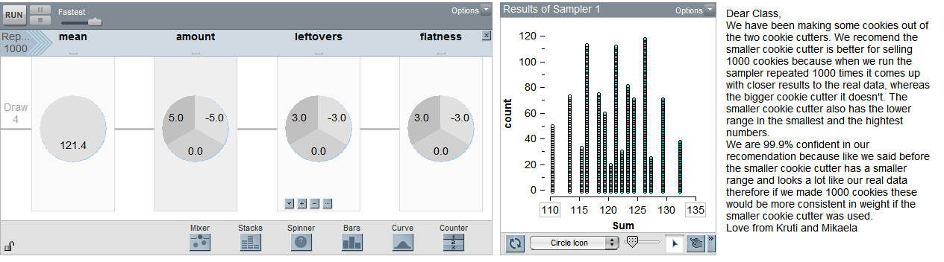

- What improvements or suggestions would you make to the letters to the class?

- Another class want to fundraise using iced cookies. They will sell either a silver fern cookie or a rugby ball cookie. They have the weights for the practice cookies they have made:
Silver fern (g): 56, 57, 50, 53, 48, 47, 53, 59, 66, 52, 58, 56, 57, 53, 52, 59, 64, 57, 61, 52, 54
Rugby ball (g): 54, 52, 61, 57, 58, 50, 60, 51, 57, 57, 53, 52, 55, 55, 52, 51, 56
They plan to sell 5000 cookies. Duplicate and adapt your kiwi cookie model to show them what percentage of Silver fern and Rugby ball cookies they can expect to reject if the weights of the cookies have to be within 5 grams of a typical cookie. Write your recommendations below for which cookie cutter they should choose and why.

- Jackie and May are arguing about which cookie cutter the class should use. Their simulated data sets for the silver fern and rugby ball cutters are shown in the sketch. Write a key for the two sketched distributions.
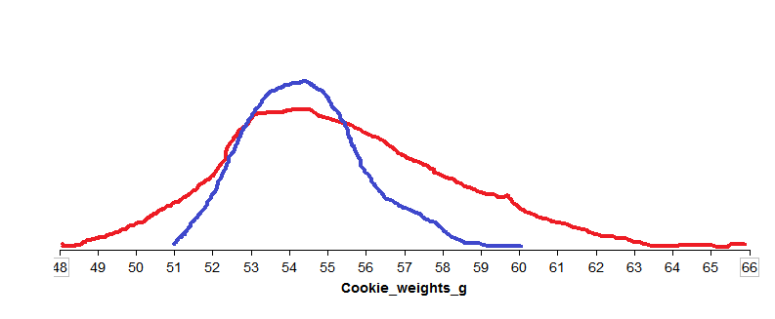
Jackie says “the rugby ball data is very close”. After discussing what Jackie means rewrite Jackie’s explanation more clearly so that May understands what she means.

- Later in the year, the class also has plans to fundraise during the Christmas season.
They decide to put coloured lollies on top of iced rugby ball cookies. Before you extend your rugby ball cookie weights model, investigate how much weight placing around 20 lollies on top of the cookie tree will add to the total weight of the cookies.
Sketch the distribution of the weights of 20 lollies

- Which of the model devices below is the best (realistic) model of the weight of 20 lollies? Explain why you think this.
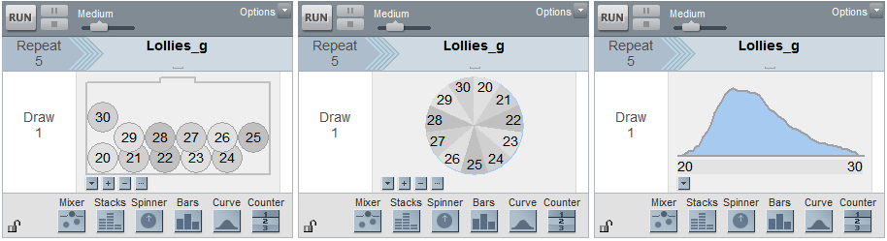

- Now extend your model for the Christmas rugby ball cookie weights using the continuous distribution device to include the weights of the 20 lollies.

- Advise the class what they should print on the packet for the average weight of a Christmas rugby ball cookie? Include the percentage of the cookies that can be sold.

- Redo your original small kiwi cookie model using the continuous curve device in place of your discrete devices (spinners and mixers). Does this change make the simulated data a better fit to the real data? Explain your reasoning.

