2017 Stat Day

Unfolding
Secondary TKI activities for teaching L3 Probability
(Calc teacher’s learning journey
for teaching L3 Stat)

Sun Mee Kim
Westlake Girls Highschool
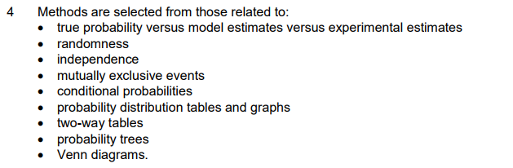
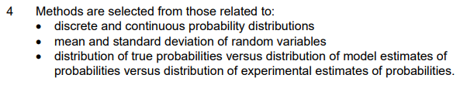
http://seniorsecondary.tki.org.nz/Mathematics-and-statistics/Achievement-objectives/AOs-by-level/AO-S8-4
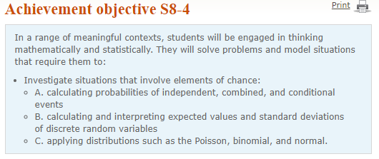
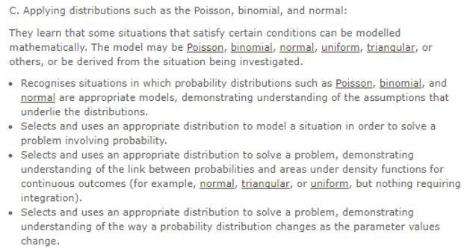

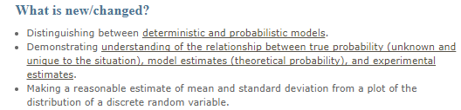

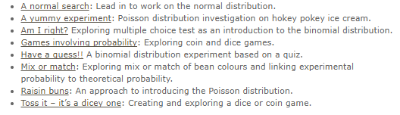

Your List: Probability Games or Probability Context
- Craps
- Two up
- De Mere’s problem

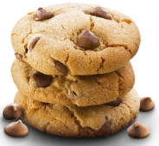
Part 1) Yummy Experiment
"Introduction to Poisson Distribution Model

Chief Tui is making a batch of choc button cookies and realised he has a very small amount of choc. buttons. He is wondering how many cookies will not have any choc buttons.

“Frequency Distribution” X: number of choc. Buttons /cookie
x
Frequency

- Draw the distribution graph as a dot plot.
What do you notice from the graph? What do you wonder?

2. Estimate the Mean of the Distribution:
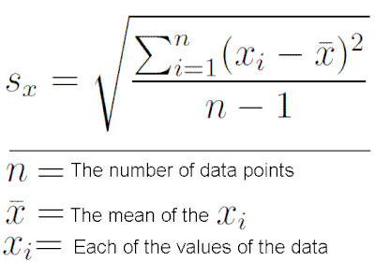
Calculate the Mean of the distribution:

3. Calculate the Standard Deviation of the distribution (by hand, or by Graphics Calculator):

4. Calculate the probability of the followings based on the experiment above.

a) Exactly ____ choc. buttons in one randomly chosen cookie
b) No more than ____ choc. buttons in randomly chosen cookie
c) At least ____ choc. buttons in randomly chosen cookie
d) ____ or more choc. buttons in randomly chosen cookie

e) Moana and Maui get one cookie each. What is the probability that both of their cookies has exactly _____ choc. buttons?

f) Granma Tala eats three cookies. What is the chance that she ate ___ Choc. Buttons ?

g) One baking tray makes 24 cookies. How many Choc Button do you expect to find in one tray?
Part 2) Comparing Probability Distributions between the Model Estimates (by Poisson) and Experimental Estimates

Use Poisson Model to calculate the probabilities and compare them with the experimental probabilities.
Poisson distribution is often called “the Law of Small Numbers” and it requires only one parameter, “ average rate “, to calculate.
E(X) = µ = λ (Lambda) = rate = _________ (buttons per cookie)
the average number of (discrete) occurrence of the event in a finite interval of time or space

“Probability Distribution” X: number of choc. buttons/cookie
x
Frequency
Experimental Estimates
Model Estimates

- Sketch the outline of the Poisson distribution over the Dot plot.
What do you notice?

Discuss whether a Poisson distribution could be a good model for the distribution of the number of chocolate buttons in a cookie. “S C S C C”

- A Unique feature of the Poisson distribution is that the mean is equal to the square of the standard deviation (aka variance). How is it in this sample?

3. Calculate the probability of the followings using the Poisson model. (Use Graphics Calculator)

a) Exactly ____ choc. buttons in one randomly chosen cookie P(X= ) =

b) No more than ____ choc. buttons in randomly chosen cookie

c) At least ____ choc. buttons in randomly chosen cookie

d) ____ or more choc. buttons in randomly chosen cookie
Part 3) Introduction to Normal Distribution Model

1. Record the weight of the cookies and create a Histogram.
(It’s a bit tricky to use in excel. See here for instruction if you want to try)

What do you notice from the graph? What do you wonder?

- Estimate the mean of the weight distribution
Calculate the mean, median and mode.
Estimate the standard deviation of the weight distribution
Calculate the standard deviation of the weight distribution

- Sketch the normal distribution model of cookie weight distribution
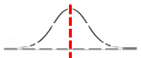
Mean =
S. D =

One cookie was randomly selected. Find the probability that it weigh
More than ____?

- Less than __ g?

- No more than___ g?

- Between __ g and ___ g?

- A class of 25 got one cookie each. How many would get the cookie weigh more than ___g

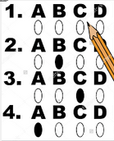
" Am I right - 20Qs?"
Introduction to Binomial Distribution Model

Part 1 ) “Experimental Probability Distribution”

X: number of question Correctly Answered

x
P_{e} (X=x)

1. Draw the distribution graph as a dot plot.
What do you notice from the graph? What do you wonder?

2. Estimate the mean and the standard deviation of the probability distribution for the number of correctly answered questions:

3. Calculate the mean and the standard deviation of the probability distribution for the number of correctly answered questions.

4. Find the probability that

a) Exactly 5 questions correctly answered. P(X= 5) =
b) At least 5 questions correctly answered.
c) More than 5 questions correctly answered.
d) Less than 5 questions correctly answered.
Part 2 ) Modelling Probability Distribution using Binomial Model

Use Binomial distribution to model the probabilities of guessing 20 questions. Binomial model requires Two (Bi) parameters to calculate the model estimates of the probabilities.

- Probability of getting right (p) =
- Number of trials (n) =

X: number of question Correctly Answered

x
P_{m}(X=x)

5. Sketch the outline of the Poisson distribution over the Dot plot. What do you notice?

Discuss whether a Binomial distribution could be a good model for the distribution. “S C S C C”

6. Calculate the followings using Binomial distribution model.

a) Exactly 5 questions correctly answered. P(X = 5) =
b) At least 5 questions correctly answered.
c) More than 5 questions correctly answered.
d) Less than 5 questions correctly answered.
The binomial distribution is one of the oldest known probability distributions. A special case of binomial distribution was first published by Bernoulli, J in 1713, a Swiss mathematician and physicist, also famous for Bernoulli’s principle in fluid mechanics. This distribution can be observed when playing Peg Board Game (or The quincunx or Galton Board)
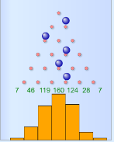
https://www.umass.edu/wsp/resources/poisson/#features
http://www.stat.yale.edu/Courses/1997-98/101/binom.htm
https://en.wikipedia.org/wiki/Daniel_Bernoulli
http://www.mathsisfun.com/data/quincunx.html

