Activity 2 – Socrative
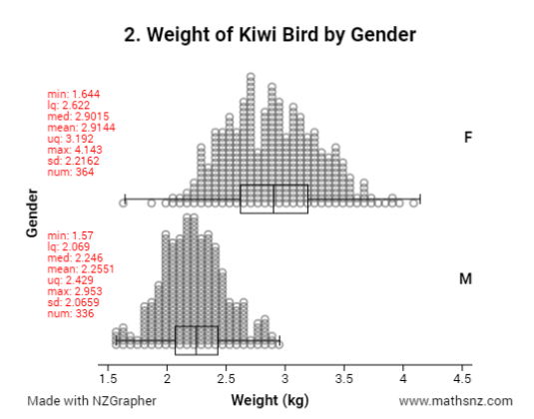
This graph from mathsnz.com shows the weights of male and female kiwi birds who were measured in bird reserves around the South Island of New Zealand.

Activity 2 – Socrative
This graph from mathsnz.com shows the weights of male and female kiwi birds who were measured in bird reserves around the South Island of New Zealand.

