Activity 1- Posters
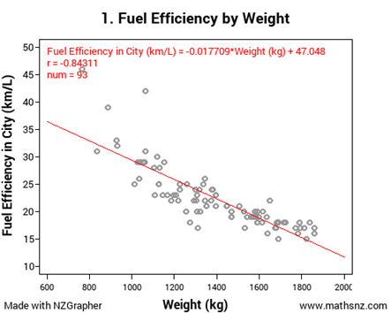

This graph from mathsnz.com shows the weights of 93 cars on the road in Auckland in 2014 and their fuel efficiency when driving in the city.

Activity 1- Posters
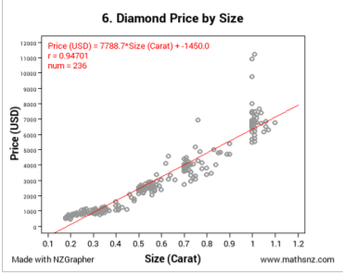
This graph from mathsnz.com shows the size and price of 236 diamonds for sale at Boston jewellers in 2012.

Activity 1- Posters
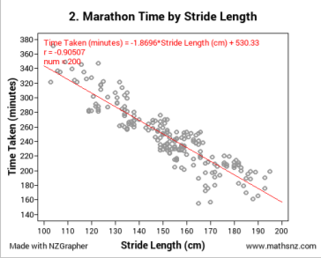
This graph from mathsnz.com shows the stride length and time taken to complete the 2000 New York Marathon for 200 runners who completed the marathon.

Activity 1- Posters
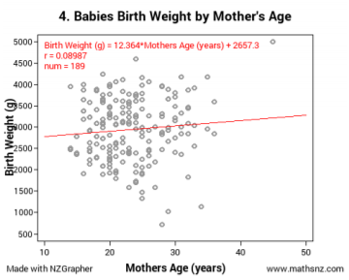
This graph from mathsnz.com shows the weight of 189 babies born in Auckland in 2014 and the age of the mothers who gave birth to them.

Activity 1- Posters
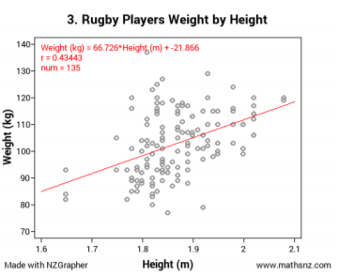
This graph from mathsnz.com shows the height and weight of 135 New Zealand professional rugby players in 2015.

