Name: __________________________________________

Form: ____________

Date Started: ________ November 2016 Date due: _____________

Statistics Assignment
All Blacks 2015
World cup team

Mini Investigation

This booklet is to be completed over three lessons. You must hand it in every day so it doesn’t get lost and I can check on your progress.

It is to be done individually and will be part of your assessment for this topic.

Please use a pencil & have an eraser handy. This means you can change your graphs and your writing to improve your work. There will be some marks for presentation.
You have been selected to investigate some aspects of the 2015 All Blacks team who won the men’s Rugby World Cup.

What sort of things do you think it would be interesting to find out?

- ______________________________________________________
______________________________________________________
- ______________________________________________________
______________________________________________________
- ______________________________________________________
______________________________________________________

Have a look at the data on the next page. Come up with three different type of investigation questions that could be answered by analysing this data

Summary Question
- ______________________________________________________
______________________________________________________
Comparative Question
- ______________________________________________________
______________________________________________________
Relationship question
- ______________________________________________________
______________________________________________________

For one of your questions above, write it out below as a full investigation ‘pose a question’

I am going to ……………………………………………………………..
……………………………………………………………………………
to see if I can find out…………………………………………………….
……………………………………………………………………………
This would be useful for………………………………………………….
……………………………………………………………………………
I am going to do this by………………………………………………….
…………………………………………………………………………....
I expect to find that ………………………………………………………

Now you are going to follow the tasks on the next pages which look at three different investigation questions. Each will be given to you at the beginning of the task.

NZ All Blacks | Tests | Age | Height | Weight
FORWARDS
McCaw Ritchie | 142 | 34 | 187 | 108
Read Kieran | 77 | 29 | 193 | 110
Messan Liam | 42 | 31 | 188 | 108
Retallick Brodie | 41 | 24 | 204 | 117
Franks Owen | 72 | 27 | 183 | 116
Coles Dane | 30 | 28 | 184 | 103
Woodcock Tony | 115 | 34 | 184 | 120
Mealamu Kevin | 126 | 36 | 181 | 108
Kaino Jerome | 60 | 32 | 196 | 110
Codie Taylor | 3 | 24 | 183 | 106
Crockett Wyatt | 40 | 32 | 193 | 116
Faumuina Charlie | 27 | 28 | 185 | 125
Franks Ben | 43 | 31 | 185 | 120
Romano Luke | 20 | 29 | 199 | 119
Whitelock Samuel | 66 | 26 | 203 | 114
Cane Sam | 24 | 23 | 189 | 103
Vito Victor | 28 | 28 | 192 | 112
BACKS
Kerr- Barlow Tawera | 15 | 25 | 187 | 89
Perenara TJ | 15 | 23 | 184 | 94
Barrett Beauden | 30 | 24 | 187 | 92
Slade Colin | 20 | 27 | 183 | 90
Feikitoa Malakai | 11 | 23 | 187 | 99
Milner-SkudderNehe | 2 | 24 | 180 | 90
Smith Ben | 41 | 29 | 187 | 91
Carter Daniel | 106 | 33 | 178 | 94
Savea Julian | 35 | 25 | 193 | 108
Smith Conrad | 88 | 33 | 186 | 95
Nonu Ma’a | 97 | 33 | 182 | 108
Naholo Waisake | 1 | 24 | 186 | 96
Williams Sonny Bill | 26 | 30 | 194 | 108
Smith Aaron | 41 | 26 | 171 | 85
Task One – Summary Question
How do the ages of the 2015 All Blacks world cup team vary?
1. First put the ages in order
AGE
2. Calculate the following statistical measures
Statistics
Highest (Maximum)
Upper Quartile
Median
Lower Quartile
Lowest (Lowest)
Range
Mean
Mode

Age | Tally | Frequency
23
24
25
26
27
28
29
30
31
32
33
34
35
36
Total

3. Complete the frequency table below

4. I notice that ……………………………………………………………………………………..
5. Using your frequency table complete the bar graph below for the ages of the All Blacks (remember the bars DO NOT touch) and give titles to the graph and axes.
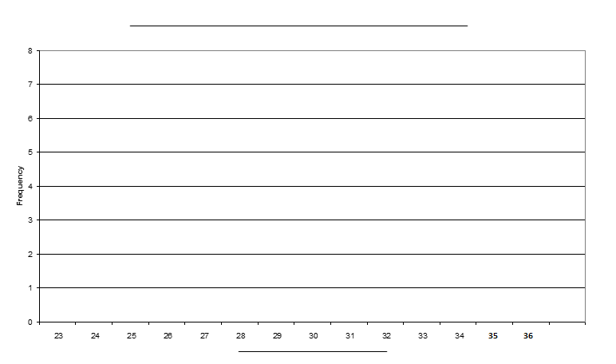
6. By looking at the graph I can see that…………………………………………….........
………………………………………………………………………………………………………
I also notice that……………………………………………………………………………….
……………………………………………………………………………………………………….
I interpret from ………………………………………….that……………………………….
………………………………………………………………………………………………………..
7. Draw a Box and Whisker plot below for the ages of the All Blacks
8. Use your graph and your statistics to write at least 3 ‘I notice… statements (descriptive & interpretive) - to help you answer the question. How do the ages of the ALL Blacks vary?
________________________________________________________________________________________________________________________________________________________________________________________________________________________________________________________________________________________________________________________________________________________________________________________________________________________________________________________________________________________________
___________________________________________________________________________________________________________________________________________________________________________________________________________________________________________________________________________________________________________________________________________________________________________________________________________________________________________________________________________________________________________________________________

____________________________

33
32
31
30

3635
34
29
28
27
26
25
24
23

Task Two – Comparative Question

CONCLUSION: Write a summary of this investigation where you say what question was being asked, who was being studied and what your major findings are (with some evidence). Tell the whole story as if it was an article for a news item or comment page and your writing was all that people would see.
How do the heights of the Forwards compare to the heights of the Backs?

- Draw a Back to Back stem and leaf plot in the space below

______________________________________________

______________ ______________
20
19
18
17
16

Key
=

- Calculate the following statistics
Statistics | Forwards | Backs
Highest (Maximum)
Upper Quartile
Median
Lower Quartile
Lowest (Minimum)
Range
IQR (Interquartile range)
Mode
Mean

- Draw a side- by- side box and whisker plot below

_________________ _________________

₂₀₄
₂₀₂
₂₀₀
₁₉₈
₁₉₆
₁₉₄
₁₉₂
₁₉₀
₁₈₈
₁₈₆
₁₈₄
₁₈₂
₁₈₀
₁₇₈
₁₇₆
₁₇₄
₁₇₂
₁₇₀

- Write at least 3 statements to analyse your results (use your graphs and statistical measures) with evidence. I notice…. I found that…… I interpret from ………………..that…………………
___________________________________________________________________________________________________________________________________________________________________________________________________
CONCLUSION: Write a summary of this investigation where you say what question was being asked, who was being studied and what your major findings are (with some evidence). Tell the whole story as if it was an article for a news item or comment page and your writing was all that people would see.

Task Three – Relationship Question
What is the relationship between the height and weight of the 2015
All Blacks team that won the men’s rugby world cup?

1. Draw a scatter plot below of the weight vs height.

2. Write at least 3 sentences below about any patterns you notice. (Use your graph to help you answer the question) Use statements of what you notice directly and also interpretation statements of what you see fits the data.

_____________________________________________________________________________________________________________________________________________________________________________________________________________________________________________________________________________________________________________________________________
_____________________________________________________________________________________________________________________________________________________________________________________________________________________________________________________________________________________________________________________________________
Task Four: (Extension for maximum marks)
PPDAC investigation
You may want to look at the data for the current All Black team and compare some aspect of the two teams. Follow all parts of the statistical enquiry cycle.

- Pose a question (fully –what, who for, why?
- Plan how you will get the data, how will you analyse it, what is your prediction
- Data – collected, tables
- Analyse – measures, graphs
- noticing, interpreting
- Conclusion – fully answer the question and tell the whole story, what does this investigation lead you to wonder?

