Activity: Observational Studies versus Experiments

“Does the amount of caffeine you consume affect the amount of sleep you get?”

TASK 1

We want to explore the relationship between the amount of caffeine each of you consumes and the amount of sleep you each get. Specifically, does more caffeine lead to less sleep?

To do this, we will obtain estimates of the amount of caffeine each of you consumed yesterday and compare it to your total hours of sleep last night.

To speed things up, here are some facts off the internet (http://www.nutritionfoundation.org.nz/nutrition-facts/nutrition-a-z/Caffeine)
to help you estimate how much caffeine you consumed yesterday:

1 cup (250ml) flat white or cappuccino or brewed coffee (single shot of coffee): 80mg
1 cup (250ml) of instant coffee (1teaspoon): 60mg
1 cup (250ml) tea : 55mg
1 can of Cola = 38mg
250ml of an energy drink e,g V, Red Bull = 80mg
50g milk chocolate bar (10 squares) = 2 teaspoons of unsweetened cocoa powder: 10mg
50mg dark chocolate (10 squares) : 35mg

(Note: the caffeine content of drinking chocolate and lemonade type soft drinks is minimal)

My estimate = _____________mg

How much sleep (in hours) did you get last night (measure to the nearest quarter-hour)?
My estimate: ___________ hrs (e.g. 6$\frac{1}{4}$hrs means enter 6.25hrs etc on the spreadsheet)

Quickly estimate and enter your results in the google sheet I have set up using google classroom. Then, answer the following questions:

- Is this an observational study or an experiment? Why?

- Is it retrospective or prospective study? Why?

- How were the participants selected?

- What is the explanatory variable?:
and the response variable?:

- How should we display the results?__________________

- From our study, does it appear that there is a relationship between caffeine consumption and sleep?

- What is the scope of the conclusion from this type of study?

- What are the limitations of this study? What improvements could we make?

To broaden the scope of our conclusion, we need to design an experiment.

- Design an experiment to test the effect of caffeine consumption on the amount of sleep a person gets. (You may ignore ethical concerns for this hypothetical experiment.-you may assume you have a group of willing volunteers who are aware of the potential harmful effects of caffeine and have agreed to participate.) Think, instead, of the experimental design elements that will be needed in order to come to a meaningful conclusion.

Briefly describe how you would conduct the experiment and justify each of your decisions. (Bullet points with reasons are OK: Work in a group with 2 or 3 other students)

- What is the scope of the conclusion that can be drawn from a properly designed experiment?

Why ?

TASK 2: Evaluation of an actual study report

Read Report A and Report B below and then answer the questions.

Report A is an extract from the actual study report, written by the researchers,
on the effects of caffeine on sleep. The researchers (Drake, C. et al) are from the Henry Ford Hospital and Wayne State College of Medicine in Detroit, and Zeo Inc, a company that works in the area of sleep and produces sleep monitoring devices. Report A was published in the peer-reviewed Journal of Clinical Sleep Medicine: Vol. 9, No. 11, 2013 (Note: Although the study was funded by Zeo Inc, it does not make any recommendations about the use of sleep monitoring devices, so there is no apparent direct conflict of interest.)

Report B is an extract from an on-line news report about the same study.

Report A
Subjects
The participants comprised 12 healthy normal sleepers, as determined by a physical examination and clinical interview by a sleep specialist. Any individuals with reported current or previous history of any psychiatric illness or current medical disorder were excluded from participation. Individuals currently using oral contraceptives, hypnotics, or any central nervous system acting medications were also excluded.

Habitual sleep data was determined by self-report with a 1-week sleep diary the week prior to participation. Only individuals with habitual total sleep times between 6.5 and 9 h, with a sleep onset < 30 min were included. Habitual caffeine consumption was based on self-report and was calculated from the question “How much caffeine do you consume in an average day, including coffee, pop [soft drinks], tea, chocolate, or energy drinks? Please specify type and amount.” Daily and weekly servings (1 serve =100 mg) of caffeine were then estimated based on type and amount indicated. The amount of caffeine in specific beverages/sources was determined based on information provided at the brand website and published literature. Subjects were selected if they met either of the following criteria: (1) ≥ 3 servings of caffeine in any single day or (2) ≥ 5 caffeinated servings per week. Subjects who consumed > 5 caffeinated beverages per day were excluded from participation. There were no inclusion or exclusion criteria as to time of caffeine consumption.

A total of 16 healthy day-workers met initial screening criteria but data was not used from 4 subjects due to their violation of the study protocol.

Individuals were recruited from the Detroit area through local advertisements and were compensated for their participation.

Procedures
The study was a randomized, double-blind, placebo-controlled design.
For the experimental period, participants were instructed to maintain their normal sleep schedules, including a bedtime between 21:00 and 01:00, wake times between 06:00 and 09:00, time in bed of 6.5-9 h, and no habitual napping.

One week prior to the experiment, each participant completed a baseline sleep diary.

Each subject completed 4 treatment-condition nights which consisted of 400 mg of caffeine taken in pill form at either 6, 3, or 0 hours prior to scheduled bedtime, with identical placebo pills given at each of the other times. Thus, subjects were instructed to take 3 pills each study day with one of the pills being caffeine and the other 2 placebo. On one of the days, all 3 pills were placebo. Each participant completed all 4 caffeine condition days (none, 6hrs before bed, 3hrs before and at bed-time) in random order. Each condition day was preceded by 1 washout day where subjects did not wear any sleep sensors and did not take any study pills. Thus, experimental nights occurred every other night during the protocol. However, sleep diary data was collected in the morning for all nights (experimental and washout).

Subjects were given the pills in an alarm activated pill-case. Participants were required to maintain a fixed bedtime and wake time schedule based on [their habitual] sleep diaries throughout the protocol. Subjects were also given a sleep diary to complete each morning throughout the study. The pill-case alarms were set according to the subjects’ habitual bedtime, and the alarm was designed to sound until the subject manually turned it off. Study drug intake was monitored by having subjects call in to a time-stamped answering machine to verify that the study drug was taken at each predetermined time period (6 h prior, 3 h prior, and at bedtime).

In order to avoid any potential caffeine withdrawal effects, subjects were allowed to use caffeine during the study. However, subjects were instructed to refrain from consuming any alcohol or caffeine after 16:00 on study days.

Adherence to a fixed bed-time and wake time schedule was likely to be dependent upon perceived sleep quality effects. Sleep disturbance (e.g. sleep quality, difficulty falling asleep) was therefore measured subjectively by means of the morning sleep diary and objectively using a widely available and previously validated in-home sleep monitor.

The monitor comprised a headband unit containing dry fabric sensors that wirelessly transmitted a single-channel EEG signal obtained from the forehead to a bedside device for processing. Subjects were instructed to put on the wireless system headband immediately upon going to bed with the intent to go to sleep and to keep the headband on all night long, placing it back on its bedside device upon rising from bed in the morning.

Measures
The head-band monitor provided objective measures of total sleep time (TST), latency to persistent sleep (the time it took for the person to enter persistent sleep) (LPS), wake time during sleep (WTDS) and sleep efficiency (the number of minutes of sleep divided by the number of minutes in bed) (SE). Although these were the primary measures of interest, the headband also enabled measures of combined stage 1 and 2 sleep, slow wave sleep, and REM sleep to be recorded.

Results
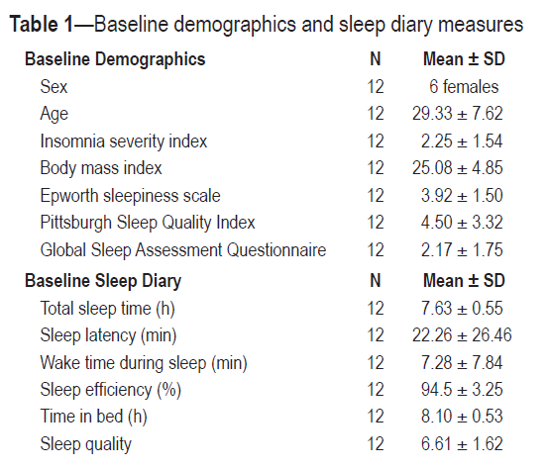

Data for the 7-day sleep diary taken during baseline as well as other self-report sleep-wake related measures are shown in Table 1.

There were no differences in these parameters across the study conditions. There were no differences in non-study related caffeine intake between any of the 4 conditions.

Tables 2 and 3 below summarize, respectively, the self-reported and objective measures of sleep.

Table 2:The self-reported diary measures of sleep
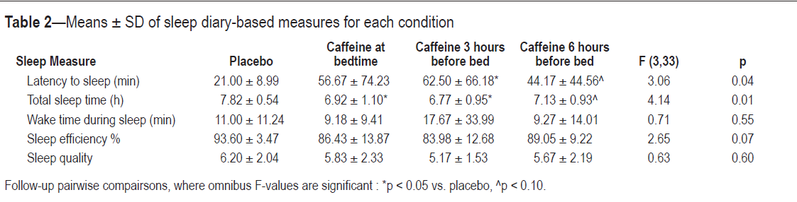

Table 3: Means and standard deviations of objective measures of sleep (i.e., latency to sleep, total sleep time, and wake time during sleep)
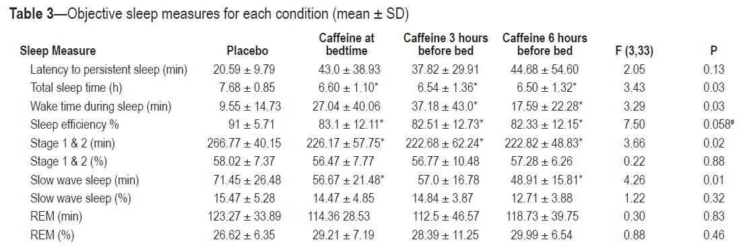
:

Report B: http://www.nhs.uk/news/2013/11November/Pages/Even-afternoon-coffee-disrupts-sleep-study-finds.aspx
Six men and six women (average age 29.3 years) completed the study correctly and their data was analysed. On average, these participants usually consumed 115mg caffeine a day. The amount of caffeine they consumed did not vary significantly on the different study days.

Based on the objective (headband) measurements, caffeine taken at bedtime, or three or six hours before bedtime significantly reduced total sleep time compared with placebo. The reduction in sleep time with caffeine was about an hour. Caffeine did affect some of the other objective sleep measures, but these differences were not always statistically significant. [A result is statistically significant if it has a p value less than 0.05: shown by a * in the results tables above]

Compared with placebo, caffeine had the greatest effect on self-reported sleep if taken at bedtime or three hours before bedtime. Taken at these time points, caffeine:
- significantly reduced total sleep time
- significantly increased the time taken to fall asleep
When people took caffeine six hours before bedtime, they reported that:
- they slept on average 41 minutes less than with placebo
- they took about twice as long to fall asleep compared with placebo
However, these differences were not as large as those seen when caffeine was taken closer to bedtime, and were not large enough to be statistically significant. Caffeine did not affect self-reported waking time during the night, sleep quality or sleep efficiency.

How did the researchers interpret the results?
The researchers concluded that even if taken six hours before bedtime, a moderate dose of caffeine has important disruptive effects on sleep. They say that this supports recommendations to avoid substantial caffeine consumption for a minimum of six hours before going to bed.

Limitations to the study:
- The study was very small and included a very select group of participants. It analysed data from only 12 healthy young to middle-aged adults who took each of the timed test doses of caffeine on one night only. Larger studies in more mixed populations would be needed to confirm the findings and see if they apply to other groups.
- Not all of the self-reported and objective (headband) measurements of sleep completely agreed. For example, caffeine taken six hours before sleep only had a statistically significant effect on the objective measure of total sleep time, but not self-reported sleep time. The researchers suggest that this difference may be as a result of people having broken sleep, which they notice less than if they take longer to fall asleep. Larger studies where people undergo more extensive measurements in a sleep lab may help confirm the effects.
- The average caffeine consumption of participants was about 115mg per day. Other studies would be needed to see if the effect of the caffeine dose used in the study (400mg) differed in people who were used to consuming more or less caffeine.

QUESTIONS
- Is the study an observational study or an experiment?
State the evidence from Report A which enabled you to determine this.

- Who were the participants and how were they selected?

- Report A describes the study as “double blind”. What does this mean and why was it important?

- In this study, what are the (i) explanatory variable(s)?

(ii) the response variable(s)?

- Report A states that the participants kept a diary of their sleeping and waking habits for one-week prior to the commencement of the study. This diary served TWO key purposes. What were they?
(i)
(ii)

- The researchers (Report A) state that there was no difference across the different treatment conditions either for the baseline measures shown in Table 1 or for the non-study related caffeine intake of the participants.

  - What aspect of the study design ensured that that was the case?

  - Why was it important for this to be the case?

- The participants had a washout day (where no pills were taken) between each treatment day. Suggest a reason why this was necessary.

- People with certain conditions were excluded from the study before it started. Who was excluded and why do you think it was necessary to do this?

- Report B states that :

“Compared with placebo, caffeine had the greatest effect on self-reported sleep if taken at bedtime or three hours before bedtime. Taken at these time points, caffeine:
- significantly reduced total sleep time
- significantly increased the time taken to fall asleep”
Use Table 2 in report A to explain the evidence which supports these conclusions.

- Report B states that two limitations of this study were the small size (12) and the “very select” group of participants. Explain the way in which these two aspects limit the study and suggest how it could be improved.

- Can you think of any potential confounding variables for this study that you have not already discussed? How might this affect the outcome of the study?

