Majority backs cannabis law change
Release Date:
Monday, August 15, 2016
A majority of the public favours a change to the legal status of cannabis according to a new poll commissioned by the NZ Drug Foundation.
64 percent of respondents think possessing a small amount of cannabis for personal use should be either legal (33%) or decriminalised (31%), with a minority (34%) in favour of retaining prohibition.
“This is the first time we’ve seen such a strong majority in favour of reforming New Zealand’s drug law. This tells us voters are ready for change even if law makers aren’t,” said Ross Bell, NZ Drug Foundation Executive Director.
“This poll shows that it doesn’t matter what party people back, there is consistent support to move away from the criminal justice approach to drugs,” said Ross. “It was an old political truth that any changes to drug law was a poisoned chalice, but this poll well and truly busts that myth. There’s a message here for politicians: they no longer need to fear talking about drug law reform.”
“The results confirm our sense of a shift in public mood. Voters are more aware that our 40-year-old Misuse of Drugs Act is no longer fit for purpose. I mean, when you have 62 percent of New Zealand First voters supporting sensible drug law change you know you’re on safe political ground!”
“This poll is important because it shows people understand drug law changes aren’t just a choice of either sticking with the black market status quo or lurching to sales from the corner dairy. Voters support regulation in some form, but not wide access that would come if cannabis shops were allowed.”
“I think what’s happening is voters have learnt of reforms being tried around the world and see the sky is not falling in, and that some of those alternatives could provide us a way forward.”
“The results provide a clear roadmap for our law makers: there is appetite for removing criminal penalties for low level offending such as personal possession, growing and social supply; there is overwhelming support for medical cannabis; and little support for a commercial free-for-all.”
The Drug Foundation favours the removal of criminal penalties for drug use, possession and social supply, the development of a strictly regulated cannabis market, and greater resourcing for prevention, education, treatment and other health and social interventions for people who use drugs.
“Politicians should now be able to proceed with cautious reform without fear of a voter backlash, but any new system needs to protect young people and those communities that already experience the harmful effects of drug use. Any new approach should be carefully designed to improve not worsen drug harm,” said Ross.
The government’s National Drug Policy includes a review of some offences and penalties in the Misuse of Drugs Act, which will begin in 2017.

Poll summary
Here are the statements that were put to callers:
“I’m going to read out a range of activities relating to cannabis. For each activity can you please tell me whether you think that activity should be legal, or illegal and subject to criminal penalties or illegal but decriminalised which means it is an offence punishable only by a fine, like a speeding ticket and there is no criminal record. So the three choices are legal, illegal or decriminalised.
- Possessing a small amount of cannabis for personal use
- Growing a small amount of cannabis for personal use
- Growing a small amount of cannabis for giving or selling to your friends
- Growing and/or using cannabis for any medical reasons such as to alleviate pain
- Growing and/or using cannabis for medical reasons if you have a terminal illness
- Selling cannabis from a store.
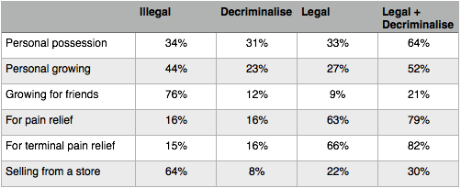
The Poll was conducted by Curia Market Research from Monday 18 July to Tuesday 2 August 2016. The sample was drawn from a random selection of 15,000 eligible NZ voters contactable on a landline. 1,029 people agreed to participate.

