HARRIER DART construction
Construction images from ‘The Best Paper Airplane:’ web link
- Fold an A4 sheet of paper in half lengthwise then unfold
- Turn down the top corners so they meet at the middle crease
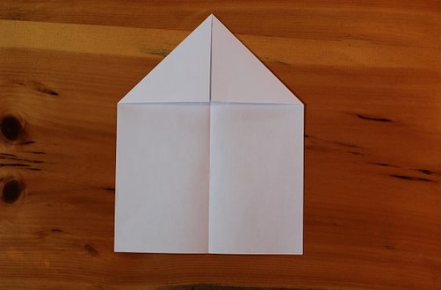
- Fold the entire top down so it resembles an envelope. Leave a centimetre to
one and a half cms between the point and the bottom edge
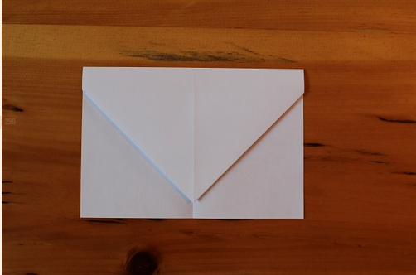
- Fold the top corners in so they meet in the middle. There should be a triangular
tail visible.
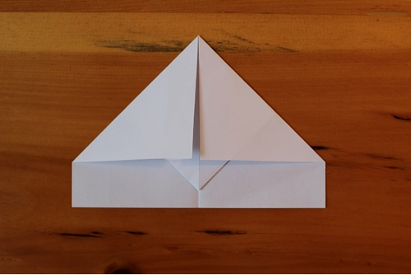
- Fold that small triangular tail up over the previous folds then fold dart in half
so the tail is visible on the outside.
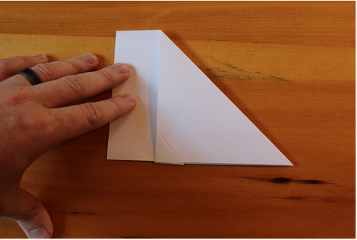
- Fold the wing down so its edge meets the bottom edge of the airplane. Repeat
on the other side
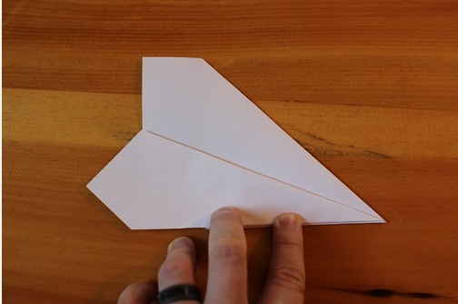

Other darts at this website are ‘The bulldog’ and ‘The hammer’

