One best number: choosing mean or median

All of statistics comes down to finding a way to simplify complex reality so that we can understand it better. People have been interested for millennia in estimating the centre or “one best number” to represent a collection of individuals. See the following link for a fascinating early history of average values and their implications for education http://www.amstat.org/publications/jse/v11n1/bakker.html.

The arithmetic mean as we know it was written down by the ancient Greeks, and has a long history of use with many applications. The median was formally developed much later, in the 19th century, as people started to develop statistics for skewed distributions. For that reason, among others, traditional statistics education used to favour the mean over the median. More lately, there have been people arguing the reverse, that “the median outclasses the mean”. It is time to give up the idea that one measure of centre is better than the other, and develop a deeper understanding of the advantages and weaknesses of each.

We first of all have to jettison the baggage that statistics carries with it from the pre-computer age. It used to be hard to compute the median because of the difficulty of ordering large groups. We used to be able to calculate a confidence interval only for the mean, using the central limit theorem. There are still many texts and resources available which favour the mean for those reasons, and we need to move beyond such considerations.

When then, should we use the mean, and when the median? What I was taught in high school still turns out to be true. If the sample or group we are looking at is fairly symmetrical and has no influential outliers, use the mean. If it is skewed or has influential outliers, use the median. Some people may know the preferred use of these measures, but not be aware of the statistical reasons for them.

The mean is a more efficient measure of centre than the median. This means that the sample mean tends to be a better estimate of the population mean than the sample median is of the population median. For this reason, if your sample does not have a lot of skew or extreme values, the mean is usually a better choice as your measure of centre. This efficiency can be seen when calculating bootstrap confidence intervals. If the sample is fairly symmetrical without extreme values, the confidence interval for the population mean tends to be narrower than the confidence interval for the median from the same sample. The confidence interval for a difference between two population means tends to be narrower than the confidence interval for a difference between the medians. Sometimes, you can make a call that the means are different back in the population when you can’t make a call that the medians are different.

Did trout in Lake Taupo tend to be longer in 1998 than in 1995?
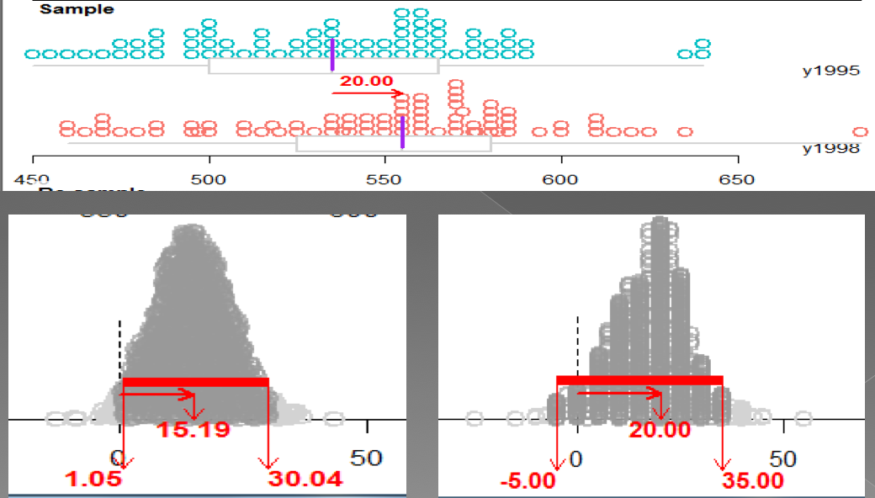
difference of means difference of medians

The median is a more resistant or robust measure of centre than the mean. This means that the median is not affected by outliers or by a lot of skew, while the mean can be pulled towards extreme values.

Simple to choose the best measure of centre then? Absolutely! While most of us lack the deep statistical understanding needed to consider the sample size, shape of the distribution and relative distance from the centre of potentially troubling extreme points, we are a lot better at judging whether the sample mean and median are fairly close to each other or fairly different. We should be learning to consider how different the mean and median are from each other relative to the spread of the sample. If the mean and median are fairly close, use the mean. If they are different enough that it seems likely that the mean has been influenced by an extreme value, choose the median.

Statistics is a new and rapidly evolving field. While at secondary school we are still using the traditional measures of mean and median, in the real world of statistics, new measures are evolving. One of the most popular is the truncated mean, which combines the advantages of the mean and median. The truncated mean is the mean of a middle % of the values, often the middle 80%. This is the sort of measure Olympic judges have been using for sports like diving and skating, removing the lowest and highest scores, then averaging the rest, to measure the one best number that represents the quality of a complex performance.

