Graph | Formula | Conditions
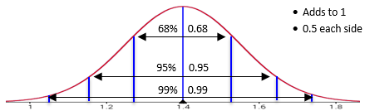 | $$Z = \frac{X - µ}{σ}$$  NOT NEEDED AND NOT GIVEN BUT DOES EXIST:  $$f\left(X\right)=\frac{1}{σ\sqrt{2π}}e^{{-(x-μ)}^{2}/{2σ}^{2}}$$ | - Bell shaped curve  - Tendency to take on central value  - Symmetrical  - No min or max (in theory)
Scenario | NORMAL DISTRIBUTION “continuous data”  * | Parameters
Students heights are normally distributed with a  mean of 1.4m and a standard deviation of 0.15m |  | $$μ=$$  $$σ=$$
Example 1 | Example 2 | Example 3
What is the probability a student chosen at  random is less than 1.2m tall?  $$P(X<1.2m)$$ | What is the probability a student chosen at random is between 1.3 and 1.5m tall?  $$P(1.3<X<1.5)$$ | What is the probability a student chosen at random is greater than 1.3m tall?  $$P(X>1.3)$$
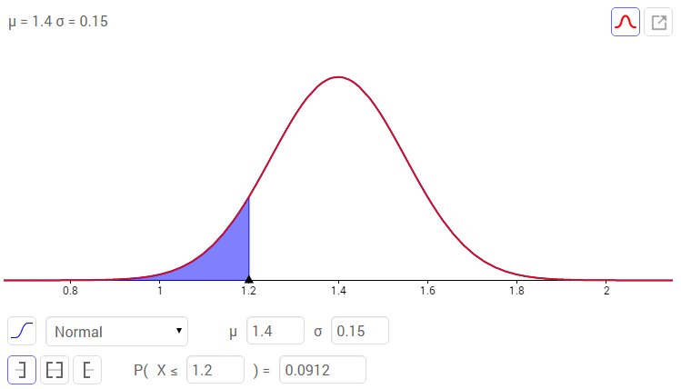 | 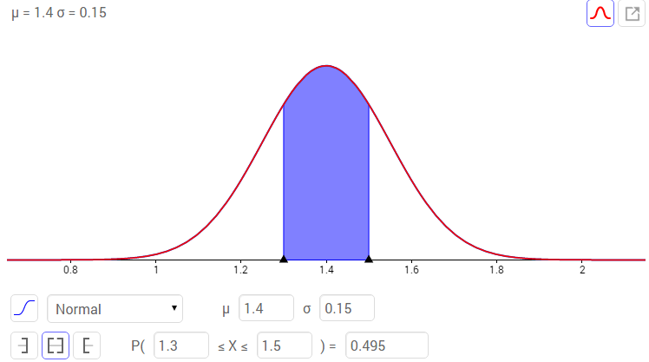 | 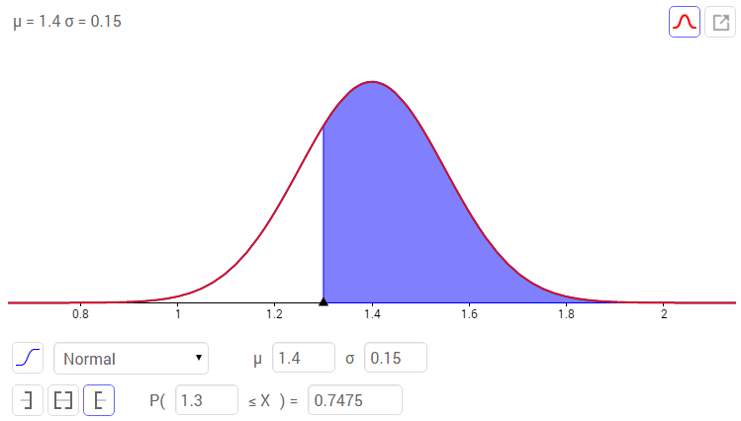
Example 4 | Example 5 | Example 6
Inverse 1 | Inverse 2 | “Continuity Correction”*

Graph | Formula | Conditions
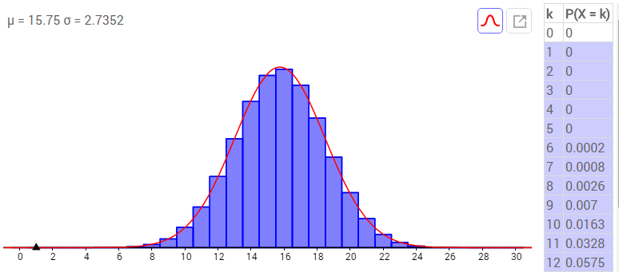 | 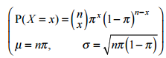 | - Two possible outcomes – success and failure  - Fixed number of identical trials  - Probability of success remains constant  - Each trial is independent
Scenario | BINOMIAL DISTRIBUTION  “discrete data” | Parameters
A random class of 30 students, in a Year level  that has 105 boys and 95 girls. |  | $$π=$$  $$n=$$
Example 1 | Example 2 | Example 3
What is the probability that the class has  10 or fewer boys?  $$P(X≤10)$$ | What is the probability that the class has between 12 and 15 boys?  $$P(12≤X≤15)$$ | What is the probability that more than half of the class are boys?  $$P(X≥16)$$
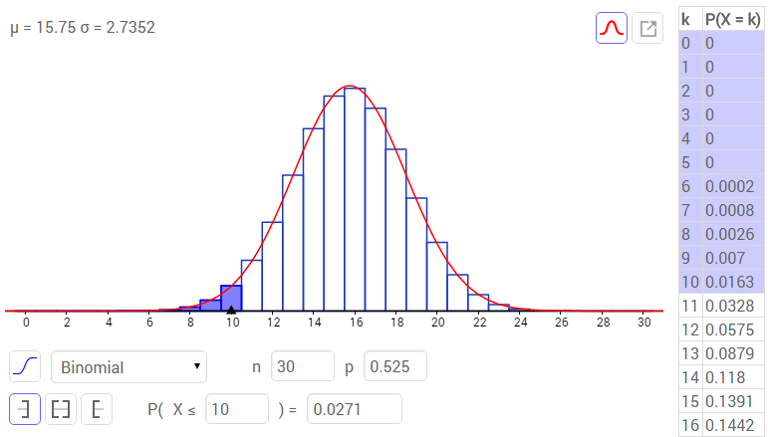 | 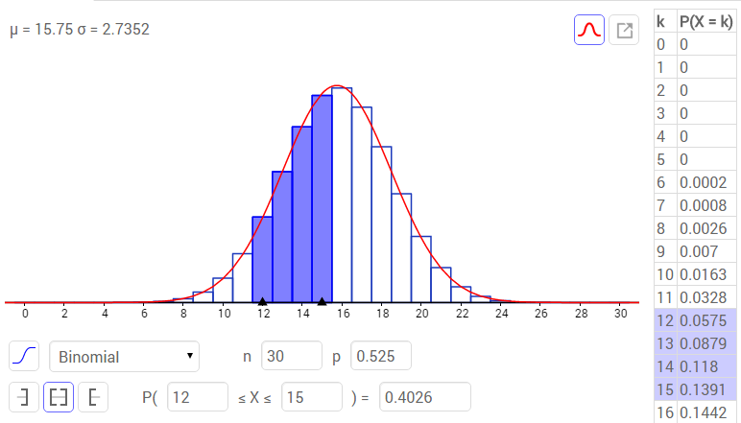 | 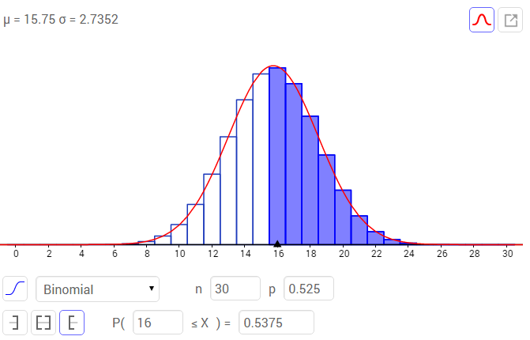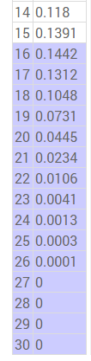
Example 4 | Example 5 | Example 6
Graph | Formula | Conditions
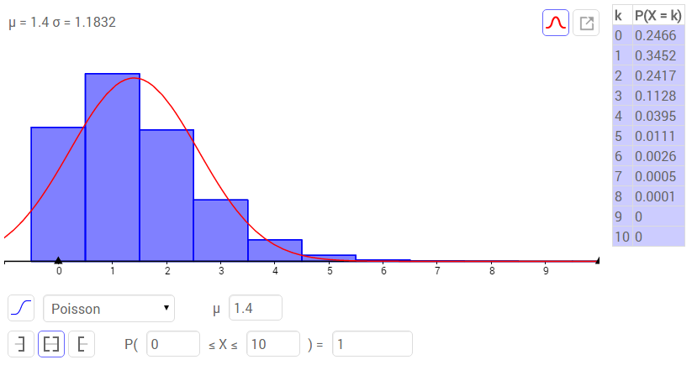 | 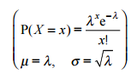 | Discrete events within continuous interval  - Rare event that occurs randomly (can’t be predicted)  - Two events can’t occur at same time  - The probability of event occuring is proportional to size of interval  - Each occurrence is independent of others
Scenario | POISSON DISTRIBUTION  “discrete data” | Parameters
Lightning strikes in a certain park at a rate of  1.4 strikes per month. |  | $$λ=$$
Example 1 | Example 2 | Example 3
What is the probability that lightning does not strike in a particular month?  $$P(X=0)$$ | What is the probability that lightning stikes between 2 and 4 times in a particular month?  $$P(2≤X≤4)$$ | What is the probability lightning strikes 5 or more times in a particular month?  $$P(X≥5)$$
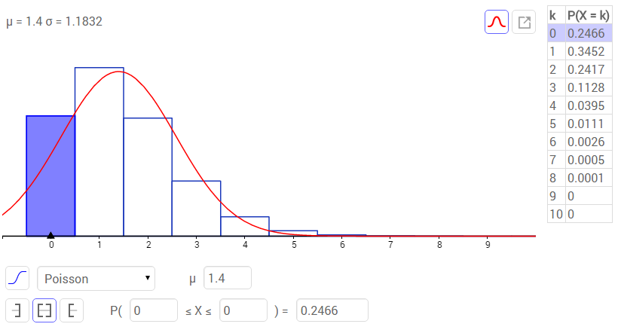 | 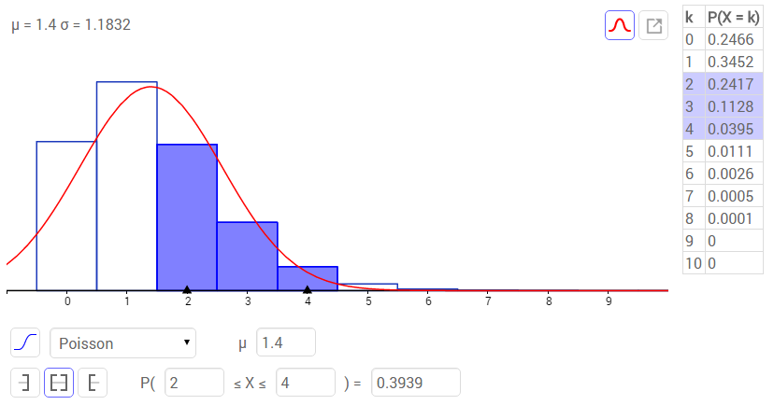 | 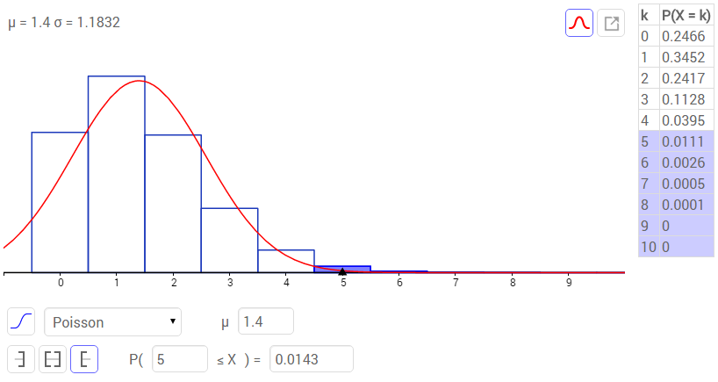
Example 4 | Example 5 | Example 6

Graph | Formula | Conditions
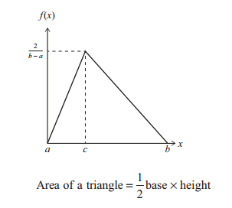 | 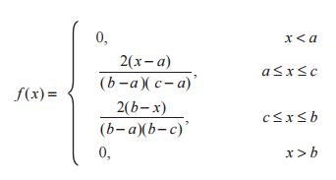 | - Function is modelled by triangle with min, max and mode  - Assumes a straight line is a reasonable model between these three points  - Definite max and min  - Good for skewed distributions
Scenario | TRIANGULAR DISTRIBUTION  “continuous data” | Parameters | Piecewise function
The time taken to solve a maths problem takes between 4 and 20 minutes. Most students take 8 minutes. |  | $$a=$$  $$b=$$  $$c=$$ | $$f\left(x\right)=\left\{\begin{matrix}\begin{aligned}0 x<4 \\ \\ \frac{2\left(x-4\right)}{\left(20-4\right)\left(8-4\right)} 4≤x≤8 \\ \\ \frac{2\left(20-x\right)}{\left(20-4\right)\left(20-8\right) } 8≤x≤20 \\ \end{aligned} \\ 0 x>20\end{matrix}\right.$$
Example 1 | Example 2 | Example 3
What is the probability a student chosen at  random takes less than 7 minutes to solve the problem?  $$P(X<7)$$ | What is the probability a student chosen at random takes between 5 and 10 minutes to solve the problem?  $$P(5<X<10)$$ | What is the probability a student chosen at random takes more than 15 minutes to solve the problem?  $$P(X>15)$$
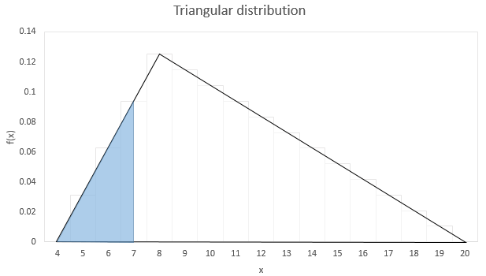 | 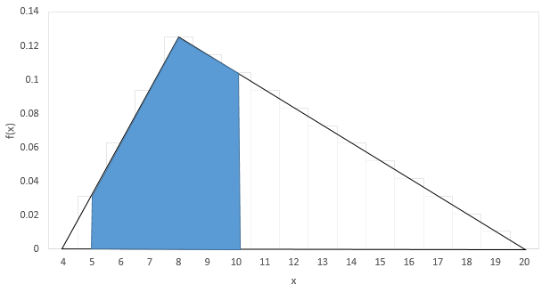 | 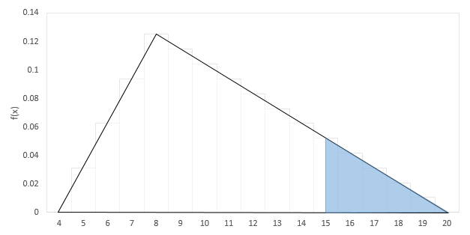
Use your answer to find $P(X>7)$ | Use your answer to find $P(X<10)$ | Use your answer to find $P(X<15)$

Graph | Formula | Conditions
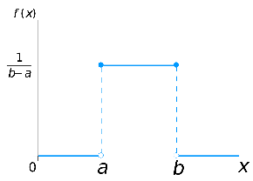 | 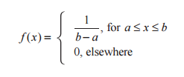 | - All intervals have same probability  - Max and min given but no mode  - No knowledge distribution  - Equally likely
Scenario | UNIFORM DISTRIBUTION  “continuous data” | Parameters
The bus in Auckland arrives at a stop every ten minutes. If a turn up at the bus stop how  long will I expect to wait for a bus? |  | $$a=$$  $$b=$$
Example 1 | Example 2 | Example 3
What is the probability on any random day you will wait  more than 5 minutes for the bus? | What is the probability on any random day you you will wait between 2 and 8 minutes? | What is the probability on any random day you will wait more than 8 minutes for the bus?

Graph | Formula | Conditions
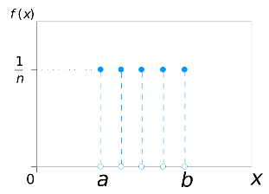 | Not given  $f(x) =\left\{\begin{aligned}\frac{1}{n}, for 1<x<n \\ 0, elsewhere\end{aligned}\right.$ | - All outcomes are equally likely (have same probability)
Scenario | UNIFORM DISTRIBUTION  “discrete data” | Parameters
The number shown when a 12  sided dice is thrown. |  | $$n=$$
Example 1 | Example 2 | Example 3
What is the probability  the number is less than 5? | What is the probability  the number rolled is between 4 and 10? | What is the probability  the number rolled is greater than 9?
P(number is odd $∩$ prime) | P(umber is even $∪$ prime) | P(X is odd | >9)

