Statistical Surprises and Stories
Louise Addison 27th November
louise.addison@howick.school.nz / louaddison@hotmail.com
Key Ideas in Statistics and Mathematics
(from Senior Secondary Guides)
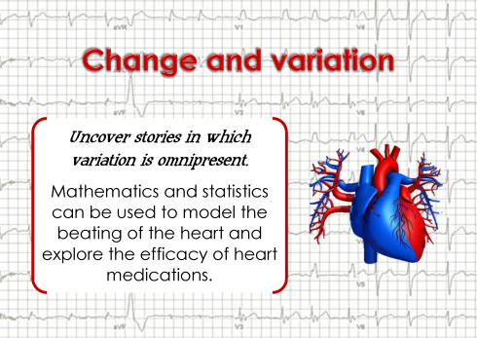 | 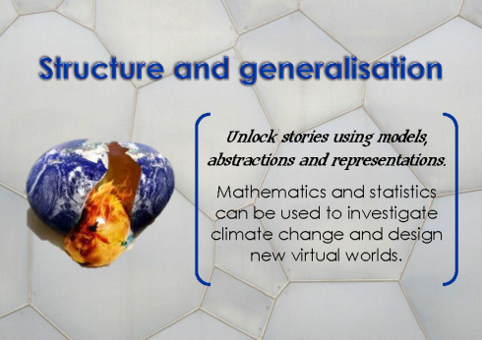 | 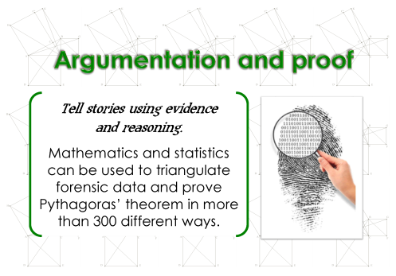
Uncover stories  in which variation is omnipresent | Unlock stories  using models, abstractions and representations | Tell stories  using evidence and reasoning

https://sway.com/JBTWmM8vpxS6FN5t
Topic | Resources | Variation | Surprise / Story
- Time Series | Baby names A, B, C, Research  Summary 1 /2  Written response  Time Series Report Writing | How does this data vary over time?  Trend  Seasonal / cyclical | Don’t start with ‘model’ example
- Bivariate Data | Learning from exemplar (AIS Data set)  Inzight instructions  Bivariate Report Writing | How do these data sets vary in relation to each other? | Attendance  Diamonds  AIS  Heptathlon
- Inference | Intro  Bootstrapping  Inference Report Writing | Variation within a group  By chance alone  Sample variability  Sampling variation | Perception of graphs / difference
- Simultaneous equations | Play doh creations | Types of solutions (deterministic models…) | Makes 15 internal credits
- Probability | Alcohol testing drunk drivers  Probability summary  See think do check  Estimating means and standard deviations | Experimental / Theoretical / True  Random variables / variation | Risk / Absolute / Relative
- Probability Distributions | One page summaries  ​Using geogebra  Distributions experimental and theoretical​  All black scenarios | How much variation is too much?  Model and ‘real life’ | What do we expect?
- Revision | Post its | Every one… | Key ideas
- Data Visualisation | http://www.radionz.co.nz/national/programmes/thiswayup/audio/201779602/data-visualisation  ​http://pitchinteractive.com/

