Patterns of morphological integration in the appendicular skeleton of mammalian carnivores
Evolution (Impact Factor: 4.61). 11/2014; 69(2):321-340. DOI: 10.1111/evo.12566
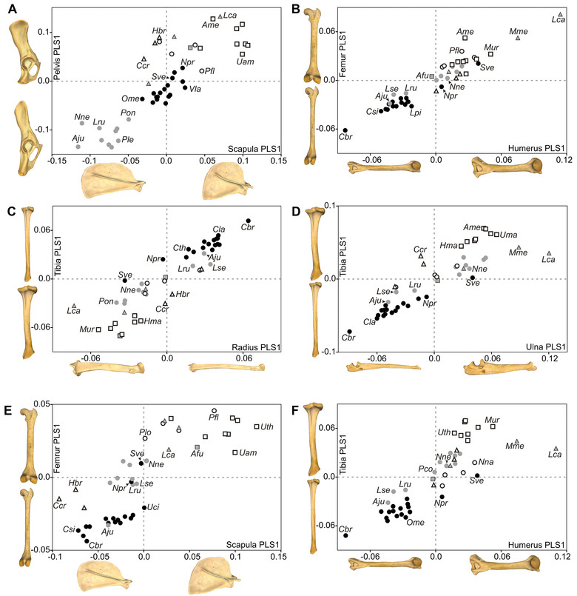
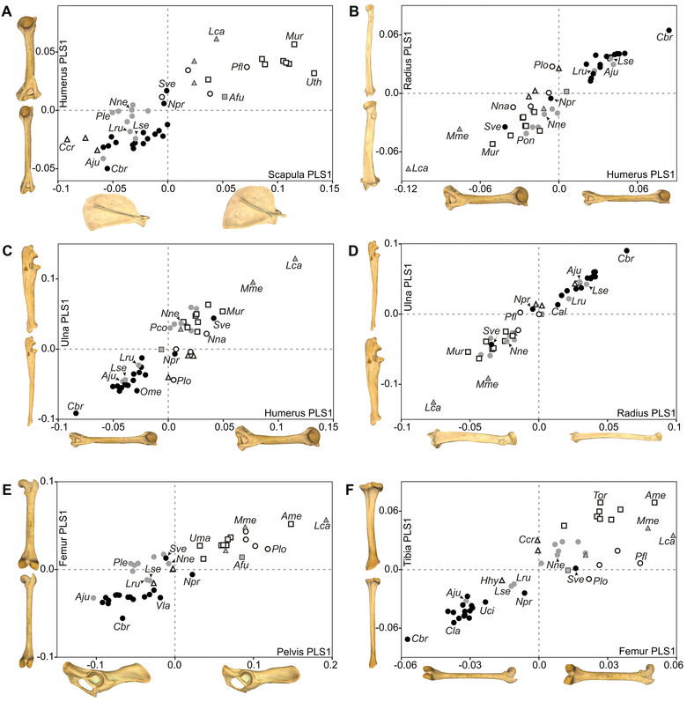
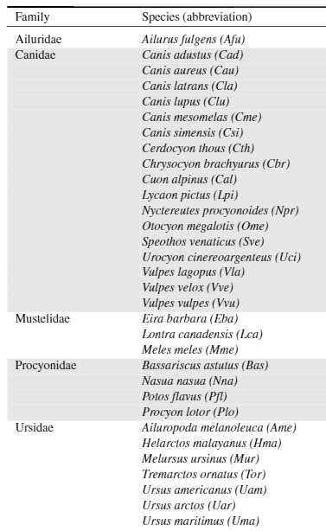 |  | 