The Earth is wrapped in a blanket of air called the 'atmosphere', which is made up of several layers of gases. The sun is much hotter than the Earth and it gives off rays of heat (radiation) that travel through the atmosphere and reach the Earth. The rays of the sun warm the Earth, and heat from the Earth then travels back into the atmosphere. The gases in the atmosphere stop some of the heat from escaping into space.These gases are called greenhouse gases and the natural process between the sun, the atmosphere and the Earth is called the 'Greenhouse Effect', because it works the same way as a greenhouse. The windows of a greenhouse play the same role as the gases in the atmosphere, keeping some of the heat inside the greenhouse.
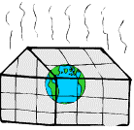
THE NATURAL GREENHOUSE EFFECT
The atmosphere has a number of gases, often in tiny amounts, which trap the heat given out by the Earth.
To make sure that the Earth's temperature remains constant, the balance of these gases in the atmosphere must not be upset.

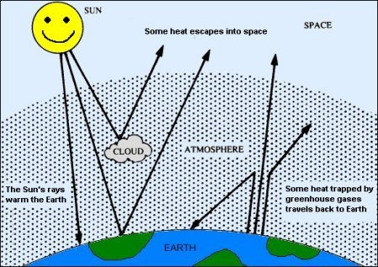

The GREENHOUSE GASES are very important and are mainly:
• water vapour
occurs naturally in the atmosphere.
• carbon dioxide
produced naturally when people and animals breathe. Plants and trees absorb carbon dioxide to live. Volcanoes also produce this gas. Carbon dioxide is not the same as carbon monoxide (See Air Quality)
• methane
comes from cattle as they digest their food. The gas also comes from fields where rice is grown in paddy fields.
• nitrous oxide
when plants die and rot, nitrous oxide is produced.
• ozone
occurs naturally in the atmosphere.
THE ENHANCED GREENHOUSE EFFECT
Some of the activities of man also produce greenhouse gases. These gases keep increasing in the atmosphere. The balance of the greenhouse gases changes and this has effects on the whole of the planet.
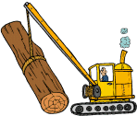
Burning fossil fuels - coal, oil and natural gas - releases carbon dioxide into the atmosphere. Cutting down and burning trees also produces a lot of carbon dioxide.
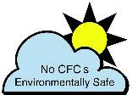
A group of greenhouse gases called the chlorofluorocarbons, - which are usually called CFCs, because the other word is much too long! - have been used in aerosols, such as hairspray cans, fridges and in making foam plastics. They are found in small amounts in the atmosphere. They are dangerous greenhouse gases because small amounts can trap large amounts of heat.
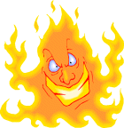
Because there are more and more greenhouse gases in the atmosphere, more heat is trapped which makes the Earth warmer. This is known as GLOBAL WARMING.
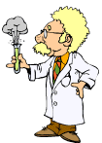
A lot of scientists agree that man's activities are making the natural greenhouse effect stronger. If we carry on polluting the atmosphere with greenhouse gases, it will have very dangerous effects on the Earth.
THE EFFECTS
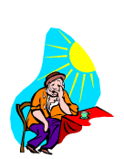
With more heat trapped on Earth, the planet will become warmer, which means the weather all over Earth will change. For example, summers will get hotter, and winters too. This may seem a good idea, but the conditions we are living in are perfect for life, and a large rise in temperature could be terrible for us and for any other living thing on Earth.
At the moment, it is difficult for scientists to say how big the changes will be and where the worse effects will occur.
The Weather
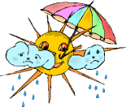
In Britain, winter and summer temperatures will increase and the weather will be warmer. In winter it may also rain more but in summer it may become drier.
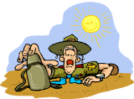
In other parts of the world, the effects will be different, some places will become drier and others will be wetter. Although most areas will be warmer, some areas will become cooler. There may be many storms, floods and drought, but we do not know which areas of the world will be affected.
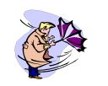
All over the world, these weather changes will affect the kind of crop that can be grown. Plants, animals and even people may find it difficult to survive in different conditions.
Sea Levels
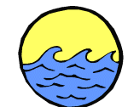
Higher temperatures will make the water of the seas and oceans expand. Ice melting in the Antarctic and Greenland will flow into the sea.
All over the world, sea levels may rise, perhaps by as much as 20 to 40 cm, by the beginning of the next century.
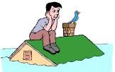
Higher sea levels will threaten the low-lying coastal areas of the world, such as the Netherlands and Bangladesh. Throughout the world, millions of people and areas of land will be at danger from flooding. Many people will have to leave their homes and large areas of farmland will be ruined because of floods. In Britain, East Anglia and the Thames estuary will be at risk from the rising sea.
Farming
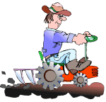
The changes in the weather will affect the types of crops grown in different parts of the world. Some crops, such as wheat and rice grow better in higher temperatures, but other plants, such as maize and sugarcane do not. Changes in the amount of rainfall will also affect how many plants grow.
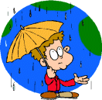
The effect of a change in the weather on plant growth may lead to some countries not having enough food. Brazil, parts of Africa, south-east Asia and China will be affected the most and many people could suffer from hunger.
Water
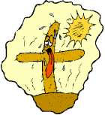
Everywhere in the world, there is a big demand for water and in many regions, such as the Sahara in Africa, there is not enough water for the people. Changes in the weather will bring more rain in some countries, but others will have less rain.
In Britain, the Southeast will be at risk from drought.
IN DANGER!
Plants & Animals
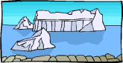
It has taken million of years for life to become used to the conditions on Earth. As weather and temperature changes, the homes of plants and animals will be affected all over the world.
For example, polar bears and seals, will have to find new land for hunting and living, if the ice in the Arctic melts.
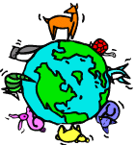
Many animals and plants may not be able to cope with these changes and could die. This could cause the loss of some animal and plant species in certain areas of the world or everywhere on Earth.

People
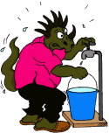
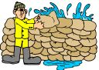
The changes in climate will affect everyone, but some populations will be at greater risk. For example, countries whose coastal regions have a large population, such as Egypt and China, may see whole populations move inland to avoid flood risk areas. The effect on people will depend on how well we can adapt to the changes and how much we can do to reduce climate change in the world.

