PART THREE: Making Predictions from Time Series Data
Prior Learning: Use of statistical language to describe time series data
Learning Intention: Analyse time series data to make predictions
Success Criteria: Use key features, trends, and patterns of time series data to make predictions

http://time.com/93911/baby-name-predictor/
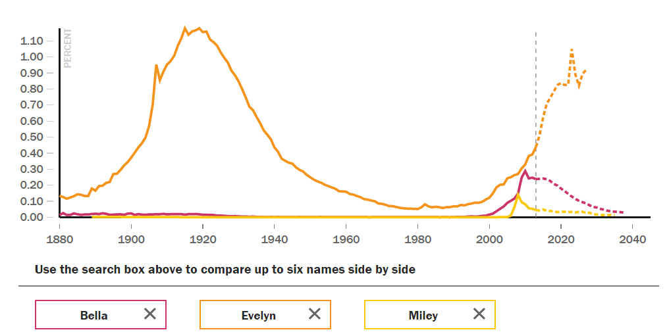
Popular names follow a familiar cycle: They become increasingly common as new parents jump on the bandwagon, only to peak and decline as everyone on the playground starts answering to the same name. Some old standards lie dormant for half a century before gradually returning–hello, Evelyn. Others skyrocket and decline in a few years (that’s you, Miley).

Parents who want to stay ahead of the curve have two major things to consider in a name: the present popularity of a name and where in its popularity cycle it currently sits. The first part is easy to get from the Social Security Administration, which published the most popular baby names of 2013 on Friday. (In the United States, Noah has unseated Jacob as the most popular boy’s name; Sophia still reigns supreme among girls.) The second is not so simple. Like stocks, hot names can stay dominant for a decade or flame out after a year.

The tool above, developed with Chris Franck, an assistant research professor in statistics at Virginia Tech, predicts how a name will rise or fall in the next 25 years by examining the performance of earlier names that followed similar patterns of popularity.

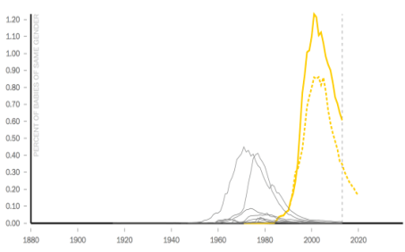
In the case of Adele, for example, our model found that the name is currently following a pattern very similar to names like Grace, Eva, and Lavinia, which were similarly popular in the early 20th century and enjoyed a comeback in the recent past. (Adele’s spike in popularity might have something to do with this one.) Because these names are farther along in their lifecycle, they offer some insight into what the next few years will look like for Adele.

Based on this method, here are a few predictions: Noah’s best days are behind him. We predict that 2013 was the most popular year the Biblical name will have in many years to come. Emma is very likely to be the top girl’s name of 2014. And keep your eyes out forHarrison and Emmett. Meanwhile, Sophia’s best days just might be behind her.

How it works: One can test a model like this by making predictions based on data from earlier years and seeing how those predictions compare to the actual results. On the right is an image of how this method predicts the growth and decline of Madison, which peaked in 2001, based only on data about the name’s growth through 1990. By comparing Madison‘s early behavior to similar names (graphed here in gray), the model was able to produce a prediction (dashed line) that closely following the actual data (solid) over the next decade.
TIME
Task One: Use the graphs and information below to write a description for a name of your choice. You need to describe the patterns, features and trends you see in the historical data, and how this data has been used to make the prediction given on the right of each graph.
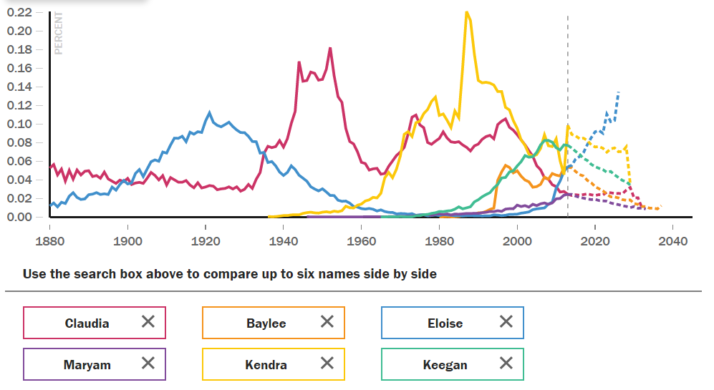
- Claudia last peaked in 1997. It will next peak as a baby name in 2029.
- Baylee last peaked in 2013. It will decline as a baby name every year from now through 2037.
- Eloise last peaked in 2013. It will next peak as a baby name in 2026.
- Maryam last peaked in 2013. It will decline as a baby name every year from now through 2033.
- Kendra last peaked in 2013. It will decline as a baby name every year from now through 2029.
- Keegan last peaked in 2008. It will decline as a baby name every year from now through 2029.

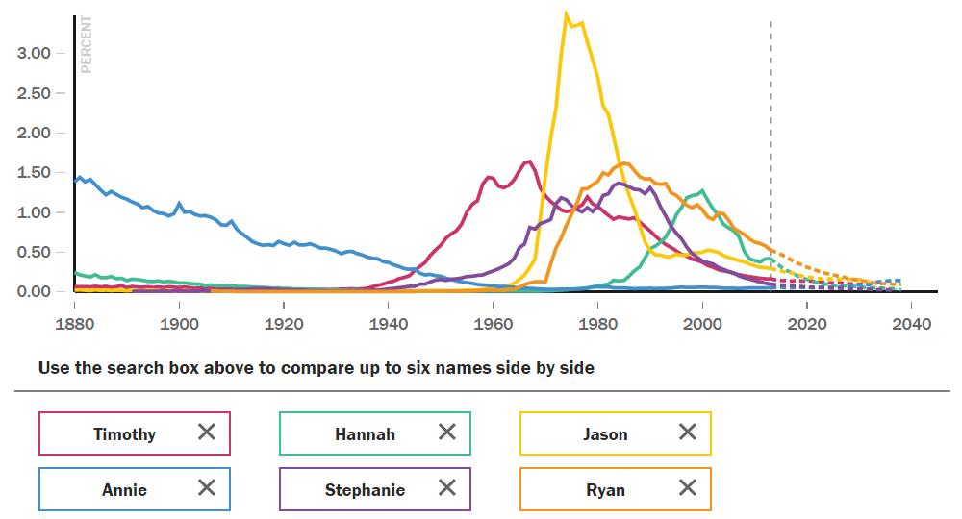
- Timothy last peaked in 1978. It will decline as a baby name every year from now through 2032.
- Hannah last peaked in 2000. It will decline as a baby name every year from now through 2038.
- Jason last peaked in 1974. It will decline as a baby name every year from now through 2032.
- Annie last peaked in 1919. It will next peak as a baby name in 2037.
- Stephanie last peaked in 1984. It will decline as a baby name every year from now through 2037.
- Ryan last peaked in 1985. It will decline as a baby name every year from now through 2038.

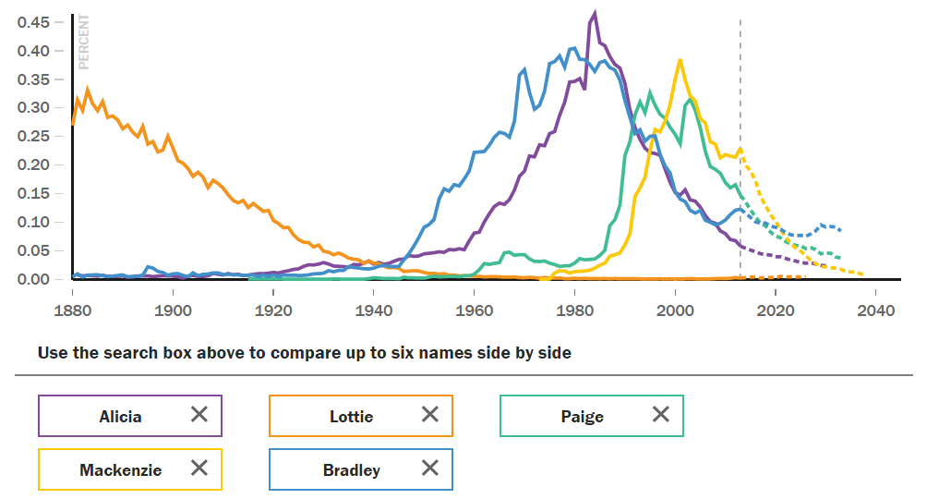

- Alicia last peaked in 1984. It will decline as a baby name every year from now through 2030.
- Lottie last peaked in 1883. It will next peak as a baby name in 2021.
- Paige last peaked in 2003. It will decline as a baby name every year from now through 2033.
- Mackenzie last peaked in 2001. It will decline as a baby name every year from now through 2038.
- Bradley last peaked in 2013. It will decline as a baby name every year from now through 2033.

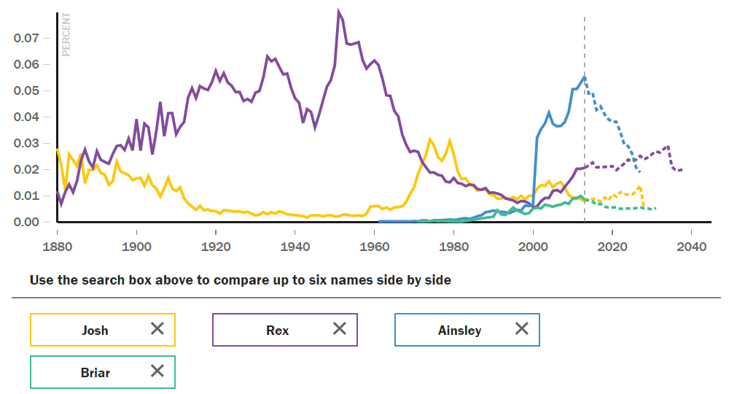

- Josh last peaked in 2004. It will next peak as a baby name in 2027.
- Rex last peaked in 2013. It will next peak as a baby name in 2034.
- Ainsley last peaked in 2013. It will decline as a baby name every year from now through 2027.
- Briar last peaked in 2012. It will decline as a baby name every year from now through 2031.

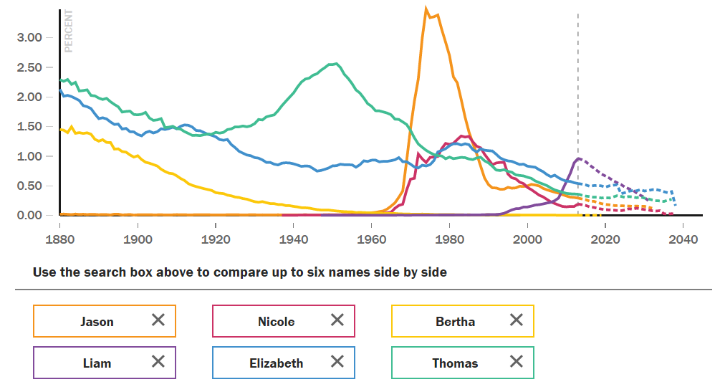
- Jason last peaked in 1974. It will decline as a baby name every year from now through 2032.
- Nicole last peaked in 1983. It will decline as a baby name every year from now through 2038.
- Bertha last peaked in 1883. It will next peak as a baby name in 2018.
- Liam last peaked in 2013. It will decline as a baby name every year from now through 2031.
- Elizabeth last peaked in 1982. It will decline as a baby name every year from now through 2038.
- Thomas last peaked in 1988. It will decline as a baby name every year from now through 2037.

Task Two: Compare and contrast the data for at least two different names.
Task Three: Evaluate the adequacy of the models for predicting future popularity of names.

