PART ONE: Is your name popular or UNIQUE?
Learning Intention: Use statistical language to describe features of time series data
Success Criteria: Identify key words for describing time series data. Use appropriate statistical language to describe features of times series data.
Task One: Look at the following graphs and describe what you see…
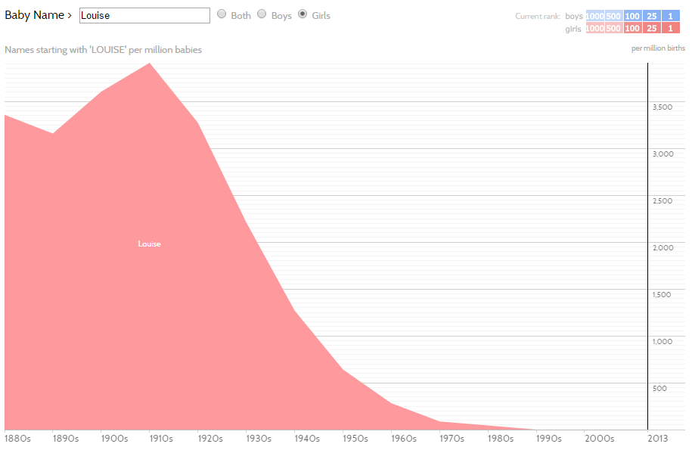
http://www.babynamewizard.com/voyager#prefix=&sw=both&exact=false

Context: | Key words / phrases:

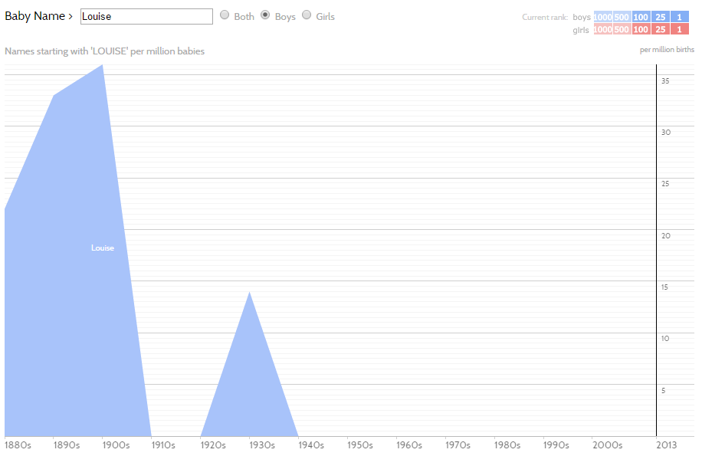

Do you think your name is popular or UNIQUE? For girls? Boys? Both? Make a prediction below:
