De La Salle College

The Statistical Enquiry Cycle
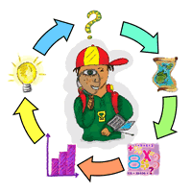

Unit Plan for Years 7 – 10

Table of Contents
Unit Plan
Teaching Unit Plan and Resources for Years 7 - 10
NZ Curriculum Levels 1 - 6 for Statistical Investigations and Statistical Literacy
Y7 PPDAC Overview
Y8 PPDAC Overview
Y9 PPDAC Overview
Y10 PPDAC Overview
PPDAC Poster
PPDAC Poster (Maori Version)

Key to resources in this document:
Youtube clip | Video File | PDF Document | Web Link | Link in this Document | Digital Learning Object
Folder in share drive | Excel File | Word Document | Image File | Power-Point Document
Subject: Mathematics & Statistics |  |  |  | Year Level: 7 - 10 |  | Curriculum Level: 1-6 |  | Duration: 4 weeks
Standard Title: | Statistical Investigations and Statistical Literacy
Achievement Objectives: S1-1 S1-2 S2-1 S2-2 S3-1 S3-2 S4-1 S4-2 S5-1 S5-2
Key Competencies highlighted in this unit: |  |  | How students will be encouraged to develop the selected competencies during the unit: |  |  | Values highlighted in this unit: |  |  | EOTC opportunities in this unit:
Thinking |  |  | - Pose questions for exploration  - Plan and carry out an investigation  - Make Connections |  |  | Excellence  Innovation, Enquiry and Curiosity  Diversity/Equity  Community and Participation  Ecological Sustainability  Integrity  Respect |  |  | - Design a questionnaire and administer this to students from different classes or to the community  - Identify a problem from Year 7 – 10 camps  - Look at water safety and the swimming ability of De La Salle students  - Identify a problem within the community or school to support ecological sustainability and follow the PPDAC cycle to improve this issue (An example could be litter within the school)
Using language, symbols and texts |  |  | - Choose appropriate graphical displays  - Interpret findings in context  - Use words and symbols in generalisations
Managing self |  |  | - Work Independently  - Manage time effectively  - Set achievable goals
Relating to others |  |  | - Actively listen  - Negotiate meaning  - Compare and contrast ideas
Participating and contributing |  |  | - Participate actively in group presentations  - Empower and enable others in a group  - Show awareness of others  - Contribute own ideas to discussions
 |  |  |  |  |  |  |  |  | Managing Authenticity:
- Oversee data collection
- Monitor group work and collaboration
- Individual assessment can be included in group presentations to assess that learning has taken place

Catholic Character Content: |  |  | Principles: |  |  |  |  |  | Cross-Curricular Links:
- Investigation on Bible reading by adapting Assessment resource Bank question “sentence lengths” |  |  | High Expectations  Treaty of Waitangi  Cultural Diversity  Coherence |  |  | Inclusion  Learning to Learn  Community Engagement  Future Focus |  |  | - Using data from P.E classes to do analysis – beep test scores, push up and sit up scores, vertical jump  - Look at a relationship covered in science to make meaningful connections
Catering for Gifted & Talented Students: |  |  | Catering for Maori/Pacifica Students: |  |  | Catering for Learners with Difficulties: |  |  | Literacy / Numeracy Strategies:
Figure this challenges  ISLP Poster Competition  - Critique the PPDAC cycle |  |  | PPDAC Poster (Maori Version)  Pasifika Education Plan  Effecting change for Pasifika students Supporting Pasifika success Pasifika Compass |  |  | I Can Do Sheet  Year 9 Student Handbook  Year 10 Student Handbook |  |  | - Scaffolding tasks with students  - The use of writing frames  Use of Glossaries  Forbidden words activity
Diagnostic Assessment: |  |  | Formative Assessment: |  |  | Student Feedback/Feedforward: |  |  | Teacher Reflection / Evaluation:
- NumPa testing  - ASTTLE testing |  |  | - Investigations within class  KareKare data investigation  Kiwi Capers investigation  Sports investigation |  |  | - Reporting on National standards  - E-AsTTle data  - Numpa testing data |  |  | - Faculty Professional development  - Annual review of Unit planning
Summative Assessment:
Investigation will be summarised in a presentation.
ISLP Poster Competition

Teaching Unit Plan and Resources for years 7 – 10
Timeline | Achievement Objectives |  |  | Literacy and ICT |  | Resources and Activities |  | Page references
Week 1 | - Introduction to the PPDAC cycle  - Investigative questions  - Planning an investigation  - Gathering and sorting data |  |  | The PPDAC Cycle explained  Amazing Statistics Video  200 years that changed the world  Explaining a sample  Bias in Sample Selection |  | Figure it out activity - CLAWS |  | NZMATHS
 |  |  |  |  |  | Figure it out activity - Social Sounds |  | Statistics L4 Bk2 Page 1
 |  |  |  |  |  | Figure it out activity – Open or closed |  | Statistics L4 Bk2 Pg 10-11
 |  |  |  |  |  | Figure it out activity - Logo Appeal |  | Statistics L2/3 Pg 18
Week 2 | - Displaying data in multiple ways  - Identifying trends, patterns, variations, spread, relationships  - Interpreting results in context  Year 10 PPDAC overview  PPDAC poster  PPDAC poster (Maori) |  |  | OESM video analysing data  Module 3 – Which Graph?  Module 4 – Making evaluations  Census@schools Data Viewer  NLVM Boxplots (requires java)  BBC Handling data  Khan Academy videos  Bias in a survey |  | Presenting data |  | Hooked on Statistics Pg 22-36
 |  |  |  |  |  | Interpreting data |  | Hooked on Statistics Pg 37-44
 |  |  |  |  |  | Figure it out activity - My Town |  | Statistics Level 2/3 Pg 12
 |  |  |  |  |  | Figure it out activity - Too much Telly? |  | Statistics Level 2/3 Pg 6
 |  |  |  |  |  | Figure it out activity - Discussing Data |  | Statistics Level 2/3 Pg 14
 |  |  |  |  |  | How long is a name? |  | From Census@schools
 |  |  |  |  |  | Figure it out activity - Wild about Juice |  | Statistics Level 3 Pg 1
Week 3 | Investigations part 1  - Select an investigative question to explore the PPDAC cycle, linking the first two weeks of learning into one project.  - S5-2 Critique the sampling process for years 9 and 10 |  |  | Spreadsheet tutorials  Graph Investigator |  | Sports Investigation |  | From NZMATHS
 |  |  |  |  |  | Ideas for Statistical Investigations |  | Hooked on Statistics Pg 45-47
 |  |  |  |  |  | KareKare Investigation |  | Karekare data cards  Survey questions  Blank graph
 |  |  |  |  |  | Kiwi Capers Investigation |  | Teacher Instructions
 |  |  |  |  |  | Assessment resource Bank |  | ARB’s website
Week 4 | Investigations part 2  - Students are familiar with the PPDAC cycle and so now they should be able to investigate a problem and display their findings in classrooms.  Assessment can be in the form of (but not limited to):  - Poster  - Report  - Power-Point Presentation  - Video Presentation  - ISLP Poster Competition |  |  | Lego city investigation video  For more investigation ideas, refer to:  Statistical Investigations Units of Work  Statistical Literacy Units of work |  | Ideas for statistical investigations |  | Hooked on Statistics Pg 45-47
Statistics Project exemplar
Statistics Project Rubric
Superhero Statistics Exemplar Y7 & Y8
 |  |  |  |  |  | Pie investigation  Pie Data |  | Pie Power-Point
 |  |  |  |  |  | Paper plane Investigation |  | From NZMATHS
NZC Statistics Levels 1 - 6
Level | Statistical Investigation | Statistical Literacy
1 | Conduct investigations using the statistical enquiry cycle:  •posing and answering questions  •gathering, sorting and counting, and displaying category data  •discussing the results.  Key Ideas for Statistical Investigations Level 1 Level 1 Elaborations | Interpret statements made by others from statistical investigations and probability activities.  Key Ideas for Statistical Literacy Level 1
2 | Conduct investigations using the statistical enquiry cycle:  •posing and answering questions  •gathering, sorting, and displaying category and whole-number data  • communicating findings based on the data.  Key Ideas for Statistical Investigations Level 2 Level 2 Elaborations | Compare statements with the features of simple data displays from statistical investigations or probability activities undertaken by others.  Key Ideas for Statistical Literacy Level 2
3 | Conduct investigations using the statistical enquiry cycle:  • gathering, sorting, and displaying multivariate category and whole number data and simple time-series data to answer questions  • identifying patterns and trends in context, within and between data sets  • communicating findings, using data displays.  Key Ideas for Statistical Investigations Level 3 Level 3 Elaborations | Evaluate the effectiveness of different displays in representing the findings of a statistical investigation or probability activity undertaken by others.  Key Ideas for Statistical Literacy Level 3
4 | Plan and conduct investigations using the statistical enquiry cycle:  • determining appropriate variables and data collection methods  •comparing distributions visually  •communicating findings, using appropriate displays.  •gathering, sorting, and displaying multivariate category, measurement, and time-series data to detect patterns, variations, relationships, and trends  Key Ideas for Statistical Investigations Level 4 Level 4 Elaborations | Evaluate statements made by others about the findings of statistical investigations and probability activities.  Key Ideas for Statistical Literacy Level 4
5 | Plan and conduct surveys and experiments using the statistical enquiry cycle:  •determining appropriate variables and measures •considering sources of variation  •gathering and cleaning data  •comparing sample distributions visually, using measures of centre, spread, and proportion  •presenting a report of findings.  •using multiple displays, and re-categorising data to find patterns, variations, relationships, and trends in multivariate data sets  Key Ideas for Statistical Investigations Level 5 Level 5 Elaborations | Evaluate statistical investigations or probability activities undertaken by others, including data collection methods, choice of measures, and validity of findings.  Key Ideas for Statistical Literacy Level 5
6 | Plan and conduct investigations using the statistical enquiry cycle:  •justifying the variables and measures used;  •managing sources of variation, including through the use of random sampling;  •making informal inferences about populations from sample data;  •justifying findings, using displays and measures.  •identifying and communicating features in context (trends, relationships between variables, and differences within and between distributions), using multiple displays;  Key Ideas for Statistical Investigations Level 6 Level 6 Elaborations | Evaluate statistical reports in the media by relating the displays, statistics, processes, and probabilities used to the claims made.  Key Ideas for Statistical Literacy Level 6
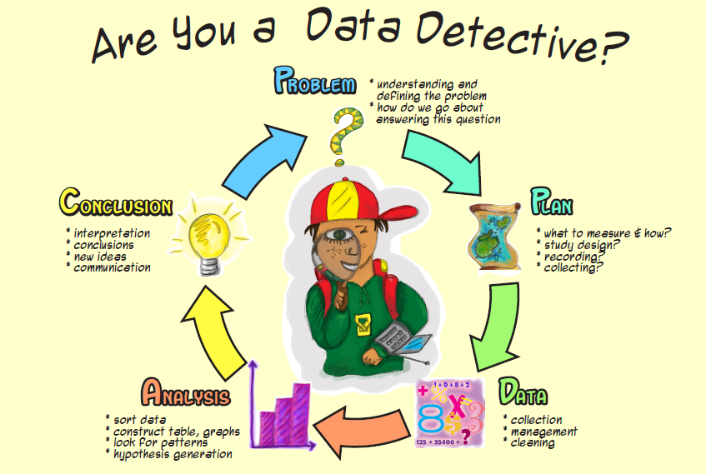
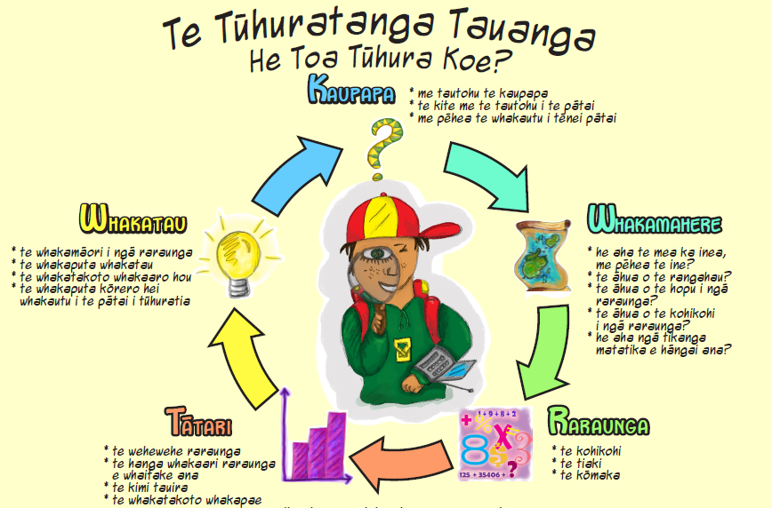
Y10 PPDAC OVERVIEW | Problem | Plan  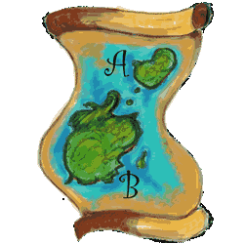 | Data  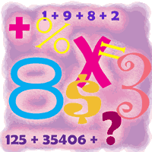 | Analysis  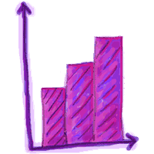 | Conclusion
Vocabulary  These words can be used across the PPDAC cycle | Relationship  I wonder / I notice  Compare  Difference | Who what why when how  Random, cluster, sampling, stratified, self-selected sample  Fair and bias | Graphs and displays  pie, dot plot scatter plot | Outliers, line of best fit, analysis, trend, relationship, +ve –ve strong weak UQ LQ IQR  Mean median mode | Relationship analysis justify conclude
What to teach | Give students a list of possible questions | Explore difference between population and sample  Introduce /use census at schools  Discuss why we use sample and not population eg NZ census | Explore a variety of different graphs students to identify which graph best to display data based on problem | How to draw a dot plot / scatter plot | Look at exemplars of conclusions and how they relate to PPDAC cycle.
What students will complete | Students should be able to identify what a suitable question looks like and possibly write their own statistical problems | Identify Variables  Collect data  - Census at schools  - Survey  - questionnaires | Construct  Table  Students to explain why they chose their specific graph eg scatterplot | Construct appropriate graphs or displays | Answer question explaining the relationship between the variables  Include a list how to improve on their Investigation eg eliminate outliers to have a more reliable conclusion.
Glossary

- Average | - Fair and Bias | - Box and Whisker Plot | - Shape | - Problem
- Mean | - Data | - Dot Plot | - Distribution | - Plan
- Median | - Continuous | - Bar Chart | - Cluster | - Data
- Mode | - Discrete | - Histogram | - Spread | - Analysis
- Frequency | - Cluster | - Pictogram | - Skew | - Conclusion
- Range | - Outcome | - Pie Chart | - Trend | - Summary
- Inter-Quartile Range | - Population | - Scatter plot | - Relationship | - Inference
- Upper Quartile | - Sample | - Stem and Leaf Plot | - Random | - Predict
- Lower Quartile | - Limitations | - Positive | - Compare | - Difference
- Unusual | - Representative | - Negative

