**Child Smoking – does it affect children’s lung strength?**

**Problem / Plan:**

There have been many studies on the effects of smoking on health. Around 5,000 New Zealanders die each year from smoking. Smoking is the number one preventable cause of death in New Zealand. ASH’s (Action on Smoking and Health) fact sheet on youth smoking says "almost all smokers start as children.”

Every cigarette that is smoked is harming nearly every organ and system in the body. There are more than 60 chemicals in cigarette smoke that can cause cancer. In the lungs, cigarette smoke damages the tiny hairs (cilia) that help clean the lungs. Without these hairs, toxins from cigarette smoke remain in the lungs, and can move to other organs via the bloodstream. The lungs are also coated in tar. Smoking is the cause of over 80% of lung cancer in New Zealand. Chronic obstructive pulmonary disease (COPD), is one of the most common lung diseases. COPD is most commonly caused by tobacco smoke, which triggers an inflammatory response in the lung. It is defined by poor airflow (as measured in lung function tests) as a result of the breakdown of lung tissue (known as emphysema) and dysfunction of the small airways. The main symptoms include: shortness of breath, cough, mucus production and infection. Smoking around children increases their risk of serious infections that affect breathing, such as croup, bronchitis and pneumonia as well as being more susceptible to colds.

Smoking will stunt the growth of developing lungs in children. Growing cells in the body need a good oxygen supply and when the body is starved of oxygen it needs to work harder to function, because of this cells aren't responding in the way they normally would in a non-smoking person. Healthy cells contribute to growth and development.

Forced Expiratory Volume (FEV) is measured using a spirometer. Spirometry (meaning the measuring of breath) is the most common lung function test. It measures how fast and how much air is breathed out. However, spirometry can only be used on children old enough to comprehend and follow the instructions given (6 years old or more). FEV for children increases with height and age. However, female children have a slightly lower FEV than male children at the same height.

The purpose of this investigation is to see whether smoking affects the lung capacity of children. I wonder what the difference is between the median Forced Expiratory Volume of child smokers, compared to children who do not smoke, in New Zealand. I assume it is lower, but how much lower is the FEV value?

**Data:**

The variables I am investigating are Forced Expiratory Volume (FEV), measured in litres, using a spirometer and Smoking Status (Smoker or Non-Smoker). All these statistics are from a study collected, from children in New Zealand, where the children self-selected their group; Smoking or Non-Smoking. There is no identification in the data as to how long any smoker has been smoking.

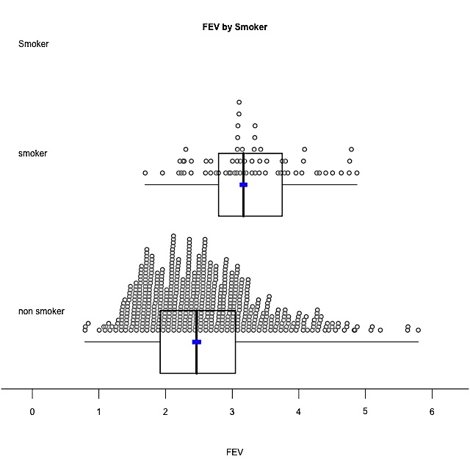**Analysis:**

Initial observation:

This shows that smokers tend to have a higher FEV value than non-smoking children in New Zealand. However, this is not backed up by my research as it says that the more you smoke the more the lungs suffer. Their growth is stunted and lung function is affected. Therefore there are lurking variables in this graph that, if not removed, will make my investigation invalid. One lurking variable is the age of the children as in the data they range from 3 to 19 years old. Age is going to have a big difference on the amount of air, in litres, that they can force out over one second. So, I will look at a series of graphs to see where smoking starts and also where it starts affecting the lungs due to smoking longer, in order to conduct my investigation.

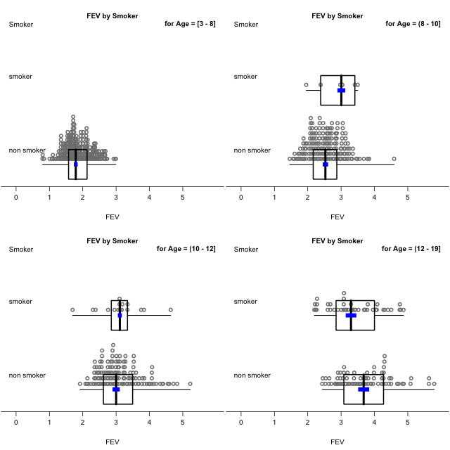

So by looking at these graphs and the data, I can see that the youngest smoker in my sample is 9 years old. Also, the FEV values for children under 6 years old are actually invalid, as they are technically not capable of doing the spirometer test. Until the age of 13 there are not enough smokers in relation to the non-smokers to conduct any thorough investigation. The age of the smokers would impact on my earlier analysis, as this would increase the overall FEV values for smokers.

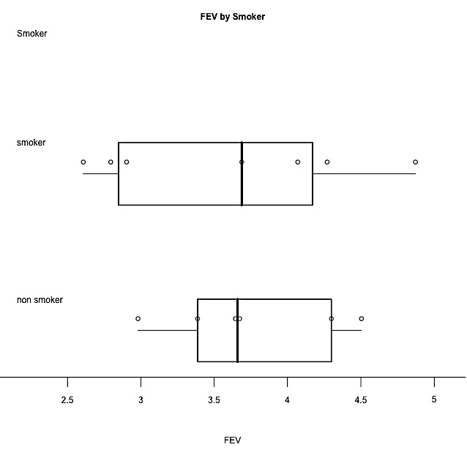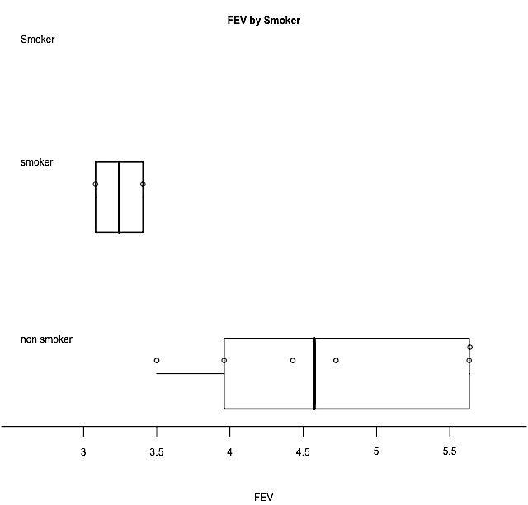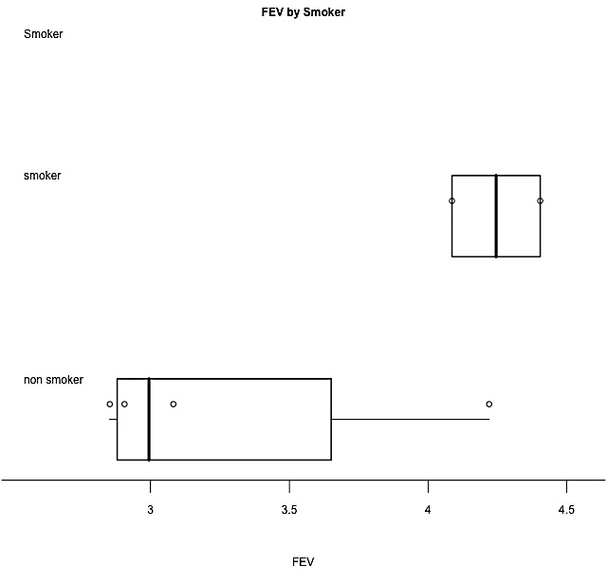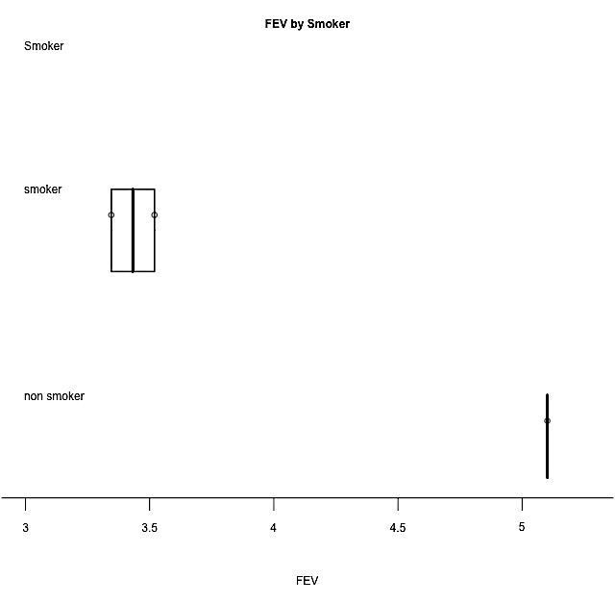

12 year olds 13 year olds 14 year olds 15 year olds

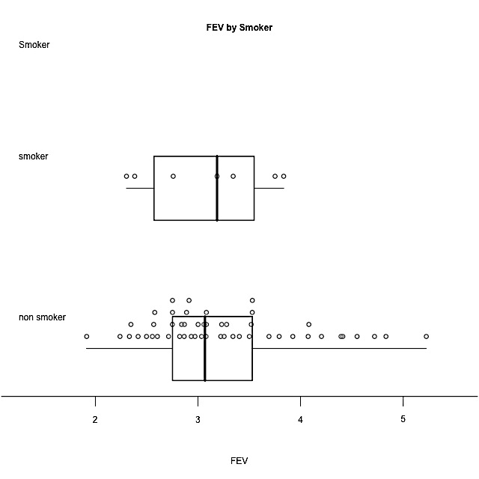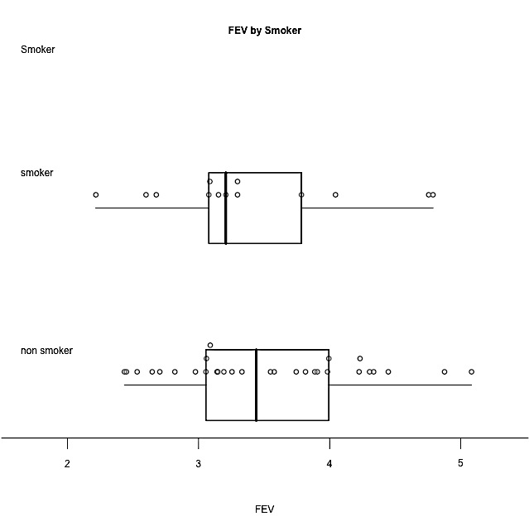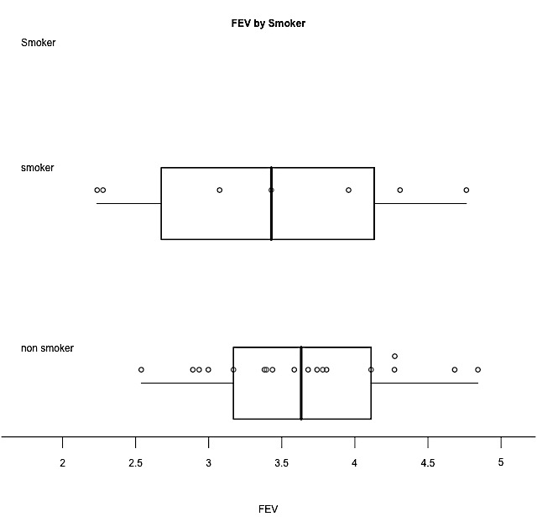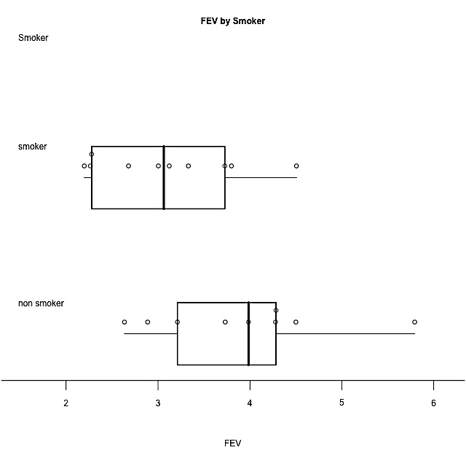

16 year olds 17 year olds 18 year olds 19 year olds

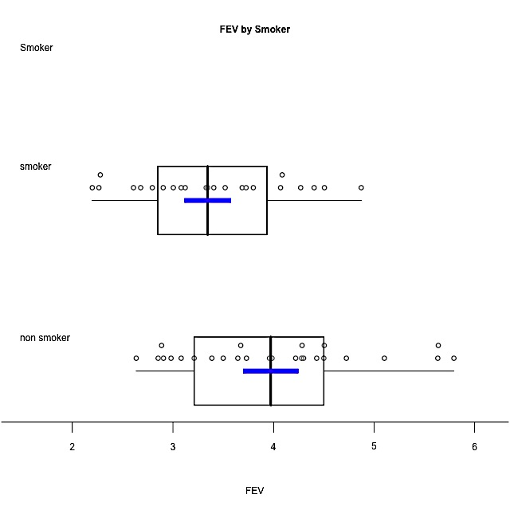Looking at these graphs, by the age of 15 when the children have been smoking for a few years the FEV results decrease compared to the FEV results of healthy non-smokers. The 16, 17 and 19 years olds are the same. At 18 years, it goes the other way around, possibly caused by a few top athletic students. Therefore, I will take a subset of my data and only look at the FEV values for child smokers and non-smokers aged between 15 and 19 years old as this is backed up by research and gets rid of the lurking variable of age.

Group Medians with Percentile

Bootstrap Confidence Intervals

ci.lower estimate ci.upper

Non-smoker 3.44 3.97 4.36

Smoker 2.9 3.35 3.73

Summary of FEV by Smoker

Min. 1st Qu. Median Mean 3rd Qu. Max. Std.dev Sample Size

Non-smoker 2.635 3.255 3.972 3.994 4.482 5.793 0.902 26

Smoker 2.198 2.849 3.345 3.389 3.934 4.872 0.755 23

Central tendency:

Looking at this subset group of 15 to 19 year olds, the median FEV for non-smokers is high at 3.97L (3sf) compared to the FEV value of smokers at 3.35L (3sf). Based on information from the National Asthma Council, respiratory function tables, the figure for the non-smokers is normal for an average child both male between the heights of 160-170cm and female between the heights of 170-175cm. However, on average for the same height, male children have a higher FEV value than females, due to their stockier shape. Hence their lungs are bigger and stronger causing a higher FEV value. My research also backs up smokers having a lower FEV value than non-smokers as their lungs get coated in tar and they get shortness of breath. This means their lungs are not as strong and hence cannot force the breath as hard. So by the age of 15 when the children have been smoking for a few years we can see the effect of smoking on the strength and health of their lungs. This will continue to deteriorate as they continue smoking.

Shape:

The shape of both the smokers and the non-smokers graphs are a rectangular distribution. The non-smokers distribution is more rectangular in shape compared to the smokers. Both distributions seem to be slightly skewed to the right possibly due to extreme values pulling it to the right. The maximum FEV for the smokers is 4.48L. This is possible but would probably be caused by the smoker recently starting smoking and hence their lungs had not been affected as much yet. Compared to the non-smokers distribution, which seems fairly symmetrical and the maximum value of 5.79L. This value is an extreme value as it is unlikely that a 19-year-old could produce this amount on air forced unless they were male, over the height of 185cm and very healthy. Therefore, the distributions for both the smokers and non-smokers are rectangular and the FEV values are less for smokers than non-smokers.

Spread:

The middle 50% of the non-smokers overlaps the middle 50% of the 15 to 19 year old smokers. The Inter-quartile range for the smokers is an FEV of 1.14L, compared to the non-smokers inter-quartile range being an FEV of 1.22L. This range for both of them is very similar. This will be caused by the similar sample sizes of 26 children for non-smokers and 23 children for smokers. This range is also consistent with my research as the gender and height of the child increases the amount of air they can force out in one second. The data is consistent and not varied. This is because the standard deviation for both smokers and non-smokers is small. The standard deviation for smokers is less at 0.75L compared to non-smokers at 0.90L. This difference is small and the data is fairly consistent and not that varied. This assures me that the confidence interval will be more accurate as the spread is not too varied and is only varied based on the gender and height of the children.

Unusual / interesting features:

An unusual feature in this graph is that for the non-smokers there seems to be a small cluster by the maximum point compared to the smokers, which has a small cluster at the minimum point. This could be because the small cluster at the maximum point for the non-smokers could be healthy sportsmen and hence their lungs are stronger due to their active sports training and hence can force more air out than the average 15 to 19 year old. This is compared to the small cluster at the minimum for the smokers, which could be due to the 15 to 19 year olds that have been smoking the longest. Their lungs are not as strong so their breathing is weak in comparison to the other smokers who have not smoked as long.

**Conclusion:**

Claim/inference:

The median FEV value for the child smokers aged between 15 and 19 is lower at 3.35L than for the non-smokers at 3.97L. This suggests that smoking could affect children’s lungs as it deteriorates the lungs and reduces both their strength and capacity.

Looking at my bootstrapping graph I am unable to make a clear-cut call whether or not there is a difference between the FEV value for smoking and non-smoking 15 to 19 year olds in New Zealand. However, from these samples, I am pretty sure that the median FEV value for the non-smokers is somewhere between 0.01L less and 1.25L more than 15 to 19 year old smokers in New Zealand. I cannot make this call because the confidence interval contains zero. If a number goes negative it means it could go the other way round. So, while it leaning towards non-smokers having a higher median FEV value, I cannot make the call. However, I am fairly certain that if these same people were tested again 20 or so years later and their smoking status had not changed, that I could definitely make the call that non-smokers have healthier and stronger lungs with a higher median FEV value, than smokers.

Sampling Variability:

I am basing this conclusion on the bootstrap confidence interval that I calculated. This involves re-sampling from my original sample of 49 15 – 19 year old children. I am assuming my original sample was representative of the population of all children aged 15 – 19 years old in New Zealand. If I were to take another sample, the results may have differed as that sample will contain a different makeup of children aged 15 – 19 years old.

My hypothesis was that the median FEV value of child non-smokers is higher than that for child smokers in New Zealand. I could not confirm this hypothesis. I wondered how much higher the median FEV value was for non-smokers compared to smokers and found that it could be anywhere from 0.01L less to 1.25L more. Smoking is impacting the lung strength in 15 to 19 year old children. Because they are only children, some would not have been smoking for very long. I would expect smokers who are 40 years old or more to have a different FEV value. This is because they would have been smoking for longer and hence would have damaged and weakened their lungs even more. I could have looked at the data by gender or height, as according to my research, both these variables affect the FEV values. This research, while it is not as clear-cut as I expected, could still be useful for health agencies as they can alert children that they cannot play their chosen sport as well, if they smoke, due to damaged lungs causing shortness of breath.

**Bibliography:**

Websites:

* “Health effects of smoking,” [http://www.health.govt.nz/your-health/healthy living/addictions/smoking/health-effects-smoking](http://www.health.govt.nz/your-health/healthy-living/addictions/smoking/health-effects-smoking)
* Shelley Bridgeman, “Taking to kids about smoking,” <http://www.nzherald.co.nz/lifestyle/news/article.cfm?c_id=6&objectid=10859020>
* Encyclopaedia of Surgery, “Spirometry tests,” <http://www.surgeryencyclopedia.com/Pa-St/Spirometry-Tests.html>
* National Asthma council, “Respiratory function tables,” <http://www.nationalasthma.org.au/handbook/appendices/respiratory-function-tables>
* Smokefree Aotearoa New Zealand, “The Facts,” <http://smokefree.org.nz/facts>
* Pub Med Health “Chronic obstructive pulmonary disease,” <http://www.ncbi.nlm.nih.gov/pubmedhealth/PMH0001153/>
* Yahoo answers, “Does smoking really stunt a teenagers growth?” <http://answers.yahoo.com/question/index?qid=20090422050412AAgM37s>