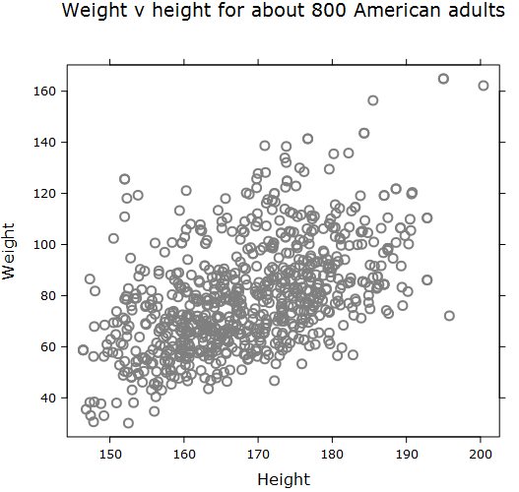
A
Add an appropriate trend line to this scatter plot.
B
Add an appropriate trend line to this scatter plot using the following method:
The trend value is the “average” weight for a given height.
Using each of the vertical guide lines, find the middle of the scattered points and the draw a line in an appropriate place through these points.

