Pilot Study – Diabetes Task
Visualising chance: Learning probability through modeling
A new housing development has been built in your neighbourhood. In order to service the needs of this new community, a new health clinic has opened. As part of the health clinic’s enrolment procedure, new patients are required to undergo health check-ups which include, among other things, a series of blood tests. One such test is designed to measure the amount of glucose in an individual’s blood. This measurement is recorded after the individual fasts (abstains from eating) for a prescribed period of time. Fasting blood glucose levels in excess of 6.5mmol/L are deemed to be indicative of diabetes. This threshold of 6.5mmol/L works most of the time with about 94% of people who have diabetes being correctly classified as diabetics and about 98% of those not having diabetes being correctly classified as non-diabetics.
The prevalence of diabetes in the NZ population is about 7%¹ (i.e. approximately 7% of the NZ population are estimated to have diabetes).
Distribution of blood glucose for undiagnosed diabetics
Distribution of blood glucose for healthy people
94% of untreated diabetics test positive (specificity)
98% of healthy people test negative (sensitivity)
*Graph above taken from Pfannkuch, Seber, & Wild, 2002.
Question 1: As part of enrolment in this health clinic, an individual has a fasting blood test. He/she is told that his/her blood glucose level is higher than 6.5mmol/L. What are the chances that he/she has diabetes?
Intuitive answer:

- How might the prevalence of diabetes in the NZ population be estimated?

- Out of 100 individuals, how many could be expected to have diabetes?

- Out of 100 individuals with diabetes, approximately how many will have a fasting blood glucose level of less than 6.5mmol/L?

- Out of 100 individuals without diabetes, approximately how many will have a fasting blood glucose level of more than 6.5mmol/L?

- If we changed the threshold value from 6.5mmol/L to 7mmol/L
    - how would this affect the percentage of correctly classified diabetics? Increase / Stay the same / Decrease
    - how would it affect the percentage of correctly classified non-diabetics?
Increase / Stay the same / Decrease
    - What would be the implications of this change?

- If we changed the threshold value from 6.5mmol/L to 5mmol/L
    - how would this affect the percentage of incorrectly classified diabetics? Increase / Stay the same / Decrease
    - how would it affect the percentage of incorrectly classified diabetics?
Increase / Stay the same / Decrease
    - What would be the implications of this change?

- Who would constitute members of the sample space?

- Do I have enough information to answer Question 1? If not, can I find the necessary information, or make certain assumptions?

- Is there any superfluous information?

- What pieces of information do I need in order to model this problem?
I need to know: the reliability of the test for diabetics Yes / No the reliability of the test for non-diabetics Yes / No
the prevalence of diabetes in the population Yes / No
Now use the software tool to answer Question 1.
Reflect on what the model has demonstrated.
How does this compare with your initial answer to Question 1?

Question 2: As part of his enrolment in this health clinic, a male aged between 65 and 74 has a fasting blood test. He is told that his blood glucose level is higher than 6.5mmol/L. What are the chances that he has diabetes?
Intuitive answer:

Use the software tool to answer Question 2.
Reflect on what the model has demonstrated.
How does this compare with your initial answer to Question 2?
Question 3: As part of his enrolment in this health clinic, a person of Pacific ethnicity and aged over 75 has a fasting blood test. He/she is told that his/her blood glucose level is higher than 6.5mmol/L. What are the chances that he/she has diabetes?
Intuitive answer:

Use the software tool to answer Question 3.
Reflect on what the model has demonstrated.
How does this compare with your initial answer to Question 3?
Question 4: Suppose the threshold for diagnosing a person with diabetes is changed to 6mmol/L. Someone from the general population (no further information available) is told that his/her blood glucose level is higher than 6mmol/L. What are the chances that he/she has diabetes?
Intuitive answer:

Use the software tool to answer Question 4.
Reflect on what the model has demonstrated.
How does this compare with your initial answer to Question 4?

Question 5: The Ministry of Health has a fixed amount of financial resources for a new diabetes treatment initiative and needs to decide how to allocate funds in order to optimize the treatment of New Zealanders. Part of this optimization process requires information on the expected number of people with diabetes enrolling in a particular health clinic.
A health clinic for approximately 10,000 patients is situated in Mangere-Otahuhu. Suppose that everyone enrolled in the health clinic has a blood test for diabetes.
- Estimate the number of people enrolled in this health clinic that test positive for diabetes.
- Estimate the number of people enrolled in this health clinic that are diabetic but test negative.
Intuitive answer:

Use the software tool to answer Question 5.
Reflect on what the model has demonstrated.
How does this compare with your initial answer to Question 5?
Question 6: Repeat Question 5 where a health clinic for approximately 10,000 patients is situated in Devonport-Takapuna.

The app used for the Eye Colour Task will be made available on the CensusAtSchool website in due course.
Note that you require on your computer to run this app.

Further information
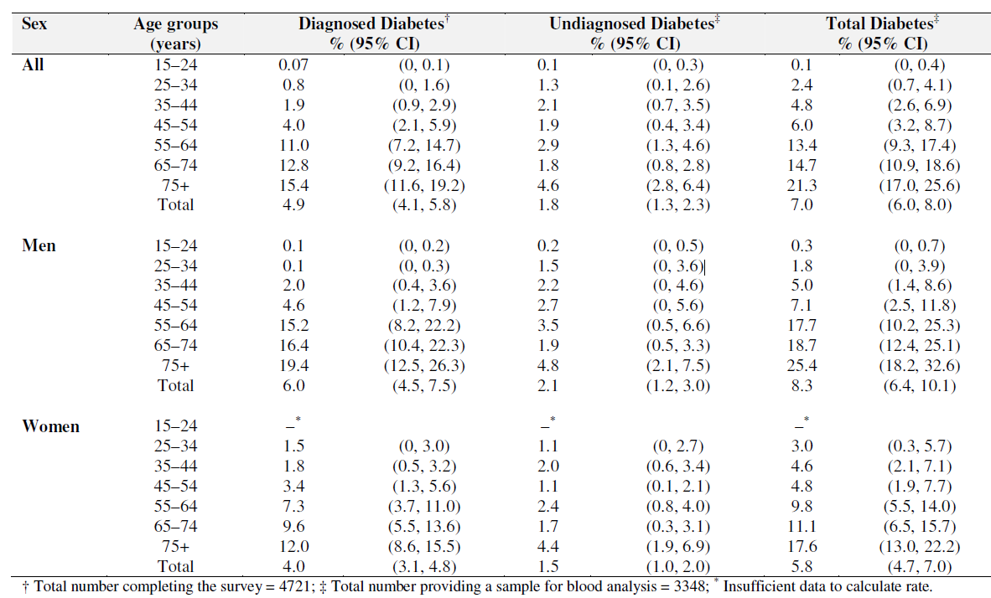
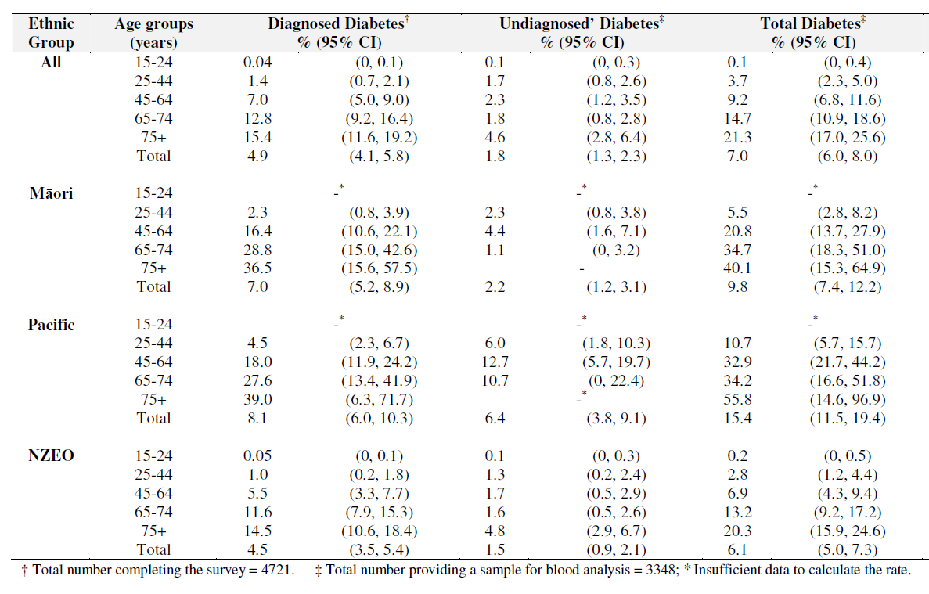
¹Data from Prevalence of diagnosed and undiagnosed diabetes and prediabetes in New Zealand: findings from the 2008/09 Adult Nutrition Survey – published in NZMJ, 1 March 2013

