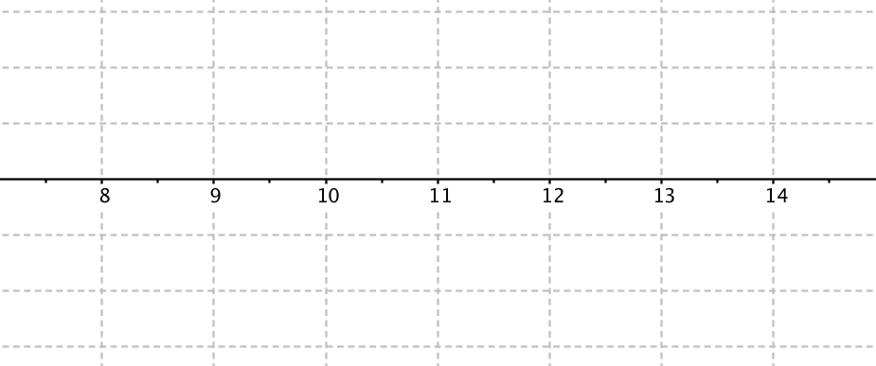
Babies Walking Experiment
Exercise
Control

Observed Difference of the experiment:

Re-Randomisation 1
Exercise
Control
Difference:

Re-Randomisation 2
Exercise
Control
Difference:

Re-Randomisation 3
Exercise
Control
Difference:

