Dice Products.
A note to teachers:

The aim of this task is
for students to explore how many times an experiment needs to be repeated before they are confident that their results will be reliable, ‘long run’.
In particular they look for the most common and least common products when you roll 2 dice and multiply the numbers.

Students should use real dice first, and class discussion should
- highlight that each student has different most common and least common products.
-some products are not possible
-a simulation is a way of generating lots of results quickly.

Students should try different run lengths in the simulation and be able to defend the run length that they think gives reasonable results.

Tinkerplots: http://www.keycurriculum.com/products/tinkerplots

It is also possible to use Tinkerplots to generate all possible outcomes (sample space). It would be good to link this with a 6 x 6 table of outcomes.

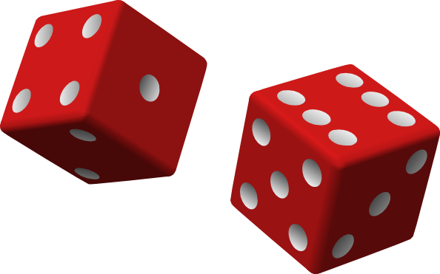
Dice Products.

If I roll two dice and multiply the numbers, what are some of the answers (products) I could get?

What is the largest product that I could get?

What is the smallest product that I could get?

Are there some products that I could not get?

Do you think that all products equally likely?

PROBLEM 1
I wonder…
If I roll two dice and multiply the numbers, what is
- the most common answer(s) that I would get?
- the least common answer(s) that I would get?
- What products are possible and what products are not?
Investigate this by….
- Rolling two dice.
PLAN 1
Roll two dice and multiply the numbers. Do this 10 times.
Record your results.
DATA 1

Trial | Dice 1 | Dice 2 | Product
1
2
3
4
5
6
7
8
9
10

ANALYSIS
What do I know about the products obtained from rolling two dice?

PROBLEM 2
If I roll two dice and multiply the numbers, what is
- the most common answer(s) that I would get?
- the least common answer(s) that I would get?
- what products are possible and what products are not?
AND HOW MANY TIMES DO I NEED TO REPEAT THE EXPERIMENT TO BE SURE OF MY ANSWERS?
- Investigate this by using a simulation model
PLAN 2
To answer these questions we need lots of data, so we will use Tinkerplots to simulate rolling two dice and multiplying the numbers.* [There is a Tinkerplot help sheet at the end]

Identify each of the following:

The model: What will you use to represent the dice?

What probabilities do you need to represent?

How will you represent the rolling of two dice?

What is one trial?

What outcomes do you need to record?

Set up your Tinkerplots simulation. Do 1 repetition and check that it is doing what you think it should.

DATA and ANALYSIS 2
Do 10 repetitions and see what happens.
How many times did a product of 6 occur?
Which is the most common answer?
Do 10 repetitions again.
How many times did a product of 6 occur?
Which is the most common answer?
Change the number of repetitions to 100. Graph the products.
Record the results for 5 lots of 100 repetitions.

 | How many 6? | How many 16? | The most common answer(s)
1st group of 100 trials
2nd group of 100 trials
3rd group of 100 trials
4th group of 100 trials
5th group of 100 trials

Does each graph look similar or are they changing from one group of 100 trials to the next?
Can you answer the questions yet?
[What is
- the most common answer(s) that I would get?
- the least common answers that I would get?
- what products are possible and what products are not?
- And how many times do i need to repeat the experiment to be sure of my answers?]
If not, increase the number of repetitions until you are convinced of the answers.

CONCLUSION
If I roll two dice and multiply the numbers…
what is
- the most common answer(s) that I would get?
- the least common answer(s) that I would get?
- what products are possible and what products are not?

How many repetitions of the simulation did you need before you were confident of your answers?

Estimate the probability of getting a product of 10 when you roll two dice and multiply.

Explain the frequency with which each product occurs.

*Tinkerplot help sheet:
The model: What will you use to represent the dice?
A spinner with 6 sectors for each die
What probabilities do you need to represent?
The probability of getting each of the numbers 1 – 6 is 1/6
How will you represent the rolling of two dice?
The spinners will be in sequence – in each run 1 number will come from each of the spinners
What is one trial?
One trial is to spin each spinner once and then multiply the numbers
What outcomes do you need to record?
The numbers from each of the dice and the product

- Drag a sampler onto the page.

- Drag a spinner into the sampler. Use the + button below the spinner to increase the number of sectors to 6. Label the sectors 1 through 6. Use the down arrow and ‘equalise angles’ so the sectors are of equal size.

- Add another spinner to the sampler to the right of the first. It goes into the black rectangle that will appear to the right. Set the second spinner up like the first.

- REP = 1, speed to medium or slower
Attr1 = die1, Attr2 = die2
RUN

What numbers did you get on your dice?

- In the Results table head a new column up with ‘product’
Right click on the coloured bar below ‘product’ and choose ‘edit formula’
Write a formula that will multiply the numbers. Double clicking on the attribute name will insert that name in the formula.

- Change the number of repetitions to 10
Fill in the answers on your worksheet.

- Change the number of repetitions to 100.
Click on the product column and drag a plot onto the page.
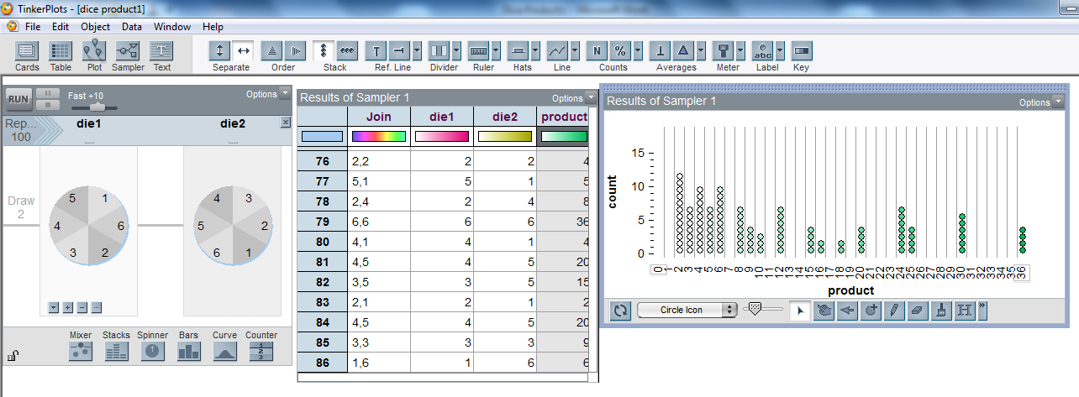
Pull a circle in the plot to the right so that the dots separate.
Double click on the x-axis labels to make the bin width = 1.
Stack. The slider will make the circles smaller if necessary.

- Repeat for five trials of 100 rolls of two dice, filling in your worksheet.

- Experiment with different numbers of trials until you can answer the questions with confidence.

Using Tinkerplots to generate the theoretical distribution (sample space)

- Change the device to a counter
Rep = 36.
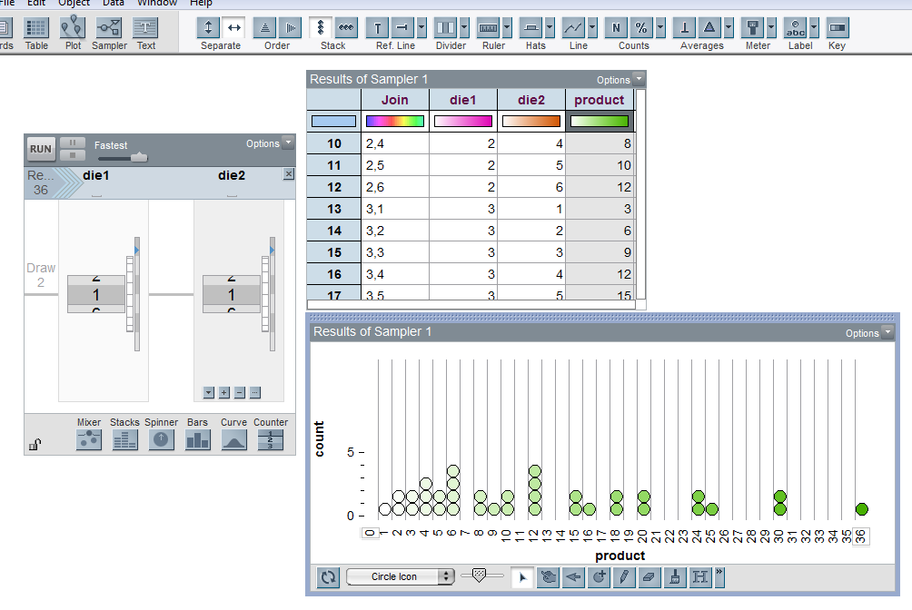

This work is supported by:

The New Zealand Science, Mathematics and Technology Teacher Fellowship Scheme which is funded by the New Zealand Government and administered by the Royal Society of New Zealand

and
Department of Statistics
The University of Auckland

