A note to teachers:

This task could be used alone or as a sequel to ‘Dice Products’
The aims of this task are:
  - To investigate how likely it is to get an odd [or even] product when you roll two dice and multiply.
  - To consider how many trials are needed in a simulation to give reasonably consistent results.
  - To design a pair of dice that will give an even product as often as an odd product in the long run
Students should use real dice first, and class discussion should
- highlight that each student has a different number of odd [or even] products in their 15 trials,
- -a simulation is a way of generating lots of results quickly.
The simulation should highlight that in any experiment there is a degree of uncertainty in the result, but that there are sensible bounds on results. They should see the importance of the ‘hump’ in the distribution and the unimportance of end ‘stragglers’ in terms of what is ‘likely to happen’.

In designing their own dice, students are challenged to think about probabilities and about providing evidence for their claim.

Tinkerplots: http://www.keycurriculum.com/products/tinkerplots

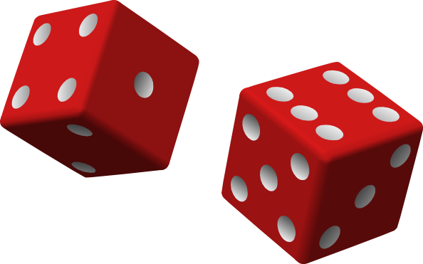
Designing Dice.

If I roll two dice and multiply the numbers, what are some of the answers (products) I could get?

What is the largest product that I could get?

What is the smallest product that I could get?

Do you think that I would get an odd answer about as often as an even answer?

Why?

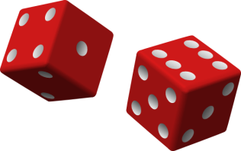
1.Task One:
Question
I wonder…
If I roll two dice and multiply the numbers, am I just as likely to get an even number as an odd number?
Investigate this by firstly…
Plan 1:
Toss 2 dice and multiply the numbers. Record whether the product is odd or even.
Repeat for 15 trials.

Data 1
Record your data in the table:
Trial # | Dice 1 | Dice 2 | Product | Even/odd
1
2
3
4
5
6
7
8
9
10
11
12
13
14
15

Analysis 1
Does your result support the idea that you are just as likely to get an odd product as an even product? Explain.

Question
I wonder…
If I roll two dice and multiply the numbers, am I just as likely to get an even number as an odd number?
Investigate this secondly by…
Plan 2
Use Tinkerplots to simulate rolling 2 dice, multiply the answers and record the answer as odd or even. This will allow you to collect lots of data quickly.
[If you are new to Tinkerplots, there is a help sheet at the end to get you started]

Identify each of the following:

The model: What will you use to represent the dice?
What probabilities do you need to represent?
How will you represent the rolling of two dice?

What is one trial?

How many trials will you perform?

What outcomes do you need to record?

Data 2
What proportion of your trials gave odd products? Even products?

Run the simulation two more times. Do you get the same proportions?
What could you change in the simulation to give you more consistent results?

Analysis 2
Estimate the probability of getting an odd product when you roll two dice and multiply the numbers.

Is this a similar result to the result you got from rolling real dice 15 times? Why?

Conclusion
If I roll two dice and multiply the numbers, am I just as likely to get an even number as an odd number?

The simulation suggests that over a large number of trials the probability of getting an odd product is about ………..

How would you get a better estimate?
Task 2 Design your own dice
Use Tinkerplots to design a pair of six-sided dice so that when you roll them and multiply the numbers you are just as likely to get an odd product as an even product.

Describe your pair of dice.

What evidence have you got that suggests that your dice will give an odd product as often as an even product in the long run?

*Help sheet: Using Tinkerplots to simulate rolling two dice, multiplying the numbers and recording the outcome as odd or even:

The model: What will you use to represent the dice?
A spinner with 6 equal sectors for each dice
What probabilities do you need to represent?
The probability of getting each of the numbers 1- 6 is 1/6
How will you represent the rolling of two dice?
The spinners will be in sequence- roll one spinner and get the number, then roll the second spinner.
[Note: this could be set up as one spinner and draw = 2 with replacement]

What is one trial?
One trial is to spin each spinner once and then multiply the numbers and decide if the answer is even or odd

How many trials will you perform?
Student choice – they could be encouraged to try different numbers of trials. Do this by changing the ‘REP’ number
What outcomes do you need to record?
The number from each of the dice, the product, whether even or odd

- Drag a sampler onto the page.
Use a spinner to represent a die. Use the + button to make six sectors in your spinner. Use the down arrow and ‘equalise angles’

- Add a second spinner to the right of the first (it goes into the black rectangle that will appear to the right). Set the second spinner up as the first.
Re-label the ATTR1 and ATTR2 as Dice1 and Dice2
Change Rep5 to Rep1 and the speed slider to slow/medium.
Run
What numbers did you roll on your ‘dice’?

- In the results table, head up a new column with ‘product’.
Right click on the coloured bar and choose ‘edit formula’
Write the formula: Product = Dice1 *Dice 2.

- Head up a new column with ‘oddeven’ Write a formula that will decide if the product is odd or even, such as the one shown here.
[trunc = truncate; this function retains onlt the whole number part of an answer. Trunc is found under functions, arithmetic]

- Change the number of repetitions to 10.
Run
and check that your simulation is doing what you think it should.

- Highlight the oddeven column.
Drag a plot onto the page. In that plot pull a circle in the plot to the right until the circles have separated into two groups- odd and even.
Stack
Counts’ [%] from the menu bar.

- Change the number of repetitions to xxx and change the speed.
Run.

This work is supported by:

The New Zealand Science, Mathematics and Technology Teacher Fellowship Scheme which is funded by the New Zealand Government and administered by the Royal Society of New Zealand

and
Department of Statistics
The University of Auckland

