A note to teachers:

The focus of this task is
    - To observe variation of results when an experiment is repeated a small number of times
    - To use simulation to estimate a probability
    - To compare the probability situation when sampling with and without replacement (Eyes Have it 1 and 2)
    - In Happy Feet the same probability situation as Eyes 2 is presented in a different context. [research suggests that students need this reinforcement]

Students should start with physically pulling cards out of a box before attempting the simulation

Tinkerplots: http://www.keycurriculum.com/products/tinkerplots

The Eyes Have It 1

Bex, Cora and Doris are drawing a ‘typical face’ for their group by working out some “average” features of their own faces.
They need to decide on what colour eyes their ‘typical face’ will have. Bex has hazel eyes, Cora has brown eyes and Doris has grey eyes.

Why do we have different coloured eyes?
Eye colour is an inherited genetic trait, but is controlled by more than one gene (maybe six or more genes are involved). The genetics of eye colour are so complex that almost any parent-child combination of eye colours can occur.
Originally it seems that we all had brown eyes. In some regions around the world, brown is the only eye colour present. More than 50% of the entire world population is estimated to have brown eyes.

The inheritance pattern followed by blue eyes is considered similar to that of a recessive trait. In 2008, new research suggested that people with blue eyes have a single common ancestor. Scientists tracked down a genetic mutation that leads to blue eyes. The researchers concluded that the mutation may have arisen in a single individual probably living in the north-western part of the Black Sea region (around modern Romania) 6,000–10,000 years ago. Currently, blue and grey eyes are common in northern and eastern Europe. About 8% of the world population has blue eyes.
Green eyes probably result from the interaction of multiple variants within the genes. They are common in Celtic and Dutch people. A study of Icelandic and Dutch adults found green eyes to be more common in women than in men. World-wide the percentage of people with green eyes is estimated to be around 1-2%.
Hazel eyes often appear to shift in colour from a brown to a green. Although hazel mostly consists of brown and green, the dominant colour in the eye can either be brown/gold or green. Hazel eyes are common throughout Caucasian populations, mainly in regions where blue, green and brown eyed peoples are intermixed.

What colour eyes do people in your class have?
Sketch a graph showing the frequency of different eye colour for your class.

How could Bex, Cora and Doris decide on what eye colour they should give their ‘typical face’?

Bex, Cora and Doris decide that they will write “hazel”, ”brown” and “grey” on 3 pieces of card and put the cards in a box. They will shuffle the cards, draw out one card and note the colour, return the card to the box, shuffle and then draw out a second card.
The two colours picked will become the colours of the eyes on their ‘typical face’.

QUESTION
I wonder if…
..it is more likely that the ‘typical face’ will have two eyes the same colour (a match) or have eyes that are different colours?

Why do you think so?

Investigate this by firstly…
PLAN 1
We will use Bex, Cora and Doris’ idea and first investigate this by a data gathering approach.
Put three cards, one of each colour eye, in a box. Shuffle the cards, draw out one card and note the colour, return the card to the box, shuffle and then draw out a second card. Do this 10 times and record each pair of eye colours:
DATA 1

draw | Eye colour 1 | Eye colour 2
1
2
3
4
5
6
7
8
9
10

ANALYSIS 1
How many times did you get a matching pair of eyes?

Compare your results with other people in your class. Does it seem that a matching pair occurs as often as a non-match?

Investigate secondly by…
PLAN 2
Now simulate selecting eye colours using Tinkerplots [help sheet at end*].
Run the simulation 10 times. Record your results:
DATA 2

draw | Eye colour 1 | Eye colour 2
1
2
3
4
5
6
7
8
9
10

How many times did you get a matching pair of eyes?

Now run the simulation for 10 sets of 10 runs
Record the number of times you get a matching pair of eyes in each set of 10 runs.

 | Number of matching pairs | Number of non-matches
1st run of 10
2nd run of 10
3rd run of 10
4th run of 10
5th run of 10
6th run of 10
7th run of 10
8th run of 10
9th run of 10
10th run of 10

ANALYSIS 2
What do you notice about these results?

Now do five simulations of pulling out 100 pairs of eye colours. Write down the proportion of matching pairs each time.
Proportion of matching pairs
1st run of 100
2nd run of 100
3rd run of 100
4th run of 100
5th run of 100

Do the simulation again using 1000 repetitions. Write down the proportion of matching pairs each time.
Proportion of matching pairs
1st run of 1000
2nd run of 1000
3rd run of 1000
4th run of 1000
5th run of 1000

Do the simulation again using 10 000 repetitions. Write down the proportion of matches each time.
Proportion of matching pairs
1st run of 10 000
2nd run of 10 000
3rd run of 10 000
4th run of 10 000
5th run of 10 000

What do you notice about the proportion of matching pairs as you change the number of repetitions from 10, to 100, 1000 and 10 000?

How many repetitions do you need to get a confident answer of what is likely to happen ‘in the long run’?

Do you think that it is more likely that the ‘typical face’ will have two eyes the same colour or have eyes that are different colours? Why?

CONCLUSION
Estimate the probability that Bex, Cora and Dora will draw a ‘typical face’ which has both eyes the same colour from the simulation.

Theoretical model approach:
Write down all the possible combinations of eye colours for a pair of eyes. Is each combination equally likely? How do you know?

What estimate for the probability that Bex, Cora and Dora will have an average face which has both eyes the same colour could you make now?

*Tinkerplots help sheet The Eyes Have It 1

- Drag a sampler onto the page. Use a mixer with 3 elements. Label the elements brown, hazel and grey.
Draw = 2.
Change Attr1 and 2 to eye1 and eye2
Check that you are sampling with replacement (use the down arrow under the mixer)
- Run once to check that the simulation is doing what you think it should.

- Change the Repeat to 10
Head up a column in the Results table for ‘match’
Right click on the coloured bar below ‘match’ and ‘edit formula’ – see below [Double click on the attribute will insert it into the formula]
)

- Highlight the ‘match’ column and drag a plot onto the page.
Pull one circle to the right until the circles separate into match and not.
Click on N (count)
Do 10 lots of 10 runs, recording the number of matches and non-matches for each group of 10 trials on your worksheet
- Stack.
- Change count N to proportion.
Change repeat to 100 and run five times, recording the proportion of matches on your worksheet.

- Change repeat to 1000 and 10 000, doing five runs for each.

Theoretical model:
Combinations possible are
HH, HG, HB, BH, BB, BG, GH, GB, GG
all of which are equally likely [or use tree]

The Eyes Have It 2

Bex, Cora and Doris are drawing a ‘typical face’ for their group as before.
They need to decide on what colour eyes their ‘typical face’ will have. Bex has hazel eyes, Cora has brown eyes and Doris has grey eyes.
They decide this time that they will take six pieces of card and have “hazel” on two cards, ”brown” on two cards and “grey” on 2 cards. They will put the cards in a box, shuffle and draw out two cards.
The two colours on the cards picked will become the colours of the eyes on their ‘typical face’.

What is the same in this situation as in ‘The Eyes Have It 1’?

What is different?

Do you think the probability of getting a matching pair of eyes will be the same, smaller or larger than in ‘The Eyes Have It 1’? Why?

PLAN
Investigate this first by a data gathering approach. Put six cards, two of each eye colour, in a box. Shuffle the cards and draw out two cards. Do this 10 times and record each pair of eye colours:
DATA 1
draw | Eye colour 1 | Eye colour 2
1
2
3
4
5
6
7
8
9
10

How many times did you get a matching pair of eyes?

Are these results similar to the ones from ‘The Eyes Have It 1’?

PLAN 2
Now use Tinkerplots to simulate this way of selecting eye colours. [help sheet at end]
Record the number of times you get a matching pair of eyes for 10 sets of 10 runs.

DATA 2

 | Number of matching pairs | Number of non-matches
1st run of 10
2nd run of 10
3rd run of 10
4th run of 10
5th run of 10
6th run of 10
7th run of 10
8th run of 10
9th run of 10
10th run of 10

What do you notice about these results?

Now simulate pulling out lots of pairs of eye colours, to estimate the proportion of matching pairs.

From this simulation, estimate the probability that Bex, Cora and Dora will draw a ‘typical face’ which has both eyes the same colour if they make their decision by drawing out two of the six cards in this way.

Theoretical model approach:
Write down all the possible combinations of eye colours for a pair of eyes. Is each combination equally likely? How do you know?

[To check, go back to Tinkerplots and plot ‘Combinations’]
CONCLUSION
What estimate for the probability that Bex, Cora and Dora will have a typical face which has both eyes the same colour could you make now for the case where they select two from six cards without replacement?

Compare your answer with that from “The Eyes Have It 1”.

Tinkerplots help sheet: The eyes have It 2

- Drag a sampler onto the page.
Use a mixer. Click the plus button until there are 6 marbles in the mixer. Label two marbles ‘hazel’, two ‘brown and two grey.
Draw = 2.
Repeat = 10
Attr1 and 2 = colour1 and colour2
- For sampling without replacing the first colour selected, click the arrow at the bottom of the sampler, click on ‘replacement’ and select ‘without replacement’.
Run

- Head up a column in the results table for ‘match’.Right click on the coloured bar below ‘match’ and ‘edit formula’ as below.
Check that your formula is working as it should.

- Highlight the ‘match’ column and drag a plot onto the page.
Pull one of the circles to the right to separate ‘match’ and ‘not’.
Click N (count)
Stack
Do 10 runs of 10 repetitions, recording your results on your worksheet.

- Change the repeat number to a larger number
Change Count to proportion
Run

- Theoretical model:

If the eye colour cards are thought of as
H_{1,} H_{2,} B_{1,} B_{2,} G_{1,} G_{2,}
Then the possible combinations could be thought of as
H₁H_{2,} H₁B_{1,} H₁B_{2,} H₁G_{1,} H₁G₂
H₂H_{1,} H₂B_{1,} H₂B_{2,} H₂G_{1,} H₂G₂
B₁H_{1,} B₁H_{2,} B₁B_{2,} B₁G_{1,} B₁G₂
B₂H_{1,} B₂H_{2,} B₂B_{1,} B₂G_{1,} B₂G₂
G₁H_{1,} G₁H_{2,} G₁B_{1,} G₁B_{2,} G₁G₂
G₂H_{1,} G₂H_{2,} G₂B_{1,} G₂B_{2,} G₂G₁
All of which are equally likely.

To see all the possible combinations in Tinkerplots-
- In the Results table, click options, Result attributes, and check ‘Combination of joined values’
Plot ‘combinations’

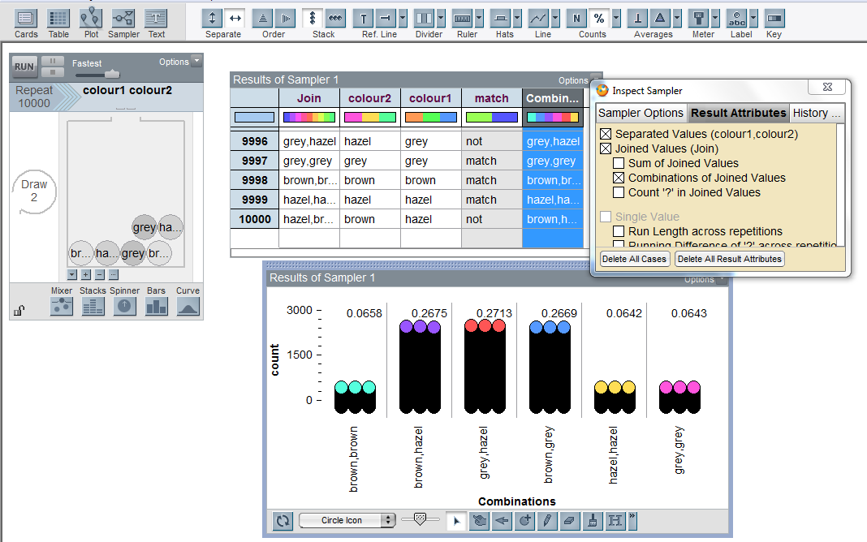

This work is supported by:

The New Zealand Science, Mathematics and Technology Teacher Fellowship Scheme which is funded by the New Zealand Government and administered by the Royal Society of New Zealand

and
Department of Statistics
The University of Auckland

c

