Happy Feet
Notes to teachers

This activity follows on from ‘The Eyes Have It’. The idea of non-replacement when selecting is used in a similar but different, context.
The number of socks to choose from could easily be changed.

Students should start with physically pulling cards out of a box before attempting the simulation.

The ’what if’ question at the end asks students to investigate picking out 4 ‘pairs’ with no replacement over all 4 selections.

Tinkerplots: http://www.keycurriculum.com/products/tinkerplots

Happy Feet

Cora has 8 socks scattered loosely in her drawer. They are 4 pairs – each pair a different design - but she has not paired them up.
One morning in the semi-dark, when she is not fully awake, Cora takes two socks out of her drawer and pulls them on.
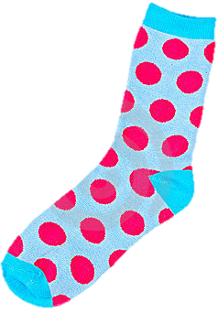
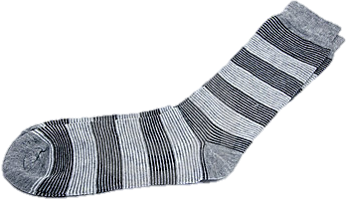
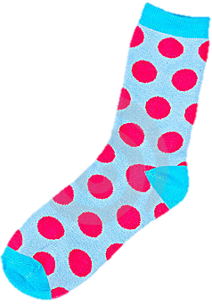

How likely do you think it is that Cora will wear a matching pair of socks?

Why?

Are odd socks a problem in your household? Why? What happens?

How do you deal with odd socks? Would you wear non-matching socks?

QUESTION
I wonder...:
What is the chance that Cora is wearing a matching pair of socks?

Investigate this situation by first taking cards out of a box:
PLAN
Use eight cards with pictures of socks, 2 of each kind, in a box.
What will you do?

How many times?

What will you record?

How will you work out the chance that Cora has a matching pair of socks?

DATA
Record the data from your experiment.
Trial # | socks | Match?

ANALYSIS
Summarise your data.

CONCLUSION
What is the chance that Cora is wearing a matching pair of socks?

PLAN 2
Now simulate selecting socks without looking using Tinkerplots so that you have lots of data to base an estimate on. [help sheet at end*].

Use a mixer. How many marbles in the mixer?

Draw = ?

Sampling with or without replacement?

Repeat =?

How do you decide if the socks are a pair?

What will you graph?

DATA 2
Run the simulation several times, recording the proportion of times a matching pair would be chosen.

ANALYSIS 2
What did you learn from the simulation?

Theoretical model approach:
Estimate the probability of picking a matching pair of socks from a theoretical model.

CONCLUSION
I estimate that the probability of picking out a matching pair of socks is

JUST CHECKING..
In what ways is “Happy Feet’ similar to “The Eyes Have It 2’?

In what ways is “Happy Feet’ different from “The Eyes Have It 2’?

WHAT IF…
If Cora pulled out two socks from her drawer, without looking, on each of four mornings, wore them that day and put them in the wash, what is the chance that she would have matching socks -
a) on all four days
b) on none of the four days?
(no socks get replaced over the four days – they disappear into the wash!)

How likely do you think she would have at least 1 pair of matching socks in the four days?.

Change your Tinkerplots simulation to investigate: [help sheet at end]

v

Help sheet for Happy Feet.

- Drag a sampler onto the page
Use a mixer with eight elements. Label two elements ‘red’, ‘stripe’ ‘dot’ and ‘purple’
Change Attr1 and 2 to sock1 and 2
Use the down arrow and select ‘replacement’ – change as shown.
Run to check.

- In Results table head up a new column ‘match’.
Right click on the coloured bar and ‘edit formula
Write a formula to check if the socks are a match.

- Highlight the ‘match’ column.
Drag a plot onto the page.
Drag a circle to the right to separate
Stack
Count - proportion

- To increase the Run length and retain previous trials, in the sampler click options, Sampler options and uncheck Replace Result Cases.

What if
- To change the model so that socks are pulled out of the drawer on 4 consecutive days without replacing any, change the replacement setting in the sampler as shown
Repeat =4
Draw = 2
In sampler options, check ‘Replace Result Cases’
Run.

- In the plot –
Count N
Stack
Right click on the number of matches and ‘collect statistic’
Run 3 times

- In History of results table, highlight ‘count match’ column and drag a plot onto page
Pull circle to the right to separate.
Stack
Bin width = 1
Count (percentage or proportion)
Change collect to a large number
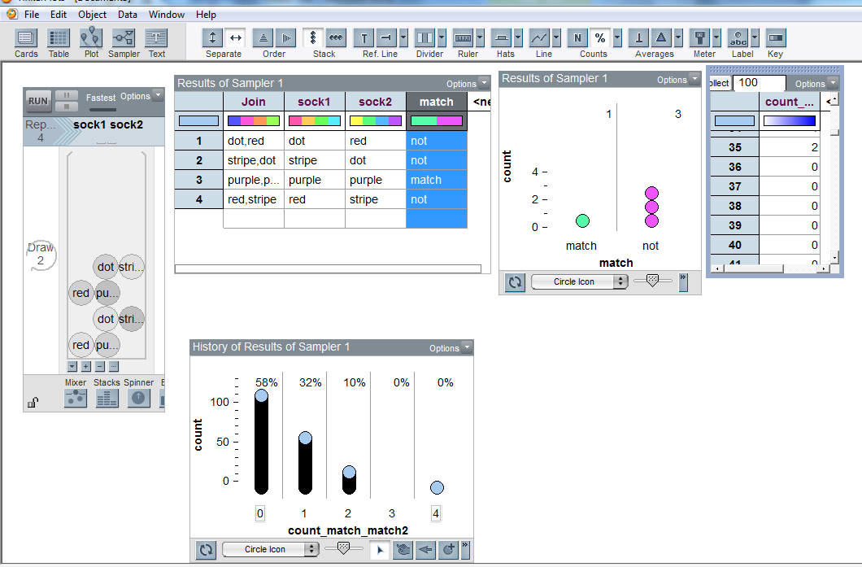
Collect

This work is supported by:

The New Zealand Science, Mathematics and Technology Teacher Fellowship Scheme which is funded by the New Zealand Government and administered by the Royal Society of New Zealand

and
Department of Statistics
The University of Auckland

