Fundraiser 2 (Tinkerplots)

A resource aimed at:
Year 11 probability
investigating the shape of a distribution by using a simulation (Tinkerplots)
connecting experimental and theoretical approaches in probability
understanding that the ‘expected’ may not happen

This is a parallel task to Fundraiser 1

Tinkerplots: http://www.keycurriculum.com/products/tinkerplots

Fundraiser 2 (Tinkerplots)

Boris’ class want to fund raise to support the Canteen charity. Boris suggests a game that students might play.

THE GAME:
The cost to play is $1.
You are given two fair 6-sided dice. You roll both dice once only. If you roll a one and a two OR a five and a six, you get your money back plus $5. If you roll any other pair of consecutive numbers you get your money back only. Any other result means you lose.

Note: Consecutive numbers are numbers next to each other, e.g. 2 and 3 or 3 and 4.

QUESTION
I wonder:
Will Boris’ class make a profit from this game if 100 people each play the game once?

Do you think that Boris’ class will make a profit?
How large? Could they make a loss?

How could you find out?

PLAN
First estimate an answer by playing the game repeatedly.
Describe:
How you will play the game.

How many times you will play the game.
What you will record.

How you will work out whether Boris’ class will make a profit

DATA
Carry out your experiment and record your data in a suitable format.

ANALYSIS
Summarise your data.
Draw an appropriate graph to show your data.

Estimate the probability of a player winning a game, based on your experiment.

Estimate the profit that Boris’ class might make if 100 people played the game once, based on your experiment.

Draw a table or other diagram that shows a theoretical model of this situation. Calculate the theoretical probability of a player winning a game. Use this to estimate the profit that Boris’ class might make from 100 people playing.

CONCLUSION
I estimate that Boris’ class will

PLAN 2
Now use Tinkerplots to gather a larger sample of data for this situation.
Write a brief description of a simulation that you can perform using Tinkerplots to help you answer your question. (Help sheet at end)
Identify each of the following in your description:

The model:
what will you use in the sampler?

what are the probabilities of the possible outcomes and how will they be represented?

what are the possible outcomes and how will they look in Tinkerplots. How will you decide if the class will make $1 or have to pay out $5?

A single trial:
what is one trial (DRAW =

how many trials for 1 simulation of 100 people playing the game (RUN =

Result(s) being collected

DATA 2
Set up the simulation in Tinkerplots and run it once to check that it is doing what you think it should.
Collect the number of times the class gains $1, $0 or loses $5 from 100 games.
Use the Tinkerplots simulation and produce a graph showing the distribution of profit from 100 games.
Sketch that distribution here:

ANALYSIS 2
What evidence do you have that Boris’ class will make a profit?

How large is that profit likely to be?

CONCLUSION 2
Write a conclusion that answers your question based on your Tinkerplots simulation.

What information does the Tinkerplots simulation provide that you did not have from playing the game or calculations based on the theoretical model?

WHAT IF…
Investigate the possible profit if a different number of people played

or

Investigate a suitable prize and cost to play that will produce a profit.

or

Investigate different options for what is classed as a ‘win’.

Tinkerplots help sheet:
The model:
what will you use in the sampler?
Two identical spinners, with 6 sectors labelled 1 – 6 to represent the two dice
what are the probabilities of the possible outcomes and how will they be represented
The probability of getting each number on a die is 1/6 so the sectors on the spinners are equal sized
what are the possible outcomes and how will they look in Tinkerplots
outcomes will be two numbers, one from each die and the money that the class gains or pays out on each game. If the numbers are 1&2 or 5&6 the class pays out $5, if the numbers are other consecutive pairs the class gains or loses $0, otherwise the class gains $1.
sampling with or without replacement
with replacement- each roll of the dice allows all 6 numbers to be used

A single trial:
what is one trial (DRAW = 2, which means 1 number from each of the spinners (dice)
how many trials for 1 simulation of 100 people playing the game (RUN = 100 to represent 100 people playing the game once

Result(s) being collected
The number of times the class gains $1 or has to pay out $5 (or the class gains or loses nothing) in 100 games, so that the profit from 100 games can be calculated.
Profit = number of games in which the class gains $1 – 5 x the number of games in which the class pays out $5

- Drag a sampler onto the page.
Use a spinner. Click the + button until there are 6 sectors.
Label the sectors 1 - 6
Equalise angles.
- Put a second identical spinner to the right of the first.
Change Attr1 and 2 to Die1 and Die2.
Draw = 2
Run (check that the simulation is doing what you think it should)
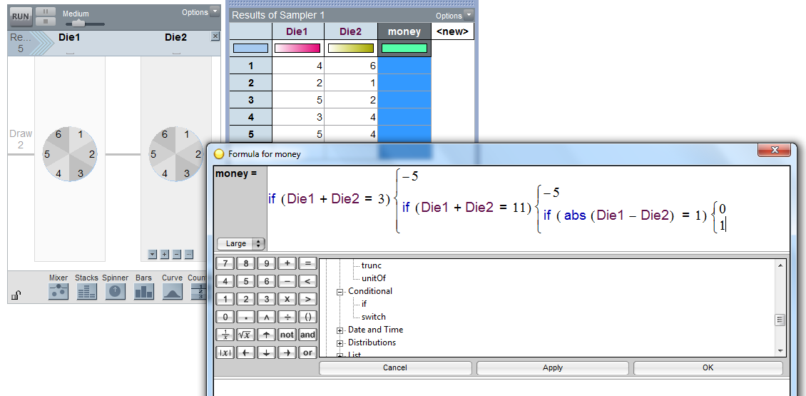
- In Results table add a column headed ‘money’.
Edit formula; -the ‘if’ statement is one way of deciding on the money made or lost for one game by the class.

- Change Repeat to 100.
Run.

- Highlight the money column and drag a plot onto the page.
Pull a circle to the right to separate.
Bin width = 1,
Stack
Counts (N)

- ‘Collect statistic’ for the number of times $5 is paid out and the number of times $1 is gained.
In History of results table, head up a new column for ‘profit’.
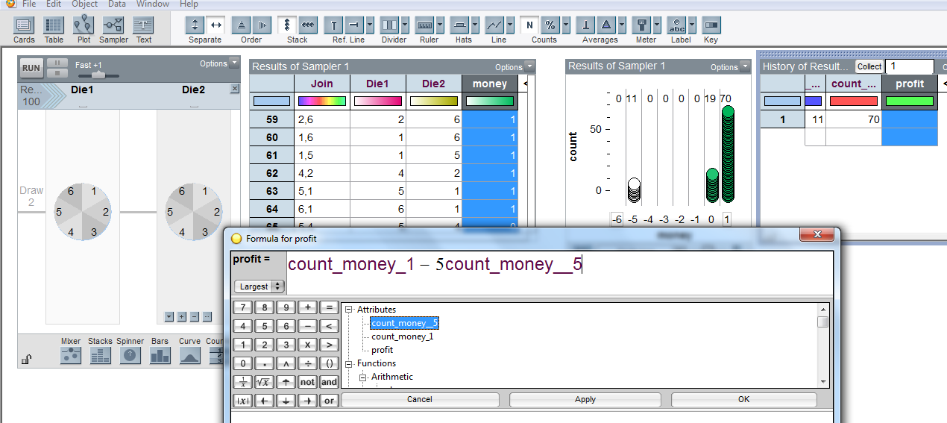
Edit formula to calculate the profit from 100 games
Run another three times, check that your formula works.

- Highlight the ‘profit’ column and drag a plot onto the page.
Pull a circle to the right to separate.
Bin width = 0.
Stack.
- Increase the speed.
Collect 10 more runs of 100 games.
Adjust graph x-axis values if necessary.

- Collect a large number of simulations of 100 games.
Add a divider to the graph and slide to cover the loss-making proportion.
Counts –percentage.
Display average profit on graph.
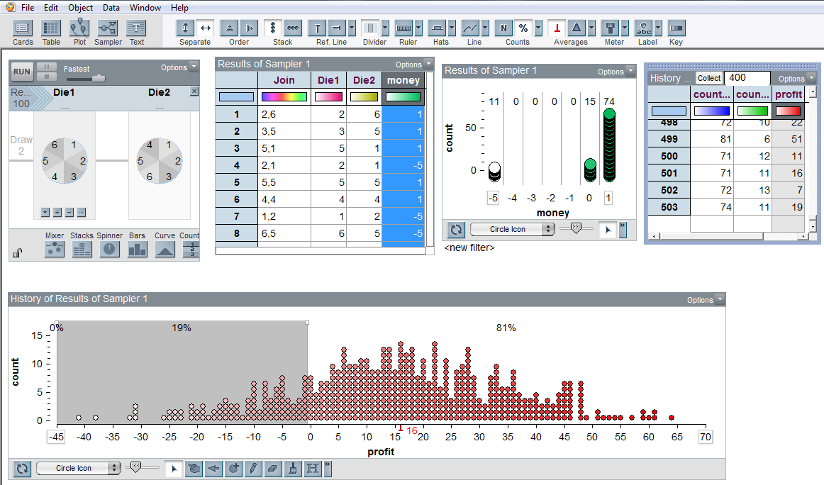

This work is supported by:

The New Zealand Science, Mathematics and Technology Teacher Fellowship Scheme which is funded by the New Zealand Government and administered by the Royal Society of New Zealand

and
Department of Statistics
The University of Auckland

