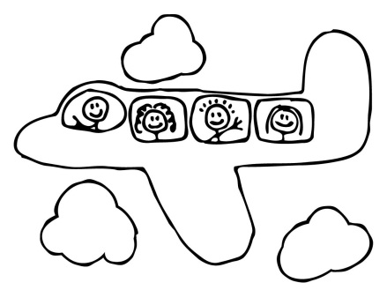
How many tickets to sell?

Adapted from: http://www.umass.edu/wsp/resources/poisson/problems.html

Air Zland has found that on average 2.9% of passengers who have booked tickets on its main domestic routes fail to show up for departure. It responds by overbooking flights. The Airbus A320, used on these routes, has 171 seats. How many extra tickets can Air Zland sell without upsetting passengers who do show up at the terminal too often?

(notes to teachers)
This resource is aimed at:
Year 13 probability distributions
connecting experimental (simulation - Tinkerplots) and theoretical approaches to probability
understand that assumptions need to be made in setting up a model
using a simulation model to see a distribution and to ask ‘what if’ questions
using the Binomial/Poisson distribution
understand that answers may be uncertain
consider consequences of decisions

Note: It is possible to view this task as a Poisson situation
- discrete
- small probability (distribution of rare events)
- events occur randomly
- events cannot occur simultaneously (?)
- events occur independently (?)
or as a Binomial situation
- discrete
- only two outcomes (arrive/not arrive)
- probability of not arriving is constant (2.9%)
- fixed number of trials ( fix the number of trials as the number of tickets sold e.g. 176- students should experiment with different numbers)
- events occur independently (?)
Either way a discussion is needed around the assumptions needed.

Some students could model using Poisson and some using Binomial so that comparisons can be made and class can discuss why both approaches are appropriate.

While it is beyond the scope and ability of Yr 13 students, it is worth pointing out that when a simulation model is set up and run it is checked against real data to see whether it is modelling the real situation adequately, and if not, modified. In particular, the assumption of independence used in the model and possible non-independence in reality may cause a discrepancy between simulated and real data. In practice, the model would be modified to include people arriving in groups and then checked against real data. Additional elements are added and checked to see if the model adequately reflects reality. Elements are subtracted to simplify the model, if, by subtracting them, the model still adequately reflects the real situation. Always, the model is checked against real data.

Tinkerplots: http://www.keycurriculum.com/products/tinkerplots

(student worksheet)

How many tickets to sell?

Air Zland has found that on average 2.9% of passengers who have booked tickets on its main domestic routes fail to show up for departure. It responds by overbooking flights. The Airbus A320, used on these routes, has 171 seats. How many extra tickets can Air Zland sell without upsetting passengers who do show up at the terminal too often?

Why might people not arrive for a flight?

How many people, do you think, will not arrive for a particular Airbus A320 flight on which they have booked if, on average, 2.9% of passengers do not show up?

Draw a picture of what you think the distribution of the number of people that do not arrive for a flight would look like.

How many extra tickets do you think it would be sensible for the airline to sell?

What are the consequences of selling too many tickets?

What are the consequences of selling too few tickets?

You are going to set up a Tinkerplots simulation to model the number of people who do not arrive, (or the number of people who do arrive), for a flight on an Airbus A320 when they have booked a ticket.
What assumptions do you need to make? Are these assumptions likely to be true?

Describe how you would set up the simulation:
What will you use in the sampler?

What are the possible outcomes and how will they look in Tinkerplots?

Sampling with or without replacement?

A single trial:
What is one trial (DRAW = Run =

What results will be collected?

How many trials?

Set up the Tinkerplots simulation and run it.
Do you need to adjust your model and run it again with different values to answer your question?
Sketch the distribution of the number/proportion of people who do not [or do]arrive for their flight.
Describe the distribution.

How does this distribution compare with the one you predicted?

Is there anything about the distribution from the simulation that surprised you?

What recommendation would you give to Air Zland for the number of extra tickets they should sell?

What are the consequences of this decision?

Compare your answer with other’s from your class.

Is there a theoretical distribution which could be used to model the number of people that do not arrive for a flight? Justify your answer.

What are assumptions do you need to make? Are these assumptions the same or different to the assumptions you made for the simulation? Are they likely to be true?

What are the parameter(s) of the distribution?

Using this distribution, write down the probabilities that you would use to deduce an answer for the airline.
Compare these probabilities with your simulation.

Would you change your recommendation to Air New Zealand regarding the number of extra tickets they should sell?

What different thinking did you need for the simulation approach and for the theoretical approach?

Is there an alternative distribution that could be used? Explain

Tinkerplots help sheet:

Method based on Binomial

Trial and improve: Try with say 5 extra tickets and see how many passengers are likely not to show. Run simulation and then change values to see the effect of different numbers of extra tickets.

P(not arrive = 0.029)

- Drag a sampler onto the page.

Put a bar device into the sampler. Use the ‘+’ or ‘-‘buttons to get 2 bars.

Rename one bar ‘arrive’ and the other ‘not’.

Click on the down arrow and click ‘show count’ percentage or proportion.

Click on the number above the bar and change the ‘not’ bar to 2.9% or 0.029

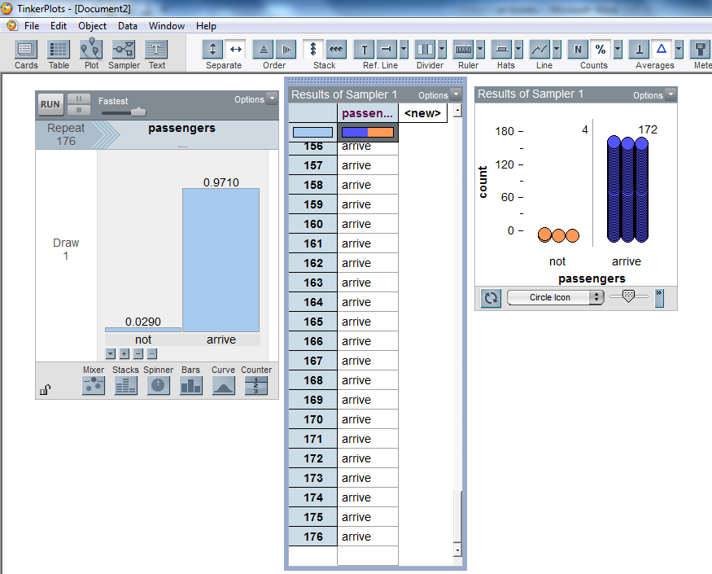
Draw =1

Change Attr1 to ‘passengers’

Repeat = 176 (or what number of tickets are sold)

Run. (this represents one plane load of passengers)

- Highlight the’ passengers’ column in the results table and drag a plot onto the page. Pull a circle to the right to separate ‘arrive’ and ‘not’.

Stack.

Count (N).

Right click on the number of non-arrivals and ‘Collect Statistic’

Run another 2 or 3 times.

- Highlight the ‘count-passengers’ column in the history of results column and drag a plot onto the page.

Pull a circle in the plot to the right to separate.

Stack.

Double click on a number on the x-axis. Make Bin width = 1, Axis starts at 0.

Counts- % - show proportion

- Change the number next to ‘collect’ to 7. Click ‘collect’.

Check that the simulation is doing what you think it should.

- Change the ‘collect’ number to a large number and watch the distribution of the number of non-arrivals grow.

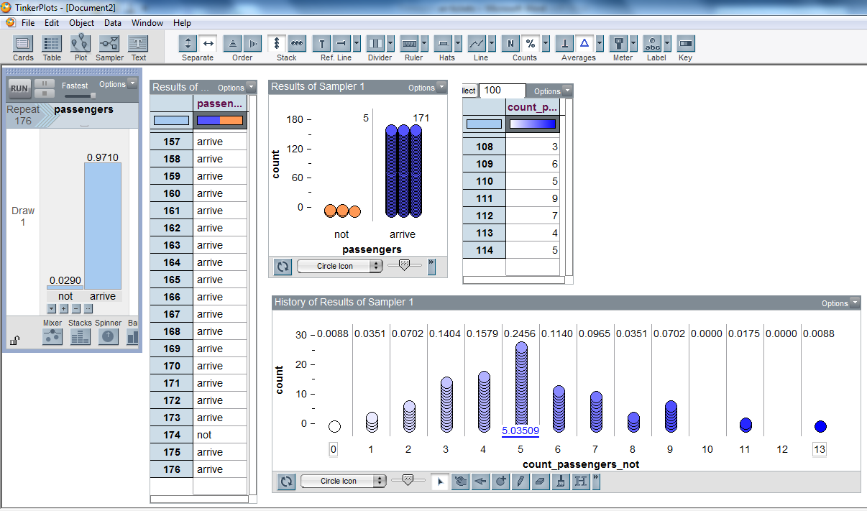
- Change bin width to 0 will allow you to use the divider to get proportion of flights with empty seats or extra people.

Average – show numeric value gives the average number who do not arrive

- Alter the number of ticket sold and rerun the simulation.

Method based on Poisson

Tinkerplots models Poisson probabilities in two ways, but there is a problem with one way for small values of .

This first way will work for any value of and relies on the idea of breaking down the interval of time or space into small quantities in which there is negligible chance of events happening simultaneously.

Think of the 171 people who are a plane load of passengers

2.9% of passengers do not arrive

Multiply this number by 1000 to get a whole number – 4959

The number who do arrive is

Multiply this number by 1000 – 166041

- Drag a sampler onto the page.

Put a Stacks device into the sampler. Use the ‘+’ or ‘-‘buttons to get 2 stacks.

Rename one stack ‘arrive’ and the other ‘not’.

Click on the down arrow and click ‘show count’.

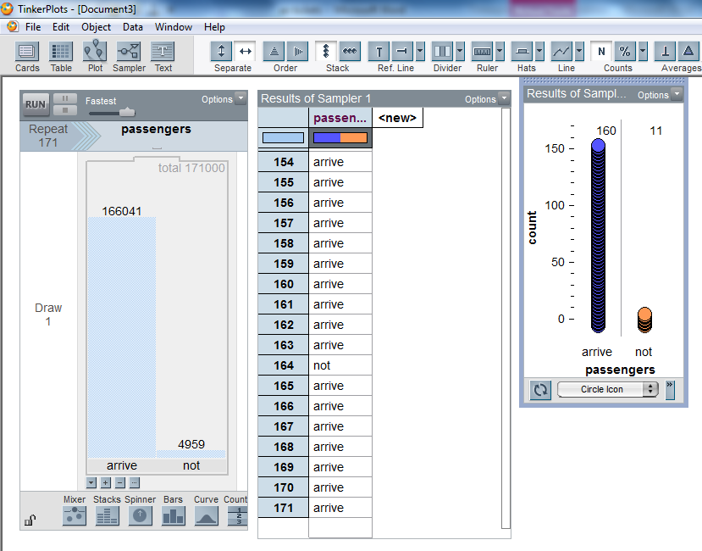
Click on the number above the stack and change the ‘not’ stack to 4959 and the ‘arrive’ stack to 166041

Draw =1

Change Attr1 to ‘passengers’

Repeat = 171

Run. (this represents one plane load of passengers)

- Highlight the’ passengers’ column in the results table and drag a plot onto the page. Pull a circle to the right to separate ‘arrive’ and ‘not’.

Stack.

Count (N).

Right click on the number of non-arrivals and ‘Collect Statistic’

Run another 2 times.

- Highlight the ‘count-passengers’ column in the history of results column and drag a plot onto the page.

Pull a circle in the plot to the right to separate.

Stack.

Double click on a number on the x-axis. Make Bin width = 1, Axis starts at 0.

Counts- % - show proportion

- Change the number next to ‘collect’ to 7. Click ‘collect’. (you will now have 10 simulations)

Check that the simulation is doing what you think it should.

- Change the ‘collect’ number to a large number and watch the distribution of the number of non-arrivals grow.

- Change bin width to 0 will allow you to use the divider to get proportion of flights with empty seats or extra people.

Average – show numeric value gives the average number who do not arrive

The simulation is very similar to the Binomial simulation but the argument about how many extra tickets to sell is now based on the number of empty seats out of 171 seats.

Alternative way to model a Poisson probability (OK for about 10 or greater; this method does not cope with x = 0 events happening, so not great for this situation, unless you modelled the number of people who did arrive. Yes this is a fault with this software)
- Use a sampler with 1 marble or a spinner with 1 sector, labeled ‘not’

Options → sampler options → repeat until condition

Random numbers → RandomPoisson(4.959)

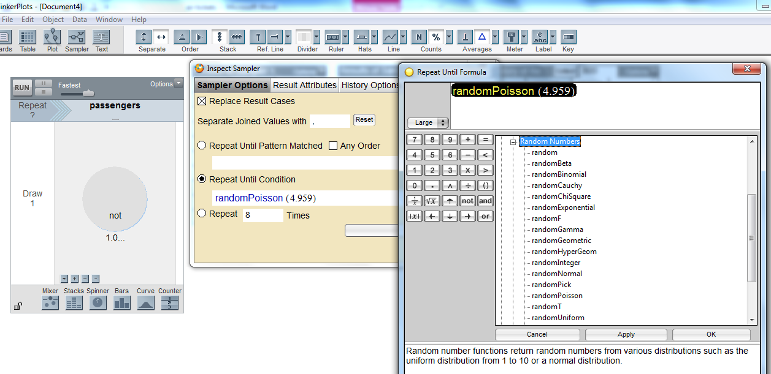

The number of passengers not arriving for each flight are generated by the Repeat function.

This seems a more intuitive approach for Poisson situations.

However, a zero repeat is not recorded, so this method is only good when P(X= 0) is negligible.

This method does not allow for observing the time of occurrences of the event (as in ‘New Arrivals’ task)

This work is supported by:

The New Zealand Science, Mathematics and Technology Teacher Fellowship Scheme which is funded by the New Zealand Government and administered by the Royal Society of New Zealand

and
Department of Statistics
The University of Auckland

