Internal Assessment Resource
Achievement Standard Mathematics and Statistics
91581v1: Investigate bivariate measurement data
Resource title: Dead Men DO Tell Tales
Credits: 4
Achievement | Achievement with Merit | Achievement with Excellence
Investigate bivariate measurement data. | Investigate bivariate measurement data, with justification. | Investigate bivariate measurement data, with statistical insight.

Student instructions
Introduction
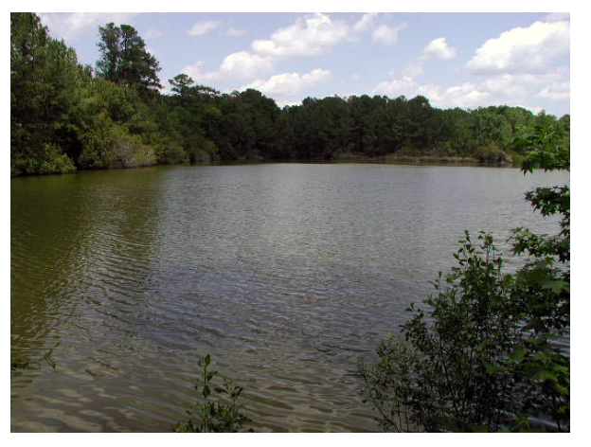
The Scene
In a quiet camping area known as Crystal Lake, two complete human skeletons were found in the mud when the lake began to dry during a drought. Oddly, the skeletons were almost completely intact due to being somewhat preserved in the clay at the bottom of the lake.
Detectives checked the missing person's reports for people in the area and found that three people had disappeared from that area over the last 10 years since the last drought.
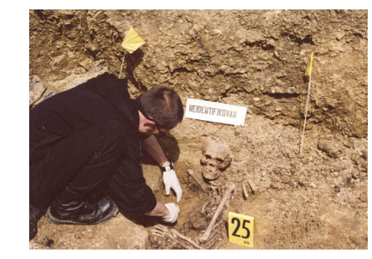
The police department budget has recently been reduced considerably so they don't want to ask for DNA analysis without good reason since it will involve visiting relatives and possibly raising their hopes.
They have have measured the lengths of those bones which have been exposed completely. Sketches with dimensions can be found in resource C.
The police have asked you to investigate which of the missing persons' remains have been found and determine which of the families, if any, should be contacted about a DNA test.

Your overall grade will be determined by how well you carry out your investigation and how well you apply the statistical enquiry cycle.

You will work independently over a period of 4 – 5 periods to complete this task.
Task
The relationship between different long bone measurements and height are of use to forensic anthropologists.
You have been given data collected by students at the university forensic science who recorded the anthropometric measurements of 52 people who donated their bodies to science. (See Resource A for column heading descriptors.)
- Use the statistical enquiry cycle to carry out a statistical investigation to determine if there is a relationship between at least one pair of variables.
- Write a report describing the investigation.

- Familiarise yourself with the data set provided. This will include doing research to help you understand the variables and develop a purpose for the investigation.
- Pose an appropriate relationship question that can be answered using variables in the data set and which will help you solve the problem. The variables you choose must be numerical, and the variable you use as your response variable must be continuous. You may choose to investigate more than one pair of variables. Select appropriate display(s) to graph your data.
- Identify features in the data, including the nature and strength of the relationship.
- Find an appropriate model.
- Use your model to make prediction(s).
- Write a conclusion answering your question.
- Support your conclusion by referring to your analysis and/or features of the visual display(s). Include a reflection on your process, which could consider other relevant variables, or evaluate the adequacy of your model(s).

In writing your report, link your discussion to the context and support the statements you make by referring to statistical evidence.

Resource A
The data set provides information about 52 individuals who have donated their bodies to science over the past several years. The students in the faculty of forensic science at the university took measurements of heights and lengths of long bones during the course of their studies. These measurements are recorded in a file which is available on the intranet.

Explanation of column headers in the data set:

ethnicity | Caucasian, African, Asian
gender | Male or femaile
femur | Femur bone length in cm
tibia | Tibia bone length in cm
fibula | Fibula bone length in cm
humerus | Humerus bone length in cm
ulna | Ulna bone length in cm
radius | Radius bone length in cm
height | Overall height (stature) in cm

This electronic dataset as well as Resource C – the forensic summary, the marking schedule and sample exemplars can be obtained from Richard Mackrory at Albany Senior High school on rmackrory@ashs.school.nz

Resource B: Missing People Profile
Name: Jun Kim
Age: 21
Height: 165cm
Weight: 62kg
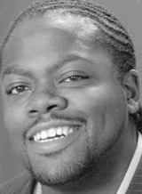 | Name: Hussein Baxter  Age: 22  Height: 172cm  Weight: 95kg
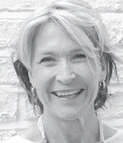 | Name: Eva Longori  Age: 55  Height: 165cm  Weight: 57kg

RESOURCE C – FORENSIC SUMMARY

This forensic summary along with Resource A – the electronic dataset, the marking schedule and sample exemplars can be obtained from Richard Mackrory at Albany Senior High school on rmackrory@ashs.school.nz

IDEAS, COMMENTS, NOTES AND REFERENCES

____________________________________________________________
____________________________________________________________
____________________________________________________________
____________________________________________________________
____________________________________________________________
____________________________________________________________
____________________________________________________________
____________________________________________________________
____________________________________________________________
____________________________________________________________
____________________________________________________________
____________________________________________________________
____________________________________________________________
____________________________________________________________
____________________________________________________________
____________________________________________________________
____________________________________________________________
____________________________________________________________
____________________________________________________________
____________________________________________________________
____________________________________________________________
____________________________________________________________
____________________________________________________________
____________________________________________________________
____________________________________________________________
____________________________________________________________
____________________________________________________________
____________________________________________________________
____________________________________________________________
____________________________________________________________
____________________________________________________________
____________________________________________________________
____________________________________________________________
____________________________________________________________
____________________________________________________________
____________________________________________________________
____________________________________________________________
____________________________________________________________
____________________________________________________________
____________________________________________________________
____________________________________________________________
____________________________________________________________
____________________________________________________________
____________________________________________________________
____________________________________________________________
____________________________________________________________
____________________________________________________________
____________________________________________________________
____________________________________________________________
____________________________________________________________
____________________________________________________________
____________________________________________________________
____________________________________________________________
____________________________________________________________
____________________________________________________________
____________________________________________________________
____________________________________________________________
____________________________________________________________
____________________________________________________________
____________________________________________________________
____________________________________________________________
____________________________________________________________
____________________________________________________________
____________________________________________________________
____________________________________________________________
____________________________________________________________
____________________________________________________________

