



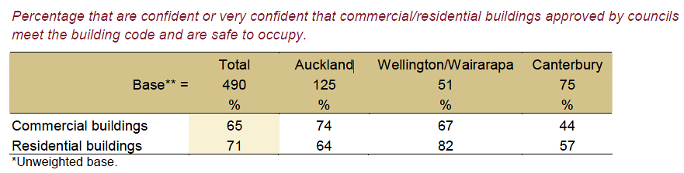



**Workshop AJ**

**Level 3 Statistical Literacy (AS3.12)**

**Margin of Error: clarifying the rules of thumb**

**Dru Rose (Westlake Girls High School)**

**Where do the “Rules of thumb” come from?**

A “rule of thumb” is a quickly calculated approximation which works in most situations.

There are three types of claim in media reports and hence three rules of thumb for estimating the corresponding margins of error.

The following summary is taken from a paper by Charles H. Franklin at the University of Wisconsin:

<http://abcnews.go.com/images/PollingUnit/MOEFranklin.pdf>

Media reports use a 95% level of confidence.

1. 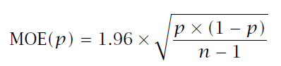**Claims involving a single poll %**

The MOE quoted in media reports is the **maximum** value when is p = 0.5.

For large samples (n is usually at least 500) (*n* -1) can be approximated by *n* and 1.96 is very close to 2 and so the above formula then reduces to ≈ $\frac{1}{ \sqrt{n}}$

This will be close to the actual margin of error for p between 30% and 70%

1. **Comparison claims within one group**

**e.g.** the lead of National over Labour within one poll

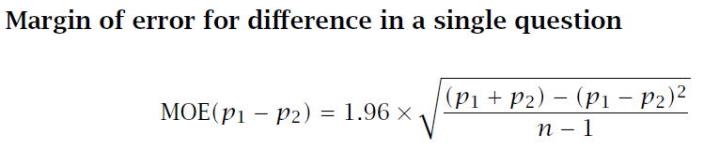

For the usual situation where there are two main parties with support not too far from 50% and support for minor parties is very small then $p_{1}$ + $p_{2}$ ≈1 , $p_{1}$- $p_{2}$ ≈ 0, *n* – 1 ≈ *n* and 1.96 ≈2 and hence the above formula reduces to approximately 2 × ≈ $\frac{1}{ \sqrt{n}}$ **i.e the 2 × MoE rule of thumb**

1. 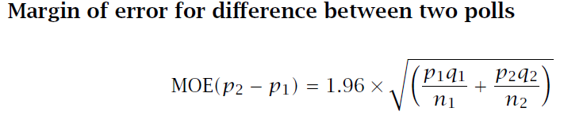**Comparison claims between two independent groups**

When both poll %s are close to 50% and the sample sizes are the same in both groups, this formula reduces to $\sqrt{2}$ × $\frac{1}{ \sqrt{n}}$**.** and we can show that the rule of thumb**:**

**“1.5 ×Average MoE” is a reasonable approximation in most situations:**

e.g. Suppose $n_{1}$ = 1000, $n_{2}$ = 500 and $p_{1}$ = $p_{2}$ = 0.3 (lowest value for rule of thumb), then the correct formula gives an MOE for the “difference”= 4.9% and the 1.5 × Average MOE rule of thumb estimates the MOE for the difference ≈ 5.7%.

Provided the difference in poll% is not in the range 4.9% ≤ p≤ 5.7% then both MOE formulae would lead to the same conclusion.

In most situations the poll sample sizes are close in value and the two poll%s are closer to 50% than 30% and hence the rule of thumb is likely to be a good approximation.

**(**furtherdiscussion can be found onAndrew Balemi’s post on Stats Chat entitled “All about election polls” <http://www.statschat.org.nz/page/2/?s=all+about+election+polls>

**Why are we using “Rules of thumb” rather than accurate formulae?**

1. This is a statistical literacy unit. Quick calculations which can be done in the head or on the back of an envelope are more appropriate when checking claims in the media
2. The formulae rely on a good grasp of both the Central Limit Theorem and approximations to the binomial and multinomial distributions, which in the past only our very top students grasped. For most students, the topic became a calculator button-pushing exercise with minimal understanding of concepts.
3. The Central Limit theorem was a convenient data reduction technique in the absence of technology. Today we have technology which can do thousands of bootstraps in a few seconds.
4. The emphasis in our teaching has moved away from mere calculations to the need to interpret the meaning of confidence intervals in context and actually use them to answer a question.

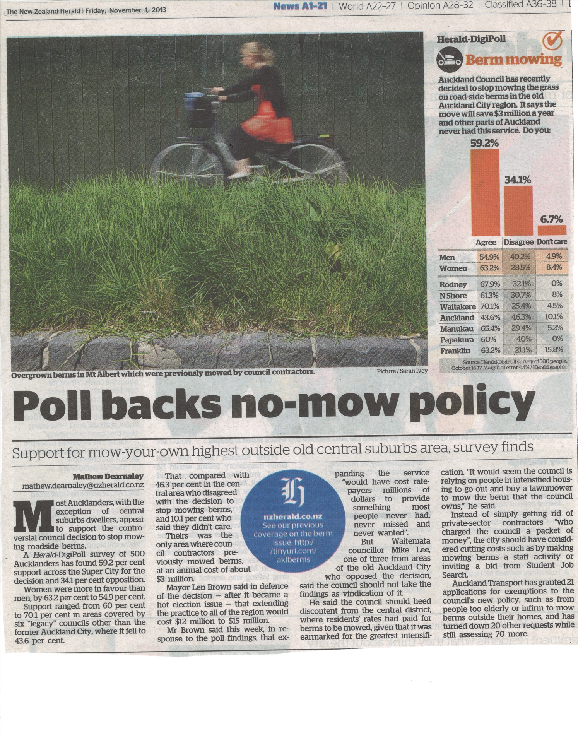

Herald DigiPoll survey of Auckland Council’s NO-MOW policy for berms (1/11/13)

Student Worksheet

1. The Herald Digipoll survey found 59.2 per cent support across the Super City for the new no-mow policy. Construct a confidence and hence test the claim that:

“Most Aucklanders… appear to support the controversial council decision to stop mowing roadside berms”

1. Test the claim that women were more in favour [of the policy] than men. (You may assume that equal proportions of men and women were sampled).

To test further claims it is necessary to assume that a representative proportion resident in each district was sampled. Use the following population statistics *(source: http://www.stats.govt.nz/browse_for_stats/population/estimates_and_projections/SubnationalPopulationEstimates_HOTP30Jun10.aspx )* to **estimate the number sampled from each district**:

|  |  |  |  |
| --- | --- | --- | --- |
|  | Population in 2010 | % in each district | Sample size |
| Rodney | 100,000 |  |  |
| NShore | 229,000 |  |  |
| Waitakere | 208,100 |  |  |
| Auckland | 450,300 | 30.47% | 152 |
| Manukau | 375,600 |  |  |
| Papakura | 49,800 |  |  |
| Franklin | 65,200 |  |  |
| **Totals** | 1,478,000 | **100%** | **500** |

Use the above table together with the other information supplied in the graphic and/ or article to construct appropriate confidence intervals and hence test the following claims:

1. In the former Auckland City, a higher proportion of residents disagreed than agreed with the new policy.
2. “Support for mow-your-own highest outside old central suburbs area, survey finds”.

Construct confidence intervals comparing the difference in support in each of the former “legacy councils” with that in the former Auckland city. Can it be claimed that support is **consistently** higher outside the old central Auckland area?

Research New Zealand 28 February 2012

**Are our Buildings Safe to Occupy?**

The earthquakes in Christchurch in December 2010 and February 2011 have led to questions being asked about whether the building consent and inspection processes are sufficiently rigorous to ensure that buildings meet earthquake standards. In Christchurch, for example, the CTV Building, where the greatest number of casualties occurred, has been found not to have met the standard. In Wellington a number of older buildings do not meet current standards, and owners have been served with notices that they must strengthen their buildings.

This leads to the question of whether New Zealanders generally trust their councils to ensure that buildings they approve meet the building code and are safe to occupy. In a recent poll, Research New Zealand asked New Zealanders whether they were confident that this was the case for (a) commercial buildings and (b) residential buildings in their area.

The Research New Zealand poll of 490 people aged 18 and over was conducted by telephone on 15-23rd February 2012. The maximum margin of error for the sample as a whole is +/- 4.7% (at the 95% confidence level). The data has been weighted to ensure it is an accurate representation of New Zealand's general population. The poll was not taken on behalf of any organization, but as part of Research New Zealand’s monthly survey of attitudes and opinions.

There were two questions (Q18 and Q19) which related to confidence in safety of buildings. The questions asked and the results tables are displayed on the following pages.

***Q18*.** *How confident are you that commercial buildings approved by your local council meet the building code and are safe to occupy?*

***Q19.*** *How confident are you that residential buildings approved by your local council meet the building code and are safe to occupy?*

Options for both questions**: Confident**

**very confident**

**not confident**

**not at all confident**

**don’t know**

**refused**

**Table A**

This table shows the results for the 490 respondents when split into three regions: Auckland, Wellington/Wairarapa, and Canterbury. In this table the two options “Confident” and “very confident” have been combined.



