Big Brother eyes 'boost honesty'
The feeling of being watched makes people act more honestly, even if the eyes are not real, a study suggests.
A Newcastle University team monitored how much money people put in a canteen "honesty box" when buying a drink.
They found people put nearly three times as much in when a poster of a pair of eyes was put above the box than when the poster showed flowers.
The brain responds to images of eyes and faces and the poster may have given the feeling of being watched, they say.
Writing in the journal Biology Letters, the team says the findings could aid anti-social behaviour initiatives.
The experiment made use of a long-running honesty box scheme based in a canteen at Newcastle University.
“ It does raise the possibility that you could get people to behave more co-operatively or pro-socially by putting up pictures of eyes ”
Dr Melissa Bateson, Newcastle University
Over the course of 10 weeks, an A5 poster listing hot drink prices was placed at eye-level above the honesty box.
Each week, the poster featured different images of either flowers or a pair of eyes looking directly at the observer.
At the end of every week, the team calculated the total amount of money collected and the amount of drink likely to have been consumed.
Processing faces
Dr Melissa Bateson, a behavioural biologist from Newcastle University and the lead author of the study, said: "We found that people paid 2.76 times as much money when we put a notice on the wall that featured a pair of eyes as opposed to when the image was of some flowers."
She believes this happens because the eyes on the poster may affect people's perception that they are being watched by other people.
"Although it was just a photocopied black and white poster, we know that people's brains are set up to process faces and eyes, and that is probably because it is very important for us to know if we are being watched by other people."
The scientists believe their findings may have applications in initiatives to curb anti-social behaviour or for law enforcement.
"It does raise the possibility that you could get people to behave more co-operatively or pro-socially by putting up pictures of eyes," said Dr Bateson.
"It would work particularly in instances where people have to make a choice between whether to behave well or badly."
She said CCTV or speed cameras might be a possible application.
Professor George Fieldman, an evolutionary psychologist from Buckinghamshire Chilterns University College, said: "This paper beautifully demonstrates that people behave better when being watched.
"It would be interesting to know how one can apply these sorts of findings more generally in organisational structures and in society in general to maximise upon honourable and altruistic behaviour."
Story from BBC NEWS: http://news.bbc.co.uk/go/pr/fr/-/2/hi/health/5120662.stm
Published: 2006/06/28 07:00:20 GMT © BBC 2012

A | A | B | B
A | A | B | B
A | A | B | B
A | A | B | B
A | A | B | B
A | A | B | B
A | A | B | B
A | A | B | B

Which group?  (circle) | Control Treatment
Slide # | Funniness (1-10)  1=not funny 10=hilarious
1
2
3
4
5
6
7
8
9
10
TOTAL:

The necessity of training farm hands for first class farms in the proficient handling of farm livestock is foremost in the minds of effective farm owners. Since the forefathers of the farm owners trained the farm hands for first class farms in the proficient handling of farm livestock, the farm owners feel they should carry on with the former family tradition of training farmhands of first class farms in the effective handling of farm livestock, however futile, because of their belief that it forms the basis of effective farm management efforts.
How many Fs did you count?
__________ __________

Turn your paper over when done
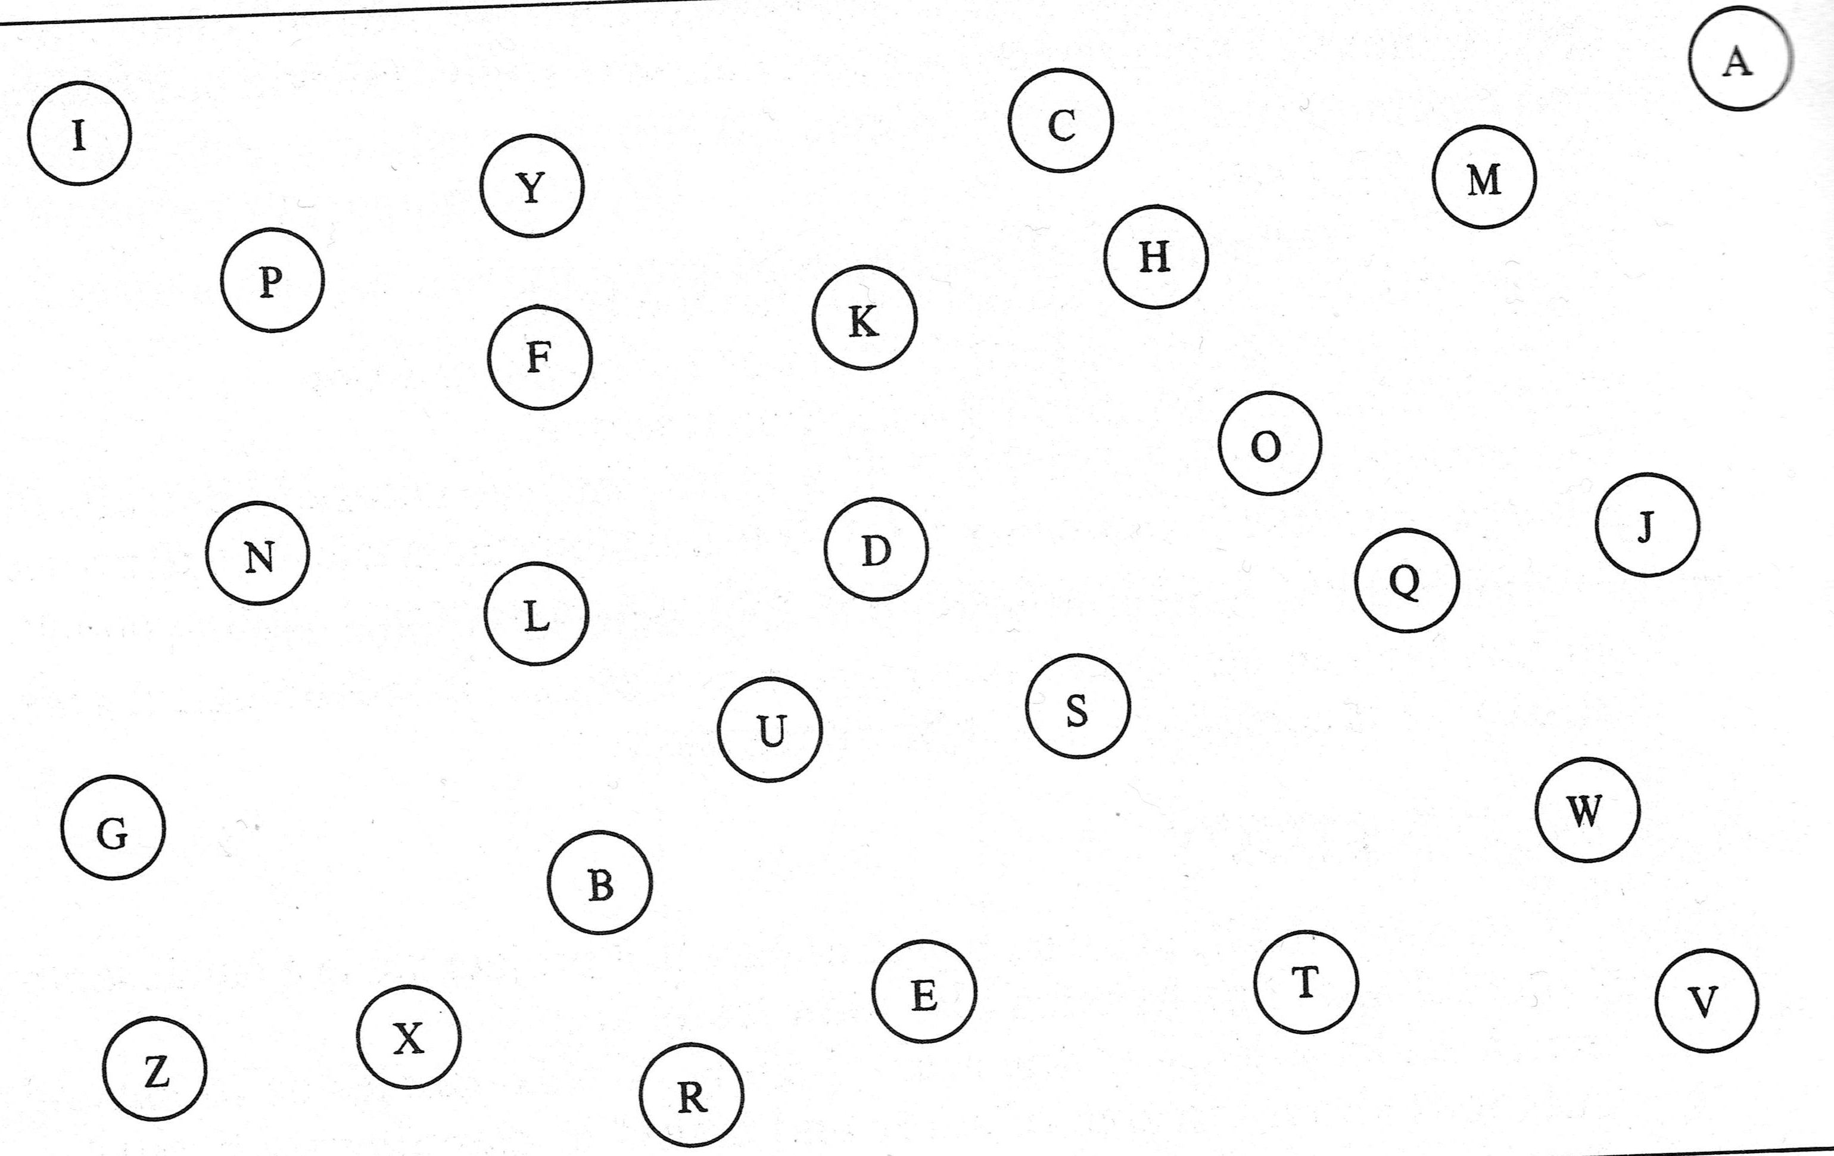
Attempt 1 time__________ Attempt 2 time__________ Attempt 3 time__________
Attempt 4 time__________ Attempt 5 time__________ Attempt 6 time__________

Does the glass shape affect drink consumption rate?
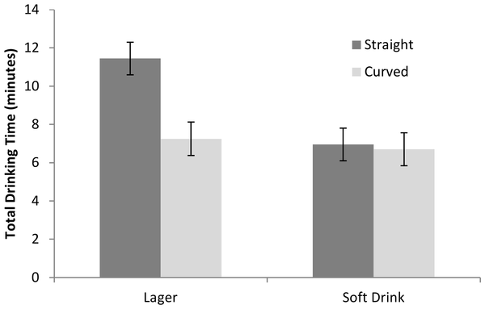
Read these articles:
- http://www.guardian.co.uk/society/2012/aug/31/drinkers-beer-quickly-curved-glass
- http://www.bbc.co.uk/news/health-19436926
- http://www.guardian.co.uk/society/2012/aug/31/drinkers-beer-quickly-curved-glass
- http://news.sciencemag.org/sciencenow/2012/08/drinking-too-much-blame-your-gla.html
The published study is here:
http://www.plosone.org/article/info:doi/10.1371/journal.pone.0043007#pone-0043007-g002
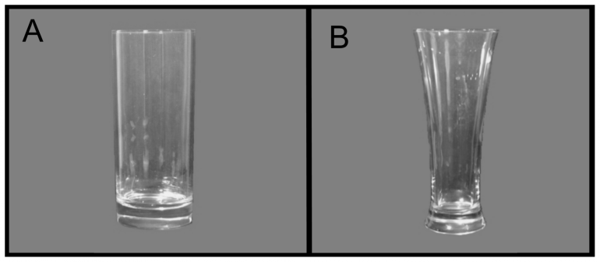
Answer these questions:
- What was the experiment testing?
- What was the hypothesis?
- What was the treatment?
- What was the response variable? What was it measured in?
- What were the experimental units? How were they allocated to treatments?
- How did they try to control for other factors? What were the other factors?
- What blinding was used?
- How was the data gathered?
- What did the experiment conclude?
- Was their hypothesis correct?
- What follow-up experiments could be done based on the findings of this experiment?

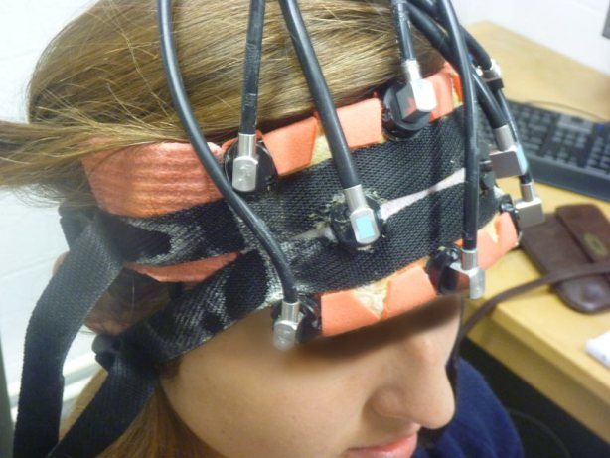
A zap away from better maths?
STACEY KIRK
Last updated 08:18 21/05/2013
Scientists at the United Kingdom's Oxford University have discovered that a person's mathematical skills increase when a gentle pulse of electricity is applied to the brain.
The study, published today in international journal Current Biology, took 25 people and measured how their maths skills fared when a small electrical current - a fraction of the energy found in a AA battery - was applied to the prefrontal cortex.
Head researcher, cognitive neuroscientist Roi Cohen Kadosh, along with a team of scientists, recruited 25 volunteers who practised maths equations while subjected to either the electrical current or a fake simulated current.
Each person had two sponge-covered electrodes fixed to either side of the forehead, which targeted an area of the prefrontal cortex considered key to arithmetic processing.
In 2010, Cohen had already discovered that combined with training, electrical brain stimulation could improve people's maths skills.
The latest study however, showed how much of an improvement could be made, and how it applied to real-world maths skills.
Jacqueline Thompson, a PhD. student in Cohen Kadosh's lab and a co-author on the study, said the electrical current was slowly ramped up to about 1 milliamp and then fluctuated randomly between.
The study found the two groups performed at the same level on the first day.
But over the next 4 days, the group receiving brain stimulation along with training learned to do the equations up to five times faster than the group who received the fake current.
The study found the effects of increased brainpower lasted for up to 6 months after the electrical treatment.
Despite the breakthrough, it's still not clear how the treatment works.
Thompson said it could be that the current helps synchronise neuron firing, enabling the brain to work more efficiently.
Although electrical currents to stimulate brain activity is not a new idea - think electroconvulsive therapy - scientists say the finding is an exciting one.

Source: http://www.stuff.co.nz/national/education/8697184/A-zap-away-from-better-maths
Published data: http://www.cell.com/current-biology/fulltext/S0960-9822(13)00486-7#Summary
91265 - Conduct an experiment to investigate a situation using statistical methods
Task One Resource: List of experimental situations.
You may choose an experimental situation from the given list, or negotiate a suitable experimental situation with your teacher:

- Can people memorise words better if they draw/imagine the words as pictures?

- Does the size of a box affect the weight that people guess it is (even when holding it)?

- Does using your non-dominant hand affect the speed that you can perform a simple task?

- Does having your eyes open help you to estimate measurements?

- Does knowing the dimensions of a page help when drawing dots a particular distance apart?

- Do people think a drink/food tastes better if they know the brand?

- Does jumping from your dominant foot improve your jumping length?

- Does drinking from a bottle/cup labelled 'expired' change the perception of taste?

- Do you jump further if there is a target line marked out for you?

- Can you perform a task quicker/better if given some advice?

- Does practice improve your ____ skill?

