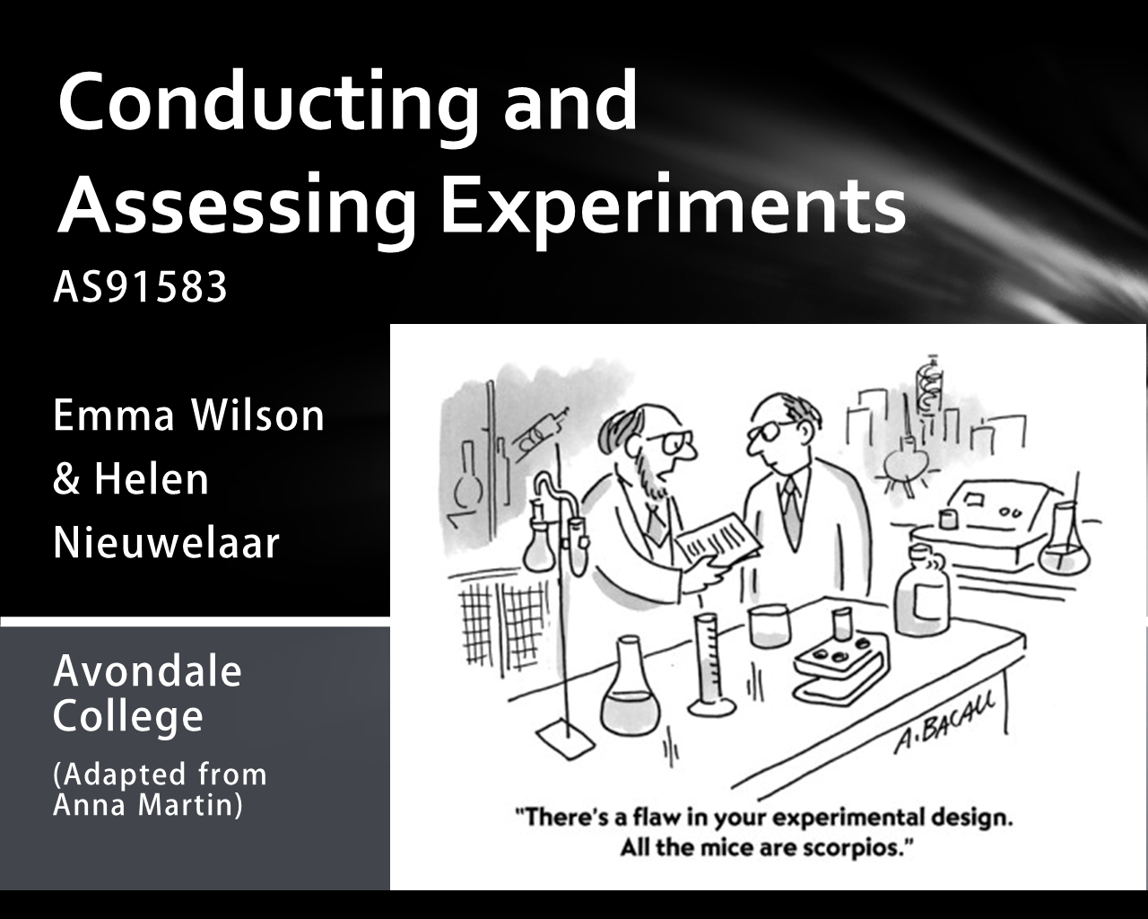

Informed contextual knowledge
- Need to develop understanding of why an experiment is needed (a meaningful investigation/context)
- Need to understand context to design experiment (what design, how to define variables, what tools/resource they will need)
- Need to see themselves as being able to contribute to what is known about the world and people
- Need to be student driven – students need to time to research the context and inform themselves
- Need to find information to form an expectation for their experiment/investigation (a hypothesis in the scientific sense)

Suggestions for setting up a context for 3.11:
- Newspaper article reporting the findings of a study or experiment
- A myth (e.g. like the show Myth Busters)
- Psychology heuristics or biases
- Well-known experiments/studies (without too much detail of the design)
- Topics of interest to teenagers!

Ideas for experiments for 3.11:
TKI exemplars
- Tricky questions – students take a basic questionnaire and see if changing ONE thing about the questionnaire can produce different numerical responses
- Estimation – students see if there are conditions or factors that influence someone’s ability to estimate time/volume/age etc.
Newspaper articles
- Drinking something faster/slower depending on the shape of the glass (with modification )
Psychology
- Anchoring bias – faced with uncertainty (e.g. being asked to estimate something) people will use available information as a reference
- Primacy/recency effects –the tendency for people to remember/use what happened first or last better than what happened in the middle
Topics of interest
- School uniform – why are jumpers normally dark colours and not light colours? [science link]
- Does studying with music playing actually help with learning?
- Motivation – will people perform better if they have a target to aim for (e.g. jumping)? [key competency link]
- Reaction time – does having a conversation at the same time as driving make you react slower? [simulation based!]

Guidelines for informed contextual knowledge:
- Provide some context and a loose definition of the response variable
- Students clearly define response variable and select and define their own treatment variable
- Students use research to develop expectation for experiment
Example:
- Investigation into running techniques - what can you do to run faster?
Informed contextual knowledge:  - Students need to research around what can make people run faster – are there things that can be changed? | Response variable:  - Provided as “how fast someone runs”  - Students need to clearly define this e.g. how many seconds it takes someone to run 100 metres
Treatment variable (something they will change):  - Student has to research this to find meaningful factor  - Students decides to investigate running with shoes or without shoes  - Shoes are defined as sports shoes/sneakers | - Research into this area would suggest that running without shoes might help you run faster (barefoot running)  - What I know about the world is that in running competitions people where shoes

Experimental design principles
- Focus on comparison of two independent groups for the overall design of the experiment
- Use random allocation to groups (and keep this idea separate from sampling)
- The treatment (explanatory variable) needs to involve changing something (so the variable has to be able to be changed – an intervention)
- Need an appreciation for other sources of variation in the response variable and account for this where possible

Suggestions for learning about experimental design for 3.11:
- Learn through taking part in experiments instead of theory first, application second
- Have guidelines for the key components of the design (a checklist), but use questions to promote students thinking and reasoning around aspects of their design

Guidelines for experimental design for 3.11:
Random allocation to two groups | Defining treatment and response variables
- Comparison of two independent groups design  - Different people/objects in each group, each person/object only provides one measurement of the response variable  - Allocation to one of the two groups done randomly – everyone is used, but a random process determines which of the two groups they are placed into  - A different treatment is applied to each group  - The groups do not have to be a certain size – you can use one class randomly allocated into two groups  - The experiment units (participants/objects) are who/what the experiment is conducted with | - Response variable is a numerical variable which is measured  - How and what is measured will need defining  - Treatment is essentially a categorical variable with two values (on vs off/control, or A vs B)  - The treatment levels need to be fully described  - Other considerations may be needed e.g. how many words to show for a memory test, how long to show the words for, how to display the words – these are related to defining the treatment and response variables (and students should test these out before deciding on how to define these) – the conditions need to allow for enough variation in the response variable
Considering other sources of variation | Procedures used to carry out the experiment
What are other related variables that would also cause variation in the response variable?  - There will be variables that can be controlled (many of which are part of the procedures to carry out the experiment) – the general idea is that only one thing is changed between the two groups  - Other variables that cannot be controlled need to be identified – these should be variables that make sense based on the context and the nature of what is being investigated – not just a generic list  - Students could also consider blocking IF they understand why this is helpful (imagine a two way table of the two treatment groups and another factor you strongly believe to be related to the response variable) | - Sequences of action to take to carry out the experiment  - How are the groups randomly allocated  - What instructions will the participants receive  - How will the experiment happen  - Who will do what  - What will be recorded and how  - When will the experiment be conducted  - The overall goal is that the conditions for the experiment are the same for the two treatment groups, and the conditions of the experiment do not provide another source of variation for the response variable

Experimental design principles – design sheet

E.g. Time perception experiment
Random allocation to two groups | Defining treatment and response variables
Considering other sources of variation | Procedures used to carry out the experiment

Exploratory data analysis
- The data for this investigation has come from an experiment with a certain group of participants or objects
- There needs to be a clear understanding that this is a different type of investigation than those students may have encountered before that have involved random samples from populations or practical investigations involving bivariate data or chance/probability
- The focus on exploring the data obtained through the experiment is on what it can tell us (or what it cannot tell us!) about the response variable and what we attempted to change/manipulate with the experiment
- Just like with sample to population inference ideas, students need to build up images of what they would expect to see in terms of variation between and within the two groups – it is not just about the proportion obtained from the randomisation test

What did you learn from the data from the experiment?
- Can you explain certain features of the data? Make links between what you can see in the data and what you know about what is being investigated or the design of the experiment.
- Can you explain the results from the analysis? Make links between what you can see in the data and what you know about what is being investigated or the design of the experiment.
- How does chance play a part in the features of the data? Make links between what you can see in the data and what you know about chance variation (and randomisation variation)

Example of analysis
A high school student named David Merrell did a fascinating study of the effects of listening to rock music on the performance of rats in a maze. He had three groups of rats, one raised in the presence of rock music (performed by the group Anthrax), one raised in the presence of music by Mozart, and one raised in the absence of music. These animals learned to navigate a maze before exposure to the music, and then performed over three additional weeks. He recorded the time in seconds it took the rats to navigate the maze. We will just focus on the Mozart and Anthrax group.
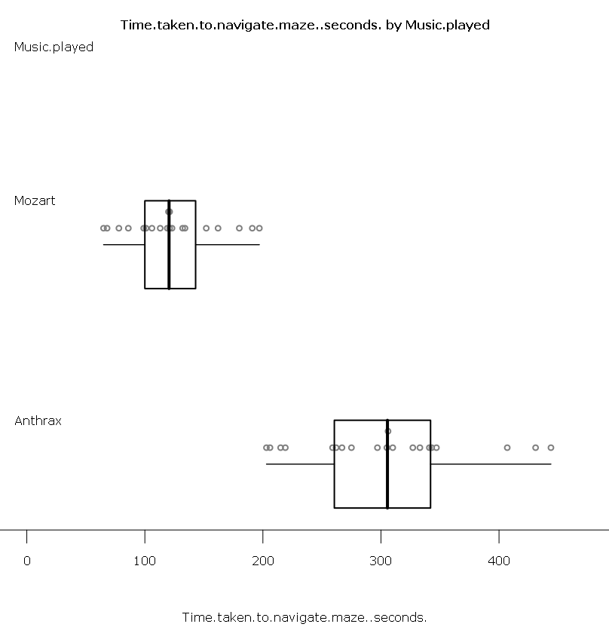 | 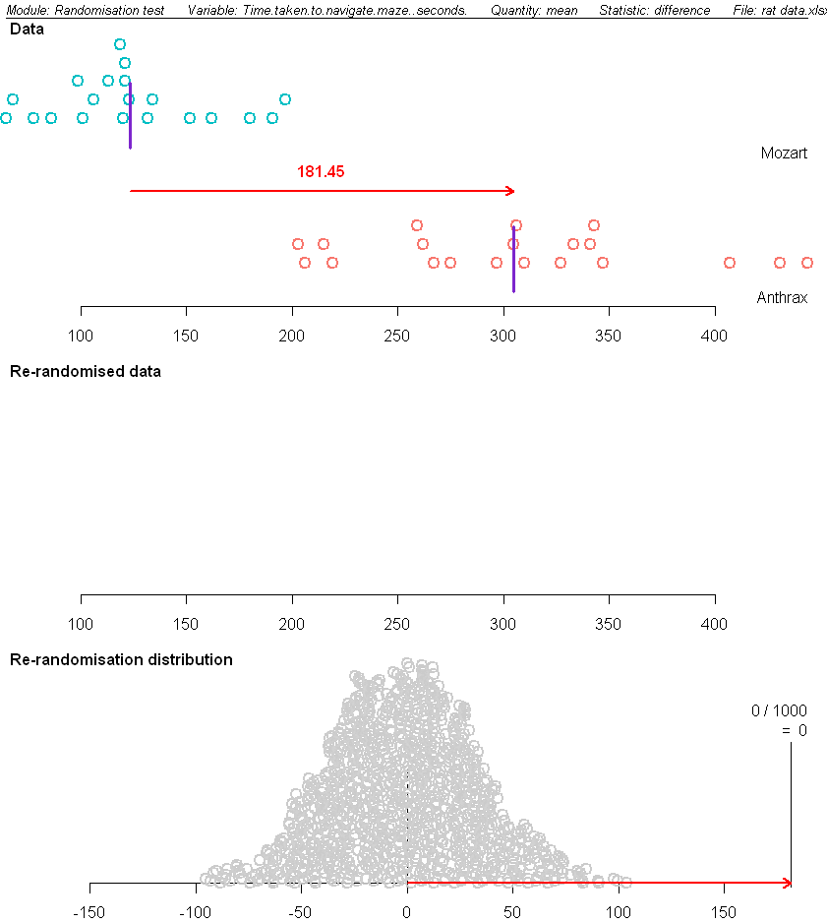

Reporting experiments
- There should be a separation at level 8 for statistical investigations between the statistical enquiry cycle and the writing of the report about the investigation
- We want students to be presenting a report about what they did (in the past tense) so they are engaging in the kind of reporting that happens in the real world about investigations
- The use of media reports and press releases can be interesting examples of reporting of studies/experiments (and a good link to the external statistical reports standard)
- Simple reports from journal articles (or even the abstract/summary) can model the style of reporting

Guidelines for reporting for 3.11:
Introduction  Information is provided about the general context that was investigated and the overall investigative problem for the investigation is presented.  The investigative problem is about a causal relationship.  The expected outcome for the investigation is presented, with supporting statements about why this was the expectation. | Method  The design used for the experiment is described, including details about the experimental units, any measurement tools/tasks used and the procedures to carry out the experiment.  Explanations are given (tied to context and statistical knowledge) to support and justify the decisions that were made.  Other sources of variation are identified and attempts to account for these in the design of the experiment are explained.
Results  The raw data from the experiment needs to be supplied in the appendix, along with notes about the experiment, measurement tools/tasks used for the experiment etc.  A dot plot and box and whisker plot is constructed for the data that compares the response variable across the two treatment groups. Summary statistics for each group are also included.  Descriptions are given about the response variable and how it varies – making links to the conduct of the experiment, the design of the experiment (e.g. how the variables were defined), the nature of the variation, and what this suggests about the effects of the treatment.  An explanation is given about the method used to analyse the data to make an inference about the causal relationship.  The output from the randomisation test is included with an identification of the placement of the difference between the medians/means of the two groups in the re-randomised distribution of differences. | Discussion  The results of the randomisation test are interpreted in context, including assessing the strength of the evidence for the causal relationship inference.  The design of the experiment is considered along with the results of the randomisation test to answer the investigative problem. Some discussion of how this matches to the expectation for the experiment is included.  Other patterns/effects that were discovered through the investigative process are presented and discussed, with discussion of how the investigation could be broadened.  Possible issues with the experiment are identified and discussed in terms of how they might impact on their findings.

Assessing experiments

Practical considerations and timing:
- Planning time (as an individual or as a group) including research : two – three lessons
- Carrying out the experiment (using a borrowed class) : one – two lessons
- Analysing the data from the experiment (individually): one lesson, need access to technology to produce graphs, statistics and run randomisation tests
- Writing up the report (individually): two – three lessons – ideally typing up a report and include relevant analysis (graphs, tables, test output etc.)
You will need to plan for enough time to assess as well as teach the topic
You will also need willing participants (and teachers) for your experiment if using people.

Incorporating into teaching and learning programme:
Approach A: Do the whole standard as one discrete topic over at least 6 weeks
Approach B:
- Do a general introduction to the whole process of conducting and experiment, focusing on the design aspect (two weeks) – students then work as groups to design their experiment
    - Over a period of time, students carry out their experiments and record data and notes from the experiment (this could be while another topic is running)
    - Do another teaching unit on analysing data from experiments and reflecting on the whole experimental process to write up a report (three weeks)
    - Students then work individually to analyse their data and write up their report (one week)

Suggestions for assessing experiments for 3.11:
Managing authenticity | - The plan that the group develops does not need to be fully justified and explained – this will come in when the individuals of each group write up their own report  - There does need to be research supporting their selection of treatment variable, but the plan could just contain enough information that you are satisfied it can be conducted in a safe and reasonable manner, and that the design will not compromise their ability to achieve this standard (the design should be a comparison of two independent groups and needs to involve random allocation to the groups)  - The report is written up individually from beginning to end AFTER the experiment has been conducted (not written up as the experiment is conducted)
Managing “open book” conditions | - Students complete a formative assessment task where they have written in their own words what they would be noticing, identifying, explaining and justifying when completing the investigation. They could then use this as reference during the investigation. This could serve as the evidence they are ready to begin the assessment and also help to reduce the amount of “copy and paste” statements into their report. Make it clear from the beginning the statements are based on context and specific data in front of them not general statements that could be applied to any data or experiment.
Managing marking! | - Read through the whole report first before trying to award the grade that matches the level of thinking shown in the investigation – are you convinced that the student understands the experimental process  - How much are they linking to the context and justifying or explaining their decisions – where is the insight?

Teaching through experiment example

Understanding why we use random allocation to groups
Lesson one  - Conduct a simple memory experiment the class where all students do the same test – students need to record their individual result for use later on in the learning sequence  - Results are collated on a dot plot/box plot and the variation of responses discussed, as well as any other features of the data related to the memory experiment (any patterns to the responses etc.)  - Then split the data by female and male and compare the results – discuss why this is not an experiment. Also discuss how the people who took part in the experiment were not a random sample from a population. At most we can say how these males in this class compared to these females in this class for the memory test  - Discuss how an intervention is needed for an experiment – we have to change the situation somehow, with a belief that by doing this it will affect the response variable (the number of items recalled in the memory test)  - Students work in groups to come up with one way they could change how the memory test is conducted and why they think this will have an effect on responses (research) | Lesson two  - Show the class the articles on how the size of someone’s brain might affect their IQ and memory ability  - Discuss with the class about how we need to be able to say that what we changed/intervened in the experiment is the only reason that the memory test results would be different for the two groups (student language used here – and also we know that chance will always be acting to produce variation in the response variable – this comes in a little bit later)  - The problem is that there other things, like potentially the size of the brain , that affect memory – get students to list these things, and explain how they might affect the response variable (type of relationship, possible strength)  - Which of these things can we control? Which of these things can we not control?  - So what do we do to make sure they don’t “get in the way” of our results – we want to be able to isolate the effect of our treatment variable  - Discuss the idea of randomly assigning people to one of two groups – with the hope that this will balance the effects of any of these variables across the two groups – hopefully the groups will be “fair”
Lesson three  - Show the class a way to randomly allocate them to one of two groups e.g. have ice block sticks labelled A or B (half of each for the size of the class), put them into a box, students select one from the box to be allocated to the group  - Take the memory test data collected at the beginning of the learning sequence, and display the data by the two randomly allocated groups – what does this show?  - Discuss with the class that there was no intervention – there was no treatment to the two groups for this original memory test – so why do the results for the two groups look different  - Get students to list reason how the results for the two groups are different and why they are different  - Focus the class into two explanations: the process of randomly allocated to groups (a chance process) will not create two exact groups, so the variation of the measurements from the people in each group will not be exactly the same – demonstrate this using iNZight VIT randomisation variation  - The other explanation for the variation within and between the two groups even before any intervention is that there will be other factors like those identified in lesson two that will be affecting memory for individuals | Lesson four  - As a class, agree on one of the ideas for a treatment variable for the memory experiment e.g. length of words, type of words, colour of words, length of time shown words……..  - Define what the treatment variable is (the levels, how it is measured)  - Arrange with another teacher to borrow their class as the experimental units – discuss why they cannot just use themselves for the experiment  - Work through with the class how they will randomly allocate people in the class to be one of the two groups and discuss again why this process is needed – there is a temptation for students to think they can use one class as one group and another different class as another group – if this comes up make sure you address this  - Depending on the size of the class and the practical considerations, either you, a couple of students from the class, or the whole class runs the revised memory experiment with class, making notes of anything that happened during this  - Collate the data and compare by treatment group  - Discuss with students the variation within each group and between in groups in terms of the response variable (the results from the memory test)  - Compare the results from this to the results from the two randomly allocated groups with no intervention –in what ways are they similar, in what ways are they different. (next move into randomisation tests)

Some articles

When it comes to grey matter, size matters
NZ Herald 11:55 AM Thursday May 10, 2012
The world's largest study of the human brain, involving over 200 scientists worldwide, found genes that affect brain size and may play a part in intelligence and memory function. Dr Margie Wright from the Queensland Institute of Medical Research (QIMR), which contributed to the study, said brain size can not only have an effect on people's thoughts and behaviour, but also intelligence.
The study was put together by combining brain scans and genetic data from 21,000 people worldwide. Dr Wright said one gene showed a strong correlation with overall brain size while another influenced the size of the brain's hippocampus, which is involved with memory.
Dr Wright said the gene involved with the hippocampus influences the rate at which this part of the brain shrinks with age. People with dementia often show pronounced shrinkage in the hippocampus so further investigation to see if there are genetic links to dementia will be worthwhile, she said.
The hippocampus is also reduced in people with schizophrenia and major depression. A separate study at QIMR showed those with larger brains scored slightly higher on a standardised IQ test.
Dr Wright said the global brain study, which has created the world's largest database of brain imaging results, could be a stepping stone for more work into the brain's genetics and disorders. "The effects of the two genes on brain size are very small and the links to cognitive function are subtle," Dr Wright said.
"However, as we can lose up to 10 per cent of our brain volume in later life, these results are quite significant in people with the genetic variant that increases shrinkage." These individuals could be more vulnerable to factors such as poor diet, excessive alcohol consumption, or little exercise, she said.

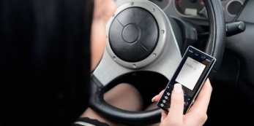
Text-speak may strain your brain: Report
NZ Herald, August 9th, 2012
It takes more brainpower to read "text-speak" than fully written words, research has found. The study, by the University of Canterbury, also concludes that the mental resources required to read abbreviated writing are more likely to mean mistakes in other tasks carried out at the same time.
Forty right-handed students wearing vibrating belts read two messages from a monitor - one in text-speak and the other correctly spelled.
The researchers defined text-speak as techniques used to present meaningful content with less information - such as subsets (txt instead of text), shortcuts (gr8 instead of great), phonetic respellings (cya for see you) and acronyms (ttyl for talk to you later). When the students felt a vibration on their left side, they were to hit the left side of a mouse, and if they sensed a vibration on their right, to tap the right side. The study assessed how quickly and accurately they recorded the vibrations and asked how well they understood the messages.
It found there were more mixed signals and delayed reaction times while the participants were reading text-speak, but no difference in understanding.
Lead researcher PhD student James Head said that could have been because participants were using the context of the message to fill in the gaps. Mr Head was interested in how reading text-speak affected drivers after a friend was nearly killed in a crash because of texting. "Previous researchers [have] shown people drive poorly because they take their eyes off the road ... but no one has ever looked at just processing texts and how it impacts your performance on a task."

