Investigation: McDonalds foods

I want to investigate whether the amount of fat per 100g of food can be used to predict the amount of energy contained in McDonalds foods. How different is the relationship for the different types of foods; dessert, breakfast, salad and dinner?
The energy is measured in kilojoules and is recorded per 100g food
The fat content is measured in grams and is recorded per 100g food.

To be healthy and to have lots of energy your diet must include foods which give you carbohydrates, protein and lipids (fats). There are other important chemicals, however, which your body needs. I know that fat is an energy source in food and that our bodies use stored fat when we are doing physical work. Typical fat in the diet is from butter and oils. Solid lipids are called fats and liquid lipids are called oils. Both types of lipid contain a lot of energy. Many plant seeds contain oils; castor oil, sunflower oil and maize oil are just three examples. Eggs, cheese, meat and milk are animal foods which contain lipids. http://saburchill.com/chapters/chap0018.html

For a typical 17 year old male in NZ the recommended daily intake of fat is about 88g and 12200kJ of energy. For a 17 year old female the recommended daily intake is 77g fat and 9500kJ energy (http://www.consumer.org.nz/reports/rdi-calculator/rdi-calculator )

The data has come from McDonalds website http://mcdonalds.co.nz/sites/mcdonalds.co.nz/files/images/Nutrition-information-NZ-22-Nov-2012.pdf
There are no sauces or drinks included. The data is recorded as per 100 grams of food so that sensible comparisons can be made.

I will produce a scatter plot with the energy content of the food on the vertical axis and the amount of fat on the horizontal axis. I think that the amount of fat would determine the amount of energy in the food. However, I also know that carbohydrates (bread, potatoes, rice etc) also provide energy
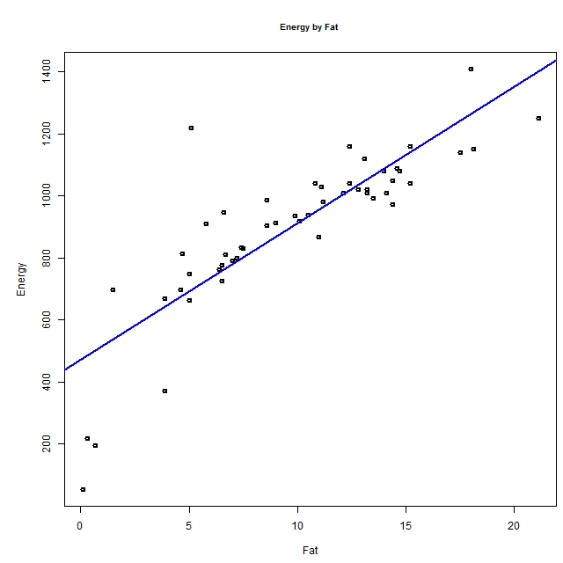

The scatterplot shows that there is positive association between the energy content and fat content of McDonalds foods. Foods with more fat tend to have more energy. I think that the relationship is linear, so I added a linear trend line. This means that the amount of energy is proportional to the amount of fat. That seems sensible as there are nine kilocalories in each gram of fat. http://en.wikipedia.org/wiki/Nutrition . 1 kilocalorie is approximately 4.2 kilojoules. So 9kcal = about 38kJ. This supports the idea that the relationship is a linear one. However, I notice on the graph that for between 5 and 10g of fat, most of the points are above the trend line. However, the linear trend was a better fit visually than the parabola or cubic.
The association is quite strong as most of the points are close to the added trend line. I have drawn a band on the graph that encloses most of the scatter. The band is quite narrow.
The amount of fat per 100g of food ranges from 0.1g to 21.1g with a median value of 9.9g.
The amount of energy per 100g of food ranges from 55kJ to 1410kJ with a median value of 938kJ

The equation of the trend line is:
Energy = 44.08 * Fat + 471.75
Correlation = 0.84

This means that for each extra gram of fat the energy increases by 44kJ. This is slightly more than the generalisation stated above (38kJ).
The correlation coefficient of +0.84 supports the idea that the relationship is quite strong.

I will make a prediction for the amount of energy per 100g of food for a food that has 10g of fat per 100g of food. This value is in the midrange of amounts of fat.
E = 44.8*10 + 471.75
= 919.75kJ.
A food with 10g of fat per 100g of food (10% of the food is fat) would be expected to contain about 920kJ energy. When I consider the scatter and width of the band I have drawn on the graph I expect the food to contain between 800kJ and 1000kJ of energy. This prediction is reasonably precise because the relationship is strong and scatter is small.

There is one point that is unusually far from the trend. It is the point for Toasted Bagel with Jam and whipped Butter, which has an unusual amount of energy (1220kJ) while only having a small amount (5.1g) of fat. I suspect that the jam would contain a lot of sugar and the bagel is made from flour which is a carbohydrate, so I think that the high energy might be explained in terms of the carbohydrate content. I removed that point and redid the analysis.

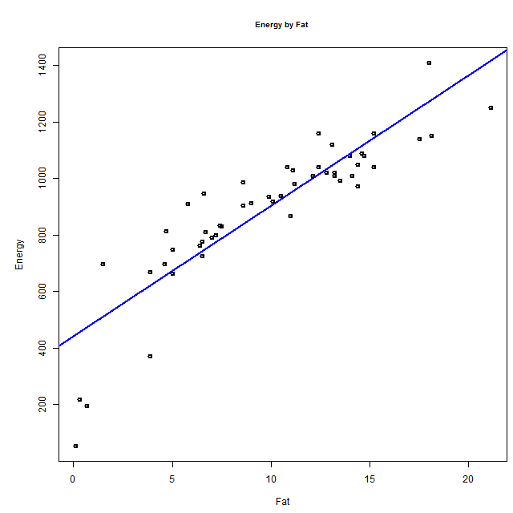

Energy = 46.13 * Fat + 441.91
Correlation = 0.88

Removing the point for the bagel did increase the gradient of the trend and increase the correlation coefficient very slightly. Using this model to make a prediction for the amount of energy in a food that contains 10g fat:
Energy = 46.13 * 10 + 441.91
= 903.21
100g of food with 10g fat would be expected to contain about 903kJ energy. This is not a lot different from my first prediction, although it is slightly lower.

I want to see if the different categories of food appear as groups in the graph so I colour coded the groups.

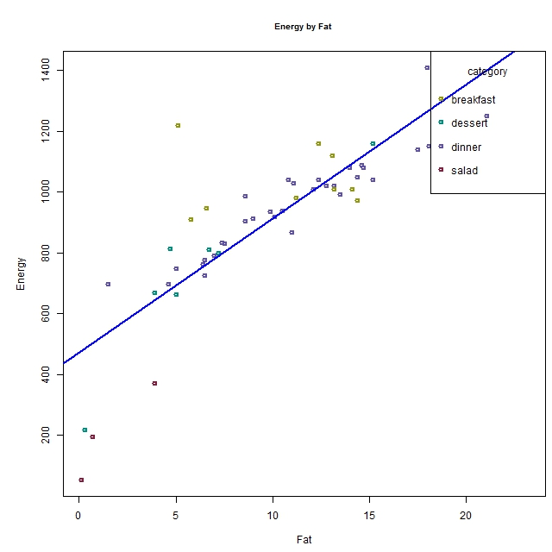

I see that most of the groups overlap but salads stand out as being a group of points away from the trend, having less energy than the amount of fat might predict.
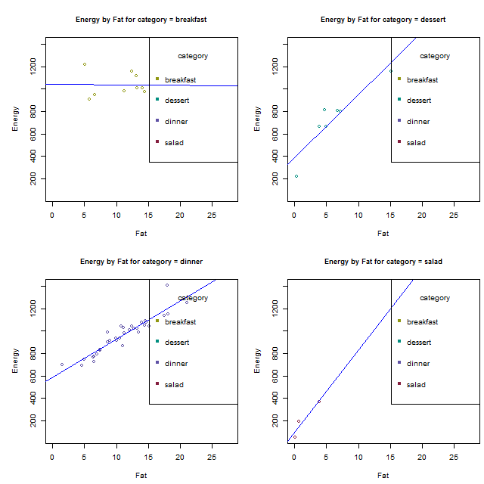

Summary for category = breakfast Summary for category = dessert
Energy = -0.39 * Fat + 1040.94 Energy = 56.31 * Fat + 387.64
Correlation = -0.01 Correlation = 0.92

Summary for category = dinner Summary for category = salad
Energy = 34.24 * Fat + 584.28 Energy = 73.7 * Fat + 91.87
Correlation = 0.93 Correlation = 0.95

When I split the categories of food into different graphs I found that the trend line for salads had the highest gradient of all, 73. However there are only 3 salads in the data set which is not enough data to really look at a relationship.
Desserts had the next highest gradient of about 56 but again there are only 6 data points which is not enough points to be confident about a relationship.
The dinner category had the most data and shows a strong relationship between the amount of energy and amount of fat. The points are distributed about evenly above and below the trend line, so I think a linear model is a good one.
Energy = 34.24 * Fat + 584.28
Correlation = 0.93
This gradient is slightly less than the 38kJ per gram of fat that was given on Wikipedia. Using this trend I would predict that a food with 10g of fat per 100g of food would contain 34.24*10 + 584.28= 927kJ. Looking at the scatter I would think that the amount of energy would be between 800kJ and 900kJ. This prediction is quite close to my previous prediction based on all categories of food, but the precision of the prediction has been improved.
There is one point that is slightly unusual in that it has more energy for the amount of fat than the general trend shown in the plot. This point is (18, 1410kJ) and is for French fries. To see if this point affects the slope of the trend I removed it and redid the analysis. Removing the French Fries from the data set gave me the following scatterplot, which shows a very strong relationship as there is very little scatter..

Summary for category = dinner Energy = 31.59 * Fat + 606.61
Correlation = 0.95
Again there is less energy predicted per gram of fat (about 32kJ) compared to Wikipedia’s assertion of 38kJ. Using this model 10og of food containing 10g of fat would be expected to have about 922kJ energy. Again this prediction does not differ much from the ones above.

The surprising find in these 4 graphs is that for the breakfast food there appears to be no association between the amount of fat and amount of energy. This may be because of the comparative large amount of bread (carbohydrate) in these foods. A further investigation might be to look at the relationship between the amount of carbohydrate and amount of energy to see if this idea has some foundation.

In this analysis the nutrition values are based on average figures and standard product formulation. Actual nutrient values would have some seasonal variation. Also the food produced at each McDonalds outlet would vary because of slight variations in cooking time, temperature of cooking and age of the oil or fat used for cooking.
These findings would apply only to McDonalds foods and not even to other fast foods because the type of oils and fats used might differ and also the method of cooking would be different.

I have found that the amount of fat in McDonalds foods can be used to predict the amount of energy in the food. This relationship is strongest for the foods categorised as dinner foods. In 100g of food the amount of energy is approximately 34 times the amount of fat plus 584 kilojoules.

