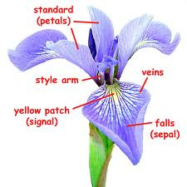
Bivariate Data Computer room Session 3 Groups

- Use the data set Fisher Iris. In the 1930s Dr. Edgar Anderson collected data on 150 iris specimens. This data set was published in 1936 by R. A. Fisher, the well-known British statistician.
Question: What sort of relationship is there between the petal length and petal width for iris flowers?
Explanatory variable is ‘Petal width in mm’. Response variable is ‘Petal length in mm’

1 Draw a scatter plot using the whole data set. Describe what you see. | 7. Colour code the different species of iris on the one graph. Do they form groups of points?
2 State the variables with units.  Does it matter which variable goes on the x-axis? | 8. Draw separate scatter plots for each of the 3 species. What is the effect of splitting the data into the separate species groups? Comment on the strength of the relationship, the steepness of the trend, the value of a prediction
3 Fit a linear regression model.
Write down the equation of this line.
4 Explain the trend in context.

5 Find the correlation coefficient, r. Comment on what it tells you.

6. Make a prediction.

- Use the data set Fisher Iris. ‘Sepal width’. and ‘Sepal length’

Write a purpose statement:

1 Draw a scatter plot using the whole data set. Describe what you see. | 4. Draw separate scatter plots for each of the 3 species. What is the effect of splitting the data into the separate species groups? Comment on the strength of the relationship, the steepness of the trend, the value of a prediction for each type of iris.
2 State the variables with units.

Does it matter which variable goes on the x-axis? Explain what you will do and why.

3. Colour code the different species if iris on the one graph. Do they form groups of points?

