Young professionals and gamers risk thrombosis |Living Local 15/05/2012
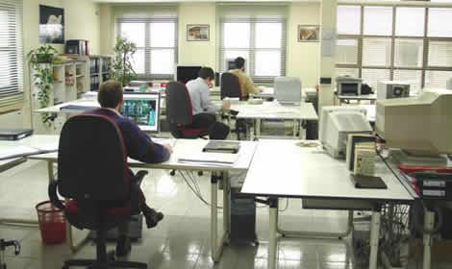
New data just published by The Thrombosis Charity Lifeblood for National Thrombosis Week shows that the ‘recession generation’ of office workers and computer game fans in the UK are more than doubling their risk of developing work and computer related DVT (deep vein thrombosis) due to dangerous levels of immobility at work and play, writes Graham Keal,

We all know that long hours sat immobile on a plane can lead to thrombosis and premature death, but it now appears you can be just as much at risk sitting at your office desk.

The charity says that we need to rediscover some of the ‘cave man’ physically active lifestyle we were evolved to perform if we don’t want to die young.

Studies show that prolonged work and computer-related immobility more than doubles the risk of developing potentially fatal blood clots. After 90 minutes of immobility, the flow of blood to your popliteal vein (behind the knee) drops by 50 per cent. For each hour longer spent seated the risk of developing blood clots increases by 10 per cent. It is estimated that there are over 60,000 cases of potentially fatal blood clots in the UK each year.

An exclusive poll by ComRes of 1000 people, published today, reveals that young professionals (21-30 years old) and video gamers (16-21 years old) are putting themselves at increased risk due to dangerous levels of immobility in the office and at home.

The poll, commissioned by Lifeblood, revealed that young professionals are seated, on average, for up to 3 hours at a time, which more than doubles their risk of developing a blood clot. Periods of immobility are further exacerbated by long working days and too few breaks.

As the UK falls into recession again, it is clear that this ‘recession generation’, some nine million office workers are feeling the pressure to put in extra hours at work, with seemingly little consideration for their health and wellbeing. The results published today clearly show the demise of the ‘9 ‘til 5’ working day, with 68 per cent of respondents working up to 10 hours on a typical day; 3 in 5 working overtime; and 58 per cent working weekends.

Even at times when young office workers should be taking a short break, they choose instead to remain seated – 73 per cent of respondents admitted to taking lunch at their desk, a habit that could double their risk of developing a blood clot. After the working day is done, these excessive periods of immobility are then replicated at home with an incredible 80 per cent revealing that they spend most of their spare time seated as well.

Young gamers at risk

In its research, Lifeblood identified young video gamers as an ‘at-risk’ group due to the long periods of time spent seated in front of games consoles or computers. The survey revealed that a staggering 96 per cent of respondents regularly play computer games for longer than 90 minutes, more than doubling their risk of developing a blood clot. In fact, the poll revealed that on average, a young gamer is seated for 2 hours without taking a break, with some respondents admitting to playing for up to 5 hours at a time.

The compelling and addictive nature of some games was also revealed, with 89 per cent of
respondents admitting to losing track of time whilst playing. Personal comfort needs were also put to one side, with almost half of respondents saying they would put off getting up for a drink, for food and even to use the bathroom.

Professor Beverley Hunt, Medical Director of Lifeblood, said:

“Our research has uncovered a ticking time-bomb with some 9 million office workers and countless young gamers putting themselves at risk of a potentially fatal blood clot. The human body is designed for the ‘caveman’ lifestyle; active, agile and constantly mobile. Instead we have become increasingly sedentary, obstructing the body’s ability to function as it should. It is imperative that we take heed of these early warning signs, and take regular breaks, be it at your desk or in front of a video game.”
http://www.newarknotts.co.uk/young-professionals-and-gamers-risk-thrombosis

Methodology
ComRes interviewed 500 16-21 year old gamers and 500 21-30 year old office workers in Great Britain online between 18th and 25th April 2012. For this survey, gamers are defined as people who say that they that they play at least 10 hours of computer games per week and are aged between 16 and 21 years old, while office workers are defined as people who work for 40 hours or more per week, describing their normal working environment as an office or a desk, and are aged between 21 and 30 years old.

