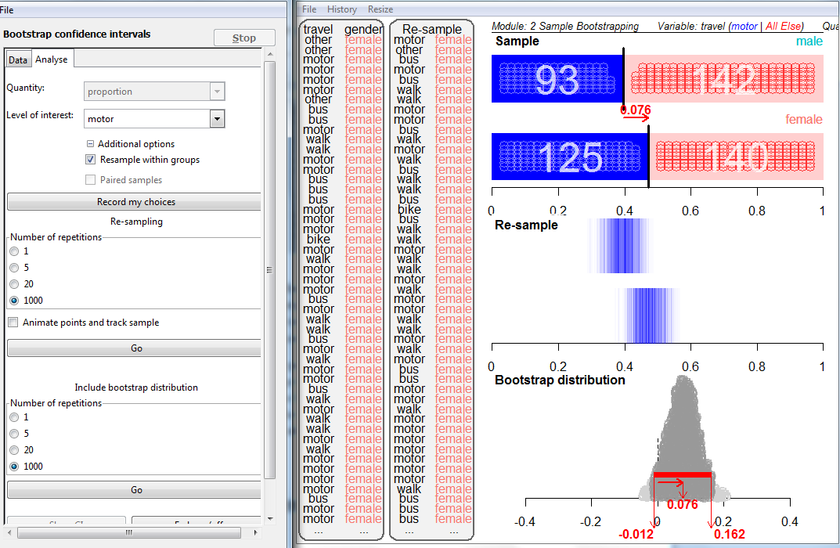

51% of young people agreed that there is too much sex, violence and bad language on TV

|  |
| --- |
| EVALUATION OF STATISTICAL REPORTS |
| Margin of Error and testing claims in the media |
| Dru Rose, Westlake Girls High School under auspices of Department of Statistics, The University of Auckland. |
| This unit is designed to be taught over a one and a half week period. A possible teaching plan is given below and associated resources are provided in the Resource Pack. |
| EVALUATION OF STATISTICAL REPORTS |

Margin of Error and testing claims in the media

UNIT OVERVIEW

|  |  |  |
| --- | --- | --- |
| Lesson | Topic | Description |
| 1 and 2 | Build the concept of margin of error  Test claims involving a single poll% | Concrete activity exploring high variability of a sample proportion  Use computer tool to develop 95% CI and the $\frac{1}{\sqrt{n}}$“rule of thumb”  Calculating and interpreting 95% CIs  and testing claims |
| 3 | Comparison claims within one group | 2 x MoE rule of thumb  95% CIs for a difference within one group *–*testing claims involving this. |
| 4 | Comparison claims involving 2 independent groups | Concrete activity and computer tool leading to 1.5 × Av MoE “rule of thumb” Calculate and interpret 95%CIs  Test claims made in media reports |
| 5 | Political polls | Power-point comparing methodologies  Removal of the un-decided voters  Key-Research Poll Activity |
| 6 | Distinguishing the 3 types of claim. Working with tables. | Flow chart  Safety of buildings activity |
| 7 | Summary Practice Activities | Herald DigiPoll + worksheet  See **new** NZQA exemplar |

# Teaching Notes

• • •

Notes about activity objectives will be made in this panel.

References to resources used such as power-point slides will be referenced in this panel.

**LESSONS ONE and TWO** (Where to break will depend on lesson length)

# Teaching Notes

• • •

Probe current knowledge and thinking.

* Sample proportions may be a new for students

Media use percentages.

* Always convert proportions to %s- in this topic.

Point out higher variability for proportions in 30% to 70% range (bus, walk, motor) and much lower variability for proportions in the 10% and below range (bike, other) and by symmetry for the “90% and over” range.

**Sampling Error Power-point slides 1 to 4**

**ACTIVITY 1:** Read a quick article to provoke the need to understand Margin of Error e.g***.* “Opinion divided on NZ-US exercises”**

*(A write-on sheet for this is in the Resource Pack)*

The reported Margin of Error is 3.6%. Ask students “What do you think this means?” *(a student in the trial thought it was like measurement error in Physics)*

**ACTIVITY 2**:

**A concrete activity to prepare students for the computer visualisation tools.**

**Resource:** Bags of **“KareKare College “** data cards.

Each pairs of students takes a **sample of size 25** (×4 gives%) and finds the sample proportion who travel to school by car (**motor** *on the cards)*

Collect class results-explore the **high variability of** **sample proportions** *(compared to previous work with means and medians)*

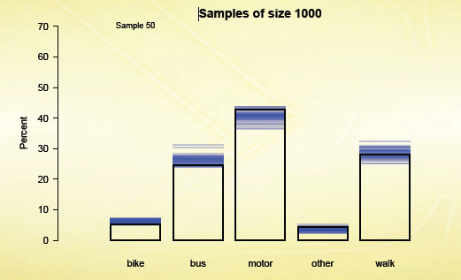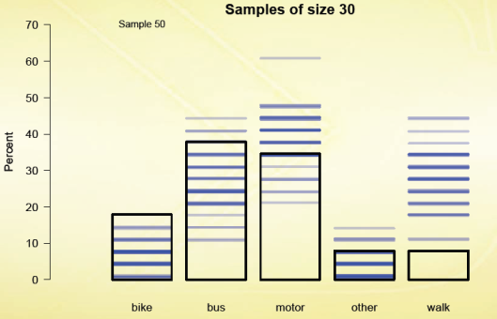

Animation showing a decrease in sampling variability with an increase in sample size for categorical data. (Wild, 2009)

**Show Wild’s animations**. (see Resource Pack)-

**Explain** (or revise) **bootstrapping** (re-sampling from the sample)

# Teaching Notes

• • •

Use of opaque bags for the sample helps reinforce the “looking through rippled glass” metaphor for sampling

**Use iNZight to** develop the concept of Margin of Error as “half the length of a confidence interval”

Ensure students understand that each vertical blue line represents a **re-sample proportion.**

**Use Sampling Error Power-point slides 1-4.**

The students do as many re-samples (**with replacement**) as needed to be able to follow the procedure in the **iNZight bootsrapping module**

**ACTIVITY 3**:

**“Developing the concept of a 95% CI and the Margin of Error”**

Now use the iNZight bootstrapping module to repeat the re-sampling process:

Import the **25 KareKare cards data from the Resource Pack** into the bootstrapping module.(You can store this file in the data folder on your copy of iNZight).

* Drag the “**Travel**” heading into the variable box.
* Select “**Analyse data**”.
* Select “motor” as the variable of interest.
* Select “**record my choices**”

Run the re-sampling at least **once with the “animations” on**, using the **pause** to show students how that the same card can be selected several times in the ‘with replacement’ sampling procedure.

Turn the **animations off**, and run **20** re-samples, pointing out the horizontal blue band showing the **variability in** **the sample proportions.**

Repeat with **1000** re-samples –point out the long width of the band of re-sample proportions, reinforcing the high variability of categorical data.

Move on to the “**bootstrap distribution**” area at the bottom- Do **one** first-pointing out the sample proportion dropping down to make a circle on the scale at the bottom of the screen.

Then **20**- pointing out the shape, with the extremes occurring less often-then **1000,** with the extremes corresponding to the very faint lines in the variability band of blue lines, as they occur only rarely.

**Ask students to** **state an interval describing where most re-sample proportions fall.**

# Teaching Notes

• • •

**Stress** that a **confidence interval** is a **line on a scale** (*not the rectangle or the mound shape).*

You may choose to use the **Fade** facility but this only works if you have not re-sized any windows and it still leaves the rectangle showing above the line..

.

Develop the idea that a 95% confidence interval “captures the true proportion in the population” 95% of the time .

Then **add the confidence interval (**where 95% of the re-sample proportions fall)**-**Explain that the **Margin of Error is half this interval**; about 20% with this small sample of size 25.

A bootstrap confidence interval for proportions in the iNZight module

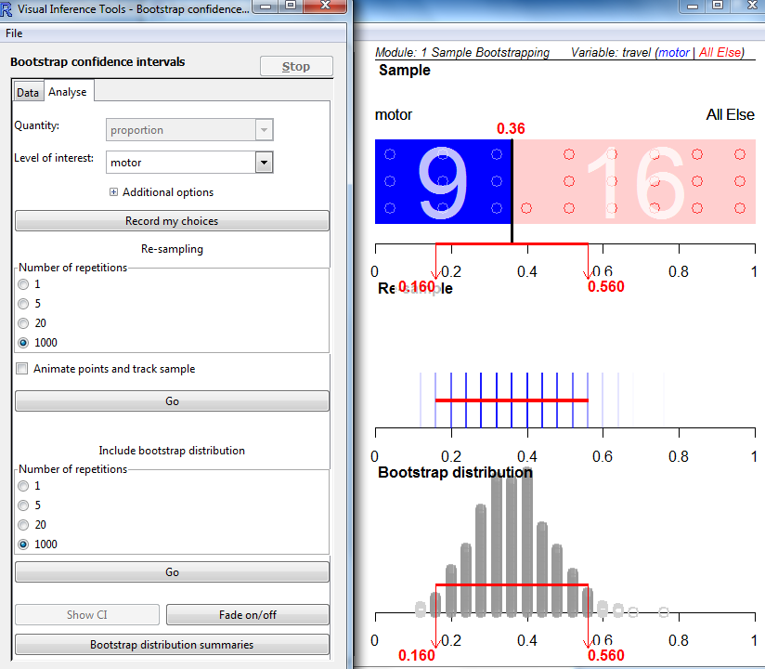

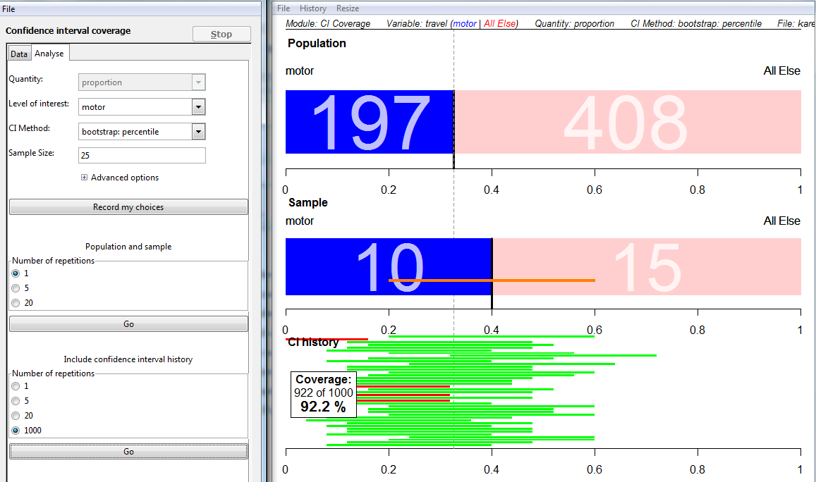**ACTIVITY 4: “Developing the concept of 95% confidence”**

**Use the “Coverage Module” in iNZight:** Import the whole population of KareKare College data.

# Teaching Notes

• • •

.

4 × sample size halves the width of the CIs and hence halves the margin of error.

Not all media reports quote a margin of error.

The rule of thumb estimates the margin of error for **a poll percentage in the 30% to 70% range** at a 95% confidence level

Poll %s outside this range will have a smaller margin of error (see Wild’s animation).

Initially use a sample of size 25.

**One** repeat, then **20**, then **1000**.

Ask students to raise their hand when they see a red line-it will help reinforce the idea that a confidence interval can miss the true parameter, but not often.

**Note:** The iNZight module may not show exactly 95% coverage. *Both the population and sample are very small in this simulation.*

**ACTIVITY 5**

**Developing the $\frac{1}{\sqrt{n}}$“rule of thumb”** for estimating a margin of error.

Repeat the coverage module with a sample size of n=100

Margin of error halves to 10%.

**Return to the bootstrapping module:**

**Import the n=500 censusatschool sample** (the variable of interest is still “travel” and motor). Obtain the confidence interval from 1000 re-samples. The CI has a length of 9% and so the margin of error is 4.5%

Hence demonstrate:

$\frac{1}{√25}$ =0.2=20%, $\frac{1}{√100}$ =0.1=10%, $\frac{1}{√500}$ =0.045=4.5%

and hence the $\frac{1}{\sqrt{n}}$ **“rule of thumb”** for estimating a margin of error.

Return to the media article ***.* “Opinion divided on NZ-US exercises”.** Verify that $\frac{1}{\sqrt{750}}$ = 3.65% is a good estimate of the reported margin of error. (note: you can now also see that the 850 below the graphic is an error).

**ACTIVITY 6**

# Teaching Notes

• • •

**Answers** **are also on “Sampling error power-point” slide 5**

**Note:** MoE from large sample normal approximation:

$$1.96×\sqrt{\frac{\hat{p}(1-\hat{p})}{n}}$$

Note the change in the way we are now interpreting a 95% confidence interval.

Drawing a diagram seems to help students with both the calculation and interpreting the meaning of a confidence interval.

**“Calculating and interpreting a 95% confidence interval for a proportion “**

Return to the media article ***.* “Opinion divided on NZ-US exercises”** and **the write-on template. Complete Q2:**

**2.Margin of Error:**

**For poll %s of about 50% *(between 30% and 70%)* ,**

**margin of error ≈ $\frac{1}{\sqrt{n}}$** at a …***95%*……** confidence level

For poll %s **below 30%** and **above70%**, the margin of error is ……***smaller***………..

95% of the time, the 95% confidence interval *…****captures****…*the true percentage in the population.

**Students should draw the confidence interval picture:**

48%

44 %

39%

We can say, with 95% confidence, that the % of NZ children who travel to school by car is **somewhere between ……*39%*…….and……48%………...**

**Note:** Bootstrap confidence intervals are not necessarily symmetric.

However, when doing “rule of thumb” calculations to test claims, we will use symmetric confidence intervals: poll% ± margin of error

The margin of error can be abbreviated by MoE in calculation working.

Encourage use of both a diagram and the square bracket notation:

[39%, 48%]

**ACTIVITY 7**

# Teaching Notes

• • •

**“Sampling error power-point” slide 6”**

AS3.12 is a Statistical Literacy standard (*not formal inference).*

Being able to interpret the meaning of a confidence interval in context is therefore essential.

.

**Now complete Q3 on the write-on sheet, testing the claim in the NZ-US article:**

**“Opinion is fairly divided”**

*Margin of error*: *(a) rule of thumb= $\frac{1}{\sqrt{750}}$*  = 3.65% *(b) reported MoE =3.6%*

*Sample % who support resumption of exercises =47.6%*

*95% confidence interval:*  (**Draw a diagram)**

51.2.%

47.6 %

44%

*Meaning:* With 95% confidence we can infer that the percentage of New Zealanders who support the resumption of military exercises with the USA is somewhere between 44% and 51.2%

*Judgement :* Support could be as low as 43.9%, and so this confidence interval does not support a claim of 50% support as implied by the “fairly divided” statement in the article.

**The Resource Pack contains a practice worksheet on calculating and using 95% confidence intervals to test claims made in other media reports.**

**LESSON THREE:**

Introducing Comparison Claims within one group

**Starter ACTIVITY:** Revision and consolidation of work to date

**Resources: Broadcasting Standards Poll report** (Curia Research) and *Worksheet 1* for this report. **(See Resource Pack** –answers supplied**).**

Ask students to complete Q1 and Q2 and go over with class.

**LESSON THREE:**  **ACTIVITY 2**: Comparison within one group

# Teaching Notes

• • •

The group may be the whole target population (as in this poll) or a sub-group of it (see lesson 6)

In a political poll: a claim that National has a lead over Labour would be in this category.

Use Sampling Error power-point **slide 8**

Note unit is **“percentage points”** in confidence intervals involving **differences** *(to ensure a distinction from %change involving a division as in % loss)*

**Note:** MoE from large sample normal approximation

$$1.96×\sqrt{\frac{{\hat{p}}_{1}+{\hat{p}}_{2}-{({\hat{p}}_{1}-{\hat{p}}_{2})}^{2}}{n}}$$

**Develop the 2×MoE rule of thumb.**

**Still using the Broadcasting standards poll*,* state the claim:**

“Young people are **more likely to agree than disagree** that there is too much sex, violence and bad language on TV”

This claim involves two response options within the same poll.

*In the absence of suitable software, we have to use a logical argument to develop the rule of thumb, but there is a tool to demonstrate that it works***.**

Consider a situation with only 2 response options: Agree and Disagree *(ie. ignore the “don’t know/refuse “option)*

**Suppose a poll produces the result exactly 50% agree and 50% disagree** *(hence a claim that this is the situation in the population)*

**Suppose this poll has a margin of error of 4%.**

**If we repeat the poll, we could get new sample results varying anywhere in the range 46% agree up to 54% agree (***meaning the % who disagree would also vary between 54% down to 46%).*

*The* **difference** *between the new sample* **poll% who agree and % who disagree** *would be* **8 percentage points** *but this would still be consistent with a* **50-50 situation in the population.**

*We therefore need to obtain* **a poll % difference of more than 8 percentage points** *to disprove the claim that the population is evenly divided between agree and disagree.*

*Hence we need* **a poll% difference of more than 2×the margin of error** *to support a claim**that more people are likely to agree than disagree (or support one response option over another).*

Now complete “Broadcasting Standards Poll worksheet 1” Question 3. ***Note the wording of the interpretation of the 95% CI for this difference (see slide 8):***

**[-1.2** perc. pts**, 15.2** perc. pts**]**

# Teaching Notes

• • •

Use Sampling Error power-point slides 9 and10

The **negative** lower limit implies that more young people may disagree than agree, **the reverse of the stated claim.**

Note the use of **“and”** rather than or, since both options are possible

Choose the one sample, 2 percentages option in the middle of the spreadsheet.

Enter the 51% agree and 44% disagree from the Broadcasting Standards Poll, the reported margin of error 4.1% and select the 2x Poll Error Method.

*You will need to drag columns T and X to the left so that* ***in/out*** *and* ***CIs*** *show on the data projector screen.*

“With 95% confidence, we can infer that more young people may disagree than agree by up to 1.2 perc.pts **and** more young people may agree than disagree by up to 15.2 perc. pts”

OR: “It is a fairly safe bet that the percentage of young people who agree is somewhere between 1.2 percentage points **lower** and 15.2 percentage points **higher** than the percentage of young people who disagree.”

Now **use the Coverage Spreadsheet** to demonstrate that this **2×MoE** rule of thumb does **capture the true % difference back in the population, about 95% of the time:**

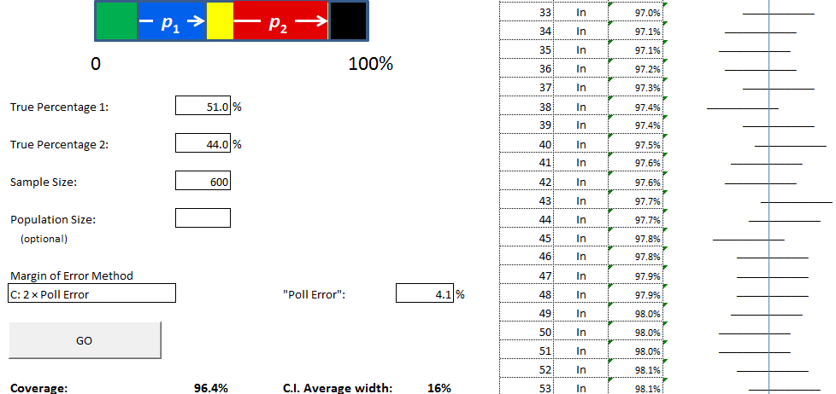

You can scroll down to show more of the confidence intervals if you wish. However, there is no slow speed option as in the iNZight coverage module. (*This spreadsheet was developed to accommodate the need for a large sample size taken from a large population when looking at claims involving poll %s.)*

**LESSON FOUR**

# Teaching Notes

• • •

It is important that the students do one pair of re-samples( female, male) at a time and note the %**difference** each time.

Comparison claims between two independent groups.

**Developing the 1.5×Average Margin of Error rule of thumb**

**ACTIVITY 1:** A concrete activity to explain bootstrapping within two separate groups. **Is the % girls who travel to school by car more than the % of boys?**

**Resource:** Bags of **“KareKare College“** data cards.

Each pair of students takes out a handful of cards (around 50 altogether) and sorts them into **males** and **females. They count the number in each group** (stress that the sample sizes do NOT have to be the same) and put each group in a separate bag.

They note the **percentage travelling by car (motor) for each group** and then record the **difference (**female % - male%).

They then **re-sample with replacement within each separate group,** noting the **difference in re-sample %s (**female % - male%).

**ACTIVITY 2** Using the iNZight bootstrap module:

Import the censusatschool sample of **size 500. (see Lesson 2)**

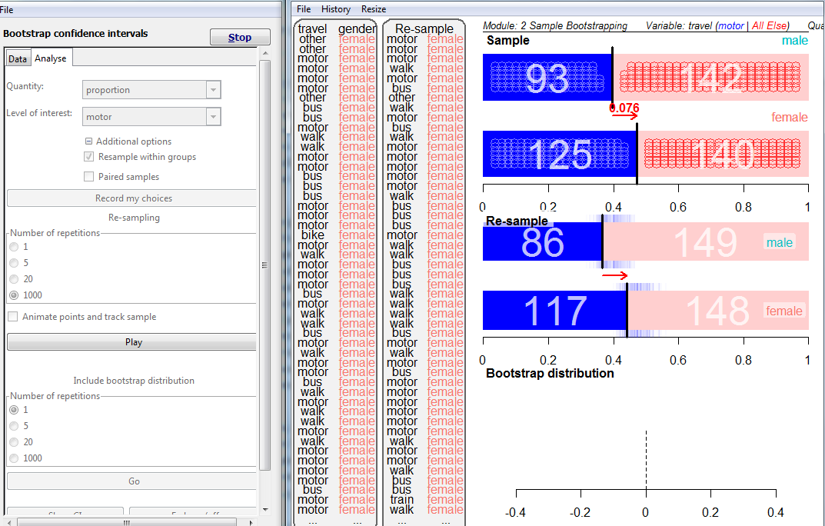

Re-sampling within groups in the iNZight module for confidence intervals for differences in proportions

This time drag **“travel”** and then **“gender”** into the variable boxes.

# Teaching Notes

• • •

Remember to convert the proportions to % and encourage the students to use %s in their discussions.

Sampling Error power-point **slides 11 and 12** have the question, confidence interval and interpretation.

Select **analyse data**. The variable of interest is **motor**. Now **click the** **+** button for additional options and select the **re-sample within groups** option. Then **record my choices.**

The red arrow shows that **in the sample,** **7.6% more females** travel to school by car than males.

Do **20** re-samples. Explain to students that the blue lines are the sample proportions **in each of the two separate samples,** with each band of blue lines showing the sampling variability within each group. The red arrow shows the difference (%female-%male) for each repeat of the re-sampling procedure. **Ask students what they think has happened when the arrow flips the other way.** Then do **1000 re-samples,** asking the students to raise their hand when they see the arrow flip *(This occurs only occasionally since in general samples have a higher % of females)*.

Now add the bootstrap distribution. **1 repeat** shows the red arrow for the **difference** dropping down onto the scale at the bottom. Do **20** repeats and point out the **negative** differences on the scale for when there was a higher % of males travelling by car. Then **1000** and add the confidence interval.

“With 95% confidence, I can infer that the percentage of females who travel by car could be up to **1.2 percentage points less** than the percentage of males who travel by car **and** up to **16.2 percentage points more.**” OR: “It is a fairly safe bet that the percentage of females who travel by car is somewhere between 1.2 percentage points **lower** and 16.2 percentage points **higher** than the percentage of males who travel by car.”

**Developing the Rule of Thumb:**

# Teaching Notes

• • •

Sampling Error power-point

**slide 10**

**Note:**

MoE from large sample normal approximation

$$1.96×\sqrt{\frac{{\hat{p}}_{1}(1-{\hat{p}}_{1})}{n_{1}}+\frac{{\hat{p}}_{2}(1-{\hat{p}}_{2})}{n_{2}}}$$

Choose the 2 independent samples option *(the third choice)*

***Enter the true %s for these populations as follows:***

True% females=38.7%

True% males = 34.2%

Enter sample sizes:

Females: n=265

Males: n=235

***For Margin of Error Method choose:***

1.5 × ( $\frac{1}{\sqrt{n1}}$ + $\frac{1}{\sqrt{n2}}$)/2 ×100%

(*Do* ***not*** *choose 1.5×Average Poll error since the exact poll errors are unknown here)*

MoE for difference = 8.5% (half the bootstrap CI)

MoE Males = $\frac{1}{\sqrt{235}}$ =6.5% MoE Females = $\frac{1}{\sqrt{265}}=$ 6.1%

Average MoE = ($\frac{6.5+6.1 }{2}$) = 6.3%

**8.5% is between 1× Av MoE and 2× Av MoE** *(previous ideas)*

**So try: 1.5 x Av MoE = 1.5 x 6.3 =9%** *(a good approximation to the 8.5% obtained by bootstrapping)*

**We can show that this rule of thumb works about 95% of the time:**

**Use the coverage spread-sheet:**

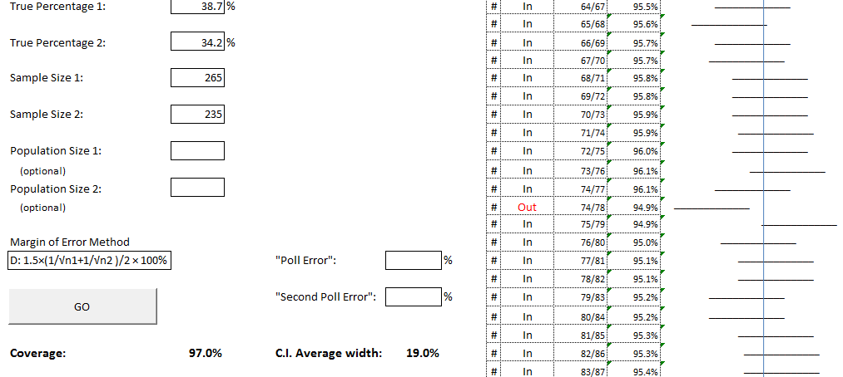

The spreadsheet shows that this rule of thumb produces a CI which captures the true **difference in population %s** slightly more than 95% of the time.

**ACTIVITY 3**  **Broadcasting Standards Poll Worksheet 2 Can it be claimed that young women were more likely to agree than young men ? :-**Sampling Error power-point **Slide 14.** (Note: Both limits positive, so claim is supported)

**LESSON FIVE: Political Polls**

# Teaching Notes

• • •

**Slides 10 and 11 in the Political Polls power-point explain the “decided voters only” issue.**

**\*Key Research Poll**

**Page 4:**

**Students should use the “Valid%” columns for claims 1 and 2 on the worksheet with sample sizes n= 794 in 2011 and n= 589 in 2012,***removing the undecided voters.*

**ACTIVITY 1** Show the **power-point presentation on Political Polls**. (see Sampling Error Resource Pack)

Most political polls **asking about the party vote** in New Zealand are for the “Decided Voters only”. Those people who are unsure or refuse to answer are usually removed before the analysis is done.

However, Horizon Research uses a very different methodology. They include voters potentially leaning towards a particular party and only take out those refusing to answer or who cannot or will not vote. They give their poll a different name: ”**A Net Potential Vote Poll”**

(Horizon have put forward an argument in defense of their different methodology: see the Microsoft Word document entitled **“Comparing Polls”** in the **Non-Sampling Error Resource Pack**.)

**ACTIVITY 2 Using the 1.5 x Av MoE rule of thumb to compare two separate political “party Vote” polls (2011 v 2012)**

**Resources: (in Sampling Error Workshop Resource Pack)**

1. Herald on Sunday **Key Research Poll** **Pages 2, 4* and 13**
2. **Political Polls Worksheet 1** (Answers in resource pack)

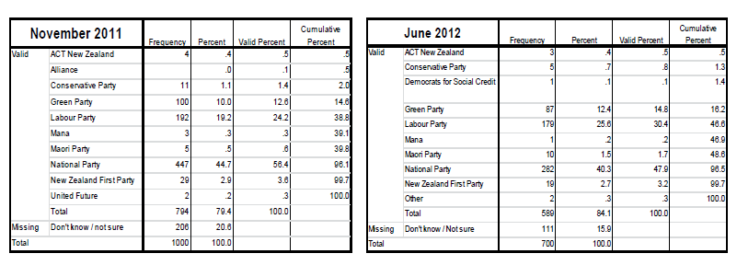(Note: The complete poll is provided in the resource pack)

Removing the un-decided voters is only necessary in **“party vote”** questions

# Teaching Notes

• • •

**Note**: The “valid%” column is not provided for the “gender” table (June 2012 poll, Page 13)

Students use the poll sample size n=700 for testing claim 3

Additional report added to resource pack: Mondayising Waitangi Day and Anzac Day

.

You may need to spend time helping students to recognize key phrases implying a comparison claim.

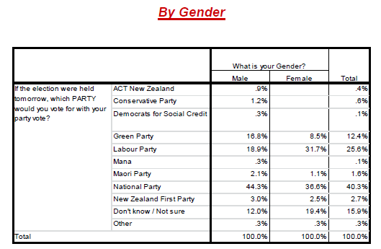

**LESSON SIX: Distinguishing the Three Types of Claim**

**Resources:**

1. Testing Claims Flow Chart
2. “Are our buildings safe to occupy?” Worksheet
3. Research NZ “Are our buildings safe to occupy?” report: Page 1with Table A + Tables 1-9 (pages 3,4,5 in full report)

Activity 1:

Students should initially focus on the statements in the **Claim Column** and use the procedural flow chart to help them to classify each statement as either a **“no-comparison**” claim, a claim **“involving a difference within the same group”** or a claim **”involving a difference between 2 independent groups”.**

Students in the trial had the greatest difficulty recognising a comparison within the same group claim, eg.”…**more confident than not confident…”,** confusing it with a “no-comparison” claim.

Check students have correctly classified each type of claim before they proceed with the rest of the sheet (see Answers in resource pack).

Activity 2

Students should now complete the rest of the “are our buildings safe to occupy” worksheet. This involves extracting the required information from the appropriate table, recognizing the group(s) involved.

# Teaching Notes

• • •

.

Nov 2102 Colmar Brunton Poll report is in resource pack. (Qs on Party vote , asset sales, NZrepublic, trust in govt depts.)

Additional resources may be added to resource pack in 2013.

Note: Categories **“confident and “very confident”** are **combined** and similarly “**not confident” and “not at all confident”**

Encourage students to **draw** each confidence interval in addition to stating the interval in [,] notation **and interpret it in words.**

**LESSON SEVEN:** Practice Summary Activities

**ACTIVITY 1:**

**Resource:**

1. **Herald Digipoll and graphics :”Labour makes big leap in polls”**
2. **Political Polls Worksheet 2**

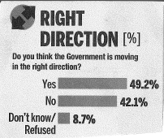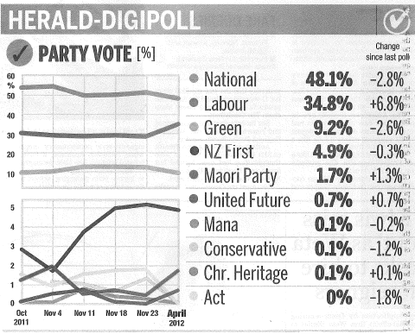

This is a scaffolded activity covering both non-sampling errors; and margin of error and testing claims.

Students should try and do it **without** using a “worry” questions sheet or the flow chart for helping to distinguish types of claims.

(Answers in resource pack)

**ACTIVITY 2:** You could use the Nov 2012 Colmar Brunton report to make your own similar activity.