ACHIEVEMENT STANDARD 3.8 TIME SERIES
SUGGESTED STUDENT RESPONSES TO POLAR ICE EXEMPLAR USING iNZight
Revised Task
Carry out a statistical investigation to determine patterns in the amount of sea ice in the polar regions and use your analysis to make predictions. Write a report describing your investigation.
Use the following steps to conduct your investigation and write your report.
- Select at least one of the variables (area of sea ice in Arctic or Antarctic) to investigate.
- Display data appropriately.
- Identify features of time series and relate this to context.
- Select an appropriate model for prediction purposes.
- Use the model to make predictions. Describe at least one prediction value in context.
- Write a conclusion. Support your conclusion by referring to your analysis and/or features of the visual display(s). Include a reflection on your process, which could consider –
-other relevant variables
-adequacy of model
-validity/accuracy of forecasts
-comparison/investigation of more than one series
-comparison/investigation of a transformed series
- in-depth understanding of the data context
In writing your report, link your discussion to the context and support the statements you make by referring to statistical evidence.
Achieved Response
At this level students would be expected to investigate only ONE series. Please note units are not included on iNZight plots but students could be encouraged to add them by hand if necessary. For the purposes of this exemplar the area of Arctic Ice has been selected.
iNZight outputs required -
- Decomposition of Arctic Sea Ice – Trend, Seasonal & Residuals
- Seasonal plot and estimated seasonal effects
- Raw data plus predictions plus prediction intervals
Teaching note – these can all be inserted as screen shots into a Word document.

ARCTIC SEA ICE OUTPUTS FROM iNZight

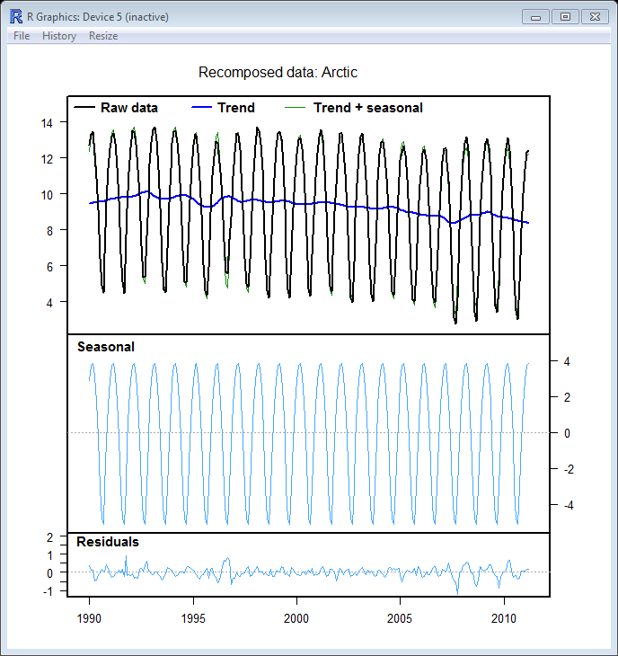

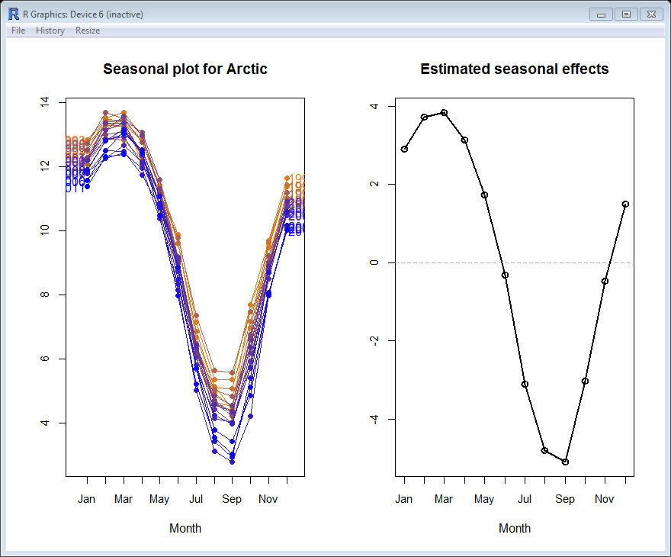
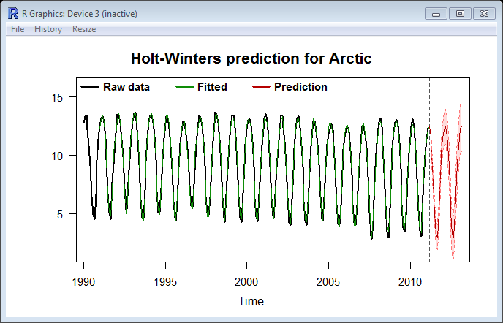

Achieved Comments
Long term trend – The area of Arctic Sea Ice shows a very gradual decline over the period January 1990 to March 2011. The trend level has fallen from around 9.5 million km² in the early nineties to around 8.5 million km² since 2008. This represents a fall of 1 million km²of sea ice or just under 4000 million km²per month.
Seasonal effects – the seasonal pattern of the area of Arctic Sea ice is very consistent. Peak months are usually February/March and trough months are usually August/September. Peaks are around 3.5 million km² above the trend and troughs are around 5 million km² below the trend. These peaks and troughs correspond with the Northern hemisphere’s summer and winter months.
Residuals – Residuals are small and the majority fall in the range of plus/minus 0.5 million km² sea ice. There is one residual of over 1 million km² sea ice which is in September 2007 which is still small when compared with the range of the data. The range of the raw data is around 11 million km² ( Max – Min = 14 - 3) so this residual represents less than 10% of this range. (Teaching note – any residual less than 10% of overall range is not considered to be of note)
Component contribution to series variation
(Ball-park figures only, taken from iNZight plots )
Arctic Sea Ice  (Million km²) | Min | Max | Range | Approx. % Contribution
Raw data | 3 | 14 | 11
Trend | 9 | 10 | 1
Seasonal | -5 | 4 | 9 | 82%
Residual | -1 | 1 | 2

The main source of variation in the area of Arctic Sea Ice is the seasonal component.
Around 82% of the overall variation in this series can be accounted for by the seasonal component. Trend and residual components account for the remaining variation in the series.
Predictions
I have produced predictions for the next twelve months and these are given below together with their prediction interval.
Teaching note – two years of predictions will be automatically provided but with monthly data sufficient to show next twelve months only.

Month | Lower limit | Prediction | Upper limit
April 2011 | 11.059 | 11.645 | 12.230
May 2011 | 9.298 | 10.008 | 10.718
June 2011 | 6.951 | 7.768 | 8.584
July 2011 | 4.073 | 4.985 | 5.897
August 2011 | 2.248 | 3.247 | 4.247
Sept. 2011 | 1.894 | 2.974 | 4.054
October 2011 | 3.886 | 5.043 | 6.199
Nov. 2011 | 6.933 | 8.161 | 9.390
Dec. 2011 | 8.835 | 10.132 | 11.430
January 2012 | 10.098 | 11.462 | 12.826
February 2012 | 10.842 | 12.269 | 13.696
March 2012 | 10.935 | 12.424 | 13.913

After a visual inspection of the plot I am confident that the model provides a good fit as differences between the fitted data and the raw data are non-existent or very small.
I predict that the area of Arctic Sea Ice in February 2012 will be between 10.8 million km² and 13.7 million km².

MERIT EXEMPLAR
At Merit level students are expected to repeat the above analysis for a second series and then to compare analyses from the two series.
Antarctic Sea Ice – INZight outputs
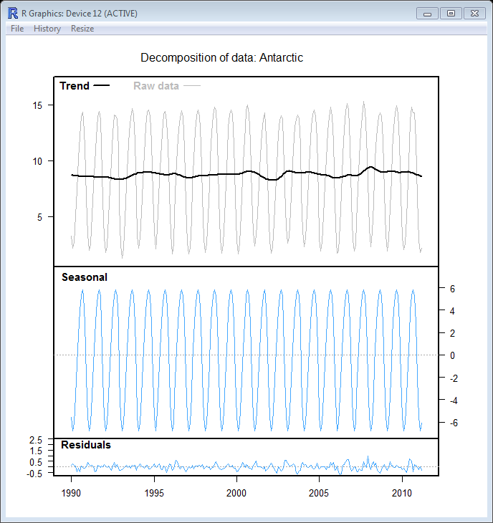

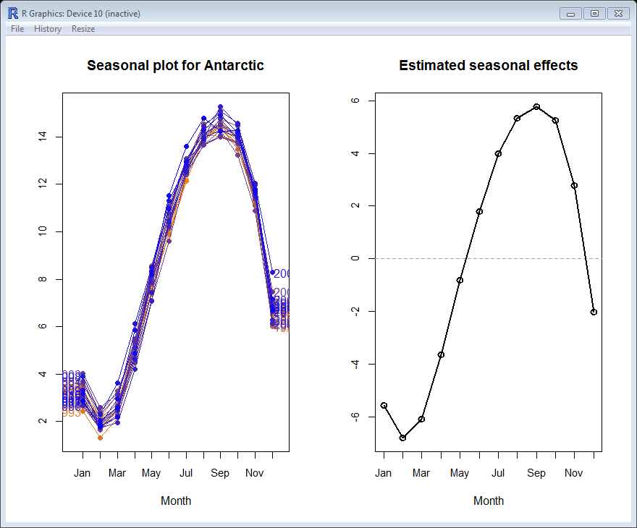
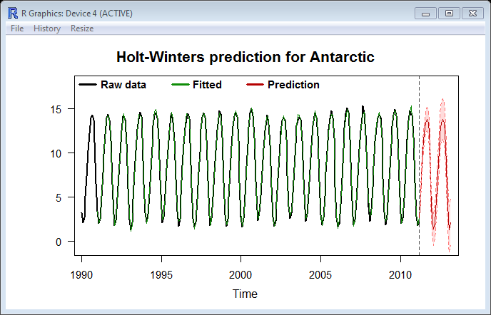
Long Term Trend – The area of Antarctic sea ice is relatively constant during the period January 1990 to March 2011. The level has remained around 8.5 million km² throughout this time period.
Seasonal effects – the seasonal pattern of the area of Antarctic sea ice is very consistent. Peak months are usually August, September and October. Peaks are around 5.5 million km² above the trend. Trough months are usually January, February and March when the area of sea ice is around 6.5 million km² below the trend.
Residuals – residual values are all very small and fall within the range of plus/minus 0.5 million km². The magnitude of these residuals when compared with the overall range of the data is less than 4% which is very small. I can conclude from this that there are no unusual observations.
Component contribution to series variation
Area of Antarctic Sea Ice
Antarctic Sea Ice  ( Million km²) | Min | Max | Range | Approx. % Contribution
Raw data | 1 | 15 | 14
Trend | 8.5 | 8.5 | 0
Seasonal | -6.5 | 6 | 12.5 | 89%
Residual | -0.5 | 0.5 | 1

The main source of variation in the area of Antarctic Sea Ice is the seasonal component.
Around 89% of the overall variation in this series can be accounted for by the seasonal component. Trend and residual components account for the remaining variation in the series.

Predictions – I have produced predictions for the next twelve months and these are given below together with their prediction intervals.
Month | Lower limit | Prediction | Upper limit
April 2011 | 4.086 | 4.712 | 5.338
May 2011 | 6.703 | 7.521 | 8.341
June 2011 | 9.357 | 10.331 | 11.306
July 2011 | 11.124 | 12.232 | 13.341
August 2011 | 12.197 | 13.425 | 14.654
Sept. 2011 | 12.473 | 13.810 | 15.147
October 2011 | 11.979 | 13.416 | 14.854
Nov. 2011 | 9.358 | 10.890 | 12.421
Dec. 2011 | 4.488 | 6.109 | 7.729
January 2012 | 0.746 | 2.450 | 4.155
February 2012 | -0.409 | 1.375 | 3.156
March 2012 | 0.305 | 2.166 | 4.027

Conclusion
After a visual inspection of the plot showing predictions I am confident that the model provides a good fit as differences between the fitted data and the raw data are non-existent or very small.
I predict that the area of Antarctic Sea Ice in December 2011 will be between 4.5 million km² and 7.7 million km². It is interesting to note that the lower limit for the area of Antarctic Sea Ice is negative for the first time in February 2012. Obviously a negative area is impossible but it does signal the possibility of no sea ice in the region at this time which may have consequences for the region’s wildlife.
Comparison between areas of Arctic and Antarctic Sea Ice
It is interesting to note that these two areas of sea ice have different long term trends. The area of Antarctic Sea Ice has remained relatively stable between 1990 and 2010 but the area of Arctic Sea Ice has gradually declined over the same time period. The rate of decrease has been an average of 4000 million km² per month.
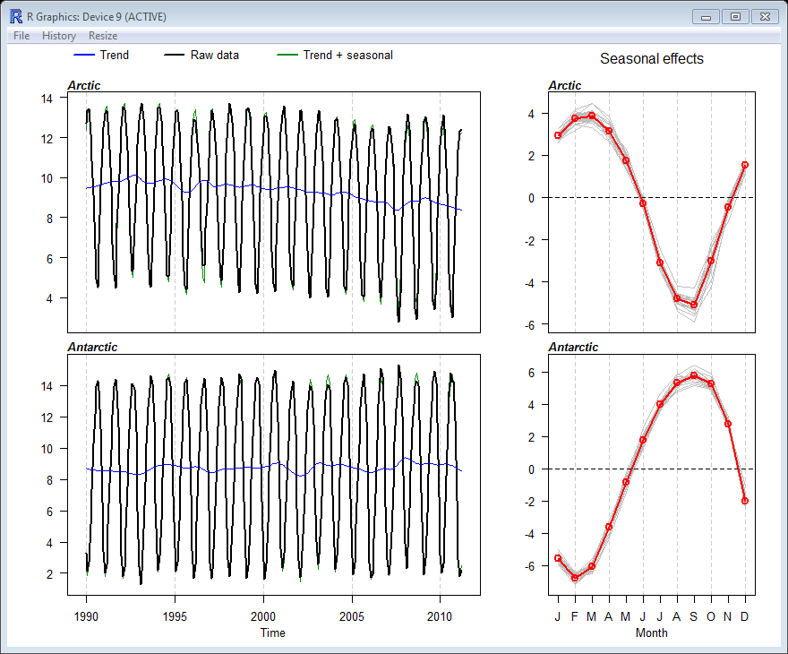
Both areas of Sea Ice have very consistent seasonal patterns which have remained largely unchanged between 1990 and 2010. However, these patterns are very different from each other. The area of Antarctic Sea Ice peaks usually between August and October but the area of Arctic Ice peaks around February or March. Similarly the troughs in area of Antarctic sea ice are usually between January and March but the troughs in the area of Arctic Sea Ice are around August or September. This observed difference reflects the different seasonal patterns of the Southern and Northern hemispheres.
The range of the seasonal effects also varies. The Arctic seasonal effects vary from 5 million km² below trend to 4 million km² above trend, or a range of 9 million km². In comparison the Antarctic seasonal effects vary from 7 million km² below trend to 6 million km² above trend or a range of 13 million km².

EXCELLENCE EXEMPLAR
( For Excellence students are expected to create a new variable from the ones originally provided. This might be a difference between two series, the sum of two series or a ratio of two series. Other transformations such as log transformations are NOT expected)
I have created a new series – TOTAL ICE – this is the sum of the Arctic and Antarctic areas of sea ice.
Total Polar Ice iNZight outputs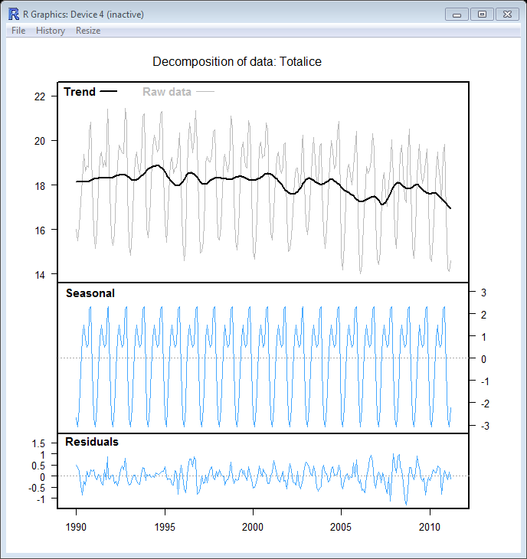

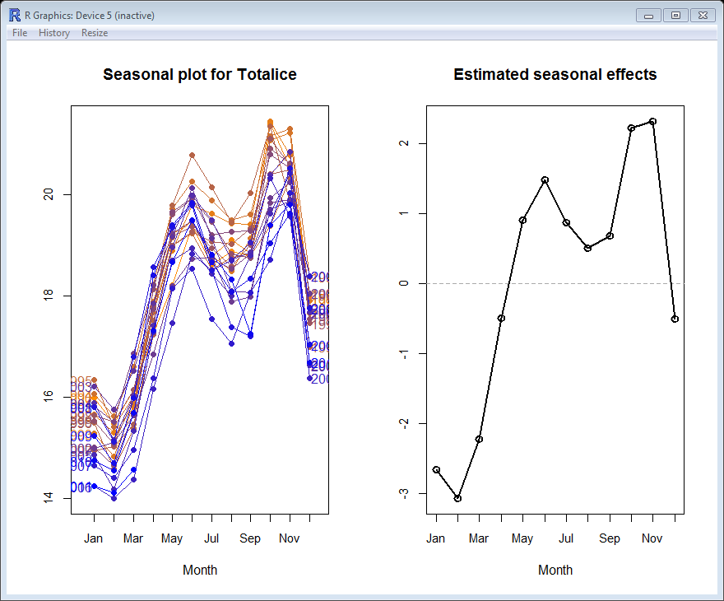
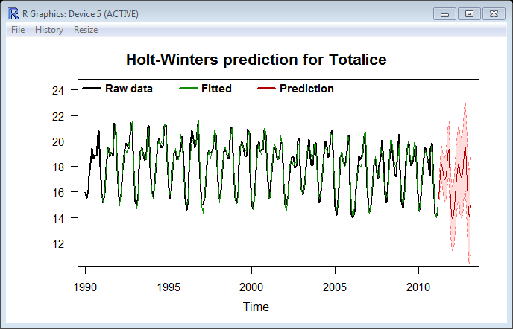
Long term trend
The long term trend is not as smooth as that of Arctic sea ice. Overall the long term trend is still declining, from just over 18 million km² in 1990s to just under 17 million km² by early 2011, a fall of just under 5000 million km² per month. The overall trend, not surprisingly, is dominated by the reduction in Arctic Sea Ice area as the long term level for Antarctic Sea Ice remained roughly constant.
Seasonal Effects
Seasonal effects for Antarctic sea ice were extremely consistent as indicated by the overlapping lines on the seasonal plot for Antarctic Sea Ice. The seasonal pattern for Arctic data had slightly more variability but still demonstrated a consistent seasonal pattern. However, when the seasonal pattern for Total Polar Ice is examined the picture is not so clear. This series peaks usually in the months of October or November and troughs in January or February. This pattern of peaks and troughs is therefore dominated by the Antarctic Sea Ice seasonal pattern or that of the Southern hemisphere. However, there is a secondary or minor trough in August which corresponds to the Arctic Sea Ice seasonal pattern. 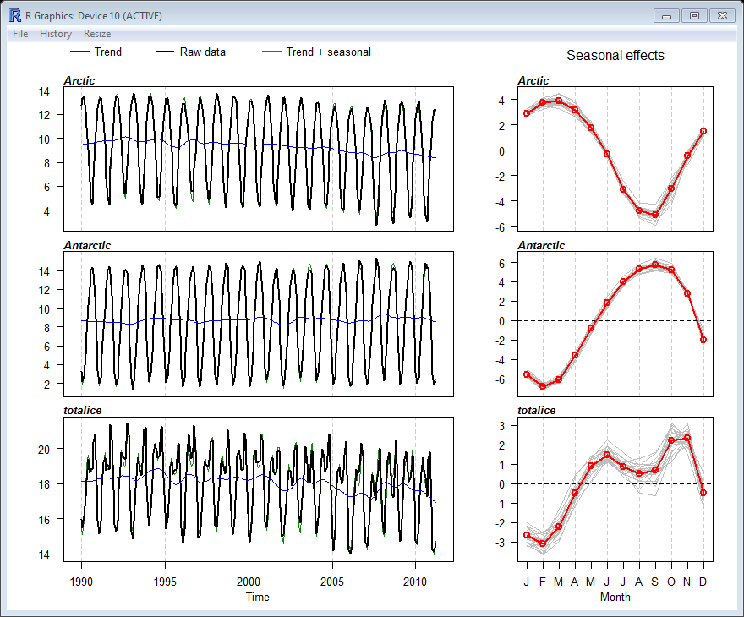
If the differing percentage changes in peak and trough levels between the start and end of the series are examined, different rates of change are observed in the Arctic, Antarctic and Total sea ice area variables.
Region | % change in Peak value | % change in Trough value
Arctic Sea Ice | -2.5% | -32.9%
Antarctic Sea Ice | 0.4% | 5.6%
Total Sea Ice | -4.85% | -6.0%

The relatively small percentage changes noted in both the Peak and Trough of the Antarctic Sea Ice area reflects the stability of both the long term trend and the seasonal pattern of this series. The markedly different percentage changes in the area of Arctic Sea Ice reflects partly the gradual decreasing long term trend but also a small increase in seasonal variability over the time period of the series. The percentage changes for Total Sea Ice are similar indicating a consistent long term trend and seasonal pattern but this masks a slight decrease in seasonal variation just over half way through the series.
Residuals
Residuals as might be expected demonstrate a slightly wider variation. The majority fall within the range of plus/minus 1 million km². Again this is less than 10% of the variation in the whole series so it can be assumed that there are no unusual values.
Component contribution to overall series variation
Total Sea Ice  ( Million km²) | Min | Max | Range | Approx. % Contribution
Raw data | 14 | 22 | 8
Trend | 17 | 18 | 1
Seasonal | -3 | 2.5 | 5.5 | 65 %
Residual | -1.5 | 1 | 2.5 | 30%

By adding the two series together we can see that the contribution of the seasonal component to the overall variation of the series has been reduced and the residuals’ contribution to the overall variation has increased. This reflects the different seasonal patterns in Arctic and Antarctic Sea Ice and gives the Total Sea Ice series a less consistent seasonal pattern.
Predictions vs Actual ( Find next 3 data values & assess accuracy of predictions or repeat analysis minus the last 3 data values)
In order to assess the model for prediction purposes the last three data values were removed, predictions found and then compared with the actual last three data values. This was repeated for both Arctic and Antarctic Sea Ice.
ARCTIC SEA ICE ( million km²)– Comparison of Actual and prediction
Date | Actual | Prediction | Lower Limit | Upper Limit
Jan. 2011 | 11.38 | 11.34 | 10.75 | 11.93
Feb. 2011 | 12.32 | 12.11 | 11.4 | 12.83
March 2011 | 12.4 | 12.33 | 11.51 | 13.15

Actual values and predictions are extremely close for Arctic sea ice indicating the strength of this model for prediction purposes. Percentage differences between actual values and predictions range from 0.4% to 1.7%.
ANTARCTIC SEA ICE ( million km²)– Comparison of Actual and prediction
Date | Actual | Prediction | Lower Limit | Upper Limit
Jan. 2011 | 2.87 | 3.04 | 2.41 | 3.66
Feb. 2011 | 1.8 | 1.94 | 1.12 | 2.76
March 2011 | 2.18 | 2.80 | 1.83 | 3.78

A comparison of actual and predicted values of Antarctic sea ice are also close but not as close as those for Arctic sea ice. However, all actual values fall within the 95% prediction intervals.
Contextual Knowledge or Research Findings
My findings of a declining long term trend of Arctic sea ice and a constant long term trend of Antarctic sea ice is NOT wholly substantiated by other research.
A NASA report ( http://www.nasa.gov/topics/earth/features/antarctic_melting.html) highlights that Antarctic sea ice is increasing by 1% per decade and Arctic sea ice is decreasing at 4% per decade. The report cites the following factors as reasons for the differing trends –
- Ozone depletion
- Changing ocean dynamics
- Flooding of sea ice
The combination of these factors has resulted in colder, stormier weather and faster winds that create open water which in turn promotes production of sea ice. The 1% per decade noted would arguably be within their measurement margin of error as could no change in level.
In a New Scientist report ( www.newscientist.com/article/dn16988-why-antarctic-ice-is-growing-despite-global-warming.html) similar trends were reported as in the NASA report. This article also comments on a record low in the area of Arctic Sea ice in 2007 which was identified in my analysis. This article also mentions that the area of “Antarctic sea ice is increasing in every month of the year except January”. This statement is not verified by our analysis but the exact time period being referred to is unclear.
Teachers - Animation of Sea Ice area available – http://arctic.atmos.uiuc.edu
Rachel Passmore
Endeavour Teacher Fellow
Email : passm@vodafone.co.nz

