TIME SERIES DATA SETS SOURCES
Global Warming
- https://public.tableau.com/en-us/s/gallery/evolution-global-temperature?utm_source=feedburner&utm_medium=email&utm_campaign=Feed%3A+VizOfTheDay+%28Viz+of+the+Day+-+Beautiful+Visual+Stories%29
- http://xkcd.com/1732/
- http://www.bloomberg.com/graphics/2015-whats-warming-the-world/
- https://www.niwa.co.nz/atmosphere/our-data/trace-gas-plots/carbon-dioxide. NIWA have collected atmospheric carbon dioxide data at Baring Head since the early 1970s. This is the longest series of data of this type in the southern hemisphere.
US site with TS on crime rates, cause of death, Walmart Sales data, cancer incidence
https://www.springboard.com/blog/free-public-data-sets-data-science-project/
Time Series Data Library created by Rob Hyndman, Professor of Statistics, Monash University. Not many NZ time series but plenty of variety.
https://datamarket.com/data/list/?q=provider%3Atsdl
This site includes OzDASL – the Australiasian Data and Story Library. Topics of Time series include rainfall, AIDS, unemployment, pig slaughter, exchange rates, tree ring widths. Lots of links to other resources too.
http://www.statsci.org/datasets.html
Daily and weekly movie box office sales, DVD/Blu-ray sales data from the US
http://www.the-numbers.com/
http://ww2.amstat.org/publications/jse/v17n1/datasets.mclaren.html
Student Cafeteria data used on worksheet
http://ww2.amstat.org/publications/jse/jse_data_archive.htm
Education Counts website has lots of education related datasets that students might engage with
https://www.educationcounts.govt.nz/statistics/indicators/main/education-and-learning-outcomes/1891
Good site for teaching and learning about trends , lots of spurious correlations can emerge!
https://www.google.co.nz/trends/
Great sites for all sorts of NZ data.
Figure NZ - particularly good for examples of trends to teach trend description.
http://www.stats.govt.nz/infoshare all sorts of NZ time series & easy to extract data files.
WORKSHOP HAND OUT
EXAMPLE ONE
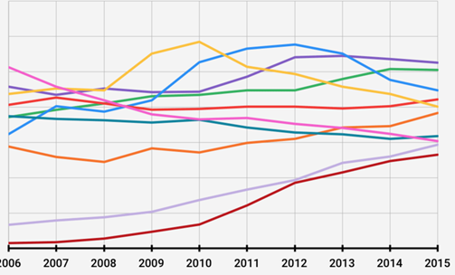
Describe what you see? What stands out? What do you think the data is? What happens next?
1.
2.
3.
4.
When you know what this data is, can you suggest any reasons why the features you observed may have happened?

1.

2.

3.

EXAMPLE TWO
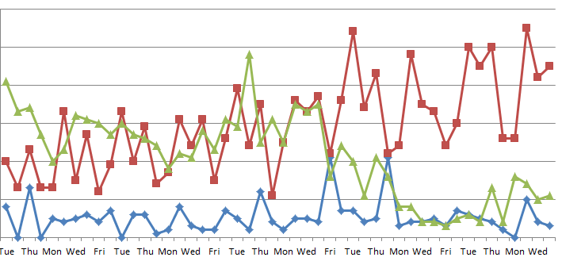

Describe what you see? What stands out? What do you think the data is? What happens next?
1.
2.
3.
4.

When you know what this data is, can you suggest any reasons why the features you observed may have happened?

1.

2.

3.

What additional information might help you to interpret this time series?

TREND – How many pieces?
EXAMPLE THREE – ROAD DEATHS IN NEW ZEALAND
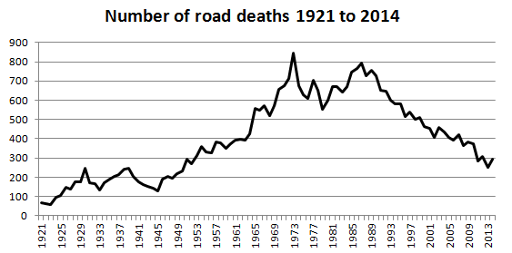
DATA SOURCE – STATISTICS NZ
TASK Describe the long term trend.
Consider where does it start, where does it finish?
How many pieces? Can you identify where the gradient changes for a sustained length of time? Try adding a trend line by hand.
Describe the start, finish, gradient and shape of each ‘piece’ of trend that you have identified. Include a statement that describes the rate of change in each ‘piece’ of the trend. Use appropriate units to quantify the rate of change.

Write your trend description in the box below. Compare your description to your neighbour’s description. Discuss any differences between your descriptions.

TREND – How many pieces?
EXAMPLE FOUR – QUARTERLY NZ BEER CONSUMPTION(millions of litres)
DATA SOURCE – STATISTICS NZ
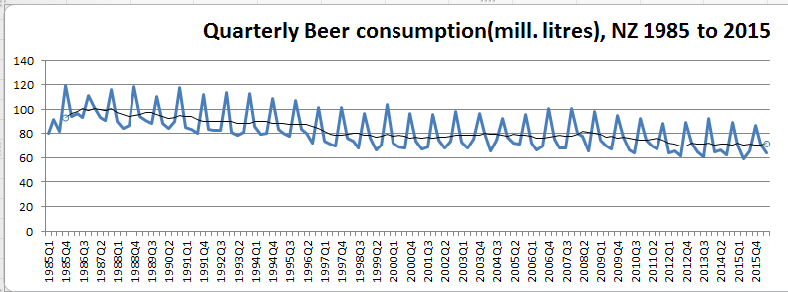
TASK Describe the long term trend.
Consider where does it start, where does it finish?
How many pieces? Can you identify where the gradient changes for a sustained length of time? Try adding a trend line by hand.
Describe the start, finish, gradient and shape of each ‘piece’ of trend that you have identified. Include a statement that describes the rate of change in each ‘piece’ of the trend. Use appropriate units to quantify the rate of change.

Write your trend description in the box below. Compare your description to your neighbour’s description. Discuss any differences between your descriptions.

