Writing reports at Level 3

# Elements of writing

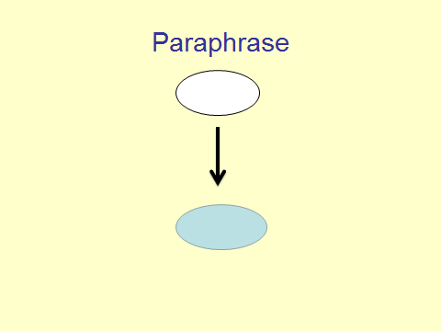

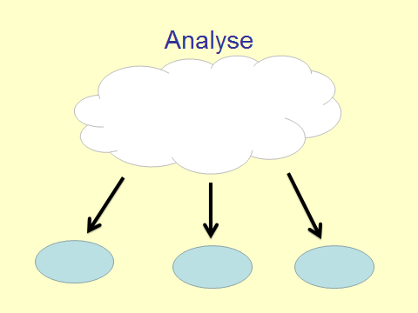

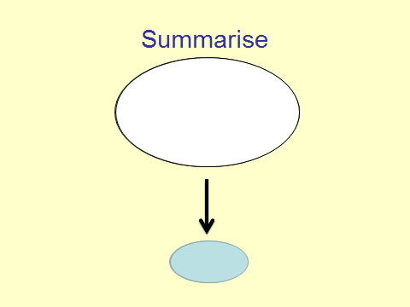

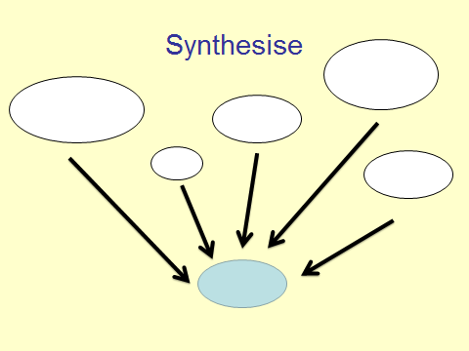

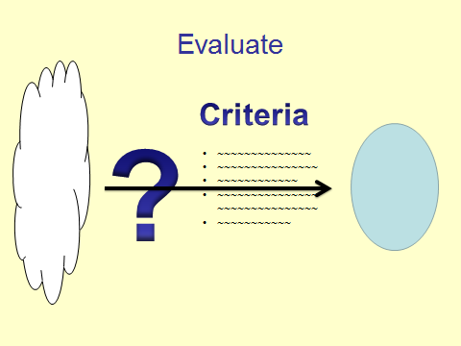

# Genres of writing for Statistical reports

|  |  |  |  |  |
| --- | --- | --- | --- | --- |
| **Elements of writing** |  | **Genre of writing** |  | **Sections of the report** |
| **What the brain is doing** |  | **The ‘nuts and bolts’ of writing** |  | **Where and When** |
| **SUMMARISE** |  | **Expository**  Informs, describes, or explains with text types such as: autobiography, biography, descriptive, essay, experiment, informational report, and media article |  | **INTRODUCTION** |
| **ANALYSE** |  | **Descriptive**  Describes and explains specific elements of the statistical graphs with text types such as labels, correctly used statistical terms and quantities |  | **DESCRIPTION OF SCATTERPLOT** |
| **PARAPHRASE** |  | **Procedural**  Explains the instructions or directions for completing a task with text types such as: experiment, how to, and recipe |  | **PREDICTIONS** |
| **SYNTHESISE AND EVALUATE** |  | **Persuasive**  Attempts to convince readers to embrace a particular point of view with text types such as: advertisement, editorial, persuasive essay, political cartoon, pro/con, and review |  | **ASSUMPTIONS & CONCLUSION** |

# INTRODUCTIONS

**V.S.P.R.L.M**

There are two approaches to introductions: **HIGHLY SCAFFOLDED** or a take a **LITERARY APPROACH**.

## HIGHLY SCAFFOLDED

Use an acronym:

|  |  |  |
| --- | --- | --- |
| Very | Variables | The variables are… |
| Smart | Subgroups | The explanatory variable is… The response variable is… |
| People | Population | The sample was taken from…. |
| Really | Relationship | The investigation is exploring the relationship between…. |
| love | (Marketing word) |  |
| Maths | Measurements | The measurements were taken using…. |

## TANGLIBLE GRAPHIC ORAGANISERS

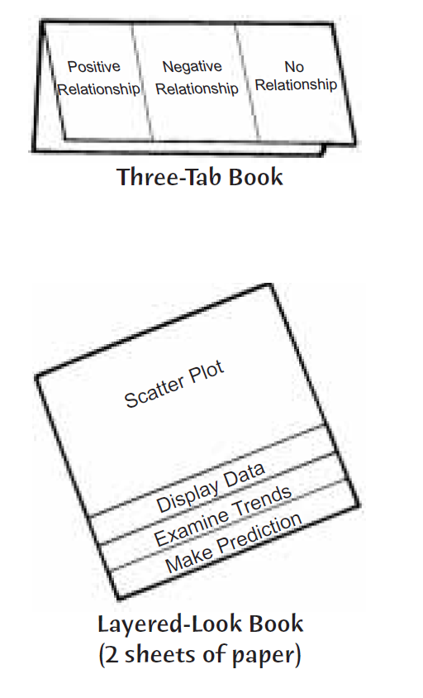

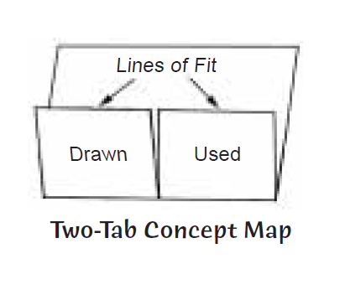

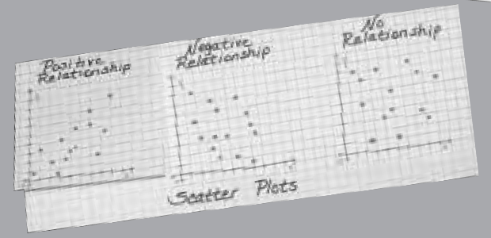

## LITERARY APPROACH

An introduction should:

* Introduce the topic.
* Indicate how the topic is going to be developed (cause-effect, reasons, examples, classification, description, narration, or explanation).
* Contain a thesis statement.
* Be inviting and entice the reader to continue after reading the first sentence.

**Funnel**

**Reveals background info leading to a focused thesis statement.**

Birds, pigs, rats and other animals all have special talents which have been used by humans. Birds can talk, pigs can find truffles, rats can run wires through walls for plumbers, but no animal has quite as many special talents as dogs, especially when it comes to helping ranchers.

**Dramatic**

**Unrolls as an eye-witness account.**

Rubble from earthquake-stricken houses is lying everywhere. Precious lives are buried deep within the piles of dirt, concrete and debris. If rescue workers can locate these souls in time, their lives may be saved. Dog teams arrive. They will employ their amazing talents in this emergency situation.

**Quotation**

**Uses a quote to lead to the thesis statement.**

"Never trust a man a dog doesn't like." the proverbs says. This somehow implies that dogs can tell the character of a person before a human can. In many ways this is true: dogs have amazing talents when it comes to assessing a person's character. But how do they do it? Pet behaviorists give the following explanations.

**Turn About**

**Starts with the opposite idea and then moves to the focus.**

Max was a cute dog, a Tibetan Terrier with a "winning smile", but he had annoying habit of "lifting his leg" on my furniture if I left him alone for more than a couple of hours. Also, half-way through our walks, he would roll on his back indicating he had had enough. I would have to carry him home. Just when I decided to give him up for adoption, he used his amazing talent as a "chick magnet" to find me the love of my life.

# DESCRIPTIONS OF SCATTERPLOTS

## THE FRAYER MODEL

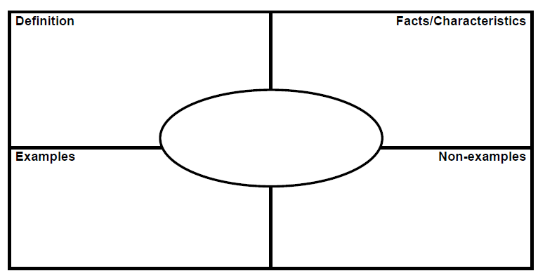

Try it now with your choice of the following bivariate vocabulary words.

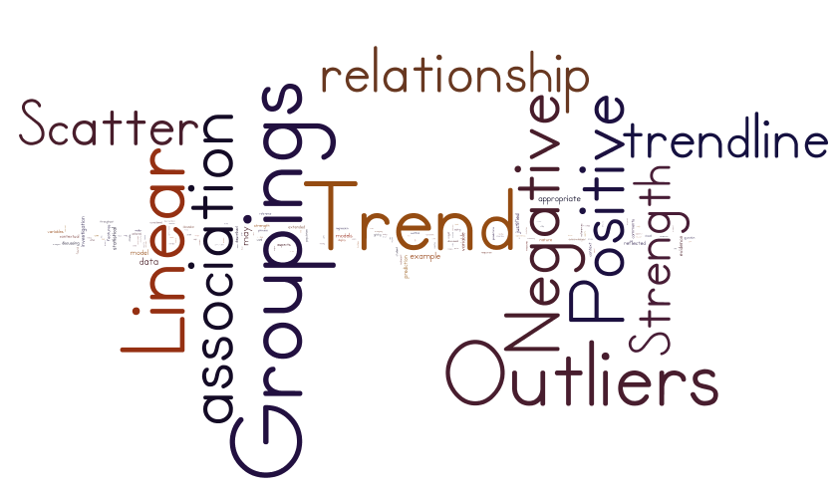

Try it now with your choice of more abstract words

**ACCOUNT FOR-** give reasons for

**ANALYZE-** examine in depth and describe the main characteristics of

**ASSESS-** weigh up the elements and arrive at a conclusion about

**COMMENT**- give an opinion and provide evidence (details) for your views

**COMPARE**- note the similarities between two or more things

**CONTRAST-** note the differences between two or more things

**DEFINE**- explain the exact meaning of

**DESCRIBE**- use words, images and diagrams to illustrate

**DISCUSS-** provide evidence or opinions about, arriving at a balanced conclusion

**EVALUATE-** weigh up or appraise

**EXPLAIN-** make the meaning of something clear

**ILLUSTRATE-** use diagrams, examples and details to make clear

**JUSTIFY-** show that an idea or statement is correct or logical

**LIST-** provide an itemized series of statements about

**OUTLINE**- describe the essential parts only

**REVIEW-** examine critically

**STATE**- express clearly

**SUMMARISE-** briefly restate main ideas

## BACK-TO-BACK TASK

Teaching students to write about the scatter plots needs to be scaffolded. An interesting way of doing this is the back-to-back task. Students turn to face away from each other and one student describes the scatterplot to the other student and the other student attempts to draw the scatterplot based on their description.

Try it now with your partner next to you, choose a scatterplot and try to describe in detail – it will get loud!

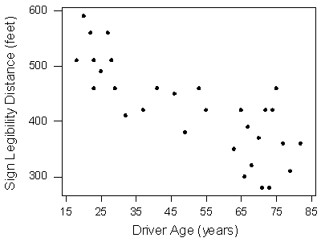 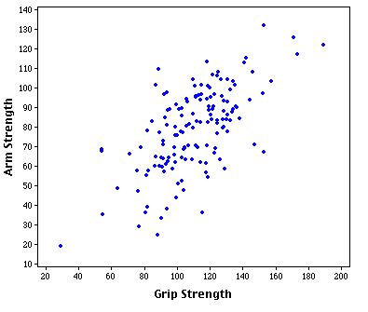

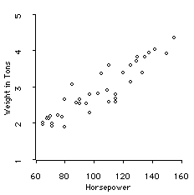 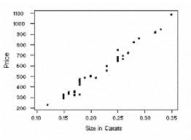

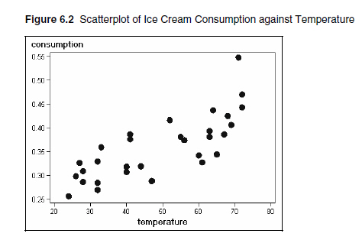 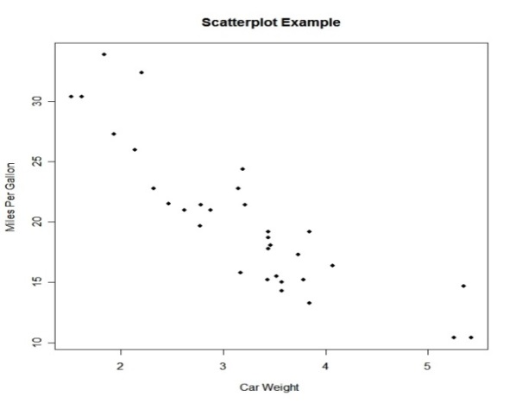

## USE OF CONJUNCTIONS

Some words are satisfied spending an evening at home, alone, eating ice-cream right out of the box, watching Seinfeld re-runs on TV, or reading a good book. Others aren't happy unless they're out on the town, mixing it up with other words; they're joiners and they just can't help themselves. A conjunction is a joiner, a word that connects (conjoins) parts of a sentence.

Conjunctions can make your essays appear much more interesting and intelligent to read.

|  |  |  |  |  |  |
| --- | --- | --- | --- | --- | --- |
| **Co-ordinating Conjunctions**  **Linking phrases** | **Subordinating Conjunctions** | | | | **Correlative Conjunctions**  **Phrases that like to hang out together** |
| For  And  Nor  But  Or  Yet  So | after  although  as  as if  as long as  as much as  as soon as  as though  because  before  even  even if  even | though if  if only  if when  if then  inasmuch  in order that  just as  lest  now  now  since  now that | now when  once provided  provided that  rather than  since  so that  supposing  than  that  though  ‘til | until when  whenever  where  whereas  where if  wherever  whether  which  while  who  whoever  why | both / and  not only / but also  either / or  neither / nor  whether / or  as / as  such / that  scarcely / when  as many / as  no sooner / than  rather / than |

Competent students use correlative conjunctions in their writing.

Practice writing sentences with the following linking terms with a co-ordinating, subordinating and correlative conjunctions.

**LINEAR TREND – STRONG RELATIONSHIP**

|  |  |
| --- | --- |
| **Co-ordinating Conjunctions** | There is linear trend **and** a strong relationship in the scatterplot. |
| **Subordinating Conjunctions** | **Although** there is apparent linear trend in the scatterplot, there is a weak relationship after x = 50. |
| **Correlative Conjunctions** | **Not only** does the scatterplot show weak linear relationship after x = 50 **but also** the linear relationship weakens after this x-value. |

**OBVIOUS OUTLIER – EFFECT ON PREDICTIONS**

|  |  |
| --- | --- |
| **Co-ordinating Conjunctions** | There is an obvious outlier **so** this could affect my predictions. |
| **Subordinating Conjunctions** | There is an obvious outlier at (30,40) which may affect my predictions **provided** it is high-leverage. |
| **Correlative Conjunctions** | **Both** the presence of a high-leverage outlier **and** non-constant scatter about the trend line may affect my predictions. |

**GROUPINGS – NEED TO STRATIFY**

|  |  |
| --- | --- |
| **Co-ordinating Conjunctions** |  |
| **Subordinating Conjunctions** |  |
| **Correlative Conjunctions** |  |

**NON-CONSTANT SCATTER ABOUT TRENDLINE – RANGE OF X-VALUES**

|  |  |
| --- | --- |
| **Co-ordinating Conjunctions** |  |
| **Subordinating Conjunctions** |  |
| **Correlative Conjunctions** |  |

## JIGSAWS AS A LITERACY LEARNING TECHNIQUE



Cut up the phrases above and have different groups of students sort through the ‘jigsaws’ and arrange in order.

# ASSUMPTIONS

## GRAPHICAL ORGANISERS

**BRAINSTORM – MINDMAP – ORGANISE – WRITE!**

**Brainstorm: issues related to immigration**

* Add to labour force
* Skills shortages in industrialised countries, e.g. teachers
* Low-level jobs – agriculture, cleaning, service work, etc.
* High-skill work – information technology, other occupations
* Declining populations of industrialised countries
* Need to support ageing populations
* Immigrants pay taxes on earnings and investments
* Entrepreneurs bringing energy, new skills
* Higher fertility rate among many groups of immigrants
* Benefits of multiculturalism: arts, religion, food
* Greater demands on educational system
* Bring new ideas to workplace; new views on old problems
* Bi/multilingual education
* Cultural issues in education, e.g. Muslim girls wearing headscarves
* Discrimination/racism against immigrants
* Don’t share local prejudices
* Fears of native population about job loss
* Issues of learning language, new culture
* Hard working, need to ‘make it’

**Mind Map of the Brainstorm**

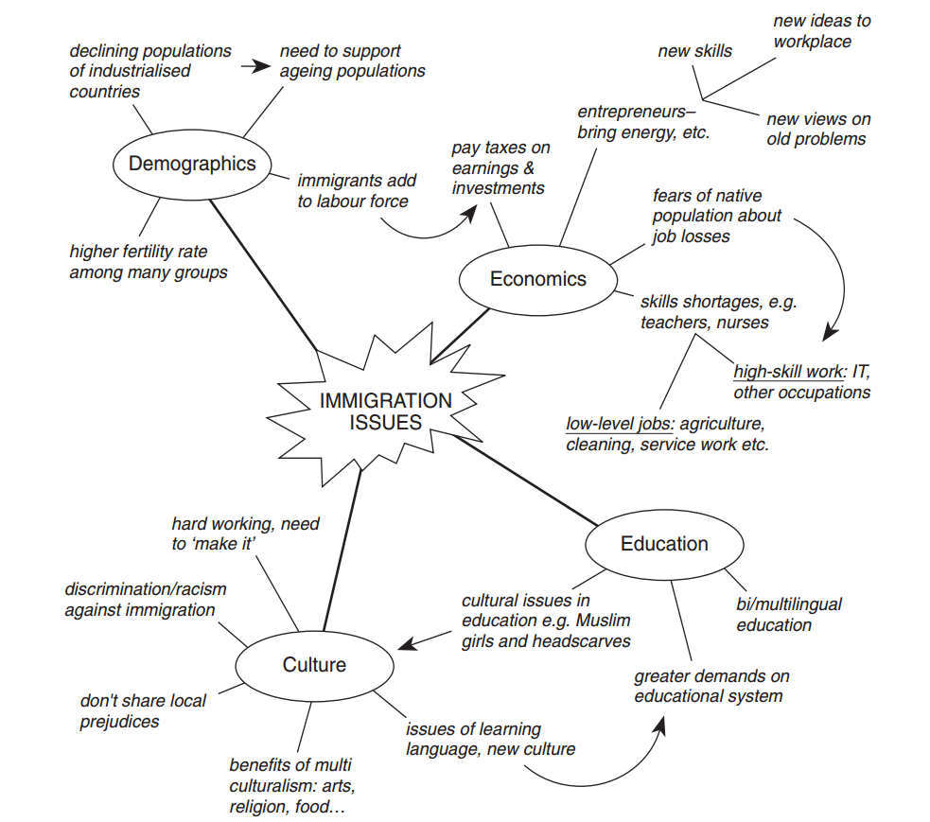

**Organisation of the Mind Map**

Outline: ‘The Benefits of Immigration to Industrialised Countries’

Position/argument: immigrants provide net economic and cultural benefits to industrialised countries.

**I Background: industrialised countries**

**A. Demographic changes**

1. ageing population

(a) (evidence)

(b) (evidence)

2. zero or negative population growth

(a) (evidence)

**B. Changes in labour force**

1. reduced work force, especially in low-level service and agricultural jobs

2. ageing work force may lack contemporary skills

3. new ideas needed for old problems

**II Benefits of immigration**

**A. Demographics**

1. higher birth rate among many immigrant groups

2. younger average age of immigrants

**B. Labour features**

1. hard workers willing to do many jobs native-born population eschews (e.g. agricultural and service work)

2. entrepreneurs with particular skills, knowledge and drive

3. pay more in taxes than receive in social services

**III Cultural issues**

**A. Benefits of multiculturalism**

1. bring diversity in an increasingly global world

2. retain connections with people in other countries

**B. Difficulties related to immigration**

1. immigrants may face discrimination and racism

2. immigrants face issues of adaptation/acculturation (e.g. Muslim schoolgirls who want to wear headscarves)

3. immigrants may need to learn a new language

4. require greater government provision of bi/multilingual education

**IV Conclusion**

**A. Challenges for both immigrants and the industrialised countries**

1. challenges for immigrants: language, work, education, culture, etc.

2. challenges for countries: education, discrimination, etc.

**B. Advantages of immigration outweigh the disadvantages**

1. some disadvantages

2. economic advantages

3. cultural advantages

**Try doing a quick mind map on either of the following topics:**

* TASSOG and the suitability of linear regression.
* Compare the suitability of another variable.
* How would you improve the data collection method?
* Consider the impact of the model on the wider Population.
* Reflect on the robustness of the model.

## EXAMPLE OF A GRAPHIC ORGANISER OF ASSUMPTIONS OF LINEAR REGRESSION

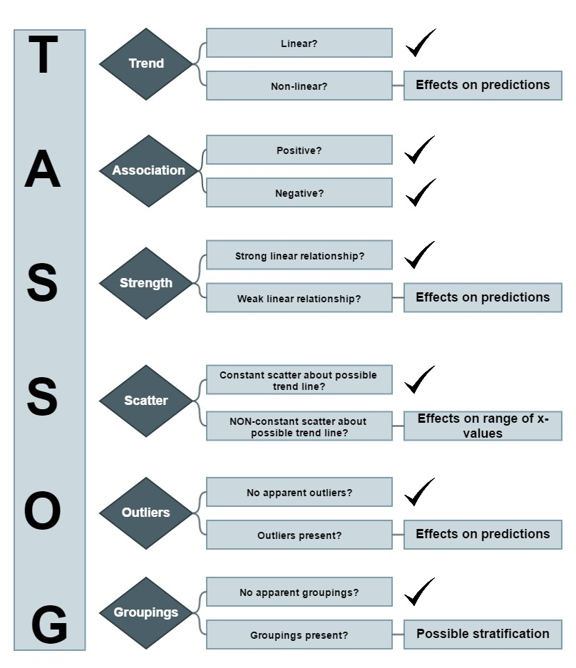

## SIGNPOSTING

'Signposts' are found in good academic essays and they will also help the reader to understand the writing more easily. They help to link what has already been said with what is about to be discussed.

|  |  |  |  |
| --- | --- | --- | --- |
| **IN ADDITION** | **REFLECTION OR BACKWARDS** | **FUTURE OR FORWARD** | **BOTH WAYS!** |
| For example  Consequently  However  Despite these difficulties  These suggestions  However, in the modern world  In the next section | This suggestion  These ideas  This brief outline suggests  Such proposals | In this section, I will  My next paragraph will consider why  A recent study suggests  One important recent finding indicates that | Despite these reports, other scientists have proposed  In spite of these findings, researchers believe  This view has been rejected by some authors who claim that  In contrast, a recent article |

TRY THIS: Look at these passages and underline any 'signposts'. Do they look **forwards, backwards or in both directions**?

**Passage A:**

Despite this difficulty, many theories have been proposed to explain these results, but the evidence has proved to be elusive. However, this does not mean that the theories can be discounted. The following chapter will explore the evidence in more detail.

**Passage B:**

In the last chapter, we examined the link between foreign direct investment and social development. In this chapter, I would like to explore the differences between this form of investment and local investment. The first section will consider the factors that encourage and discourage local investment. These factors will then be analysed in the light of recent developments in China.

**Passage C:**

Are these theories supported by data? The evidence, unfortunately, is inconclusive. Despite exhaustive studies, no positive identification has ever been made. This has proved to be the most difficult problem of all. However, quite recently, a new method of collecting the data has been proposed. This method relies on sub-sectional analysis, which has not been adopted before. This form of analysis has some interesting features. Firstly, ...

**Notes on the Task**

**Passage A:**

**Despite this difficulty** **[this looks backwards]** many theories have been proposed to explain these results, **[this looks backwards]** but the evidence has proved to be elusive. **However, this does not mean**... **[this looks backwards** ]. ...that the theories can be discounted. The following chapter will explore the evidence in more detail. **[ this looks forwards]**

**Passage B:**

**In the last chapter, we examined** **[this looks backwards]** the link between foreign direct investment and social development. In this paragraph, I would like to explore **[this looks forwards]** the differences between this form of investment and local investment. The first section will consider **[this looks forwards]** the factors that encourage and discourage local investment. These factors will then be analysed **[this looks forwards]** in the light of recent developments in China.

**Passage C:**

Are these theories supported by data? **[this looks backwards]** The evidence, unfortunately, is inconclusive. Despite exhaustive studies, no positive identification has ever been made. This has proved **[this points backwards]** to be the most difficult problem of all. However, quite recently, a new method of collecting the data has been proposed. This method **[this looks backwards]** relies on sub-sectional analysis which has not been adopted before. This form of analysis has some interesting features. **[this looks forwards]** Firstly, ...

# PREDICTIONS

## PROCEDURAL TEXT

* The purpose of a procedure is to tell the reader how to do or make something.
* The information is presented in a logical sequence of events, which is broken up into small sequenced steps.
* The most common example of a procedural text is a recipe.

A procedure usually has four components: **Goal or Aim** - states what is to be done, **Materials** - listed in order of use includes items needed to complete task, **Method** - a series of steps and **Evaluation** - how the success of the procedure can be tested.

|  |  |
| --- | --- |
| **Goal or Aim** | The model will be used to make two interpolations which are predictions made within the range of data values. This is to show that the increase in the explanatory variable, temperature (oC) has the effect of increasing the snow melt per minute (g/m3) within the sample area. |
| **Materials** | The linear regression equation y = 3.54x + 578 was formed from the data collected from…. |
| **Method** | The assumptions of linear regression were satisfied as…. |
| **Evaluation** | As the predictions for the response variable increased from 3.4 g/m3 t0 8.7 g/m3 the explanatory variable temperature (oC) can be considered…. |

## **ACTIVE VS PASSIVE VOICE**

|  |  |
| --- | --- |
| **ACTIVE VOICE**  Tells what a person or thing does.  · The subject performs the action and typically comes before the action.  · The object is who or what receives the action and typically comes after the action. | **PASSIVE VOICE**  Tells what is done to someone or something.  · The subject performs the action and typically comes after the action (verb).  · The object is who or what receives the action and typically comes before the action (verb). |

|  |  |
| --- | --- |
| **Passive:** At dinner, six shrimp were eaten by Harry. | **Active:** Harry ate six shrimp at dinner. |
| **Passive:** The savannah is roamed by beautiful giraffes. | **Active:** Beautiful giraffes roam the savannah. |
| **Passive:** From the scatterplot, these data have the appearance of linearity | **Active:** These data appear linear in the scatterplot. |
| **Passive:** The variables which were considered appropriate were Carat weight (mg) and Price (SGD$) by the researcher. | **Active:** The appropriate variables were Carat weight (mg) and Price (SGD$). |
| **Passive:** | **Active:** |
| **Passive:** | **Active:** |
| **Passive:** | **Active:** |
| **Passive:** | **Active:** |

## WRITING FRAMES

# CORRELATION/CAUSATION

## USE OF MODAL VERBS

|  |  |  |  |  |
| --- | --- | --- | --- | --- |
|  | Most frequent 🡸=====================================================🡺 Least frequent | | | |
|  | Logical possibility: expresses a degree of probability | Ability: shows capability | Necessity: expresses directness in attitude | Permissions: shows politeness |
| STRONGEST 🡸🡺 WEAKEST |  |  |  |  |
|  |  |  |  |
|  |  |  |  |
|  |  |  |  |
|  |  |  |  |

**The use of modal hedges, or weakens, the certainty of a sentence. The stronger the modal, the stronger the possibility.**

Consider the following sentences:

Other variables considered in the investigation _______ have an effect on the response variable and hence the predictions made from the model.

What sounds better?

The range of x-values _____ be taken into consideration when making predictions from the model as any predictions made below the values of 50kg may not be accurate or useful.

Not all of the assumptions of linear regression were met when initially observing the scatterplot which means the predictions of the model _______ be inaccurate.

## STATISTICALLY SIGNIFICANT TERMS

Use another form a graphic organisers called Clines.

* **NON-LINEAR**
* **WEAK VISUAL RELATIONSHIP**
* **NON-CONSTANT SCATTER**
* **RESIDUALS WITH PATTERNS**
* **POSSIBLE CONFOUNDING VARIABLES**
* **CORRELATION =/= CAUSATION**
* **NON-SIGNIFICANT RELATIONSHIP**
* **LINEAR**
* **STRONG VISUAL RELATIONSHIP**
* **CONSTANT SCATTER**
* **FEW PATTERNLESS RESIDUALS**
* **NO CONFOUNDING VARIABLES**
* **CORRELATION = CAUSATION**
* **SIGNIFICANT RELATIONSHIP**

# Self-assessment for learning

|  |  |
| --- | --- |
| **Checklist for students to use as part of self-assessment** | |
| **Covering information** | |
| My name |  |
| My title/cover page shows clearly |  |
| Date assignment handed in |  |
| The question I have chosen |  |
| **Introduction** | |
| Sets the question topic against a wider background |  |
| Clarifies my understanding of the question/topic |  |
| Defines key or problematic terms |  |
| Outlines the approach I will be taking to the question/topic |  |
| **Main text** | |
| My key points are clearly presented |  |
| The points I make are systematically backed up by facts/evidence/examples/arguments |  |
| Quotations and references to other works are accurately cited |  |
| Any diagrams, figures or tables are labelled properly |  |
| **Conclusions** | |
| Brings together the main points |  |
| Links back to the question/topic |  |
| States clearly my conclusion(s) |  |
| Style and presentation |  |
| Makes correct use of spelling, grammar and punctuation |  |
| Accurately lists the background reading I have consulted |  |
| Is within the word limits specified |  |

# Check list for more better academic writing

|  |  |  |
| --- | --- | --- |
| **More information?** |  | Besides, Furthermore, In addition, Indeed, In fact, Moreover, Second...Third..., etc. |
| **An example?** | http://sr.photos2.fotosearch.com/bthumb/CSP/CSP991/k12178276.jpg | For example, For instance, In particular, Particularly, Specifically, To demonstrate, To illustrate, Thus, for example, namely, specifically, such as. |
| **A cause or reason?** | http://images.clipartof.com/thumbnails/27038-Clipart-Illustration-Of-A-Confused-White-Person-Holding-Their-Hands-Out-Because-They-Arent-Sure-What-To-Do-About-Seo-And-Link-Exchanges-To-Market-Their-Site.jpg | As, Because, Because of, Due to, For, For the reason, that, Since |
| **A result or an effect?** |  | Accordingly, Finally, Consequently, Hence, So, Therefore, Thus |
| **A purpose or reason why?** | http://images.clipartpanda.com/guess-clipart-clipart-0117.png | For fear that, In the hope that, In order to, So, So that, With this in mind, So that, With the result that, Thus, Consequently, Hence, Accordingly, For this reason, Therefore, So, Because, Since, Due to, As a result, In other words, Then |
| **To compare (explains how two items are similar)** |  | Similarly, likewise, in like fashion, in like manner, analogous to, In comparison, Nevertheless, On the other hand, Similarly, Whereas, Yet, Considerably, Significantly, Slightly, Scarcely, Hardly, Only just (bigger than); Exactly, Precisely, |
| **Contrast (emphasizes the differences rather than the similarities)** | http://thumbs.gograph.com/gg4792049.jpg | Although, On the contrary, Contrarily, Notwithstanding, But, However, Nevertheless, In spite of, In contrast, Yet, On one hand, On the other hand, Rather, Or, Nor, Conversely, At the same time, While this may be true, In contrast |
| **Time frames** |  | After, Before, Currently, During, Eventually, Finally, First,...Second,..., etc. Formerly, Immediately, Initially, Lastly, Later, Meanwhile, Next, Previously, Simultaneously, Soon, Subsequently |
| **To summarise** | http://sr.photos3.fotosearch.com/bthumb/CSP/CSP990/k11515245.jpg | Briefly, Overall, Summing up, To put it briefly, To sum up, To summarise, Therefore, Finally, Consequently, Thus, In short, In conclusion, In brief, As a result, Accordingly |
| **To conclude** | http://writemyessayonline.com/blog/wp-content/uploads/2014/07/end.jpg | Given these facts, Hence, In conclusion, So, Therefore, Thus, To conclude, Under no circumstances, Mainly, Generally, Predominantly, Usually, The majority, Most of, Almost all, |
| **To describe quantity** | http://ec.l.thumbs.canstockphoto.com/canstock12269135.jpg | No, Minimal, Slight, Small, Slow, Gradual, Steady, Marked, Large, Dramatic, Complete, Steep, Sharp, Rapid, Sudden, Rise, Increase, Fluctuation, Decrease, Decline, Reduction, Fall, Drop off, Upwards trend, Downward trend, Peak, Plateau, Level off |
| **To describe relationship** | http://images.clipartpanda.com/relationship-clipart-37703-clip-art-graphic-of-yellow-guy-characters-embracing-by-jester-arts.jpg | This shows, It is apparent that, This mean, The link between, Subsequently, This relates to, Consequently, Difference between, That and Which |
| **To describe approximation** | http://baneofyourresistance.files.wordpress.com/2012/06/magnify-glass.jpg | Approximately, At about, In the vicinity of, Thereabouts |
| **To describe concession** | http://sr.photos3.fotosearch.com/bthumb/CSP/CSP695/k6956935.jpg | Although, At any rate, At least, Still, Thought, Even though, Granted that, While it may be true, In spite of, Of course |
| **Emphasis** | http://images.clipartpanda.com/emphasis-clipart-canstock14611916.jpg | Above all, Indeed, Truly, Of course, Certainly, Surely, In fact, In truth, Again, Besides, Also, Furthermore, In addition. |

# Correct referencing and appendices

## Guidance on using illustrative material

Graphs, pie charts, tables, schematic diagrams, photos and maps are often used to make points more clearly, effectively or succinctly than they can be made in words.

• They supplement rather than duplicate text.

• They must be relevant and discussed in the text.

• Figures and tables should be located as close as possible to the point in the text at which they are discussed and not generally in appendices.

• Graphs, diagrams and maps should be referred to as ‘Figures’. Tables and word charts are referred to as ‘Tables’ and photographs as ‘Plates’.

• Illustrative material should be large, comprehensible and self-contained, legible, customised to your work (re-drawn if necessary), correctly identified with sequential Arabic numerals, and correctly attributed if appropriate.

• Titles should specify the subject of the illustration, its location, and the time period to which it refers (e.g. Vietnamese-born population as percentage of total population, Adelaide Statistical Division, 1996).

• Maps and diagrams should have a complete and comprehensive key.

• Labelling should be neat, legible, and relevant to the message being conveyed.

# References:

(Statistical Report Writing), School of Mathematics , The University of Manchester. (http://www.maths.manchester.ac.uk/~saralees/68371_1.pdf)

What’s the big deal about Vocabulary?, Pamela J. Dunston and Andrew M. Tyminski

Writing A – Z

(http://www.writinga-z.com/razwritingweb/topic/skill+lessons?id=2)

Dinah Zike’s Teaching Mathematics with foldables, Dinah Zike

Teaching academic writing

(<http://web.iaincirebon.ac.id/ebook/indrya/Bandura/inovasi/t118.pdf>)

Derek Soles, 2003, Writing an academic essay, Studymates Coffin, C. et al. Teaching Academic Writing 2003 London: Routledge

Teaching Academic Writing (web.iaincirebon.ac.id/ebook/indrya/Bandura/inovasi/t118.pdf)

In your own words is a web document by Mike Brough

https://activemindsactivebodies.wikispaces.com/Procedural+Writing

Armbruster, B. B., Anderson, T. H., & Ostertag, J. (1989). Teaching text structure to improve reading and writing. The Reading Teacher, 42, 130-137.