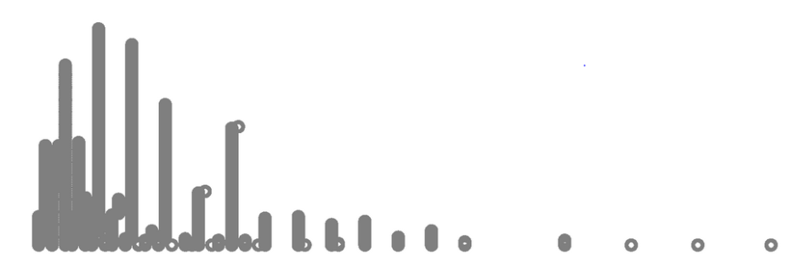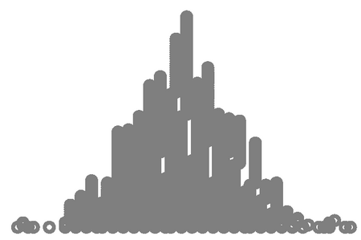

Presentation at Auckland Statistics Teachers Day 2015

Dr Pip Arnold

E: parnold@cognitioneducation.com

Developing the language of shape

Teacher Workbook

Contents

Workshop plan 3

Sketching shapes 4

Predicting graphs 7

Connecting graphs and contexts 8

Describing distributions 10

Reflection 12

Graphs and other masters 14

Glossary 21

# Workshop plan

| **Activity** | **Resources** |
| --- | --- |
| Sketching shapes  Page 4-5 | PowerPoint  Statistical language  Sketching shapes |
| Predicting graphs  Page 7 |  |
| Connecting graphs and contexts  Page 8-9 | Graphs  Contexts |
| Describing distributions  Page 10-11 |  |
| Reflection  Page 12-13 |  |



<http://new.censusatschool.org.nz/resource/data-detective-poster/>

# Sketching shapes

|  |  |  |
| --- | --- | --- |
| 1. | 2. | 3. |
| 4. | 5. | 6. |
| 7. | 8. | 9. |
| 10. | 11. | 12. |
| 13. | 14. | 15. |

Write down the graph numbers in their groups and **describe the shape** of the graphs in each group.

Sketch the different shapes that we have discovered with their statistical description.

# Predicting graphs

What do you think the graph of height in cm for year 5–10 students would look like? Describe and then sketch.

What do you think the graph of attendance percentage half days for year 7–8 students would look like? Describe and then sketch.

What do you think the graph of hair length in cm for year 4–13 students would look like? Describe and then sketch.

# Connecting graphs and contexts

|  |  |  |
| --- | --- | --- |
| 1. | 2. | 3. |
|  |  |  |
| 4. | 5. | 6. |
|  |  |  |
| 7. | 8. | 9. |
|  |  |  |
| 10. | 11. | 12. |
|  |  |  |
| 13. | 14. | 15. |
|  |  |  |

Possible contexts

* Age-years: Everyone at a high school
* Number of years living in NZ: C@S Yr 10 students
* Hair length-cm: 2007 C@S Yr 4-13 students
* Time to school-mins: 2009 C@S Yr 7-8 students
* Reaction time-secs: 2007 C@S Yr 4-13 students
* Household debt-$: Synthesised Unit Record File based on NZ data
* Wrist length-cm: 2009 C@S Yr 7-8 students
* Index finger length–mm: 2009 C@S Yr 7-13 students
* Right foot length-cm: 2003 C@S Yr 5-10 students
* Number of skips in 30 secs: 2003 C@S Yr 5-8 students
* Attendance-percentage half days: Yr 7-8 students
* Cell phone ownership-months: 2009 C@S Yr 9-13 students
* Birth month: 2003 C@S Yr 5-10 students
* Weight-kg: Kiwi Kapers Great Spotted Kiwi
* Height-cm: 2003 C@S Yr 5-10 students

# Describing distributions

|  |  |
| --- | --- |
| **Problem**  **icon-problem** | I wonder what typical heights of year 5–10 New Zealand students are. |
| **Plan/Data**  icon-plan**icon-data** | Data collected from the 2003 Census At School database.  <http://new.censusatschool.org.nz/tools/random-sampler/> |
| **Analysis**  icon-analysis |  |
| I notice…  I notice…  I notice…  I notice… |
|  |
| **Conclusion**  icon-conclusion |  |

Features that we might describe in a dot plot

## Data are numbers with a context

Check your “I notice” statements and your conclusion for the context.

Remember: **VARIABLES, VALUES, UNITS**

Actively reflect on your statements, make corrections – this is a working document…

# Reflection

## Key competencies

#### Examples of ways students think in mathematics and statistics:

* Students hypothesise, investigate, analyse and evaluate.
* Students design investigations, explore and use patterns and relationships in data and they predict and envision outcomes.
* Students ask questions, want to know ‘why’, make connections and discern if answers are reasonable.
* Students deal with uncertainty and variation, they seek patterns and generalisations.

#### Examples of ways students use language, symbols and texts in mathematics and statistics:

* Students use statistical language to pose questions and communicate findings.
* Students interpret and communicate mathematical and statistical information and ideas, they know and use specialised vocabulary, as well as their own language, to explain ideas.
* Students use ICT appropriately. They capture their thought processes, recording and communicating mathematical ideas.
* Students interpret word problems and visual representations.

Describe how students **engage in thinking** or **use language, symbols and texts** in these activities.

## Adapt, share, use.

How might you adapt the activities we have used today to better meet the needs of the students in your class?

Name two people that you can share this with in your school and the particular aspects you wish to share.

What new ideas have you learnt today that you can use in your teaching in the future?

# Graphs and other masters

Email: [parnold@cognitioneducation.com](mailto:parnold@cognitioneducation.com) for electronic copies of the powerpoint and teacher workbook.

## Contexts

|  |
| --- |
| **Age-years: Everyone at a high school** |
| **Number of years living in NZ: C@S Yr 10 students** |
| **Hair length-cm: 2007 C@S Yr 4-13 students** |
| **Time to school-mins: 2009 C@S Yr 7-8 students** |
| **Reaction time-secs: 2007 C@S Yr 4-13 students** |
| **Household debt-$: Synthesised Unit Record File based on NZ data** |
| **Wrist length-cm: 2009 C@S Yr 7-8 students** |
| **Index finger length–mm: 2009 C@S Yr 7-13 students** |
| **Right foot length-cm: 2003 C@S Yr 5-10 students** |
| **Number of skips in 30 secs: 2003 C@S Yr 5-8 students** |
| **Attendance-percentage half days: Yr 7-8 students** |
| **Cell phone ownership-months: 2009 C@S Yr 9-13 students** |
| **Birth month: 2003 C@S Yr 5-10 students** |
| **Weight-kg: Kiwi Kapers Great Spotted Kiwi** |
| **Height-cm: 2003 C@S Yr 5-10 students** |

## Statistical language

|  |  |
| --- | --- |
| **symmetrical** | **bimodal** |
| **trimodal** | **unimodal** |
| **uniform** | **long tail to the right** |
| **long tail to the left** | **bell shaped** |
| **normal curve** | **right skew** |
| **left skew** | **negatively skewed** |
| **positively skewed** |  |

## All 15 graphs

## 

## Sketched shapes

## 

## Contexts and graphs

1. Number of skips in 30 secs: 2003 C@S Yr 5-8 students
2. Birth month: 2003 C@S Yr 5-10 students
3. Weight-kg: Kiwi Kapers Great Spotted Kiwi
4. Reaction time-secs: 2007 C@S Yr 4-13 students
5. Right foot length-cm: 2003 C@S Yr 5-10 students
6. Attendance-percentage half days: Yr 7-8 students
7. Hair length-cm: 2007 C@S Yr 4-13 students
8. Household debt-$: Synthesised Unit Record File based on New Zealand data
9. Height-cm: 2003 C@S Yr 5-10 students
10. Wrist length-cm: 2009 C@S Yr 7-8 students
11. Number of years living in New Zealand: C@S Yr 10 students
12. Age-years: Everyone at a high school
13. Time to school-mins: 2009 C@S Yr 7-8 students
14. Index finger length–mm: 2009 C@S Yr 7-13 students
15. Cell phone ownership-months: 2009 C@S Yr 9-13 students

## Shape descriptors

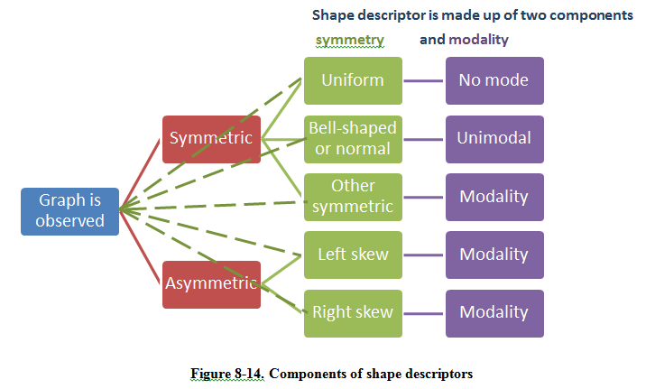

Arnold, P. (2013). Statistical investigative questions: An enquiry into posing and answering investigative questions. Doctoral thesis <https://researchspace.auckland.ac.nz/handle/2292/21305>

## Sorted graphs and shapes

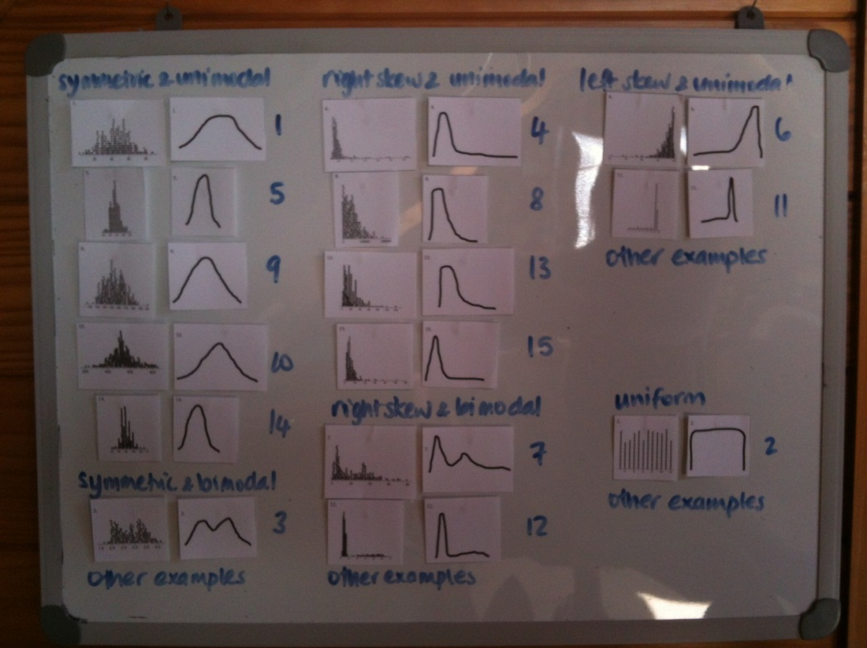

## Example of student work – building a context library

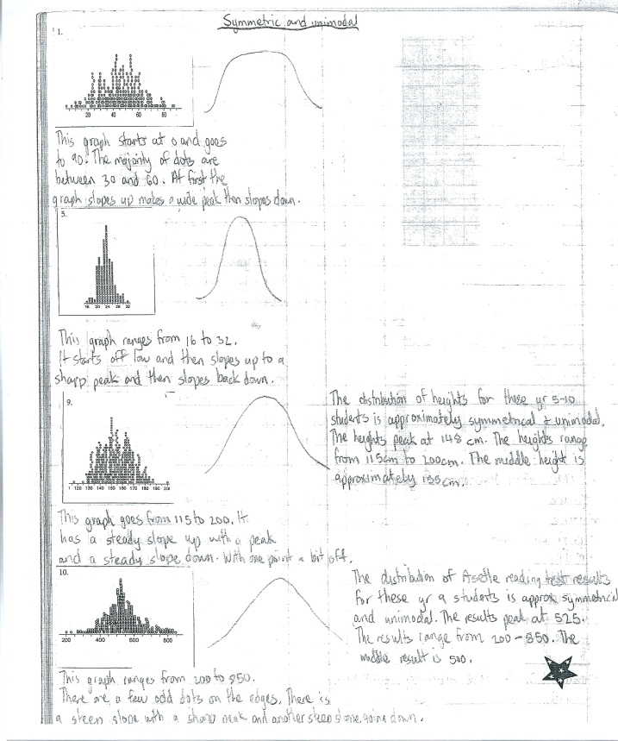 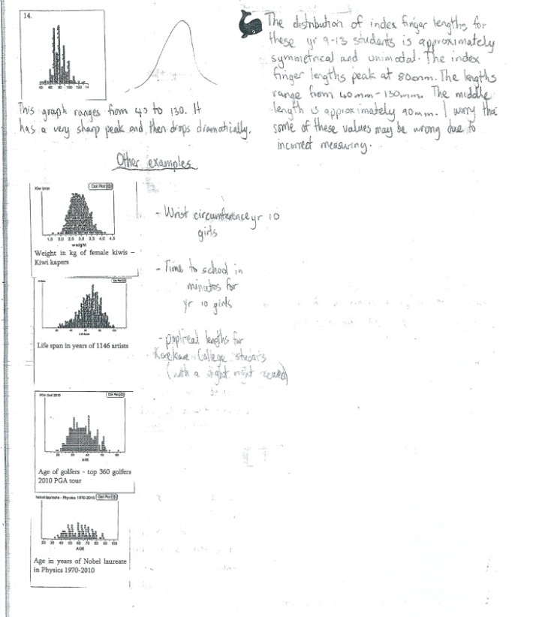

## Possible description examples

#9 Graph is: heights in cm of Yr 5-10 students



The distribution of heights for these year 5-10 students is approximately symmetrical and unimodal. The heights range from 116cm to 200cm. The middle height is about 155cm and the middle group of heights is between 142cm and 167cm.

#4 Graph is: reaction times in secs of yr 4-13 students



The distribution of reaction times for these yr 4-13 students is right skewed. Nearly all of the reaction times are tightly bunched between 0.2 and 0.6 secs. There are some reaction times slower than 0.6 secs and they spread out to 3.15 secs. The graph of reaction times peaks at about 0.4 secs and is approximately symmetrical between 0.2 and 0.6 secs.

# Glossary

## Dot plot

<http://seniorsecondary.tki.org.nz/Mathematics-and-statistics/Glossary/Glossary-page-D#dotPlot>

A graph for displaying the *distribution* of a *numerical variable* in which each dot represents a value of the *variable*.

For a *whole-number variable*, if a value occurs more than once, the dots are placed one above the other so that the height of the column of dots represents the *frequency* for that value.

Dot plots are particularly useful for comparing the distribution of a numerical variable for two or more categories of a *category variable*; this is shown by displaying side-by-side dot plots on the same scale. Dot plots are particularly useful when the number of values to be plotted is relatively small.

Dot plots are usually drawn horizontally, but may be drawn vertically.

### Example

The actual weights of *random samples* of 50 male and 50 female students enrolled in an introductory statistics course at the University of Auckland are displayed on the dot plot below.

