THE NECKER CUBE TEST
TEACHER NOTES
Background
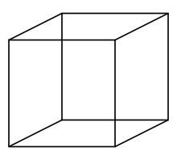

Above left is a single Necker Cube and on the right is an array of Necker Cubes.
The Necker Cube is a wire-frame cube named after the Swiss crystallographer Louis Necker (1880s) who observed that a drawing of a three-dimensional cube repeatedly reverses its perceived orientation. The Necker Cube can be seen in two different orientations. When viewed for a prolonged interval (more than a few seconds) the cube spontaneously reverses its orientation, first one of the larger squares seems closest to you and then, sometimes suddenly, the other one does. When placed in an array (see top right image) this effect becomes quite pronounced as the perspective appears to shift from ‘top viewing’ to’ bottom viewing’.
The frequency at which the cube appears to flip or change perspectives is the key factor in measuring attention (Halburt, 2011).

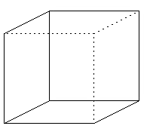
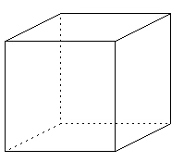
‘Top facing’ cube
‘Left facing’ cube

Attention and the mind
The capacity to solve problems is often viewed as the crowning achievement of the human mind. A central process in problem solving is the role of attention. Solving a problem requires ‘directed attention’ – applying effort of will to remain focussed on the task at hand. This mental resource is used to manage our thoughts by inhibiting one response in order to say or do something else. It is fragile and is susceptible to fatigue. Lacking effective directed attention, an individual becomes highly distractible and the task at hand does not get completed or is accomplished slowly.
What is the Necker Cube Pattern Control test?
The Necker Cube Pattern Control is an objective measure of attention (Cimprich, 1993). In this test a baseline count is taken which involves the participant observing the number of times the cube flips randomly. A second count involves counting the number of flips again but this time attempting to hold one perspective, that is control the number of cube reversals.
Greater attention capacity is indicated by the ability to control the reversal of perspectives or flips.
What does the research say?
Andrusyszyn and Yankou, (2004) state the quality of learning depends a great deal upon one’s level of clarity and the ability to focus or direct attention. Clarity, “a state of mind characterised by a strong focus and the suppression of distraction” (Kaplan & Peterson, 1993, cited in Andrusyszyn and Yankou, (2004)) is a central concept to psychological wellbeing. Clarity can motivate an individual to learn more, foster the capacity to organize, make plans and decisions, and facilitate making sense of one’s world.
“The capacity to direct attention is a foundational mental resource that allows us to voluntarily manage the focus of our thoughts. It is useful in our effort to remain effective, productive, clearheaded and helpful. We can use it to inhibit the power of certain features of the immediate physical and social environment, as well as internal distractions, so as to allow consideration of less salient but nonetheless valued information” (De Young, 2012).
Directed Attention Fatigue, causes irritability and impulsivity that results in regrettable behaviour, impatience that has us making poor decisions, and distractibility that allows the immediate environment to have a greatly magnified effect on our decisions. “Directed attention fatigue makes both pro-environmental and pro-social behaviour much less likely” (De Young, 2013).
Andrusyszyn, M. & Yankou, D. (2004). Attention Fatigue and the Effect of Debriefing in a Web-Enhanced Graduate Nursing Course. http://www.itdl.org/Journal/Apr_04/article07.htm
De Young, R. (2012). Using the Stroop Effect to test our capacity to direct our attention. http://www.snre.umich.edu/eplab/demos/st0/stroopdesc.html
De Young, R. (2013). Restoring the capacity to Directed Attention. http://www-personal.umich.edu/~rdeyoung/directedattention.html
Kaplan, S. & Peterson, C. (1993). Health and environment: A psychological analysis. Landscape and Urban Planning, 26, 17-23.
Introducing the Necker Cube in the classroom
By displaying the necker cube.ppt (attached) on a projector it should become apparent to students that the three dimensional effect of the cube spontaneously changes from time to time. Once all the students realise this phenomena, they can understand the instructions of the following experiment more easily.
Further Investigations for exploring the Necker Cube:
- You may also like to present the 3D animated version of this cube and see what direction the cube is rotating for the students, whether or not it changes direction or even if they can make it change direction while it is moving. Click the APPLET:Necker Cube link below. (NOTE: requires JAVA and you may not be able to run it due to security settings of your computer)
http://www.cs.ubc.ca/nest/imager/contributions/flinn/Illusions/NC/nc.html
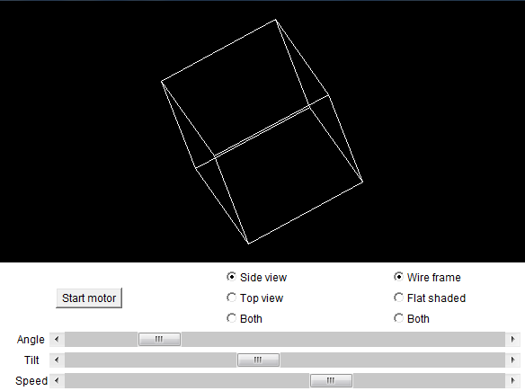
- BBC Personality test http://www.bbc.co.uk/science/humanbody/mind/surveys/neckercube/
- Test from EPLAB http://www.snre.umich.edu/eplab/demos/nt0/a1_start_NT.php?gotoTask=Go+to+Necker+Cube+Pattern+Reversal+test
Gives a nice introduction to what the Necker Cube test is all about.

Psychological Test 1: The Necker Cube Test
Conduct an experiment using experimental design

Once the class has been introduced to the Necker Cube, the question can be posed:
‘Does concentrating on the Necker Cube affect the number of ‘flips’ the cube makes?’
Using a simple experimental design we will set up an experiment in class and discover if our attention causes the flipping effect to change in frequency.
Following this experiment, students then have the option to explore the Necker Cube further by looking at people’s mental vitality. The outline for further possible experiments is on the Draft Internal Assessment Resource ‘Psychological Test 2: Necker Cube Test’ (attached).

PROBLEM

“Does concentrating on the Necker Cube affect the number of ‘flips’ the cube makes?”

PLAN

Variable
The variable of interest is the flip frequency and we are looking at whether the role of attention is a factor in this.
Resources necker cube.ppt
timer
paper to tally the number of times the cube flips
Random allocation
Randomly allocate each student in the class to either GROUP 1 (control) or GROUP 2 (concentrate). Do this in some way so that they have a 50% chance of being in either group. For example you may have a box with a number of folded bits of paper with group 1 or group 2 written on them and the students are instructed to select one.
Do not tell the students whether they are in the control or concentrate group, just tell them ‘Group 1’ or ‘Group 2’.
Sitting the Necker Cube Test
Use the necker cube.ppt powerpoint (attached). There is only one slide.
GROUP 1 go first. Make sure the students have a pen and paper ready to tally the number of times the cube flips. They are to gaze at the cube for 30 seconds, making tally marks (without looking down) on their paper each time the cube flips. These are the only instructions that need to be given to this group.
GROUP 2 go next. This group is required to gaze at the cube for 30 seconds also but they need to concentrate on maintaining one perspective. The aim is not to let it flip. If it flips, then concentrate on holding the new perspective. Always keeping the number of flips to a minimum. They still need to be making tally marks (without looking down) on their paper each time the cube flips.

- NOTE: You may like to try the experiment with a full minute instead of 30 seconds.

DATA

The following data were collected from a class and are used here to demonstrate how to analyse the data. Flip frequencies need to be collected from each student and saved in a CSV file for use in iNZight. See the following example of a CSV file which demonstrates the correct way to format the results for iNZight.
Fig 1. Example CSV file (necker_results.csv) (attached)
flip freq | group
9 | control
2 | control
4 | control
4 | control
9 | control
2 | control
1 | control
6 | control
18 | control
2 | control
9 | control
0 | concentrate
3 | concentrate
4 | concentrate
0 | concentrate
0 | concentrate
2 | concentrate
6 | concentrate
3 | concentrate
0 | concentrate
5 | concentrate
3 | concentrate

ANALYSIS
Using the Randomisation Test module from the Visual Inference Tools (VIT), a part of the iNZight programme, a graphical display similar to the following can be obtained. Inferences can then been drawn.
Fig 2. Example output using the Necker Cube test using means
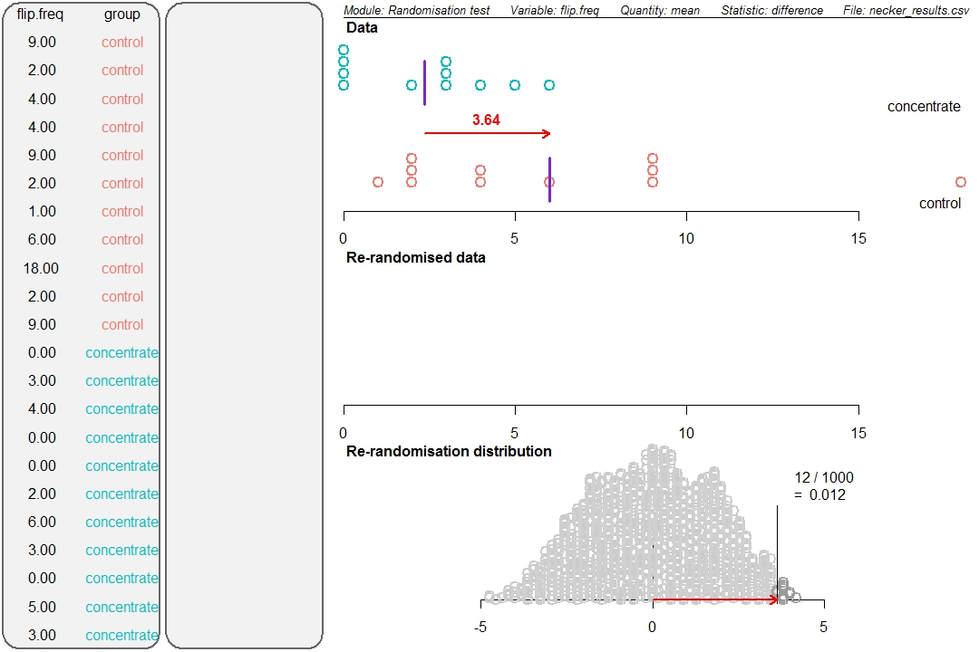
Fig 3. Example output using the Necker Cube test using medians
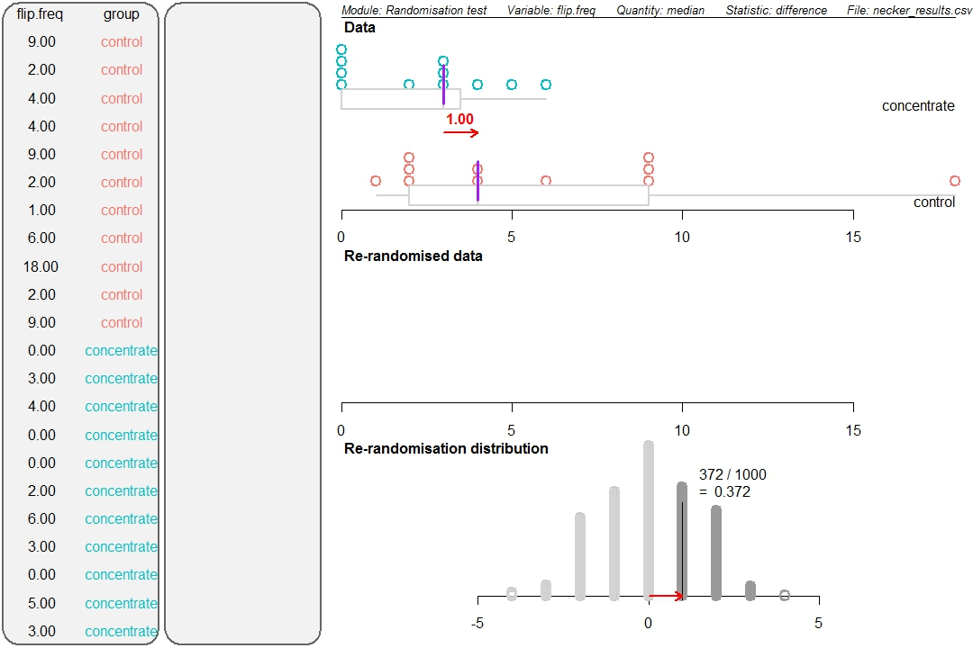
CONCLUSION

It is interesting to analyse the results from this experiment using both means and medians. 1.2% of the time we got a difference between the means of 3.6 flips or more under chance alone. This suggests that telling a group of students to concentrate on maintaining one perspective of the Necker Cube resulted in those students tending to have fewer flips than the group of students who were given no instructions.
However if we analyse the data using medians we find there is not enough evidence to make any conclusion. The randomisation test shows that a difference between the medians of 1 flip or more occurred 37.2% of the time under chance alone. It is not unusual to get differences this big or even bigger under chance alone. Therefore the observed difference is the result of either chance acting alone, or a concentration effect together with chance acting. We do not have enough information to make a call as to which has happened.
The difference in the means is larger than the difference in the medians, due to larger spread in the control group data. The control group contains a data value of 18 flips; this person saw the cube ‘flip’ nearly every three seconds. It would be interesting to investigate further by interviewing this student about their experiences when sitting the test and also ask questions about their general attention.
Because of these conflicting findings we will take a conservative approach and state we do not have enough information to make a call.
Note: Some people who have taken the test have reported being able to make the cube flip easily by shifting their attention to particular vertices. However, the correct method of viewing the cube is to ‘gaze’ at it and look at the cube as a whole form.
The test builds on the Attention Restoration Theory (ART) which states that there are two kinds of attention: involuntary and direct. Involuntary attention is a form of attention that requires no effort, happens naturally, and is resistant to fatigue, while, direct attention is a form of attention that requires effort and focus, is susceptible to fatigue, and can be used to block out distractions. The draft assessment resource (attached) gives students the opportunity to explore ways to enhance or degrade one’s direct attention.

Internal Assessment Resource
Achievement Standard Mathematics and Statistics 91583: Conduct an experiment to investigate a situation using experimental design principles

Resource reference: Mathematics and Statistics 3.11

Resource title: Psychological Test 2: Necker Cube

Credits: 4

Teacher guidelines
The following guidelines are supplied to enable teachers to carry out valid and consistent assessment using this internal assessment resource.
Teachers need to be very familiar with the outcome being assessed by Achievement Standard Mathematics and Statistics 91583. The achievement criteria and the explanatory notes contain information, definitions, and requirements that are crucial when interpreting the standard and assessing students against it.

Context/setting
This activity requires students to conduct an experiment investigating what restores people’s mental vitality. Students are to identify the response variable (number of times the necker cube flips) and consider the possible factors that might influence this variable.
This will involve:
Some sort of activity or intervention which is designed to affect the mental vitality of a person.
For example, those activities, that have a restorative effect: going for a relaxing walk in the park, listening to favourite music with headphones, doodling on a piece of paper, or those activities that have a negative effect: concentrating for long periods while hungry, not sleeping etc.

Conditions
This activity requires multiple sessions to complete the investigation. Confirm the timeframe with your students including time between the planning and data collection and analysis/conclusion phases for students to review their plan and make minor adjustments to it based on your feedback.
Students are expected to use appropriate technology, for example, statistical software.

Resource requirements Statistical packages such as INZight or Fathom

Additional information
Things to brainstorm for further experimental ideas:
What is it that makes us tired? Can you use the Necker Cube test to check these factors?
- Concentrating on a task
- Performing repeated mental arithmetic
- Proof reading
- Reading lengthy uninteresting text
- Multi-tasking
What is it that restores our mental vitality? Can you use the Necker Cube test to check these factors?
- Listening to your favourite music
- Watching TV
- Eating an energy bar, or drinking an energy drink
- Going for a walk
- Doing exercise
See attached articles of interest for further background information:
CIMPRICH, B., RONIS, D.L. (2003). An Environmental Intervention to Restore Attention in Women With Newly Diagnosed Breast Cancer. Cancer Nursing, 26 (4), 284-292.
- Study looks at utilizing the natural environment for the restoration of well-being and reducing attentional fatigue in Breast Cancer patients. The study uses the Necker Cube Pattern Control test as a measure of their capacity to direct attention.
DE YOUNG, R. (2010). Restoring Mental Vitality in an Endangered World: Reflections on the Benefits of Walking. Ecopsychology, 2 (1), 13-22.
- This paper argues that our mental effectiveness in the modern day world is severely diminished and as such we have little effective human resource available for combatting the environmental problems of today. The paper uses the Necker Cube as a measure of people’s capacity to direct attention and extolls the virtues of walking in a natural setting to restore one’s capacity.
HURLBUT, J. (2011). The Necker Cube – An Alternative Measure of Direct Attention. Proceedings of The National Conference On Undergraduate Research (NCUR), Ithaca College, New York, Mar 31 - Apr 2, 2011.
- This paper puts a number of subjects in an experimental situation to see if mathematical tasks reduces one’s mental vitality and hence capacity to direct attention.
KAPLAN, S. (1995). The Restorative Benefits of Nature: Toward an Integrative Framework. Journal of Environmental Psychology, 15, 169-182.
- This paper explores the growing amount of evidence that nature provides a restorative experience for humans to combat mental fatigue.

Internal Assessment Resource
Achievement Standard Mathematics and Statistics 91583: Conduct an experiment to investigate a situation using experimental design principles

Resource reference: Mathematics and Statistics 3.11

Resource title: Psychological Test 2: Necker Cube

Credits: 4
Achievement | Achievement with Merit | Achievement with Excellence
Conduct an experiment to investigate a situation using experimental design principles. | Conduct an experiment to investigate a situation using experimental design principles, with justification. | Conduct an experiment to investigate a situation using experimental design principles, with statistical insight.

Student instructions

Introduction
This activity requires you to produce a report describing an experiment investigating people’s ability to direct their attention. You will work in groups of <<size>> over a period of <<teacher to insert time and conditions here>> to pose an investigative question, plan, and carry out your experiment, analyse the data from your experiment, make an appropriate formal statistical inference, and write your report.
The quality of thinking demonstrated in your report (including your reflection on the investigative process you have used, and how well you link your discussion to the context) will determine your overall grade.

Task
How can a person’s mental vitality be affected so that they produce a higher or lower level of attention and focus?
Use experimental design principles to investigate an intervention which could affect a person’s mental vitality and write a report describing the investigation.
- Research possible factors which help restore people’s mental vitality and choose one intervention to investigate.
- Identify the variables you are going to investigate and write an investigative question.
- Write a plan for an experiment which includes:
  - selecting experimental units
  - determining treatment and response variables
  - determining allocation of treatments to experimental units
  - determining data collection and recording methods
  - considering other sources of variation.

- Submit your investigative question and your written plan to your teacher for feedback and adjust as necessary.
- Conduct the experiment. Record the data, making notes about your observations of the data collection and experimental processes. Record any issues that arise.
- Write a report containing:
- your investigative question including the purpose of the experiment and a prediction
- the plan and the process used to collect the data
- appropriate displays and summary statistics
- an appropriate formal statistical inference
- a conclusion communicating your findings including any reflections about the investigation process
- an appendix – evidence of how you conducted the experiment, for example, your original plan and any modifications, raw data from your experiment, notes made when conducting your experiment.

This work is supported by:
The New Zealand Science, Mathematics and Technology Teacher Fellowship Scheme which is funded by the New Zealand Government and administered by the Royal Society of New Zealand
and the Department of Statistics, The University of Auckland

