Investigating Bivariate Measurement Data using iNZight
Statistics Teachers Day
22 November 2012
Ross Parsonage

Basic principles
- Each component of the cycle is communicated
- Use context
- Refer to visual aspects

Commenting on features
- Trend
Refer to the graph
Linear or non-linear
Use descriptions of variables

- Association (Nature)
Refer to the graph
Use descriptions of variables
Use a contextual description
Use “tends to”
Can use terms such as positive, negative association

- Finding a model
Say why they are fitting this model
Discuss appropriateness

- Strength
Must refer to visual aspects (degree of scatter or closeness of points to the fitted model)
Use terms such as strong, moderate or weak
If linear, could refer to the correlation coefficient r, but not at the expense of visual aspects

- Unusual points or other features
Refer to the graph
Refer to data points where appropriate

Higher level considerations
- Justify
- Extend
- Reflect

Posing an appropriate relationship question using a given multivariate data set
- Consider several sensible pairs of variables
- Reflect on pairs of variables before deciding on those to investigate
- Extend the investigation to at least two questions
Selecting and using appropriate displays
- Justify placement of variables on axes
Identifying features in data (includes describing the nature and strength of the relationship and relating this to the context)
- Consider contextual reasons for features
- Discuss relevance to a wider population
- The existence of a statistical relationship does not necessarily imply causation
- Acknowledge that other factors (which should be specifically identified) could influence the response variable
Finding an appropriate model
- Consider alternative models, if appropriate
- Consider improving the model by removal of outliers (as long as this is justifiable) and repeating the analysis
- Analyse separate subsets
- Take account of the number of data points
Using the model to make a prediction
- Justify choice of the variable to use for predictions (This can be done if different investigations use the same response variable but different explanatory variables)
- Justify the value of the x-value used
- Discuss relevance to a wider population
- Discuss precision of predictions
General
- State any assumptions and discuss the effect on the validity of the analysis

Other issues I have been pondering

- The use or articles or reports to assist contextual understanding

- The effect of outliers on a model

- The process used for fitting a line to data that has a linear trend

- Residuals and residual plots

- Transforming variables

Where to get iNZightVIT?

http://www.stat.auckland.ac.nz/~wild/iNZight/dlw.html

Using iNZight to start a bivariate measurement data analysis
Open the iNZight folder
Select the START-iNZightVIT.bat (You may get an Open File – Security Warning. If you do, select Run)
After a short time this will appear:

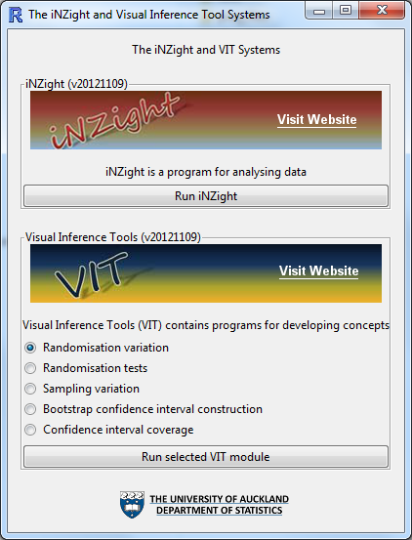

Click on Run iNZight
This will appear:

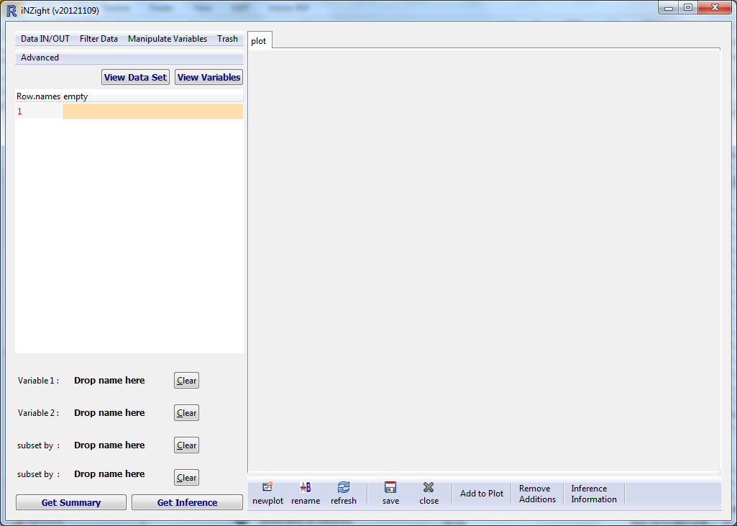
Click on Data IN/OUT
From the drop-down menu, select Import Data
In the File Browser box, click on the ‘browse’ button to find the csv file to import
Click OK
The data set now appears.
Drag the variable name of the explanatory variable to Variable 1.
Drag the variable name for the response variable to Variable 2.
The scatter plot will appear in the display screen.

Data sources

CensusAtSchool NZ
http://www.censusatschool.org.nz/resources/data-analysis-tools/

StatisticsNZ SURF
http://www.stats.govt.nz/searchresults.aspx?q=SURF
These may not have enough quantitative variables

OzDASL – Australasian Data and Story Library
http://www.statsci.org/data/
The Multiple Regression and Multiple Regression with Factors datasets are probably more useful than the First Course in Statistics
http://www.statsci.org/data/multiple.html

DASL
http://lib.stat.cmu.edu/DASL/

ConnectMV
http://datasets.connectmv.com/
Some are simulated data

StatLib JASA Data Archive (17 data sets)
http://lib.stat.cmu.edu/modules.php?op=modload&name=PostWrap&file=index&page=jasadata/

StatLib Dataset Archive (111 data sets)
http://lib.stat.cmu.edu/modules.php?op=modload&name=PostWrap&file=index&page=datasets/

StatLib Data Expo Archive (9 data sets)
http://lib.stat.cmu.edu/modules.php?op=modload&name=Downloads&file=index&req=viewsdownload&sid=30

http://www.mvstats.com/Resources/page3_datasets_greatideas.htm
Has links to 8 sources of statistical datasets
Some links are broken
There are no data sets in the UCLA Case Studies
The UCI Machine Learning Repository looks worthwhile

http://www.models.life.ku.dk/datasets
Quality and technology based from Department of Food Science, University of Copenhagen
Many are in Matlab format

From the Department of Statistics, University of Munich
http://www.stat.uni-muenchen.de/service/datenarchiv/welcome_e.html

NationMaster
http://www.nationmaster.com/index.php
Huge database of statistics from many countries

