ACHIEVEMENT STANDARD 3.8 TIME SERIES
POSSIBLE STUDENT RESPONSES TO FOOD FOR THOUGHT EXEMPLAR USING iNZight

Achieved Level Response
Students select one series to analyse from the following:
Amount of money in NZ spent on
- Supermarket & grocery stores
- Fruit & vegetables, fresh meat, fish or poultry
- Takeaway food
- Cafes & restaurants
Teachers please note that the retail series above have all been deflated to September 1995 quarter prices. In other words they have all been placed on the SAME cost basis. Consequently please ignore statement in NZQA exemplar which states that some of the increase in grocery spending can be accounted for by an increase in prices!
iNZight outputs for Amount of Money spent at Supermarkets All figures are deflated to September 1995 quarter prices and are given in millions of dollars. Figures are exclusive of GST.
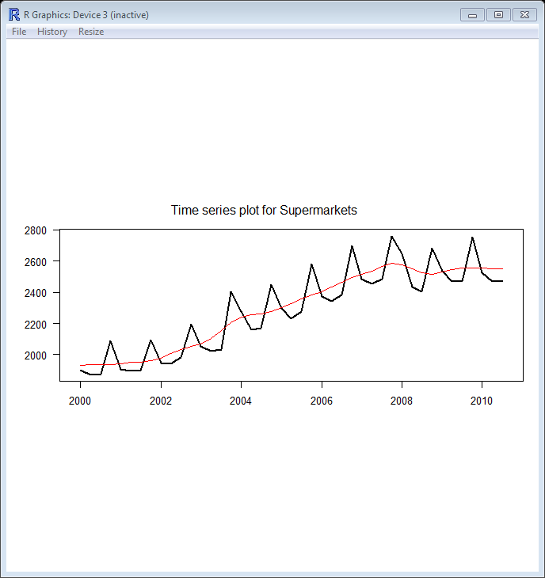
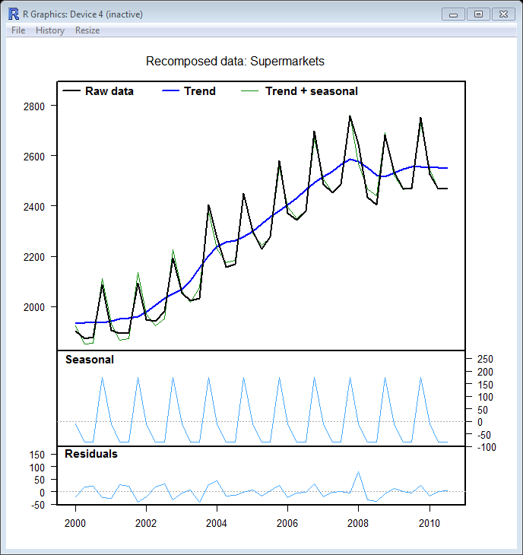
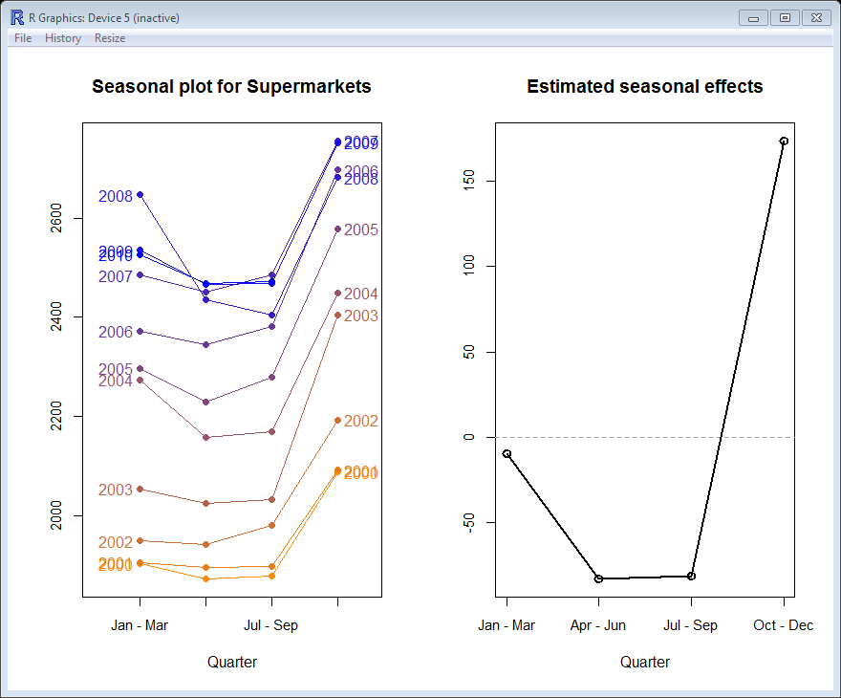
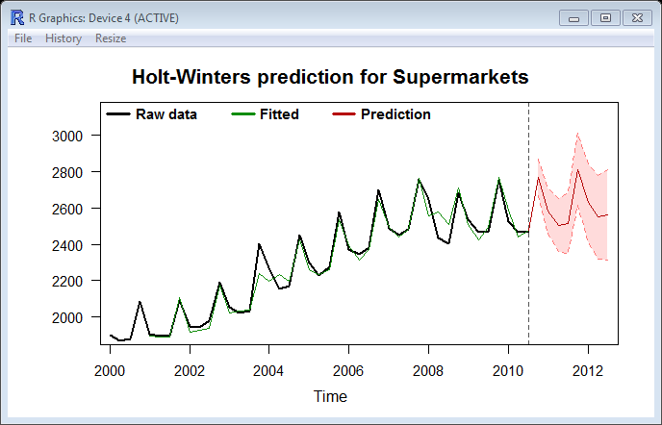
Achieved Level Comments
Long term trend - The long term trend in amount of money spent in New Zealand on supermarket shopping shows a steady increase from 2000 through to around 2008. The trend then falls between 2008 and 2009 before levelling off in 2010 at around $2550 million per quarter.
Seasonal effects – Estimated seasonal effects show that usually the second and third quarters are below trend by around $80 million, the first quarter is on trend or marginally below and the boom quarter is the fourth with spending up by around $170 million above trend. The peak reflects increased spending around Christmas.
Residuals – The residuals almost all fall within the range +/- $50 million. The range of the data is $884 million ( Max – Min = 2756 – 1872). Residuals of $50 million represent only 5.6% of this range so are not considered to be unusual values. Only one residual stands outside this range and it occurs in the first quarter of 2008. This residual is around $75 million but is still less than 10% of the overall range.
The relatively small size of the residuals together with the lack of ‘white space’ observed between the fitted and raw data, in the re-composition plot, indicate that almost all the variation in the series has been explained by the model and consequently the model can be considered a reasonably good fit to the series.
Component contribution to series variation
(Ball-park figures only, taken from iNZight plots. Include approx. contributions over 10% )
Supermarket spending | Min | Max | Range | Approx. % Contribution
Raw data | 1750 | 2750 | 1000
Trend | 1950 | 2550 | 600 | 60%
Seasonal | -90 | 180 | 270 | 27%
Residual | -45 | 75 | 120 | 12%

The main source of variation in Supermarket spending is the trend component.
Around 60% of the overall variation in this series can be accounted for by the trend component. The seasonal component accounts for about a quarter of the variation and the residual component accounts for the remaining variation in the series.
Predictions –
Predictions of spending at supermarkets in millions of dollars, (in September quarter 1995 prices).
Quarter | Lower Limit | Prediction | Upper Limit
2010, Quarter 4 | 2670 | 2770 | 2870
2011, Quarter 1 | 2460 | 2590 | 2710
2011, Quarter 2 | 2360 | 2500 | 2650
2011, Quarter 3 | 2350 | 2520 | 2680
2011, Quarter 4 | 2610 | 2810 | 3010
2012, Quarter 1 | 2410 | 2630 | 2840
2012, Quarter 2 | 2320 | 2550 | 2780
2012,Quarter 3 | 2310 | 2560 | 2810

After a visual inspection of the prediction plot I can see that the model fits the data quite well but there are times ( eg. 2004 & 2008) when there is a difference between the fitted and the actual values. This uncertainty is reflected in the prediction intervals.
I predict that the spending at supermarkets in New Zealand in the third quarter of 2011 will be between $2350 million and $2680 million (in September quarter 1995 prices).

Merit Exemplar
At Merit level students are expected to repeat the above analysis for a second series and then to compare analyses from the two series.
I have chosen to analyse amount of spending on Takeaways as my second series.
All figures are given in $ million and are deflated to September 1995 quarter prices.
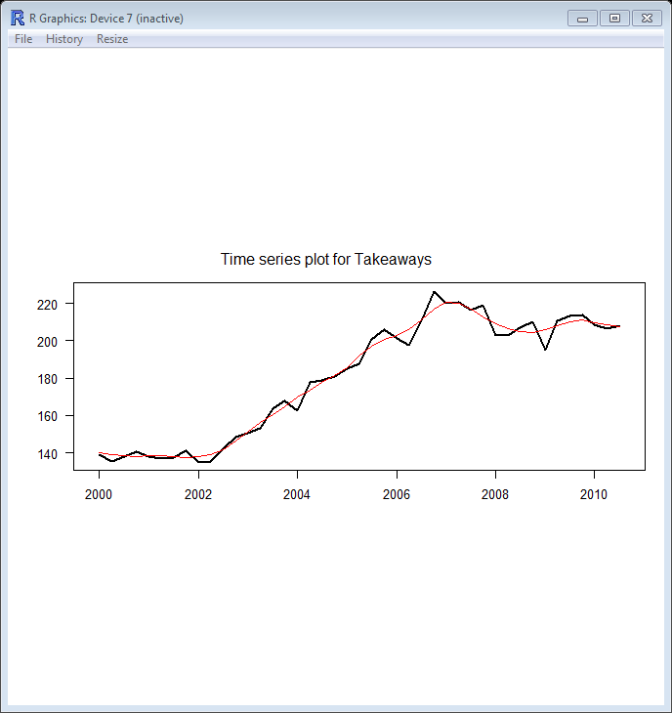
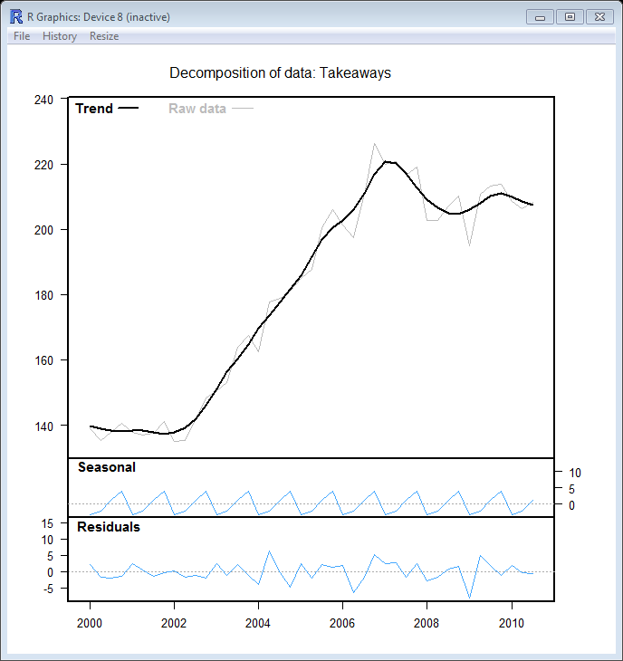
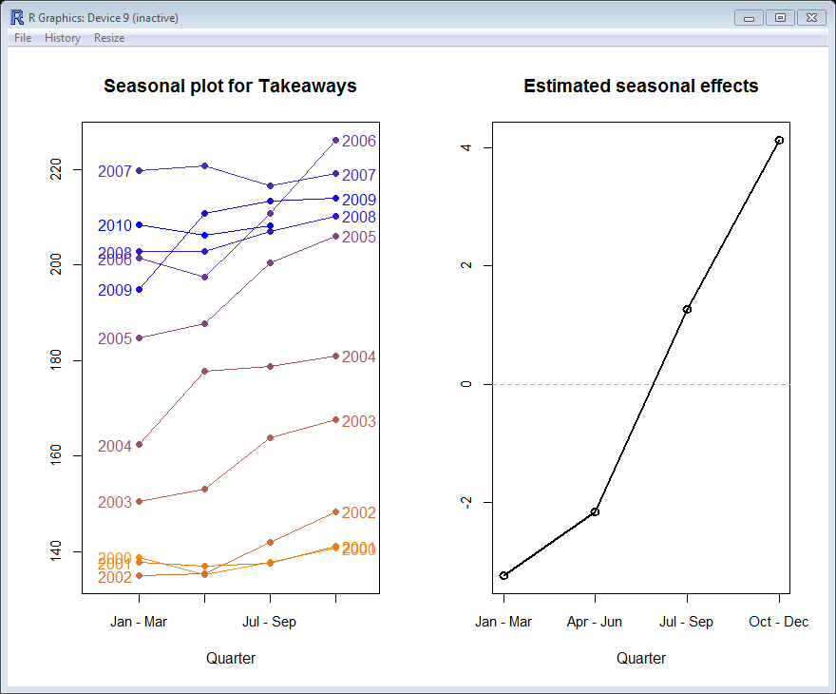
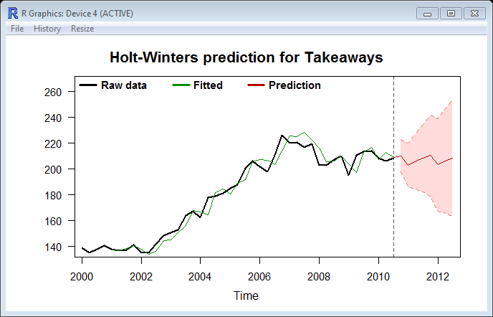
Long Term Trend – The trend in amount of money spent in New Zealand on takeaways was relatively constant from 2000 to 2002 at just under $140 million per quarter. From 2002 to 2007 the amount spent on takeaways increased rapidly to around $220 million per quarter in 2007 or around an additional $3 million per quarter during this period on average. From 2007 to 2009 spending fell slightly but by 2010 spending was reasonably constant at just under $210 million per quarter.
Seasonal Effects – Estimated seasonal effects show that during the first quarter spending on takeaways is just over $3 million below trend, during the second quarter it is around $2 million below trend. The third quarter shows spending at just over $1 million above trend and the bumper quarter for spending on takeaways is the fourth quarter with spending around $4 million above trend. However, some years have not followed this pattern – for example 2007 – where the lowest quarter was the third. In 2007 the long term increasing trend began to change and this may have disrupted the seasonal pattern during that year. As the seasonal pattern is inconsistent this component as an indicator of overall series variation is unlikely to be useful.
Residuals – The range of this series is $91.3 million per quarter. Residuals fall mainly in the range of +/- $5 million. One residual that falls outside this range is when spending fell dramatically from $210.2 million in the last quarter of 2008 to only $194.9 million in the first quarter of 2009.
Component contribution to series variation
(Ball-park figures only, taken from iNZight plots. As the range in the seasonal component is less than the range in residuals, the seasonal component can be assumed to be negligible)
Takeaways spending | Min | Max | Range | Approx. % Contribution
Raw data | 130 | 230 | 100
Trend | 138 | 220 | 82 | 82%
Seasonal | -5 | 5 | 10
Residual | -7 | 6 | 13

The main source of variation in spending on Takeaways is the trend component.
Around 80% of the overall variation in this series can be accounted for by the trend component. Seasonal components and residual components account for the remaining variation in the series. As the range in residuals is higher than the range in seasonal components, it can be assumed that the seasonal variation is not an important factor in this series. Trend is the most important source of variation in the series, and is the only component that can adequately modelled.
Predictions -
Predictions of spending on takeaways in millions of dollars ( in September quarter 1995 prices).
Quarter | Lower Limit | Prediction | Upper Limit
2010, Quarter 4 | 198 | 210 | 223
2011, Quarter 1 | 186 | 203 | 220
2011, Quarter 2 | 184 | 206 | 228
2011, Quarter 3 | 182 | 208 | 234
2011, Quarter 4 | 179 | 210 | 242
2012, Quarter 1 | 167 | 203 | 239
2012, Quarter 2 | 166 | 206 | 247
2012,Quarter 3 | 163 | 208 | 253

In this series more ‘white space’ is visible in the prediction plot between the fitted and the raw data indicating that the model does not fit as well as the model of supermarket spending did. This uncertainty is reflected in the relatively much wider prediction intervals.
Conclusion
After a visual inspection of the prediction model I can see that an excellent fit was achieved during the period 2000 to 2002, a reasonable fit was achieved during the period 2002 to 2006. However, during 2007 & 2008 when there was a dramatic trend change the fit was not so good. In the latter years, 2009 onwards, the fit appears to be gradually improving again. Consequently I have reasonable confidence in my predictions but recognise that the relatively wide prediction intervals reflect that this series has the potential for substantial changes in trend level and direction.
I predict that the spending on takeaways in New Zealand in the third quarter of 2011 will be between $182 million and $234 million (in September quarter 1995 prices).

Comparison between amount of spending at Supermarkets and on Takeaways
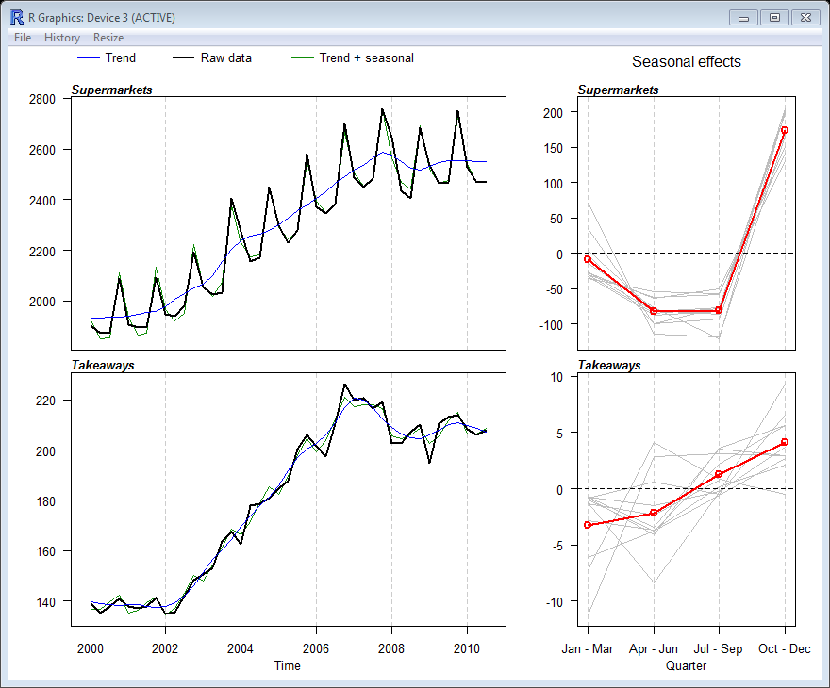
The trends of both series show slight or no growth initially followed by a period of rapid growth followed by a reasonably sharp decline and latterly a modest recovery. What is interesting is that the timing of this pattern is different for the two series. Spending on takeaways remained constant until 2002 whereas spending at supermarkets began to increase from 2001. Peak levels in takeaway spending was observed at the end of 2006 & early 2007 but peaks in supermarket spending were later at the end of 2007. For both series the modest recovery began in the latter half of 2008.
The seasonal pattern for spending at supermarkets has remained relatively consistent throughout the time period whereas the seasonal pattern for spending on takeaways is negligible. In particular seasonal effects in the first, second and fourth quarters have shown a range of around $10 million per quarter eg. First quarter from -$11 million to -$1 million. The magnitude of the estimated seasonal effects is also very different which is reflected in the component contribution to variance figures (Supermarkets – 27% due to seasonal factors, Takeaways – 10% due to seasonal factors). For supermarket spending, estimated seasonal effects range from -$80 million in quarters 1 and 2 to +$180 million in quarter 4. This is contrasted with the Takeaways series where estimated seasonal effects range from -$3 million in quarter 1 to +$4 million in quarter 4.

EXCELLENCE EXEMPLAR
(For Excellence students are expected to create a new variable from the ones originally provided. This might be a difference between two series, the sum of two series or a ratio of two series. Other transformations such as log transformations are NOT expected. Alternatively students might look at all the series provided and provide informed commentary on similarities and differences.)
I have created a new series – Totalpop . To calculate this series I have divided the total amount of spending at supermarkets, on fresh food, on takeaways and at cafes/restaurants by population figures. I have then compared the two series already analysed with my new series.
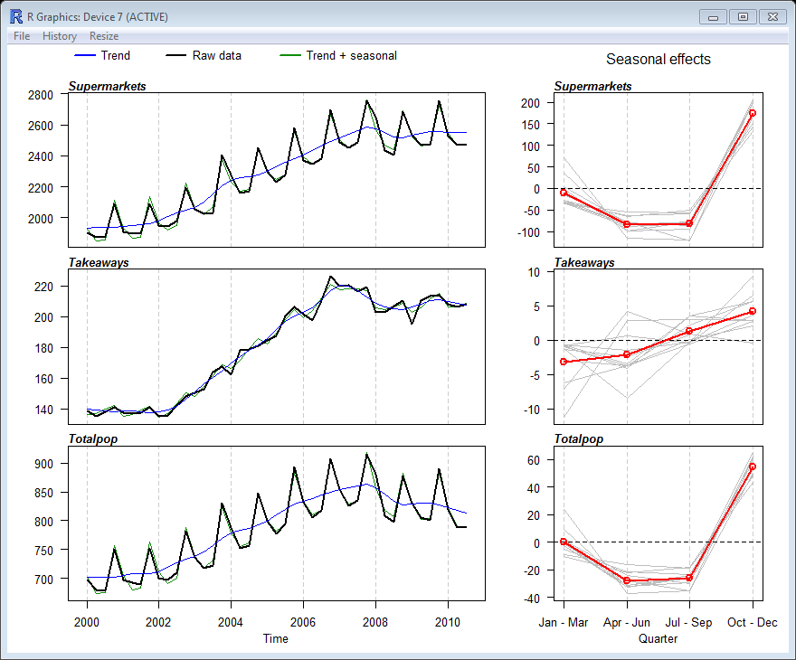
I can see that the trend of my new series, which is total spending per million population, closely follows the trend pattern exhibited by the supermarkets series. That is the decline in spending began in 2008, unlike the decline in takeaways spending which began in 2007. The seasonal pattern of my new series is also similar to that of supermarket spending with the fourth quarter consistently showing the highest level of spending. This dominance of supermarket spending confirms that supermarket spending represents the largest component of expenditure in the retail series examined.
Contextual Knowledge or research findings
The global financial crisis began in 2008 but in New Zealand a financial crisis occurred somewhat earlier. In the second half of 2006 the first finance companies began to get into trouble. During 2007 major finance companies collapsed, including Bridgecorp (losses of $500 million) in July, Nathans in August and Capital & Merchant in December. The collapse of these finance companies meant that many ordinary (“Mum and Dad“) investors lost large sums of money and many lost their life savings. A necessary result of such widespread losses was a reduction in spending which is seen in all our retail spending series but appears to have impacted on spending on takeaways earlier than spending at supermarkets.
Spending on takeaways is usually regarded as ‘discretionary spending’ or money available once all the necessities have been paid for. When economic times are hard, it is discretionary spending that usually gets hit first and hardest. Spending on takeaways is also partially driven by behaviour. For example, families who have a takeaway night every Friday. In hard economic times the behaviour may have to be modified eg. cook your own fish and chips at home, or swap to a cheaper type of takeaway food, thereby reducing overall spending on takeaways.
Supermarket spending on the other hand is regarded as spending on ‘necessities’ and so takes longer to react to hard economic times. The decline in supermarket spending does not mean that people have stopped shopping at supermarkets but that they have taken steps to try and reduce their supermarket bills. For example, swapping expensive items for cheaper alternatives, steak for sausages, branded products for home brand products.

Comparison of four retail spending series
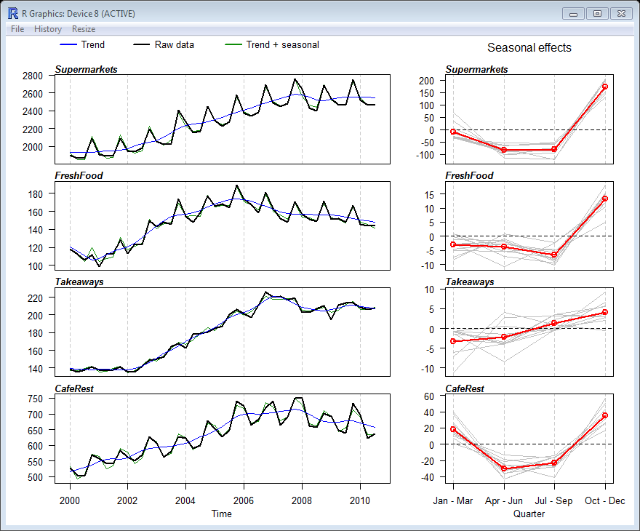
If the four areas of retail spending are examined, it can be seen that the downturn in spending occurred earliest (from 2006) in spending on fruit, vegetables and fresh meat (see FreshFood above). Next was a reduction in spending on takeaways and lastly we see spending in supermarkets and at cafes or restaurants declining from 2008. Spending at cafes and restaurants is largely associated with those from higher income brackets. Such people are likely to be initially more sheltered from the effects of economic crisis and thus the decline in spending starts slightly later than the decline in spending on takeaways. Seasonal patterns in supermarket spending and spending at cafes/restaurants are similar and consistent but seasonal patterns of spending on takeaways and fresh food are more variable. It is interesting to note that three of the series have a bumper fourth quarter largely explained by Christmas, but that spending at cafes and restaurants also has an above trend first quarter, which can be explained by the summer holiday period.
Accuracy of Predictions
Comparison of Actual and Predicted values for spending at supermarkets.
(in September quarter 1995 prices)
Date | Actual | Prediction | Lower Limit | Upper Limit
2010, Quarter 1 | 2526.2 | 2590 | 2490 | 2700
2010, Quarter 2 | 2467.7 | 2490 | 2360 | 2620
2010, Quarter 3 | 2471.2 | 2500 | 2360 | 2650

All actual values are within the prediction intervals calculated indicating model robustness for prediction. All predictions are slightly higher than the actual values but are all within 3% of the actual value.
Comparison of Actual and Predicted values for spending on takeaways.
(in September quarter 1995 prices)
Date | Actual | Prediction | Lower Limit | Upper Limit
2010, Quarter 1 | 208.4 | 206 | 194 | 219
2010, Quarter 2 | 206.2 | 212 | 194 | 229
2010, Quarter 3 | 208.1 | 214 | 192 | 236

All actual values are within the prediction intervals calculated indicating again model robustness for prediction. All predictions are within 3% of the actual value.

Rachel Passmore
Endeavour Teacher Fellow
Email : passm@vodafone.co.nz

